**Fire Drill Scenario**

By Geumhyung Jeong

Access Guide

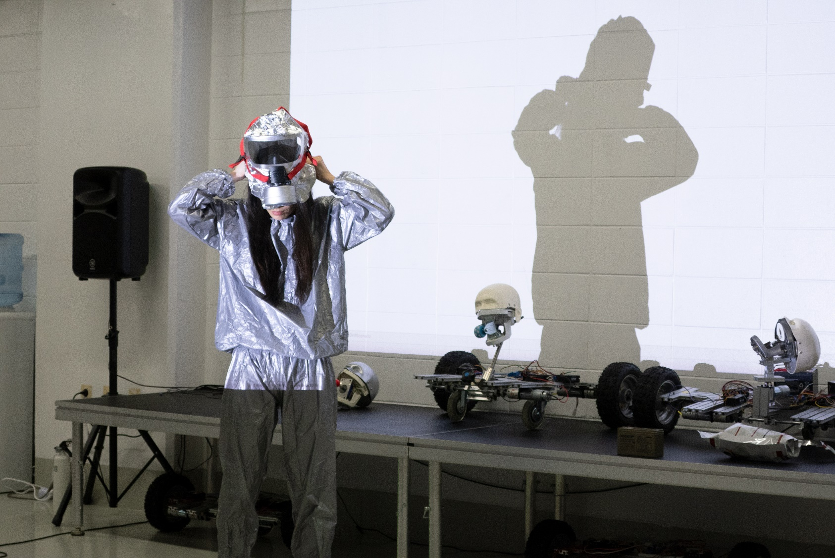

Image description: Performer Geumhyung Jeong, stands in a long–sleeve metallic silver outfit. She places a hand-made silver helmet on her head with a gas mask, shielding her face. Behind her is a robot with a mannequin head.

Image credit: Photo by Kanghyuk Lee. Geumhyung Jeong, Fire Drill Scenario.

# **Updates to this document**

Please note this is a remount of a performance and changes are being made by artists until opening. We will endeavour to provide the latest access information on performances to ticket holders across key stages of rehearsal and presentation.

Arts House website will contain the most up to date version of this document and all ticket holders will be notified of any revisions made 3 days and 1 day prior to the event.

This document was created: 27/02/2025

**Contents**

**Updates to this document** 2

**Where** 4

**When** 4

**Access Services** 4

**Sensory Elements** 7

Sound 7

Lighting 7

Physical 7

Smell 7

Visual 7

**Audience Experience** 8

Entry to space 8

Shocks or surprises 8

Audience experience 8

Social expectations 8

Performance expectations 9

**Other** 9

Content Warnings 9

General Notes 9

**The Venue** 10

Front Entrance 10

Accessible Entrances 11

Box Office 12

Ushers 12

Bar 13

Quiet Space 14

Bathrooms 14

The Warehouse 15

The Warehouse Entrance 16

Warehouse Bathrooms 17

**Transport** 18

Tram 18

Train 18

Bus 18

Parking 18

**COVID Safety** 19

# **Where**

Arts House

521 Queensberry Street

North Melbourne VIC

# **When**

Thursday 6 – Sunday 9 March 2025

Thursday – Saturday, 7.30pm

Sunday, 5pm

Duration: 90 minutes, no interval

# **Access Services**

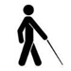

Tactile Tour - Sunday 9 March, 4pm (Commences 1 hour before performance).

This service is book on request by Wed 5 March.

Offered in conjunction with Audio Description, this service invites patrons who are blind or have low vision and their companions to explore the set, props and costumes prior to the performance.

   
Audio Describer Guides - Sunday 9 March, 5pm

This service is book on request by Wed 5 March.

Describer guides available for meet and greet on arrival and one-on-one live descriptions of the performance.



Assistance Animals are welcome.



Aural Rating 50%– contains both sound and visual components.



Visual Rating 50% – this performance has music and sounds in the background.

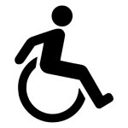

This performance is wheelchair accessible. More information is provided further below in this guide about the accessible entrances at Arts House and bathrooms.

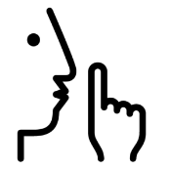

Quite Space Available - The quiet space will be available for you to use before and after the show. More information about the quiet space can be found later in this guide.

  
Companion Card - Arts House supports the Companion Card program.

**Performers**

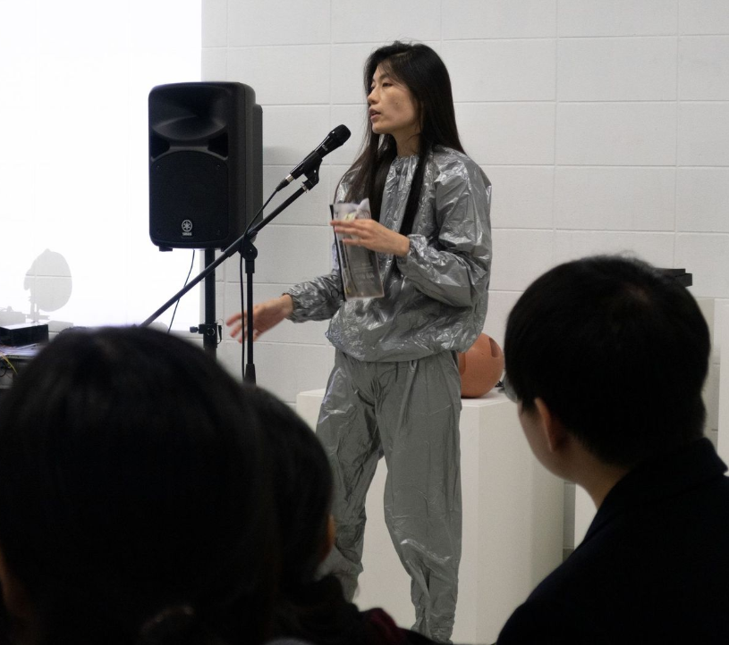

Image description: Performer Geumhyung Jeong, stands in a long–sleeve metallic silver outfit. She has long black hair and is talking into a microphone.

Image credit: Photo by Kanghyuk Lee.

# **Sensory Elements**

## Sound

There will be no sound or music played in the space on entry. There is a three-minute track that is played during the performance loudly. When it is time to evacuate the space, a fire alarm will play loudly until all audience clear the space.

## Lighting

The lighting will be standard room lights and fluro light battens. There is a moment when

there is a simulation of the fire with coloured lights with movement during the performance. There are strobes and flashing lights during the 3 minutes 30 second performance piece and evacuation.

## Physical

Audiences will be asked to evacuate the space in pairs. They will be in close proximity to one another when they exit the building. The muster point is outside and there might be inclement weather.

## Smell

There is a short moment smoke will be used in the space.

## Visual

There is an installation in the space containing several gallery plinths with various emergency evacuation materials and objects including a fire extinguisher, remote controllers, and protection gear.

In the middle of the space there is an installation of robotic sculptures on a stage. The robotic sculptures will be controlled shortly at some point during the performance.

There are several screens in the space installed against each wall playing looped videos. There is a projection in the space which the performer will operate with different images and videos.

When exiting the building there will be small orange witches’ hats guiding a pathway to the evacuation muster point.

# **Audience Experience**

## Entry to space

This performance takes place in the Warehouse, which is a separate self-contained building adjacent to North Melbourne Town Hall. Arts House ushers will guide audience to this space. The audience enter the main sliding door to the Warehouse as a group. You are welcome to wander through the space for up to 10 minutes and explore the installation. You are free to sit or walk around.

## Shocks or surprises

The audience will be instructed to evacuate the space. There will be a loud evacuation fire alarm sounded in the space and smoke.

## Audience experience

Once everyone is seated in the space, the performer will start by giving an overview of fire evacuation procedure and scenario, before practicing the evacuation drill. The audience will listen to the instructions and then practice the instructions, and then physically enact the drill.

The performer will move around the space, sometimes will give eye contact when talking and point to groups of people in the room during the instructions.

The performer will instruct audience when the drill is happening and what to do in the space. The performer will instruct the audience to evacuate the space and there will be two different routes to follow outside the building to the muster point. Audiences will follow the instructions of Arts House staff and the performer.

## Social expectations

There are three four areas in the space people can sit. There is a range of different seating in the space – stools of various sizes, chairs with backs, plinths and cushions on the ground. There will be installation objects in the middle of the space and surrounding areas. You’re encouraged to remain in your seats until instructed otherwise. No glass, plastic cups are allowed in the space. Closed drink bottles allowed.

## Performance expectations

There is one performer leading the fire drill scenario. They will be wearing a silver parachute material outfit. They will put on a silver emergency escape hood used specifically to prevent smoke inhalation at one point during the work. The performer will address the audience throughout the work.

# **Other**

## Content Warnings

Fire Drill Scenario contains simulation of emergency evacuation, including moving inside and outside the venue.

It contains the use of smoke effects, haze, high pitched frequencies, loud music, flashing and strobe lights, abrupt lighting changes, low lighting, lights that black out and change in colour and intensity.

## General Notes

There will be an acknowledge of country that will play during this performance.

# **The Venue**

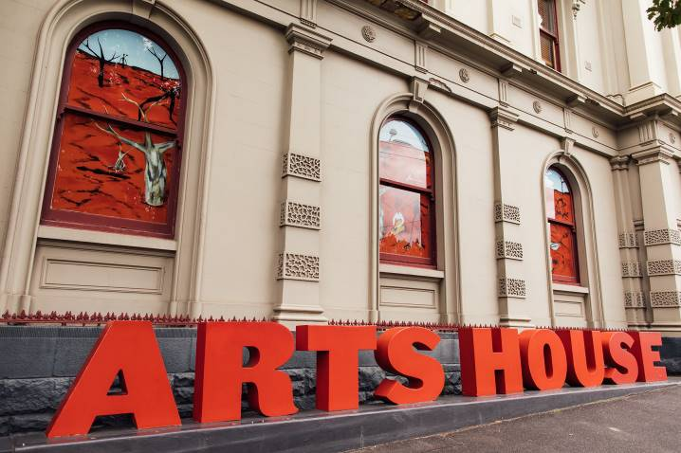

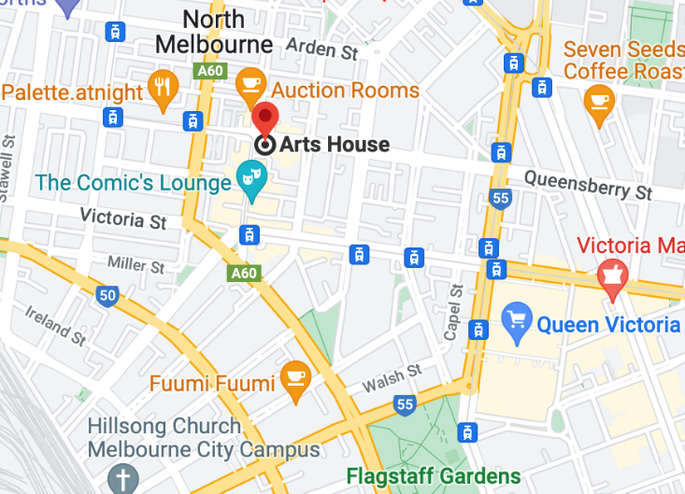

Image: North Melbourne Town Hall features giant red letters that say ARTS HOUSE out the front of it.

Image: a map of Arts House and its surrounding area. [LINK TO MAP](https://www.google.com/maps/place/Arts+House/@-37.802973,144.9486818,17z/data=!4m5!3m4!1s0x0:0x64c465ac7ef21cff!8m2!3d-37.803239!4d144.9498609?shorturl=1)

## **Front Entrance**

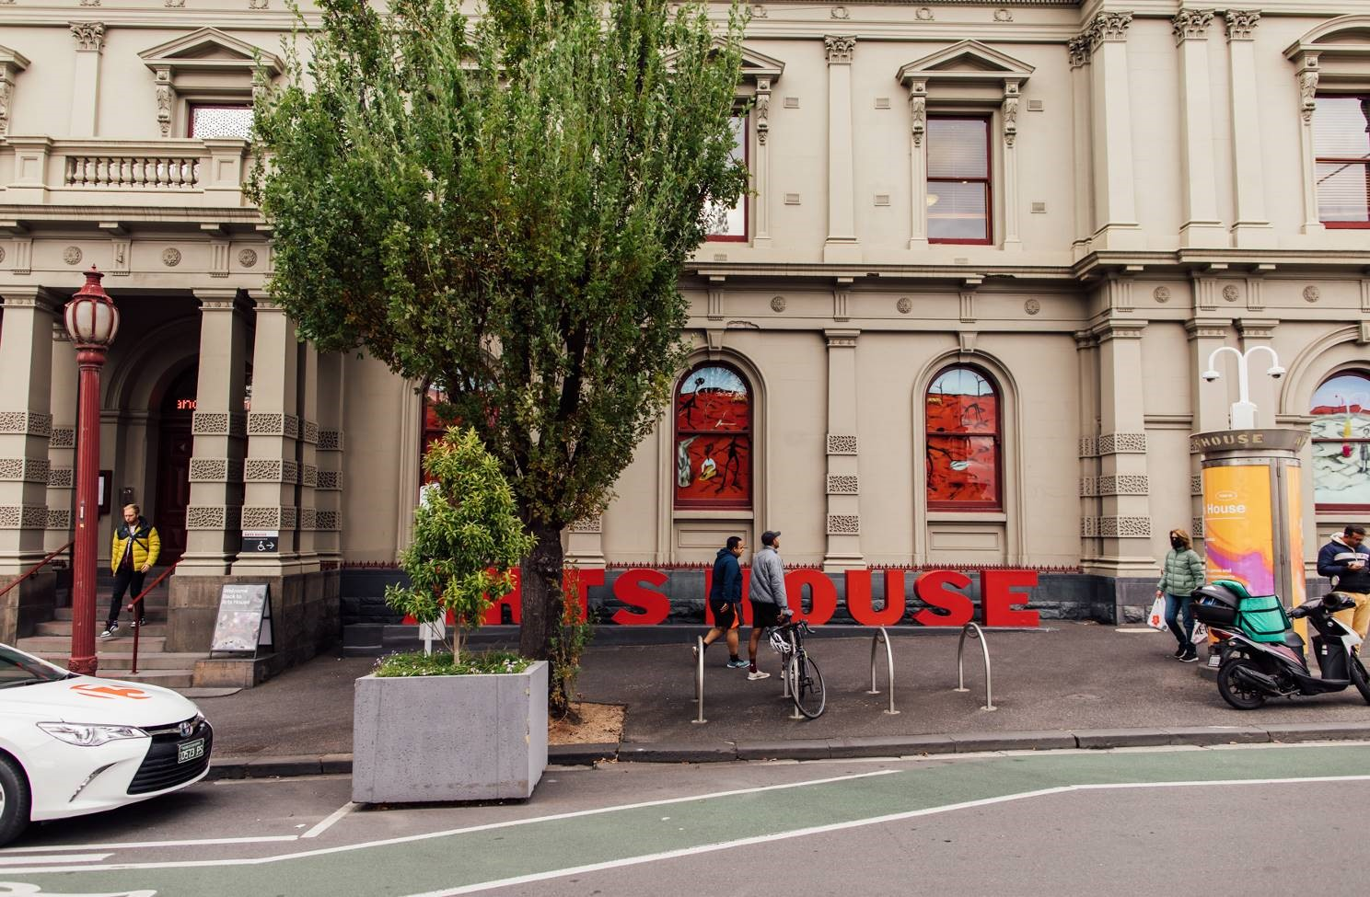

## **Accessible Entrances**



There are two Accessible Entrances. The first is on Errol St next to the Post Office.

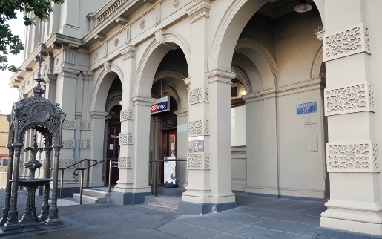

Image: Errol Street entrance next to the Post office with wheelchair accessible ramp or two steps with grab rails.

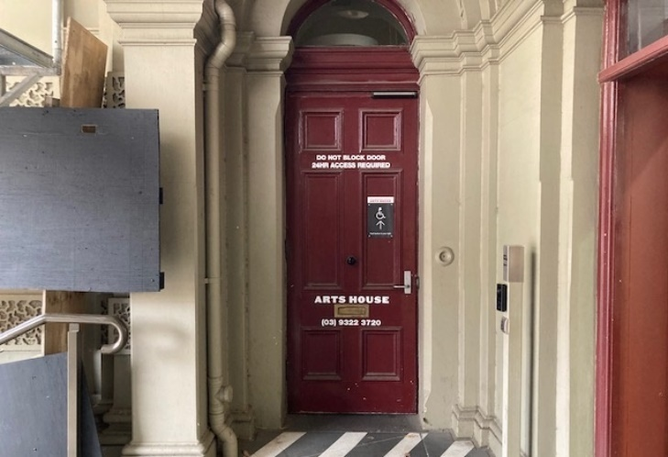

Image: View of door entrance.

The second Accessible Entrance is towards the end of George Johnson Lane.

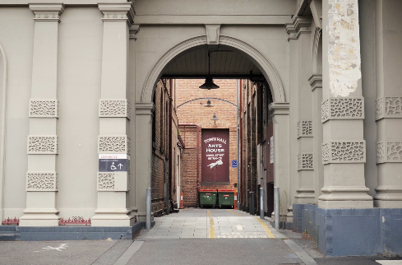

Image: View of George Johnson Lane from Errol St. The laneway passes through an archway with a brick wall at the end.

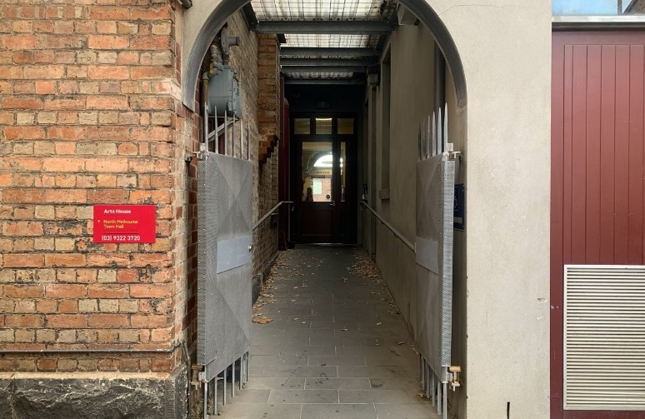

Image: view of the ramp leading from George Johnson Lane to the automated door which opens into the Arts House foyer.

## **Box Office**

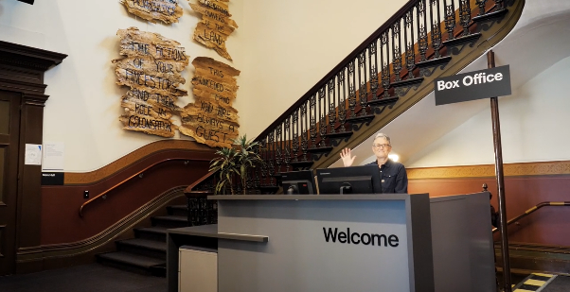

Image: Reception desk. Box Office / Reception Desk is located in the foyer under the stairwell.

## **Ushers**

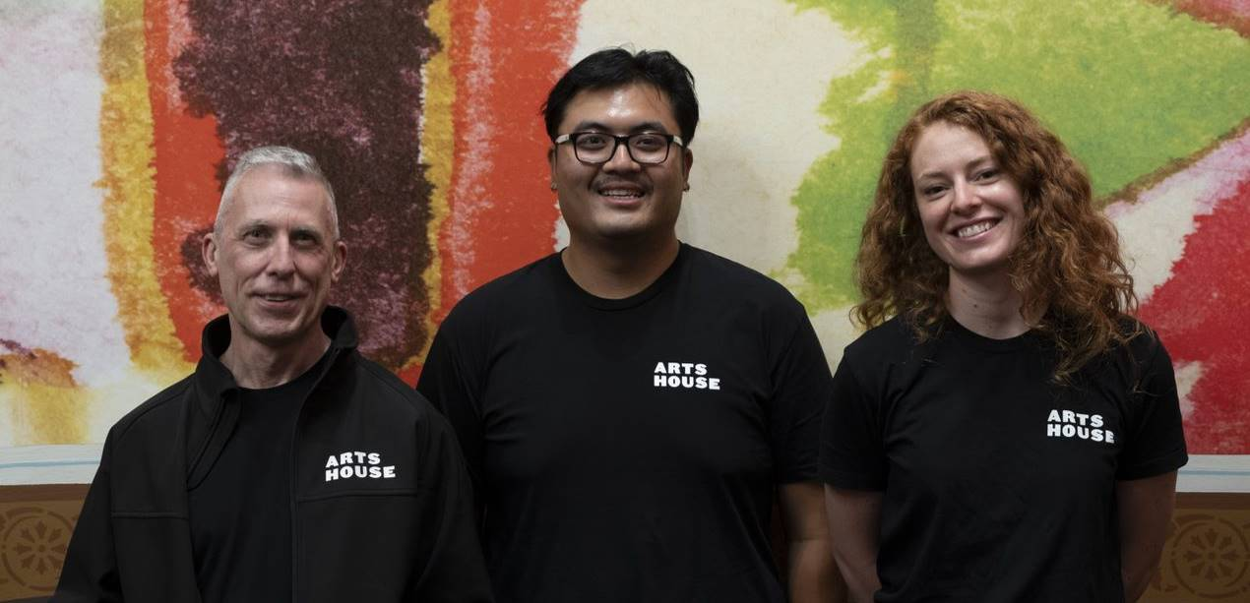

Image: Three Arts House Ushers.

Ushers will be wearing black with an Arts House Logo on the left hand shoulder.

## **Bar**

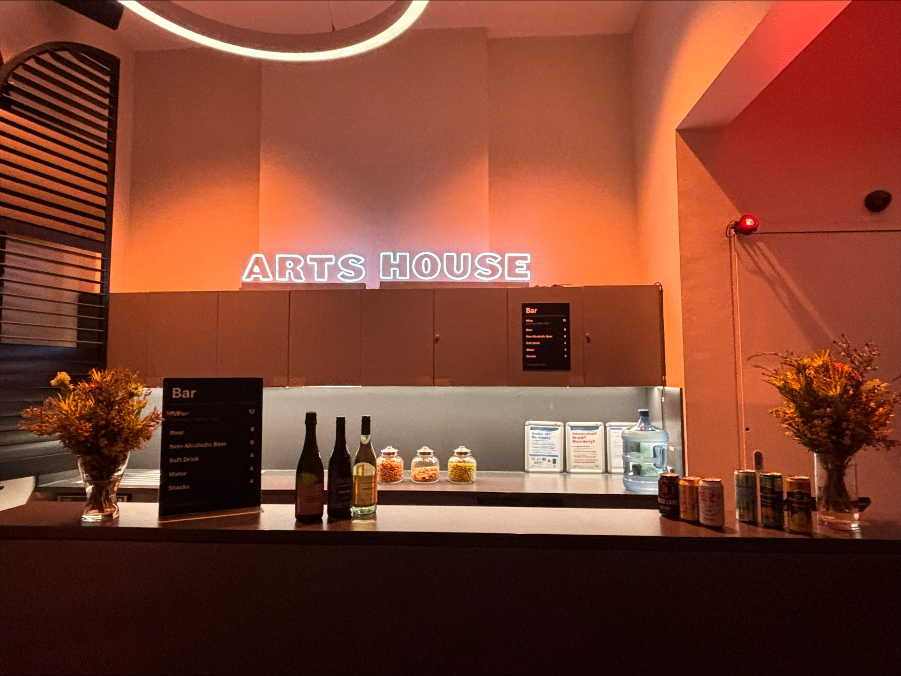

Image Description: Arts House Bar

Bar staff will be wearing black with an Arts House Logo.

We have a range of alcoholic and non-alcoholic beverages for sale.

We are a cashless venue and accept EFTPOS, Visa and Mastercard payments.

## **Quiet Space**

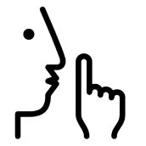

Arts House Quiet Space is located on Ground Level and is nearby reception and opposite the accessible bathrooms. It includes a range of seating options including soft furnishings, dimmable lights, sensory and stim objects. It is open during venue opening hours and events as a quiet space, prayer or parenting space.

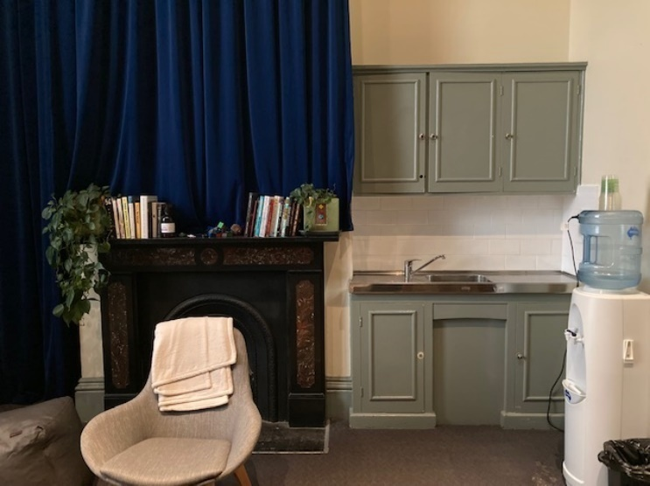

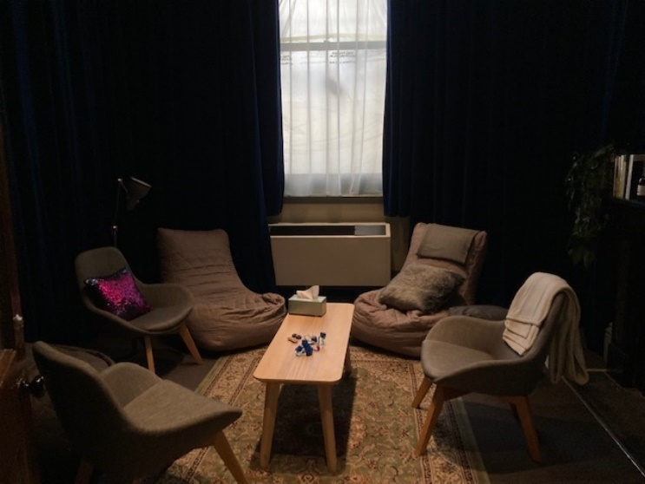

Image: Quiet Space with lights dimmed

## **Bathrooms**

All bathrooms have Dyson hand dryers with sensor activation. There is an accessible bathroom that is single use on ground level opposite the Quiet Space. There is another accessible bathroom upstairs – this is accessible via lift or stairs.

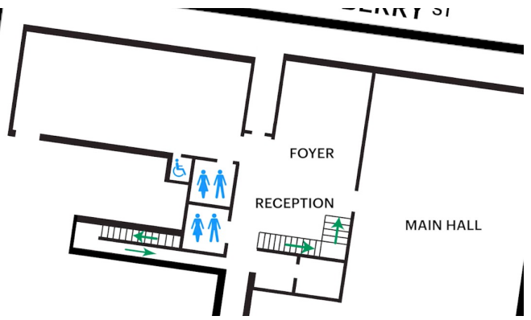

Image: Map of ground floor bathroom locations.

## **The Warehouse**

This performance takes place in The Warehouse. You will meet in Arts House main building and front of house staff will guide you to this space.

The Warehouse is separate to the main building of Arts House. You can find the Warehouse by following George Johnson Lane as it snakes around the back of the main Arts House building. The path to the Warehouse from George Johnson Lane is a smooth asphalt surface with a cobblestone strip in the centre for part of the journey.

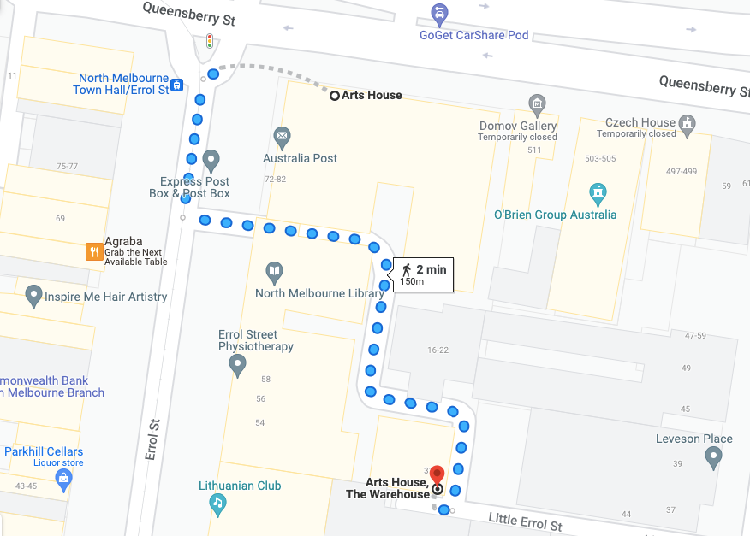

Image: A screenshot of a map with walking directions from the front of the main building of Arts House to the Warehouse behind it. The map indicates a 2 minute walk.

## **The Warehouse Entrance**

The main Warehouse entrance has a wheelchair accessible ramp that is 1150mm wide. The bottom section of the ramp has a gradient of 1:6 and has no handrails. The upper section has a gradient of 1:12 and has handrails on both sides. This main entry to the Warehouse is through an automated, glass sliding door.

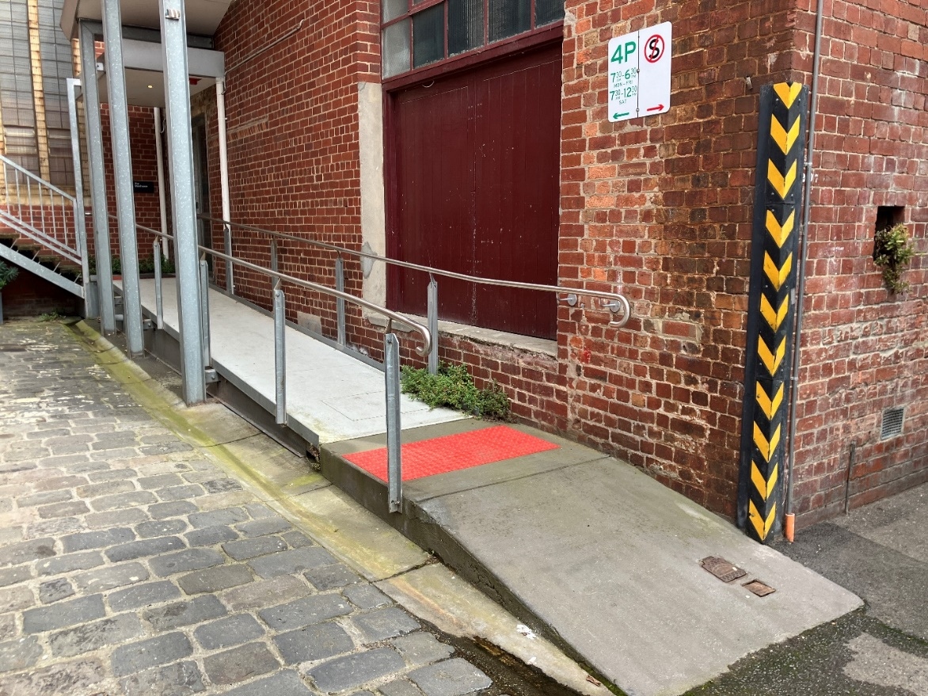

Image: view of the ramp leading to the main entrance of the Warehouse. The bottom section has no handrails. There are handrails either side of the ramp at the top section and a large red tactile surface indicator on the flat middle section. The door to Warehouse is on the right at the top of this ramp.

## **Warehouse Bathrooms**

The Warehouse space has three separate bathrooms located on the opposite, far right corner from the main entrance. These are all self-contained and fully enclosed spaces, accessible from a corridor which leads off the main Warehouse space.

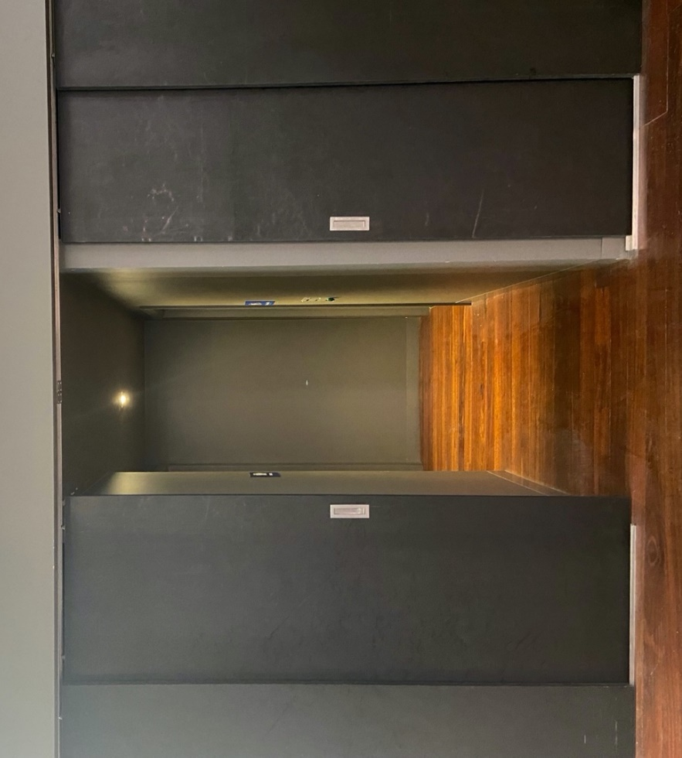

Image: Entrance to the block of toilets off the main area of the Warehouse space.

The first bathroom on the left of this corridor is a small room with a toilet, sink and mirror. This toilet area does not feature grab rails and is not wheelchair or mobility aid accessible.

The second bathroom on the left has a urinal only with a sink and mirror.

The toilet on the right is an accessible bathroom with an automatic door which is operated by a push button. The panel with the button to open the door is to the right of the doorframe and features raised print and braille signage. The door to this toilet opens inwards and remains in its open position for around 20 seconds. This toilet cubicle features an accessible toilet with grab rails, a sink and mirror and has enough turning room for a wheelchair or mobility aid.

# **Transport**

## **Tram**

Route 57 (High Floor trams only)

Stop 12, North Melbourne Town Hall.

Please note, this is not a wheelchair accessible tram

[GETTING TO ARTS HOUSE VIDEO LINK](https://vimeo.com/544169506)

## **Train**

Arts House is 1.1km from   
North Melbourne Train Station,   
approximately 16 minute walk

[North Melbourne Station Information](https://www.ptv.vic.gov.au/stop/1144/north-melbourne-station/0/train/)

1.2km from Flagstaff Station,   
approximately 15 minute walk

[Flagstaff Station Information](https://www.ptv.vic.gov.au/stop/1068/flagstaff-station/0/train/#StopPage:::datetime=2023-04-06T04%3A41%3A27.669Z&directionId=-1&showAllDay=false&_auth=408ac3b1e97f4b0beb5bdf00c2f797057d10dd6e6cf2ad40a69334c4dfdf5e21)

## **Bus**

Bus number: 216

## **Parking**

There is limited paid on-street parking on Queensberry Street and Errol Street.

There are two accessible on street car parking spaces on Queensberry Street (150m to our accessible Errol Street entrance) for holders of a Parking Permit for Disabled people.

# **COVID Safety**

Please note: If you have a cough, sore throat, fever, shortness of breath or flu-like symptoms, you must not attend our venue or programs in person.

We will provide a refund if you need to cancel your attendance due to illness. Please [contact us](mailto:ArtsHouse.Ticketing@melbourne.vic.gov.au) by 9am on the day of the event.

To minimise the risk of COVID-19 transmission, we advise all patrons, artists and staff to:

* Practise physical distancing where possible
* Practise good hygiene by washing and or sanitising your hands often
* Wear a mask as directed by Victorian Government guidelines

Throughout the venue you will find:

* hand sanitiser stations available
* masks available in foyer (ask one of our staff for assistance)​

We also ensure that spaces are well ventilated.

Staying COVID-safe remains important. We must all follow these steps:

* Follow the [Victorian Government’s measures on how to stay safe.](https://www.betterhealth.vic.gov.au/coronavirus-covid-19-victoria)
* When you cannot safely socially distance it is recommended to wear a well fitted mask where required.
* Practise [COVID-safe hygiene protocols.](https://www.health.gov.au/news/health-alerts/novel-coronavirus-2019-ncov-health-alert/how-to-protect-yourself-and-others-from-coronavirus-covid-19/good-hygiene-for-coronavirus-covid-19)