**1880: Manifesto of Silences   
Development Showing**

By Irene Holub and Walter Kadiki

Access Guide

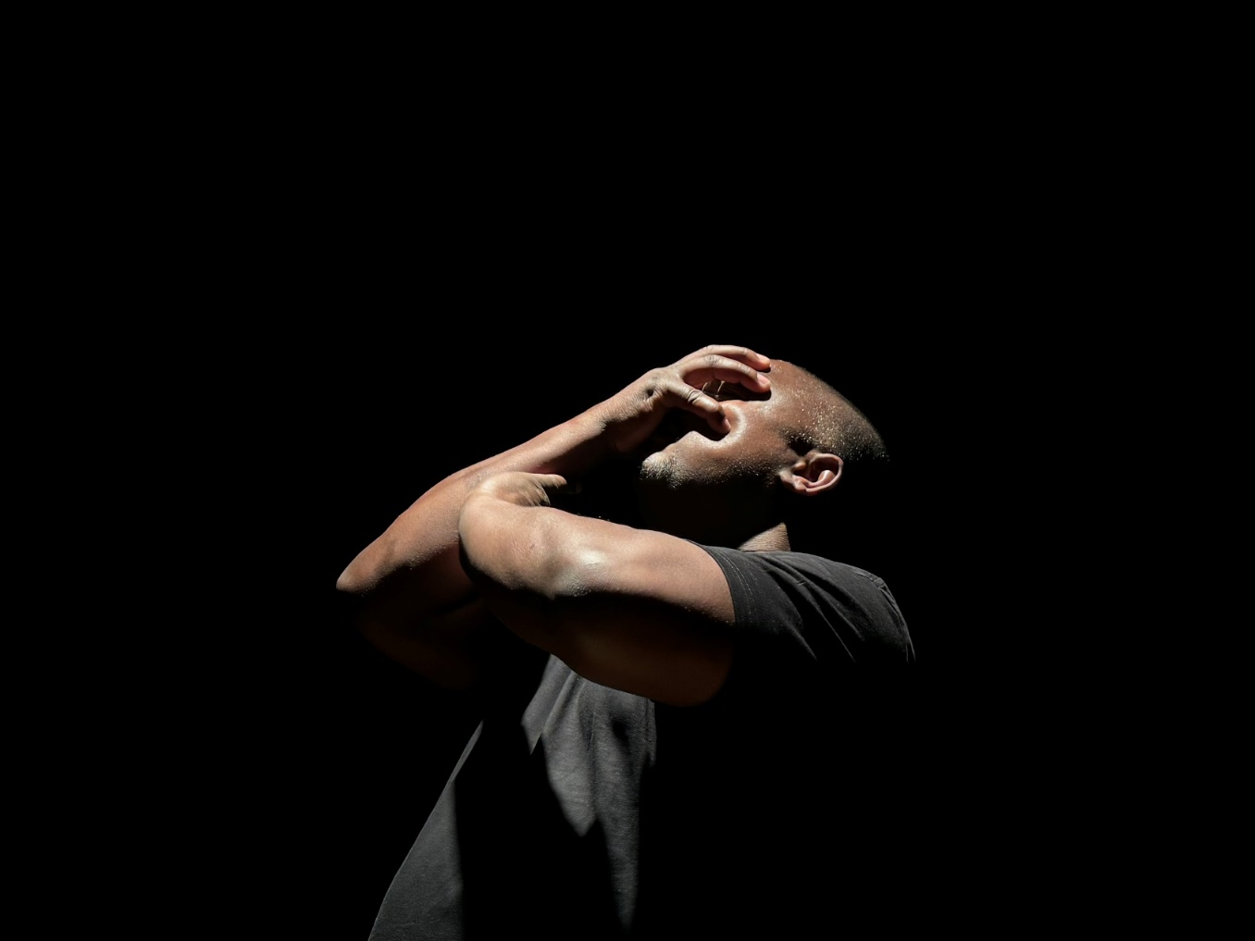

Image credit: Irene Holub   
Image description: Profile of the face of a black man, his right hand raised to cover his face.

# **Updates to this document**

Please note, this development showing is the first stage of a new work and changes are being made by artists until opening. We will endeavour to provide the latest access information on showings to ticket holders across key stages.

Arts House website will contain the most up to date version of this document and all ticket holders will be notified of any revisions made 3 days and 1 day prior to the event.

This document was created: 27 March 2025

**Contents**

Updates to this document 2

Where 4

When 4

About the work 4

Access Services 5

Performers 7

Sensory Elements 8

Sound 8

Lighting 8

Physical 8

Smell 8

Visual 8

Entry to space 9

Shocks or surprises 9

Audience experience 9

Social expectations 9

Performance expectations 9

Other 9

Content Advice 9

The Venue 10

Front Entrance 10

Accessible Entrances 11

Box Office 12

Ushers 12

Bar 13

Quiet Space 14

Bathrooms 15

Door to Studio 1 16

Lift 17

Transport 18

Tram 18

Train 18

Bus 18

Parking 18

COVID Safety 19

# **Where**

Arts House

521 Queensberry Street

North Melbourne VIC

# **When**

Friday 28 March, 6:30pm   
40 minute showing + 40 minute post-show Q&A which will be Auslan interpreted

Saturday 29 March, 6:30pm

40 minute showing

# **About the work**

In 1880, one decision echoed through time, suppressing Deaf language, culture and identity – shaping generations to come.

From Irene Holub and Walter Kadiki, the development showing of *1880: Manifesto of Silences*weaves together operatic performance, sign language opera, projection art, sound vibrations and experimental techniques to revisit the pivotal decision to ban the use of sign language in deaf education.

*1880: Manifesto of Silences Development Showing* deeply examines the poetic and emotional dimensions of this historic event, raising awareness of its cultural impact and honouring the resilience and vibrancy of the Deaf community.

This development showing is the culmination of Irene and Walter’s eight-week residency at Arts House as part of The Warehouse Residency.

# **Access Services**

This is a work in progress showing performed predominantly in visual vernacular and will not be Auslan interpreted. It is suitable for a Deaf or signing audience.

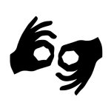Auslan Interpreted Q&A, Friday 28 March show only



Assistance Animals are welcome  
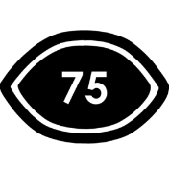

Visual Rating 75%– has minimal dialogue and some background music or sounds, or may be fully subtitled, so Deaf and hard of hearing audiences can have close to the full experience of the event.



This performance is fully wheelchair accessible. More information is provided further below in this guide about the accessible entrances at Arts House and bathrooms.

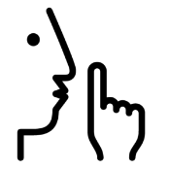

Quite Space Available - The quiet space will be available for you to use before and after the show. More information about the quiet space can be found later in this guide.



Companion Card - Arts House supports the Companion Card program.

# **Performers**

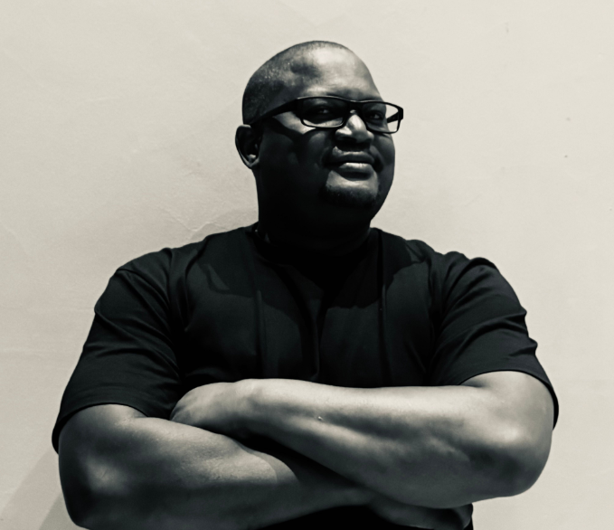

Image: Walter Kadiki

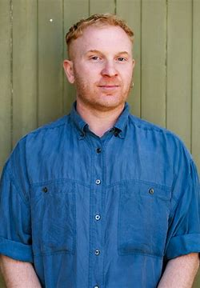

Image: Luke King

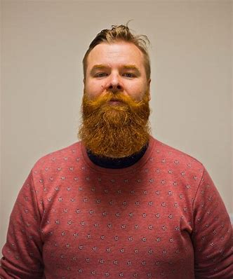

Image: Ramas McRae

**Director**

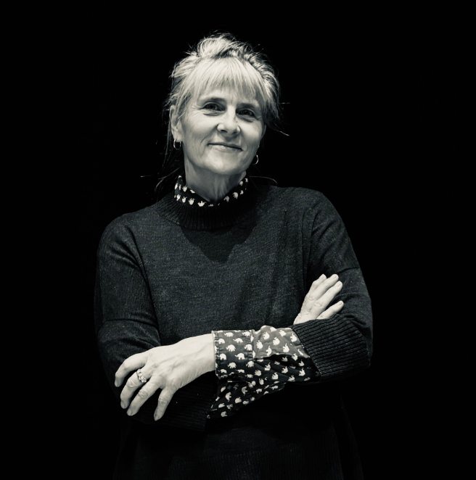

Image: Irene Holub

# **Sensory Elements**

## Sound

The sound can be loud at times. There are low frequency noises and vibrations throughout the work. Sounds may have no clear source. There are no overlapping voices.

## Lighting

The lighting changes in colour and intensity throughout the work. The lights go on or off, and the room is occasionally dark. There are no strobe or flashing lights. Changes to lighting are gradual rather than sudden. There is no lighting or projection directly onto the audience. There are no mirrors or surfaces that reflect light on the audiences.

## Physical

Audience members will be able to feel vibrations from loud sounds and music. There is no touching of audiences in the work. The performers and audience are not in close proximity at any time throughout the work. There are no uneven floors. Audiences will be seated together in a seating bank. The temperature in the room does not change and there is no smoke or air blowing around the room. There are no touch, taste, temperature, vestibular elements in the work.

## Smell

There are no smells in the space where the work will be presented. Catering will be available on Friday night only. This may have some general food smells.

## Visual

The overall experience is visually poetic, where the imagery on screen accompanies the poetic nature of the performance. The footage on screen mixes historical images of deaf people with contemporary images of Melbourne Deaf Community members. There is a repetitive and hypnotic background footage of small waves.

Audience Experience

## Entry to space

Audiences will enter from the foyer, up the stairs and straight into Studio 1. There is no assigned seating. A staff member will assist with any seating inquiries.

## Shocks or surprises

There are no shocks or surprises in the work.

## Audience experience

There is no expectation of audience participation and no contact between the performers and the audience.

## Social expectations

The audience will sit in the seating bank. There is no interaction with the audience. Audience members are not able to enter the space once the lock out has commenced. We prefer audience members to remain seated unless there is a health and safety issues. Audiences can make noises if required. The three performers are Deaf and will not be distracted by noise from the audience. There are no designated places to move around once in the space. People bring in snacks or stim toys?

## Performance expectations

The dialogue is in a mixture of Auslan and visual vernacular, performed in a poetic mode. There is not a linear storyline to follow, but a series of scenes depicting historical events with present day impacts for Deaf people. There are three performers in the work, who appear on stage at different moments. The performers appear in historical costume. Two of the performers depicted as historical characters are men (played by Luke King and Ramas McCrae and the narrator, who is unnamed in the work, is a man played by Walter Kadiki.)

# **Other**

## Content Advice

There are deeply emotional and impactful themes about language suppression and eugenics throughout the work.

# **The Venue**

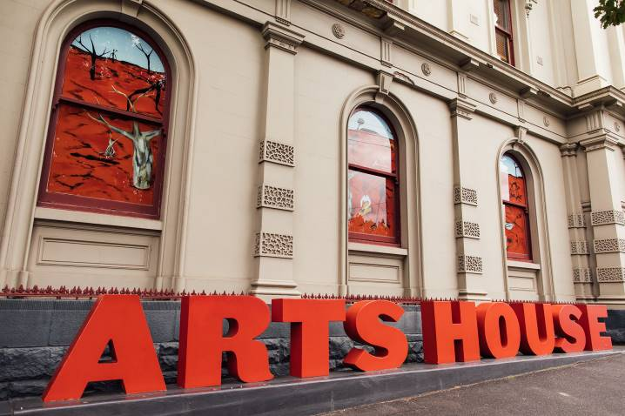

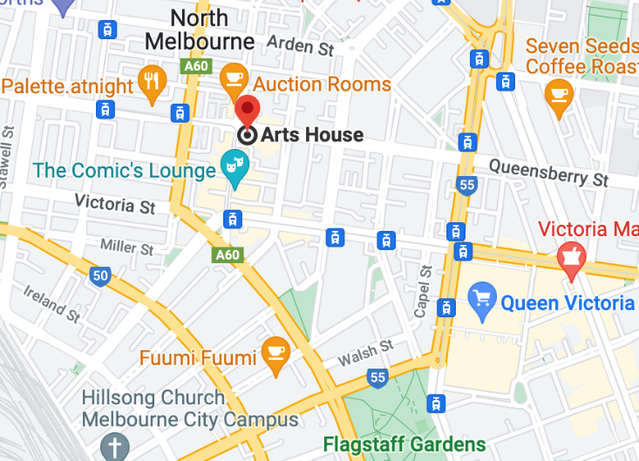

Image: North Melbourne Town Hall features giant red letters that say ARTS HOUSE out the front of it.

Image: a map of Arts House and its surrounding area. [LINK TO MAP](https://www.google.com/maps/place/Arts+House/@-37.802973,144.9486818,17z/data=!4m5!3m4!1s0x0:0x64c465ac7ef21cff!8m2!3d-37.803239!4d144.9498609?shorturl=1)

## **Front Entrance**

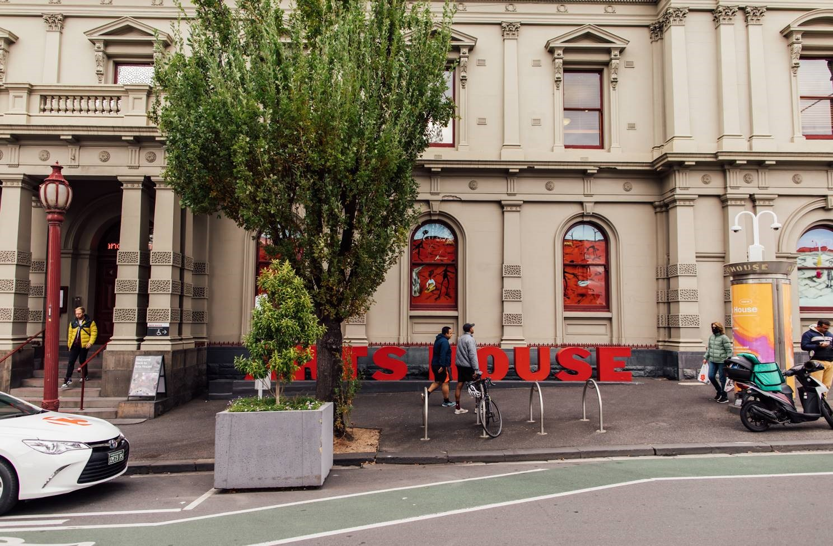

## **Accessible Entrances**



There are two Accessible Entrances. The first is on Errol St next to the Post Office.

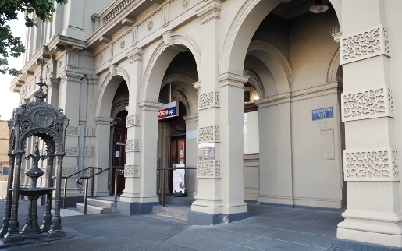

Image: Errol Street entrance next to the Post office with wheelchair accessible ramp or two steps with grab rails.

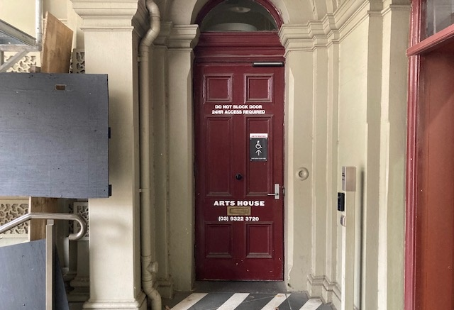

Image: View of door entrance.

The second Accessible Entrance is towards the end of George Johnson Lane.

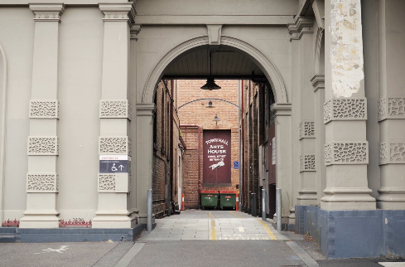

Image: View of George Johnson Lane from Errol St. The laneway passes through an archway with a brick wall at the end.

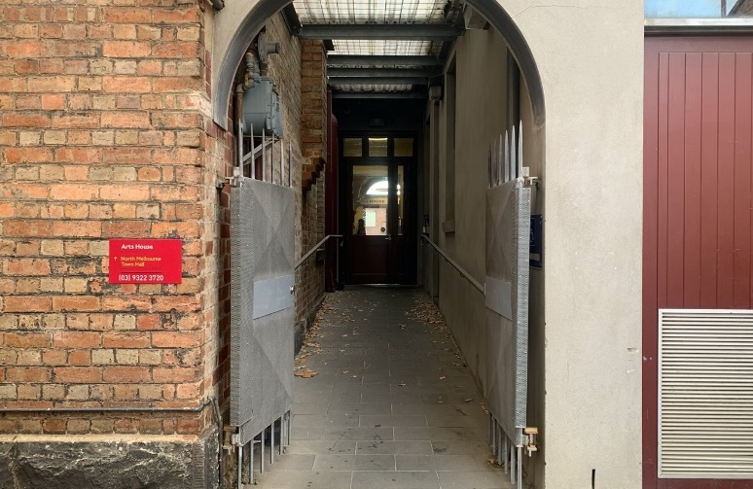

Image: view of the ramp leading from George Johnson Lane to the automated door which opens into the Arts House foyer.

## **Box Office**

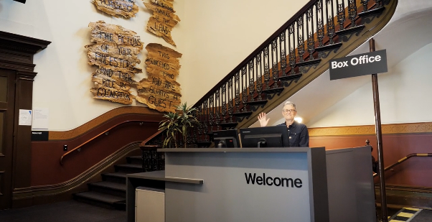

Image: Reception / Box Office in foyer.

## **Ushers**

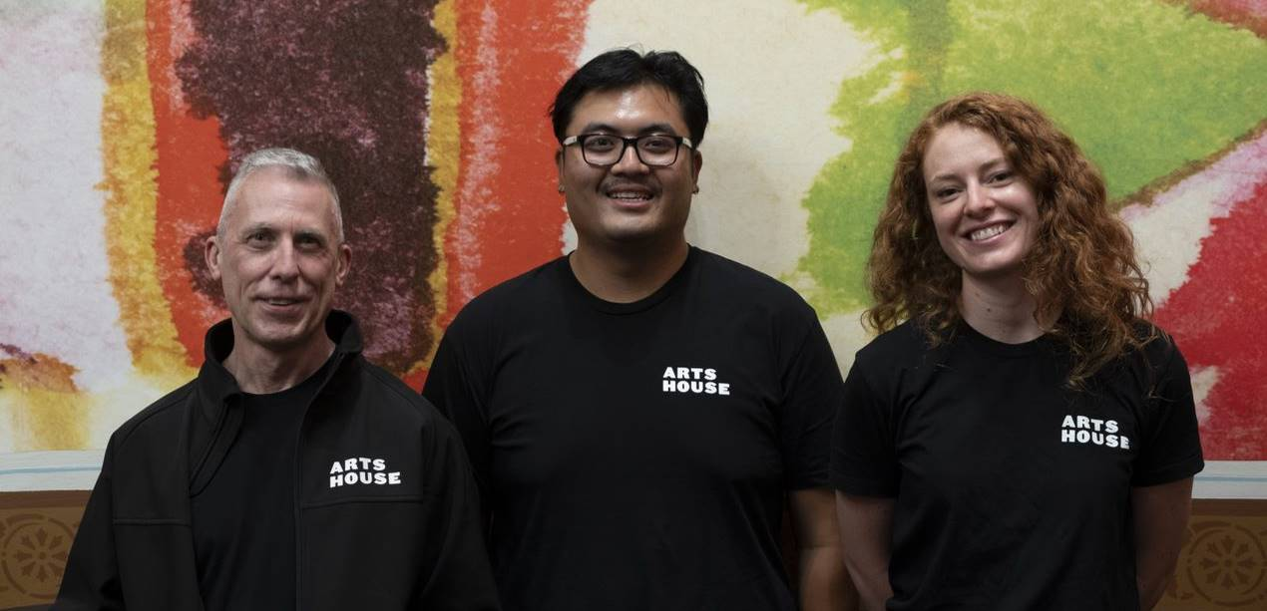

Image: Ushers will be wearing black with an Arts House Logo on the left hand shoulder.

## **Bar**

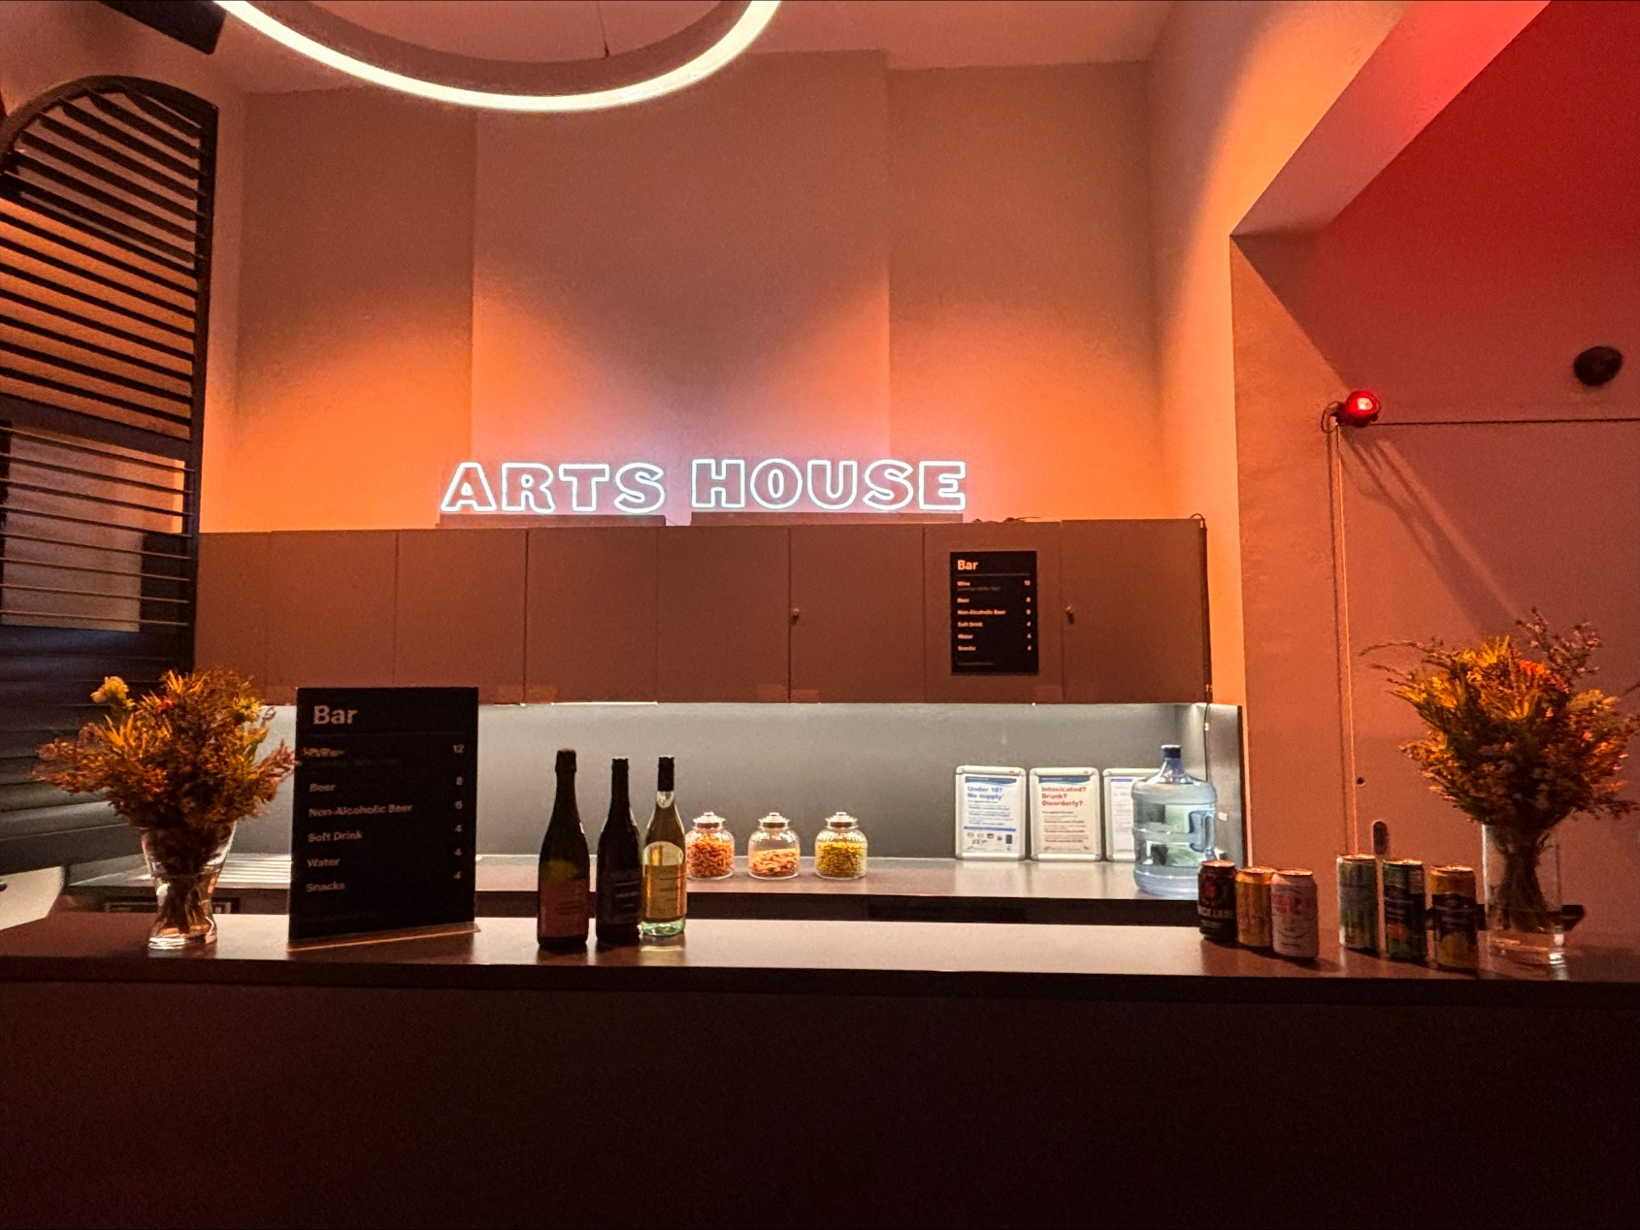

Image Description: Arts House bar  
  
Bar staff will be wearing black with an Arts House Logo.

We have a range of alcoholic and non-alcoholic beverages for sale.

We are a cashless venue and accept EFTPOS, Visa and Mastercard payments.

## **Quiet Space**

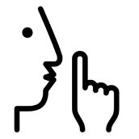

Arts House Quiet Space is located on Ground Level and is nearby reception and opposite the accessible bathrooms. It includes a range of seating options including soft furnishings, dimmable lights, sensory and stim objects. It is open during venue opening hours and events as a quiet space, prayer or parenting space.

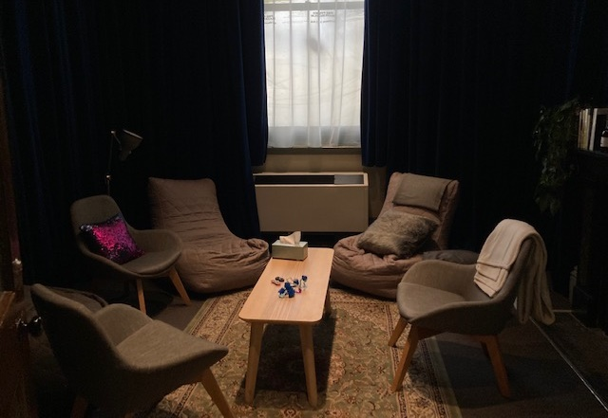

Image: Quiet space with lights dimmed

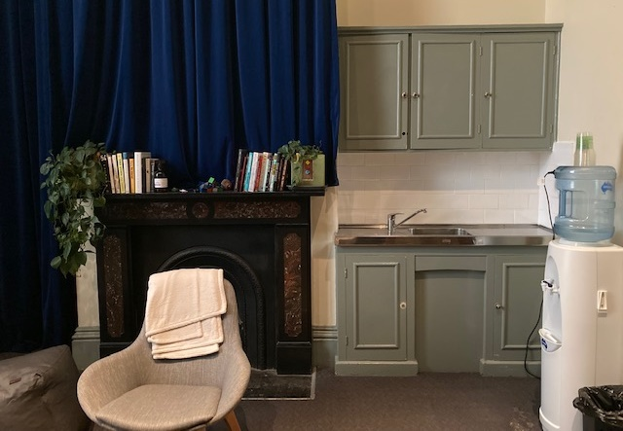

Image: Quiet space kitchenette and book shelf

## **Bathrooms**

All bathrooms have Dyson hand dryers with sensor activation. There is an accessible bathroom that is single use on ground level opposite the Quiet Space. There is another accessible bathroom upstairs – this is accessible via lift or stairs.

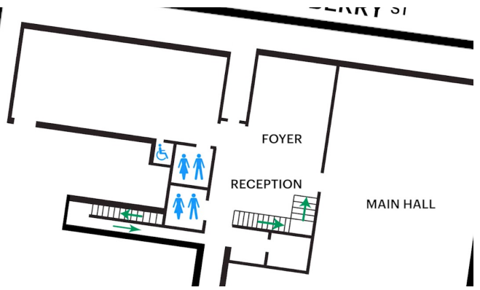

Image: Map of the bathrooms located on the ground floor of Arts House.

## **Door to Studio 1**

The Performance is in Studio 1.

It is on the first floor.

You can access these spaces via stairs with hand-railing or the lift.

An artist statement is available on signage and warnings on the door.

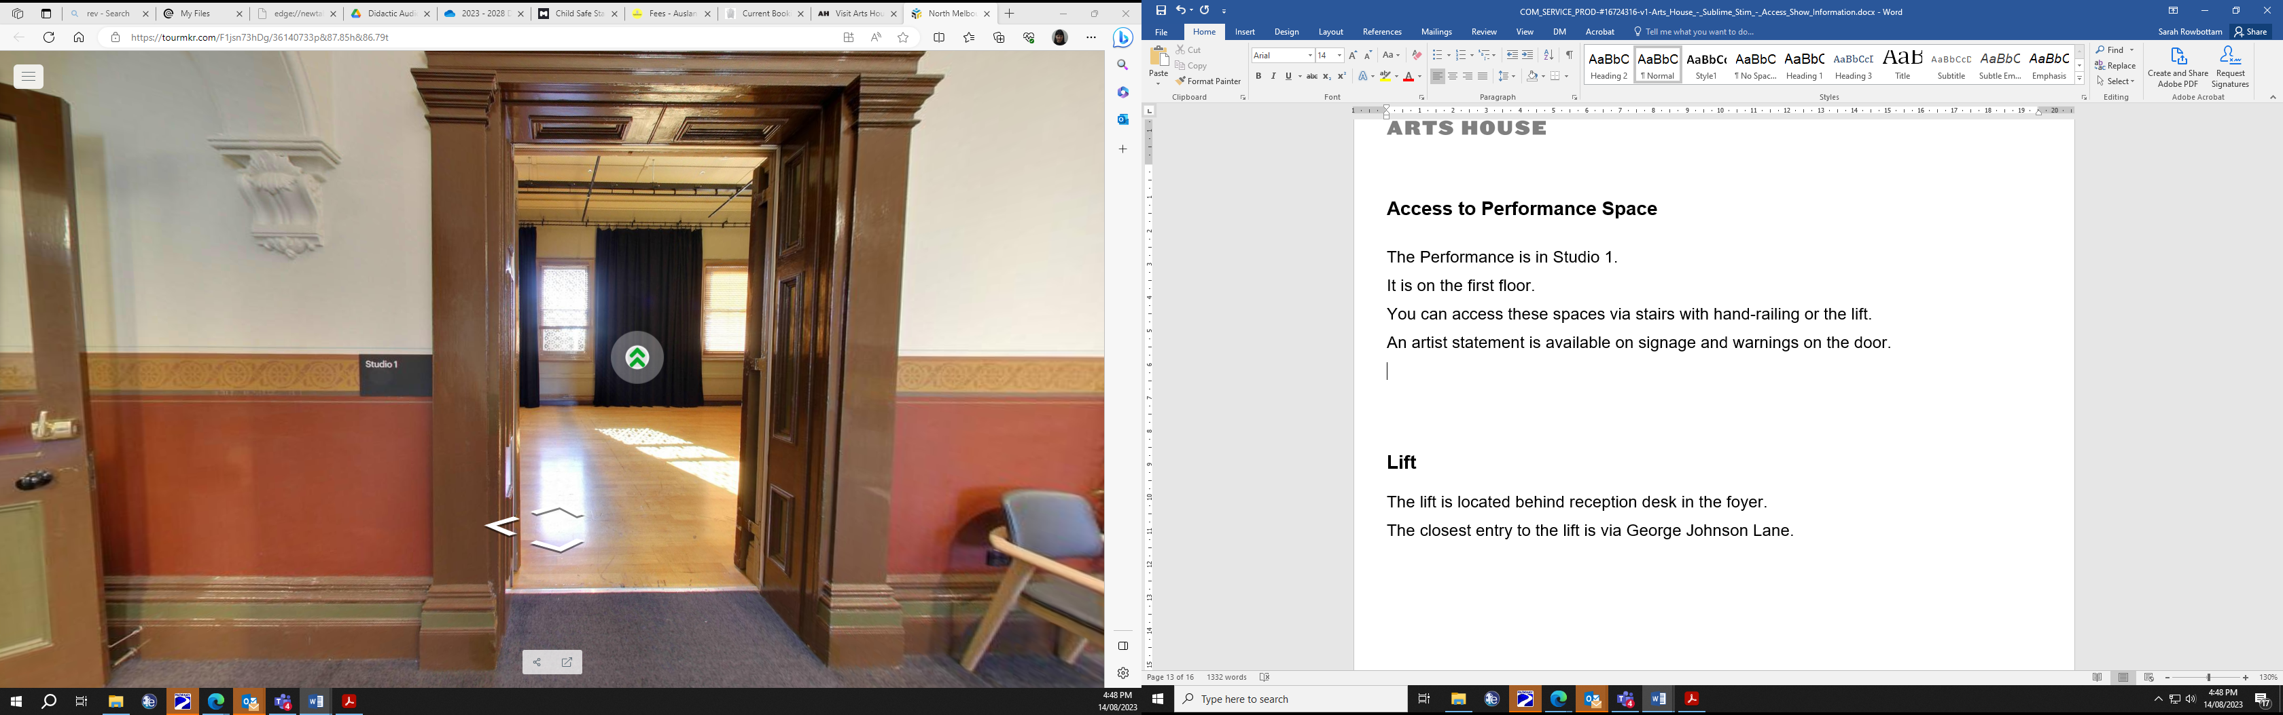

Image: Doorway to Studio 1.

## **Lift**

The lift is located behind reception desk in the foyer.

The closest entry to the lift is via George Johnson Lane.

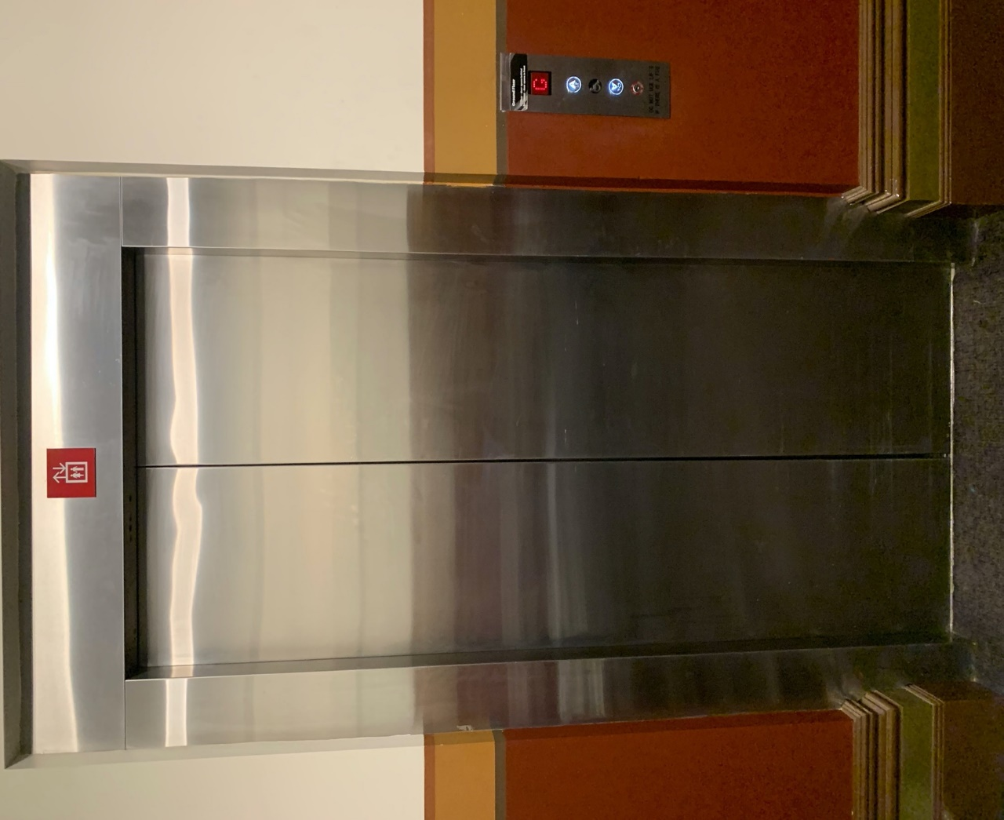

Image: Elevator doors.

# **Transport**

## **Tram**

Route 57 (High Floor trams only)

Stop 12, North Melbourne Town Hall.

Please note, this is not a wheelchair accessible tram

[GETTING TO ARTS HOUSE VIDEO LINK](https://vimeo.com/544169506)

## **Train**

Arts House is 1.1km from   
North Melbourne Train Station,   
approximately 16 minute walk

[North Melbourne Station Information](https://www.ptv.vic.gov.au/stop/1144/north-melbourne-station/0/train/)

1.2km from Flagstaff Station,   
approximately 15 minute walk

[Flagstaff Station Information](https://www.ptv.vic.gov.au/stop/1068/flagstaff-station/0/train/#StopPage:::datetime=2023-04-06T04%3A41%3A27.669Z&directionId=-1&showAllDay=false&_auth=408ac3b1e97f4b0beb5bdf00c2f797057d10dd6e6cf2ad40a69334c4dfdf5e21)

## **Bus**

Bus number: 216

## **Parking**

There is limited paid on-street parking on Queensberry Street and Errol Street.

There are two accessible on street car parking spaces on Queensberry Street (150m to our accessible Errol Street entrance) for holders of a Parking Permit for Disabled people.

# **COVID Safety**

Please note: If you have a cough, sore throat, fever, shortness of breath or flu-like symptoms, you must not attend our venue or programs in person.

**We will provide a refund if you need to cancel your attendance due to illness.**

**Please**[**contact us**](mailto:ArtsHouse.Ticketing@melbourne.vic.gov.au)**by 9am on the day of the event.**

To minimise the risk of COVID-19 transmission, we advise all patrons, artists and staff to:

* Practise physical distancing where possible
* Practise good hygiene by washing and or sanitising your hands often
* Wear a mask as directed by Victorian Government guidelines

Throughout the venue you will find:

* hand sanitiser stations available
* masks available (ask one of our staff for assistance)​

We also ensure that spaces are well ventilated.

Staying COVID-safe remains important. We must all follow these steps:

* Follow the [Victorian Government’s measures on how to stay safe.](https://www.betterhealth.vic.gov.au/coronavirus-covid-19-victoria)
* When you cannot safely socially distance it is recommended to wear a well fitted mask where required.
* Practise [COVID-safe hygiene protocols.](https://www.health.gov.au/news/health-alerts/novel-coronavirus-2019-ncov-health-alert/how-to-protect-yourself-and-others-from-coronavirus-covid-19/good-hygiene-for-coronavirus-covid-19)