**Goldfish**

By Terrapin in association with Aichi Prefectural Art Theater

Relaxed Performance Guide



Image description: A young person wearing bright orange high vis vest, raincoat and safety goggles, stares directly at the camera. They puff out their cheeks with tightly closed lips as they hold their breath with a slight smile on their face. They are contrasted against a bright blue background.

Image credit: courtesy of Terrapin/Peter Mathew.

**Relaxed performance**

Sat 1 March, 1pm  
60 minute duration

**Arts House**

521 Queensberry Street

North Melbourne VIC

**Contents**

**What is a Relaxed Performance? 3**

**Getting to Arts House 4**

Tram 4

Train 4

Bus 4

Parking 4

**Venue Information 5**

Front Entrance 5

Post Office Entrance 5

George Johnson Lane Entrance 6

Foyer 6

Quiet Space 8

Bathrooms 8

**Inside the theater 10**

Show Overview 11

Performers 12

**Content Warnings 14**

Basic Content Warnings 14

Detailed Content Warnings (may contain spoilers) 14

**COVID Safety 16**

# 

# **What is a Relaxed Performance?**

A relaxed performance is designed to alter a performance to create an environment that may be friendlier to those with a range of needs including sensory sensitivities and a variety of other disabilities that may not find the social rules around attending the theatre accessible.

To assist with this the following changes have been made to Goldfish:

* House lights will remain on the entire duration of the show
* All audience members are encouraged to move, stim, pace and/or make noise during performance in whatever manner helps you to best enjoy the show. We also encourage you to bring and use your own stim toys, headphones or anything else that will help with self-regulating.
* The quiet space partway down the hallway near the foyer will be available to use at any time during the show for anyone that needs a break or a space to decompress, self regulate or take a moment alone.
* Some technical elements of the show (lighting/sound) have been softened.
* Some performance moments have been softened.
* The audience capacity has been reduced to allow everyone the option of more space.

# Getting to Arts House

Arts House is on the corner of Errol and Queensberry Streets in North Melbourne.

There is a lot of Public Transport nearby and some on-street parking.   
This [Getting to Arts House video](https://vimeo.com/544169506)  can be watched for visual examples.

## **Tram**

Route 57 (High Floor trams only)

Stop 12, North Melbourne Town Hall.

Please note, this is not a wheelchair accessible tram

## **Train**

Arts House is 1.1km from   
North Melbourne Train Station,   
approximately 16 minute walk

[North Melbourne Station Information](https://www.ptv.vic.gov.au/stop/1144/north-melbourne-station/0/train/)

1.2km from Flagstaff Station,   
approximately 15 minute walk

[Flagstaff Station Information](https://www.ptv.vic.gov.au/stop/1068/flagstaff-station/0/train/#StopPage:::datetime=2023-04-06T04%3A41%3A27.669Z&directionId=-1&showAllDay=false&_auth=408ac3b1e97f4b0beb5bdf00c2f797057d10dd6e6cf2ad40a69334c4dfdf5e21)

## **Bus**

Bus number: 216

## **Parking**

There is limited paid on-street parking on Queensberry Street and Errol Street.

There are two accessible on street car parking spaces on Queensberry Street (150m to our accessible Errol Street entrance) for holders of a Parking Permit for Disabled people.

# Venue Information

Arts House has three entrances.

## **Front Entrance**

## 

The front entrance is on Queensberry Street. It is up a short staircase with grab rails which is found under an archway beside the red ARTS HOUSE letter sculpture.

This entrance leads you directly into the foyer.

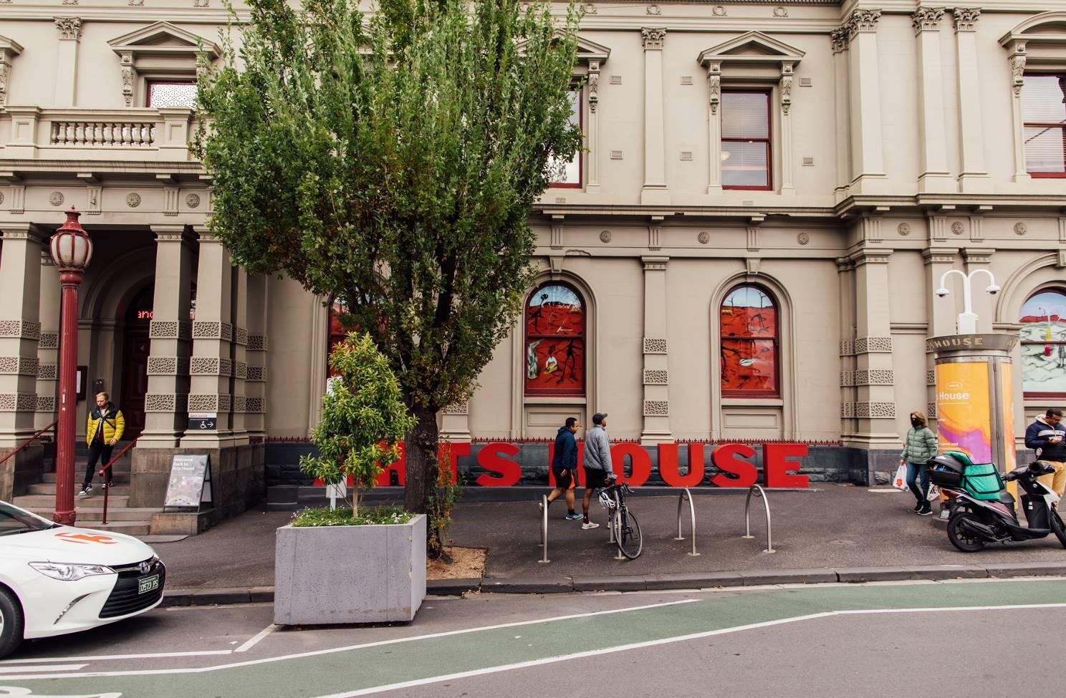

Image: Queensberry Street Entrance to Arts House. There is a staircase with grab rails beside the ARTS HOUSE letter sculpture and art in the windows.

## 

## **Post Office Entrance**disability access symbol wheelchair black

There are two Accessible Entrances. The first is on Errol St next to the Post Office.

It can be accessed via a short staircase or tiled ramp. There is a button to the right of the door that will open it mechanically when pressed.   
  
This ramp opens up to a long hallway which ends in the foyer.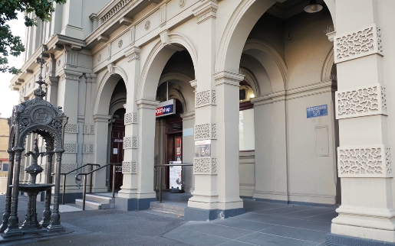 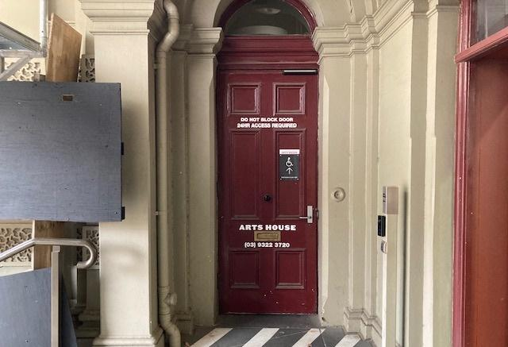

Image: Errol Street entrance next to Image: View of door entrance.   
the Post office with wheelchair accessible   
ramp or two steps with grab rails.



## **George Johnson Lane Entrance**

The second Accessible Entrance is towards the end of George Johnson Lane.

Entering this way will involve a left run and navigating up a ramp towards the automated door at the end.

This entrance opens up directly into the foyer.

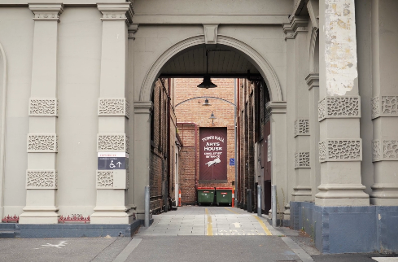

Image: View of George Johnson Lane from Errol St. The laneway passes through an archway with a brick wall at the end.

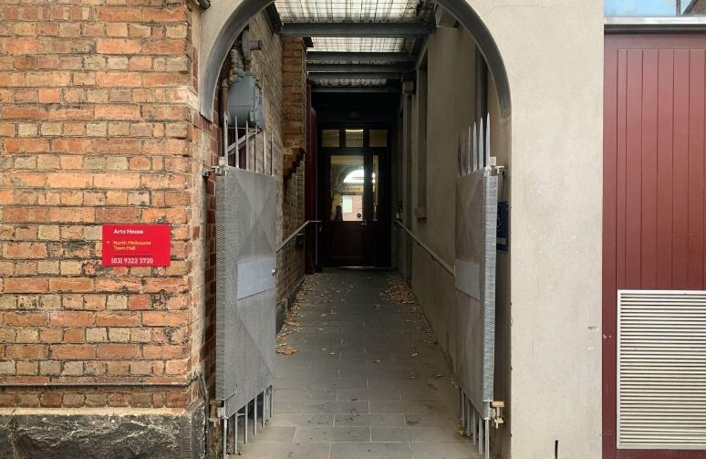

Image: View of the ramp leading from George Johnson Lane to the automated door which opens into the Arts House foyer.

## **Foyer**

The foyer is the main gathering space at Arts House. In this space you can relax before the show.

The Box Office/Reception Desk is located in the foyer under the stairwell.   
This is where you can go if you have any questions or need help with your tickets.

Arts House Ushers will be in the foyer. They will check your tickets and be there to answer questions you might have. Ushers will be wearing black with an Arts House Logo on the left shoulder.

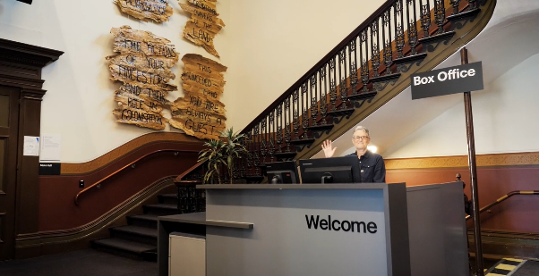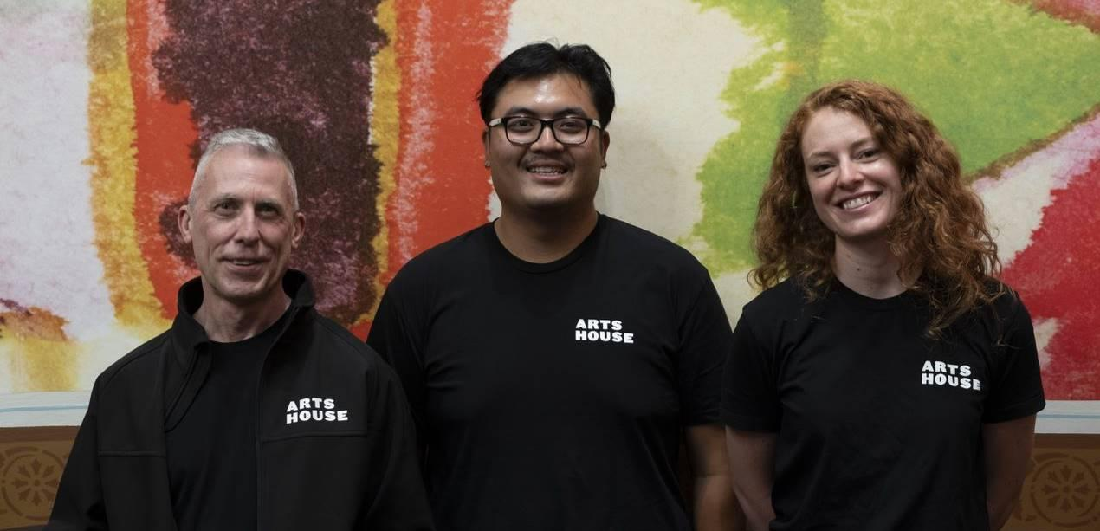

Image: Reception/Box Office Image: Three Arts House Ushers.

In the foyer there is also a Bar. You can get refreshments from here.

Bar staff will be wearing black with an Arts House Logo.

Both alcoholic and non-alcoholic beverages will be for sale.

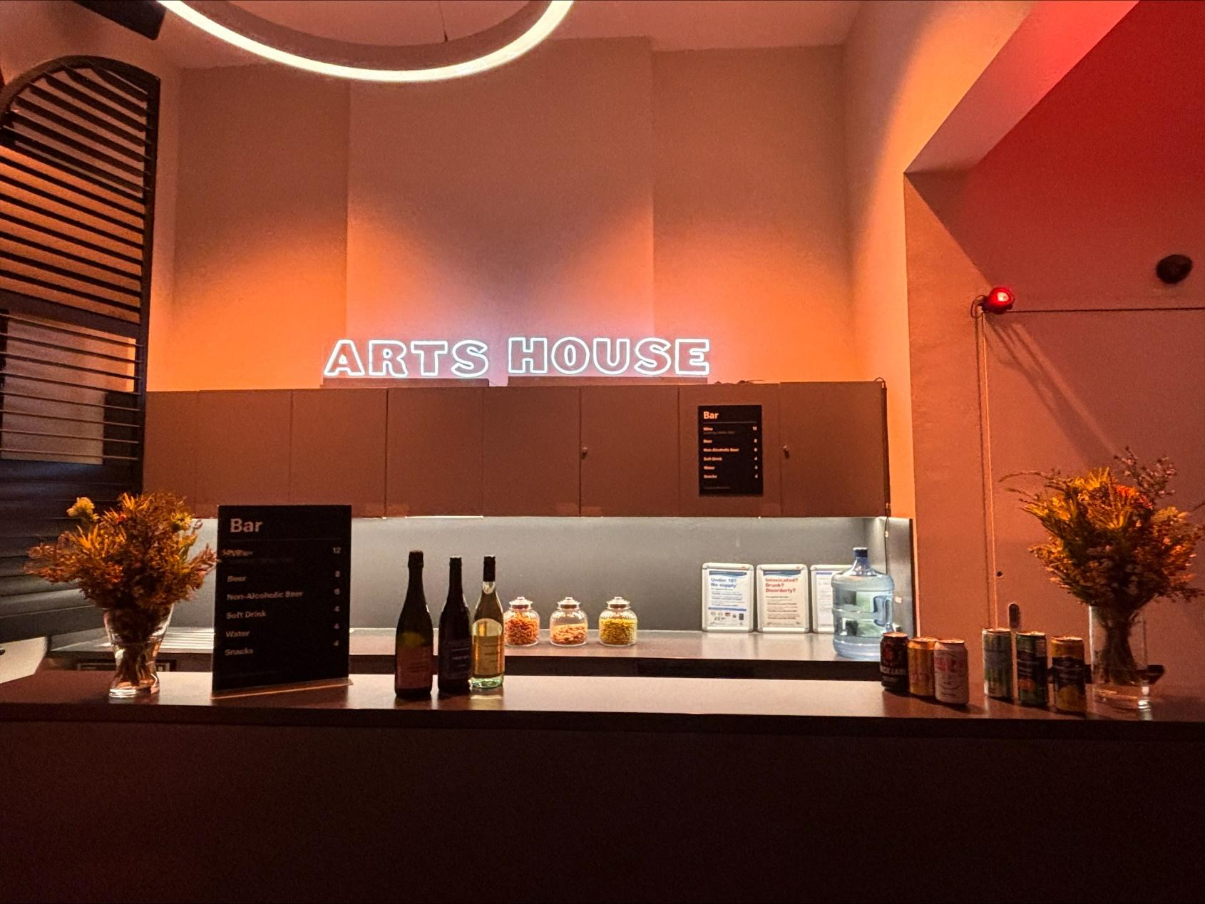

Image: Arts House Bar

Arts House is a cashless venue so if you would like to buy drinks or tickets you will need to pay by EFTPOS, Visa or Mastercard.

## Quiet Space

The quiet space is down the hall between the foyer and the Post Office and opposite the accessible bathrooms.

It includes a range of seating options including soft furnishings, dimmable lights, sensory and stim objects.

You are encouraged to use this space whenever you need, including during the show.

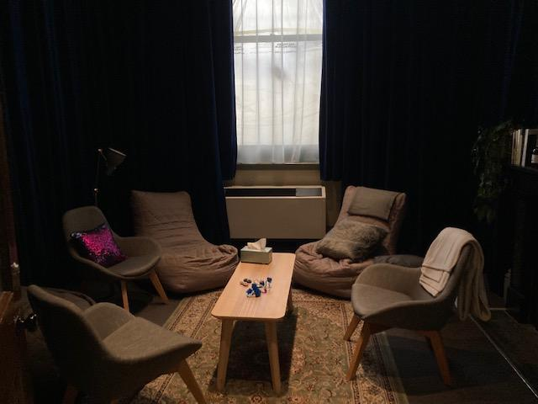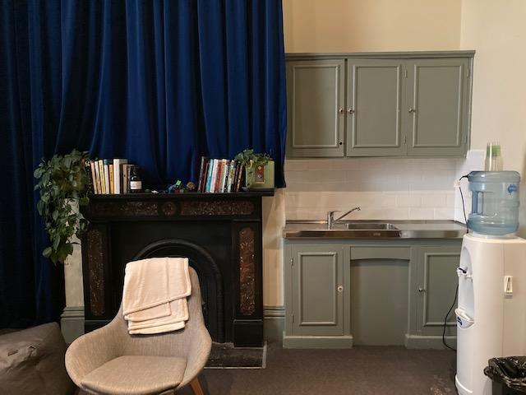 Image: Quiet Space kitchenette and shelf Image: Quiet Space with lights dimmed

## 

## Bathrooms

All bathrooms have Dyson hand dryers with sensor activation. These can be quite loud.

All bathrooms are all gender bathrooms.

There is a single occupancy accessible bathroom opposite the Quiet Space.

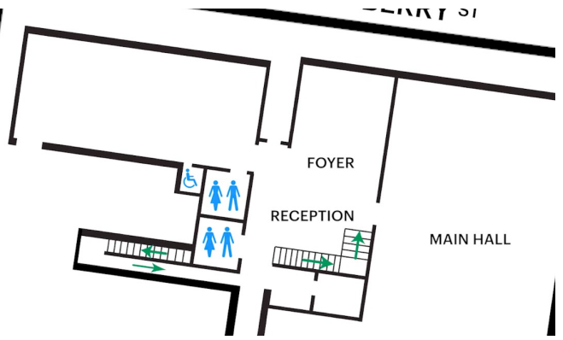

Image: Map of ground floor bathroom locations.

**Door to Main Hall**

The Performance is in the Main Hall.

It is on the ground floor.

It is to the left of the box office desk and right of the bar.

An artist statement is available on a QR code and warnings on the door.

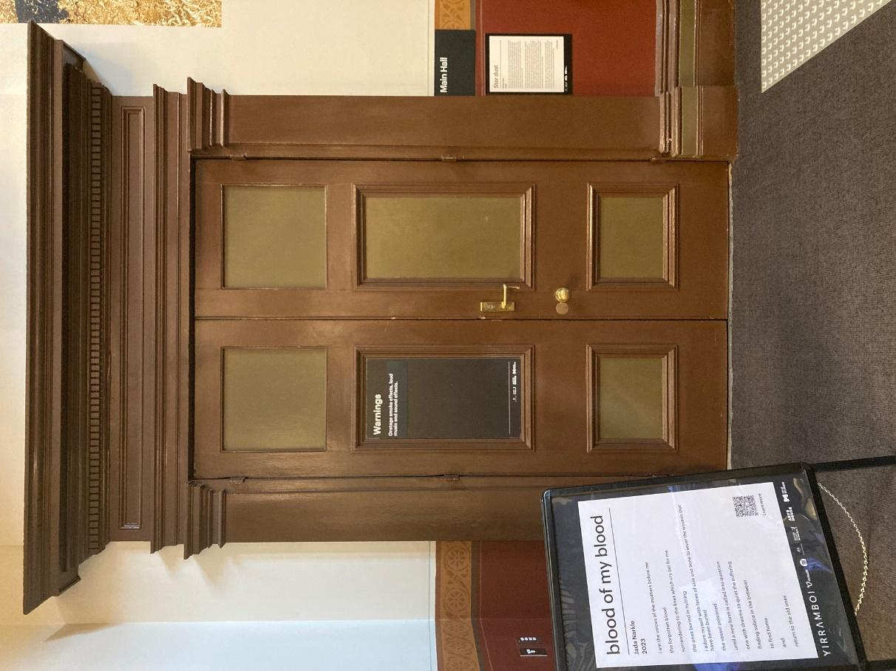

Image: Photo of the Main Hall doorway.

# Inside the theater

**The space**

To your left after entering is the seating bank where you will be seated for the performance. Seats are not allocated, you can go and pick any seat you like.

If you have an access requirement for a particular seat, Arts House is happy to ensure it

remains reserved for you. Please contact the team or speak to an Usher when you arrive.

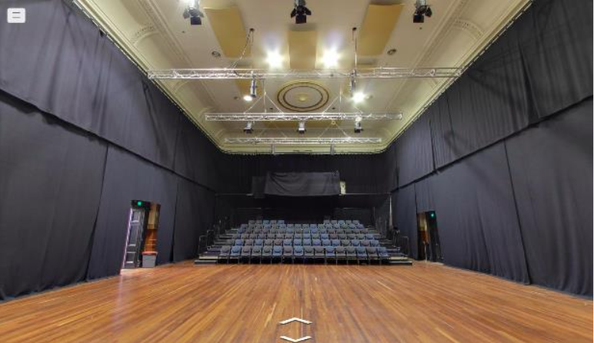

Image: The seating bank in the main hall.

Black curtains line the walls and house lights are on.

On the stage at the beginning of the show you will see a shadow puppetry set and a performer will be walking around the set adjusting things.

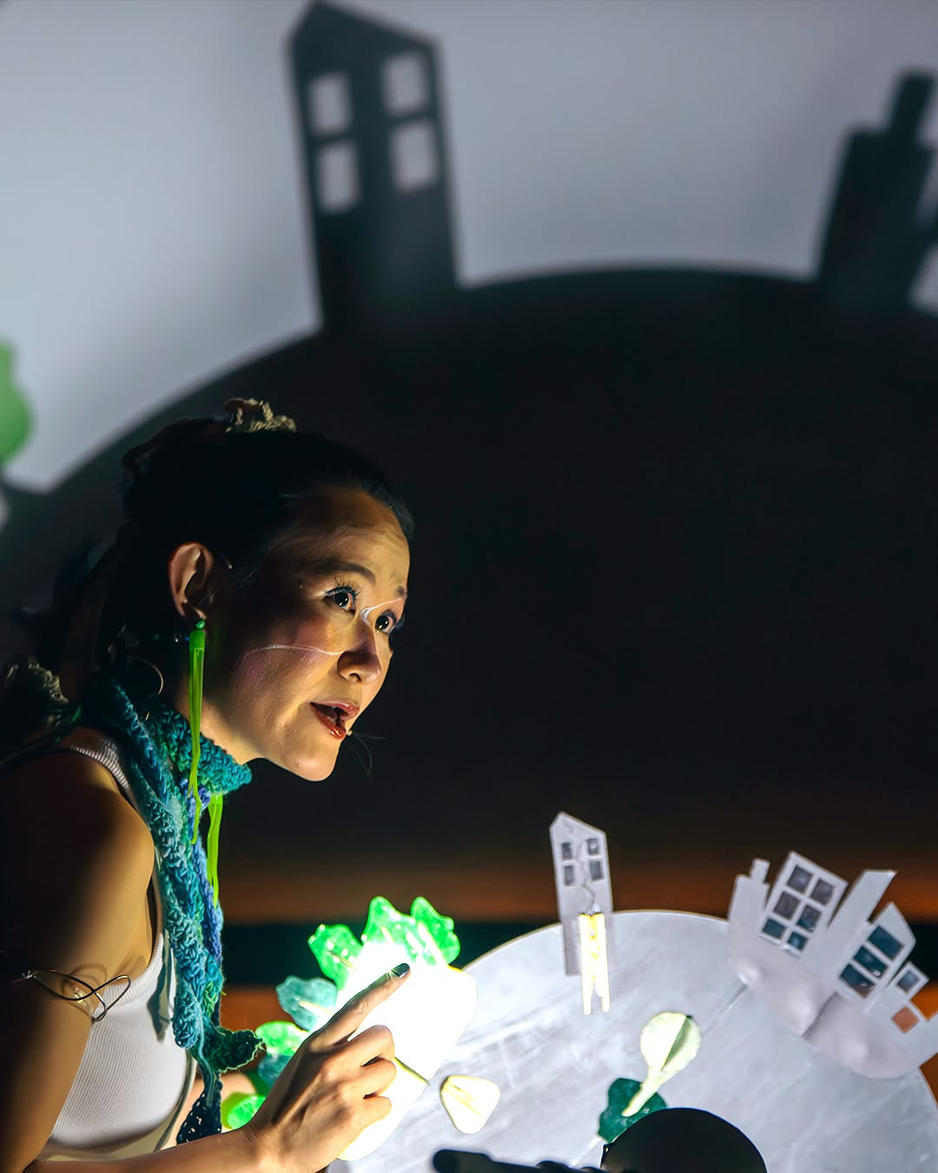

Image: The Storyteller with a shadow puppetry set piece looks out towards the audience. A shadow city fills the background.

The stage space will change greatly throughout the show as new items are brought in and characters interact with and change the space.

## 

## 

## Show Overview

The show will run for one hour. It is performed with speech, movement, puppetry, prop, sound and lighting effects.

There are two separate narratives happening in Goldfish which overlap with each other. Both are stories that engage with environmental disaster.

The audience will be acknowledged as part of the performance - both as the audience of a show and as part of the story. You do not have to respond when the performers address you but you can if you like.

In parts of the show, performers sit in the seating bank (where the audience is) and use doors that leave the theatre within the show. If you leave the theatre you may see a performer in the foyer.

The show can be both visually and sonically busy. The set is made up of unusual items which are used in both narratives of the show. Props and set pieces are moved around a lot so the stage will look different in different parts of the show. There is music but also speaking, yelling and noises from the stage and props. Lights go on and off quickly and some light may be reflected from the stage into the audience.

Performers do things that may look scary or dangerous. These are professionals who know what they are doing and are able to be safe. The narrative of this show may also be scary. This is okay. You do not need to be concerned about dangers conveyed by the performers.

## 

## Performers

There are three performers in Goldfish. They will all be wearing brightly coloured costumes with make-up during the show.

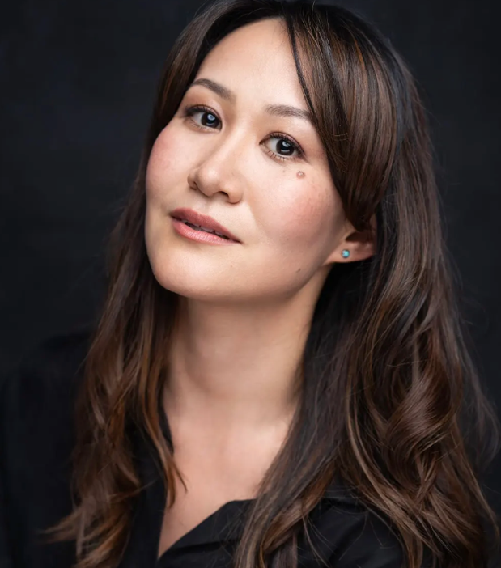

Image: A professional headshot of a woman with   
 long, wavy brown hair, wearing a black top and   
 turquoise earrings. She has a soft expression,   
 with a slight tilt of her head and a confident   
 gaze. The background is dark, contrasting with   
 her fair complexion.

Performer: Mayu Iwasaki

Role within Goldfish: Storyteller

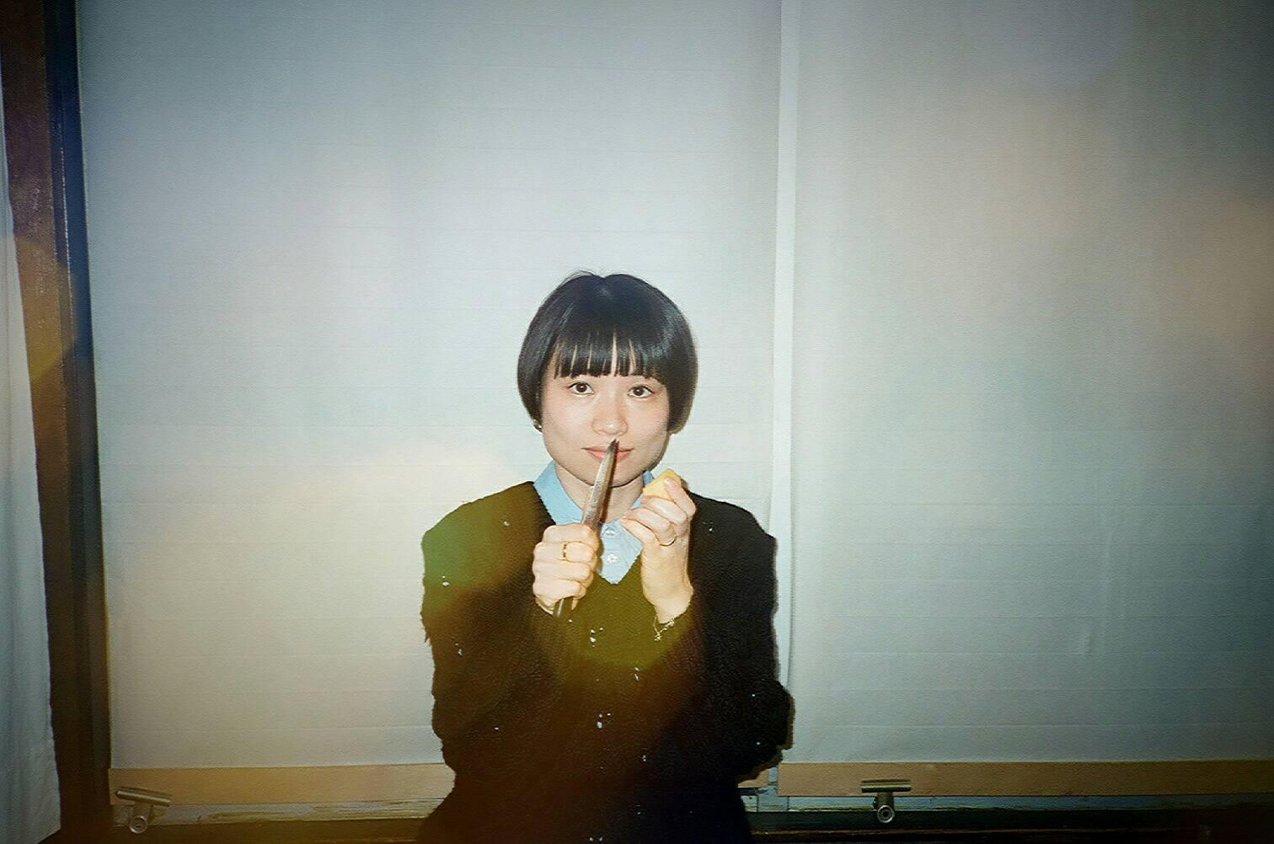

Image: A portrait of a woman with a short bob haircut   
 and blunt bangs, wearing a black sweater over a light   
 blue collared shirt. She is holding something upright in   
 one hand and what appears to be a small piece of   
 food in the other, with a calm and direct expression.   
 The background features white blinds, and the image   
 has a slightly nostalgic, film-like quality with light   
 flares.

Performer: Rino Daidoji

Role within Goldfish: Goldfish and Manager

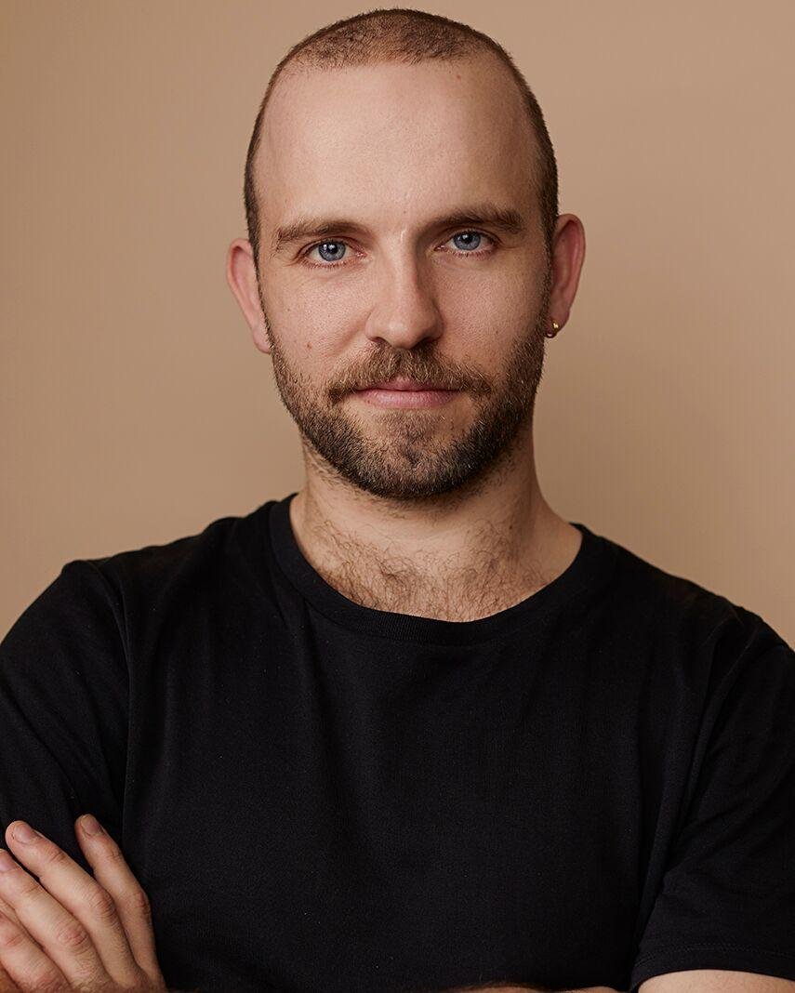

Image: A professional headshot of a man with a   
 shaved head, short beard, and blue eyes,   
 wearing a black t-shirt. He has a confident and   
 approachable expression, with his arms   
 crossed. The background is a warm beige tone,   
 complementing his skin tone and creating a   
 clean, minimalist look.

Performer: Marcus McKenzie

Role within Goldfish: Apprentice

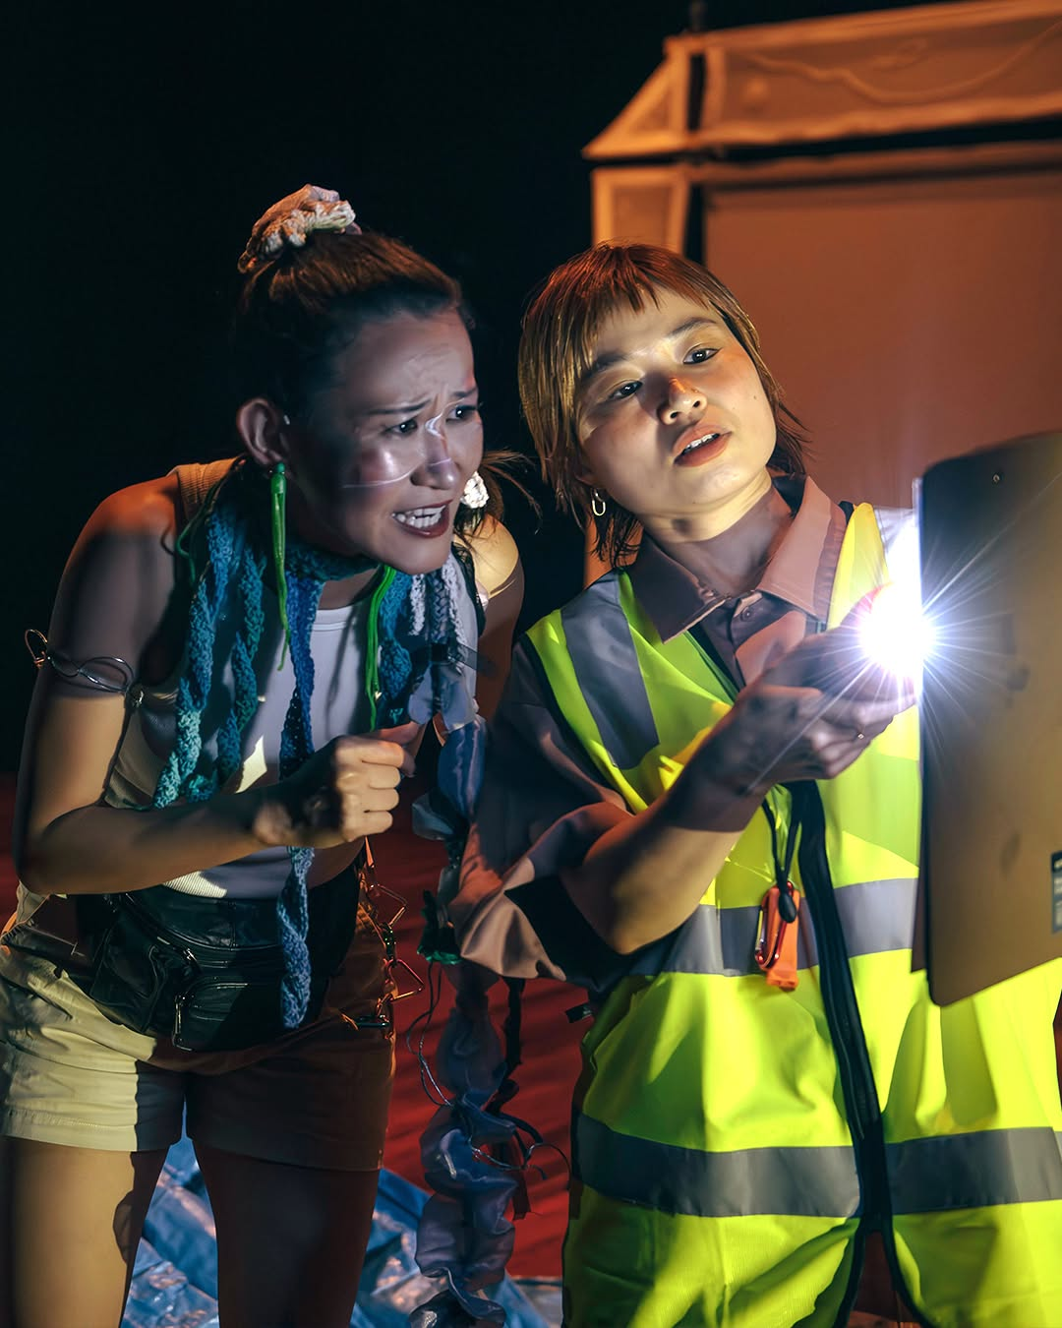

Image: Goldfish performance image.   
 Storyteller and Manager looking at a   
 clipboard illuminated by a torch.

# 

# Content Warnings

## Basic Content Warnings

Goldfish is an intergenerational work for adults and children (8+) alike.   
  
Goldfish may contain smoke effects, haze, loud music, effects and noises, flashing lights, abrupt lighting changes, low lighting and moments of black out. The lights change in colour and intensity.

The show engages with themes of environmental disaster, isolation and helplessness. There are moments of audience participation throughout the show.

## Detailed Content Warnings (may contain spoilers)

*Audience Participation*

The characters might talk to you directly and acknowledge any sounds in the space. Someone will be called on by the Manager to help set up a prop onstage.   
You do not have to respond when the performers address you but you can if you like.

At one point, the Storyteller is kicked off the stage by the other characters. She enters the seating bank and continues to tell her story. At another point two characters sit in the audience!

*Sound effects*

Throughout this performance the audience can expect background noise, sudden noise, overlapping voices, and at times loud voices. One character has a microphone, but two others don't. They might be harder to hear, but don't worry if you can't catch every word–what they do is more important than what they say.

*Lighting effects*

The lighting changes throughout this performance, where lights will be turned off and on, there will then be light from the back of the auditorium. Lighting will change quickly however there is no strobe lighting. There is a mirror, goggles and disco ball which will reflect light. This may reflect into your eyes as an audience member. Characters will also point torches around the space.

At the start of the performance, while the Storyteller tells the story, the lighting makes the room feel intimate. Then two new characters enter. When this happens, the lighting changes quickly, which makes the room feel much bigger. The Storyteller and the Manager fight over the lighting design, causing the lights to switch between the ‘big’ and ‘small’ state quickly.

*Props and Set*

The set is made of unusual items, items most required by relevant disaster recovery organisations such as boxes, food, but also a ladder, mirror and a tarp.

The performance has two visual parts. The first is the shortest. This is where the narrator is telling her story. She's using her voice and shadow puppetry to tell the story. The second part of the story starts with two characters entering suddenly. They are "disaster-recovery" workers. This section of the play is more visually chaotic and these characters bring in the other set elements, partially tearing down the shadow theatre set.

*Depictions of Disaster*

In the narrative of the Storyteller’s tale, the society got rid of night and day, which causes a flood. In the moment she tells the audience this, two disaster recovery workers burst into the space and declare there to be a real flood outside of the theatre. This is another layer of story. There is no real flooding they are referencing.

In the storyteller’s tale, attempts to resolve the flooding cause an earthquake, which causes a forest to fall. These disasters are addressed by the characters in her tale, including the titular goldfish.

*Depictions of Isolation*

The three children who are the subject of the Storyteller’s tale do not know each other until disaster strikes. After the earthquake, one of them is lost to the others temporarily. For a moment, the children accept that they will not find the goldfish again.

*Depictions of Violence*

A ladder falls on a character. The performer and the character are both okay but they are stuck underneath it for a little bit.

# 

# COVID Safety

Please note: If you have a cough, sore throat, fever, shortness of breath or flu-like symptoms, you must not attend our venue or programs in person.

We will provide a refund if you need to cancel your attendance due to illness. Please [contact us](mailto:ArtsHouse.Ticketing@melbourne.vic.gov.au) by 9am on the day of the event.

To minimise the risk of COVID-19 transmission, we advise all patrons, artists and staff to:

* Practise physical distancing where possible
* Practise good hygiene by washing and or sanitising your hands often
* Wear a mask as directed by Victorian Government guidelines

Throughout the venue you will find:

* hand sanitiser stations available
* masks available (ask one of our staff for assistance)​

We also ensure that spaces are well ventilated.

Staying COVID-safe remains important. We must all follow these steps:

* Follow the [Victorian Government’s measures on how to stay safe.](https://www.betterhealth.vic.gov.au/coronavirus-covid-19-victoria)
* When you cannot safely socially distance it is recommended to wear a well fitted mask where required.
* Practise [COVID-safe hygiene protocols.](https://www.health.gov.au/news/health-alerts/novel-coronavirus-2019-ncov-health-alert/how-to-protect-yourself-and-others-from-coronavirus-covid-19/good-hygiene-for-coronavirus-covid-19)