**Neighbourhood Gathering, Season 1 2025**

Hosted by Arts House

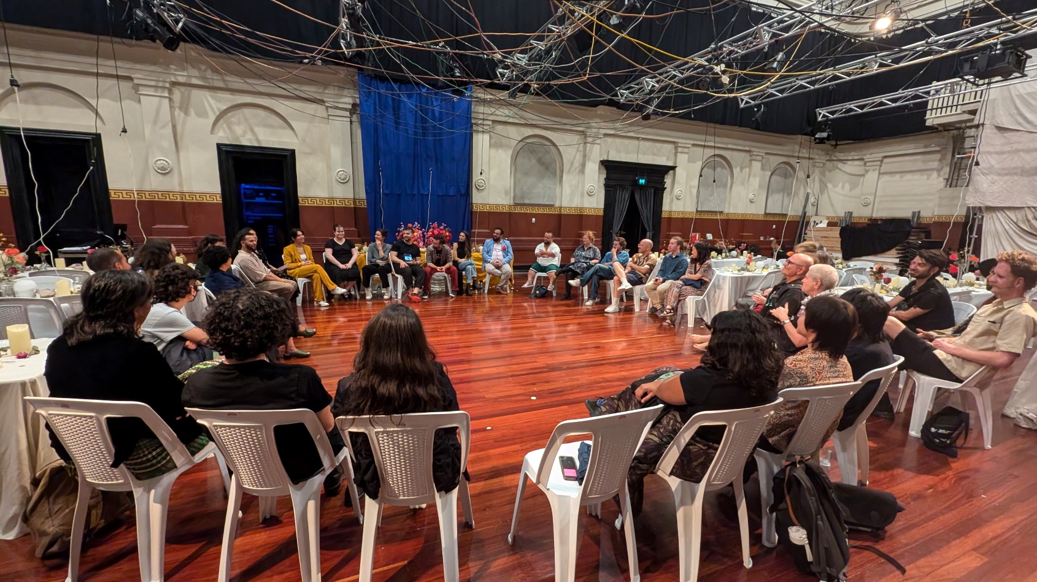Access Guide

**Image credit:** Zaffé post-show artist talk, photo by Varsha Ramesh

**Image description:** A large group of people gathered in Arts House main hall – sitting in a circle on white plastic chairs, facing each other, in conversation.

# **Updates to this document**

Please note, this event includes a rehearsal excerpt of a new work and changes are being made by artists until opening. We will endeavour to provide the latest access information across key stages of planning.

Arts House website will contain the most up to date version of this document and all ticket holders will be notified of any revisions made 1 day prior to the event.

This document was created: 20/02/2025

**Contents**

Updates to this document 1

Where 3

When 3

Access Services 3

Co-Hosts 5

Running Order 7

Sensory Elements 7

Sound 7

Lighting 7

Physical 8

Smell 8

Visual 8

Entry to space 8

Shocks or surprises 10

Audience experience 10

Social expectations 10

Other 11

Content Warnings 11

General Notes 11

The Venue 12

Front Entrance 12

Accessible Entrances 13

Reception and Box Office 14

Ushers 14

Quiet Space 15

Bathrooms 15

Door to Main Hall 16

Transport 17

Tram 17

Train 17

Bus 17

Parking 17

COVID Safety 18

# **Where**

Arts House

521 Queensberry Street

North Melbourne VIC

# **When**

Tuesday 25 February, 2025  
10:30am to 12pm

Duration: 90 minutes

# **Access Services**

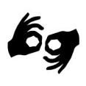

Auslan Interpreters on request. This service needs to be pre-booked by Monday 20 February by emailing [artshouse.ticketing@melbourne.vic.gov.au](mailto:artshouse.ticketing@melbourne.vic.gov.au)



Audio Describer Guides available for meet and assist and one-on-one descriptions of performance excerpt. This service needs to be pre-booked by Monday 20 February by emailing [artshouse.ticketing@melbourne.vic.gov.au.](mailto:artshouse.ticketing@melbourne.vic.gov.au)



Assistance Animal are welcome.



This performance is fully wheelchair accessible.

# **Neighbourhood Gathering Co-Hosts**

|  |  |
| --- | --- |
| **Veisinia Tonga**  Artist and local community member | **Stéphanie Ghajar**  Lebanese-born theatre and filmmaker |

|  |  |
| --- | --- |
| **Olivia Anderson**  Arts House Acting Artistic Director | **Louana Sainsbury**  Arts House Creative Producer |

|  |  |
| --- | --- |
|  |  |

Approximately 18 other members of Arts House staff will also be in attendance.

|  |  |  |
| --- | --- | --- |
|  |  |  |

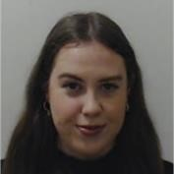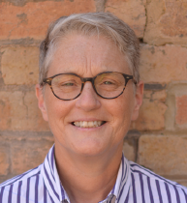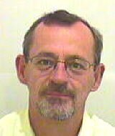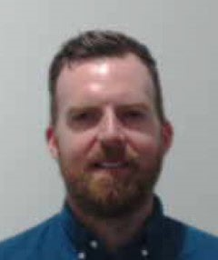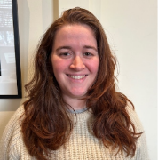

Jake  
Marketing Manager

Monique  
Ticketing Supervisor

Varsha  
Creative Producer

Sarah  
Program Manager

Louana  
Creative Producer

Amrit   
Creative Program Lead

Olivia   
Acting Artist Director

Tish  
Associate Producer

Adam  
Front of House Manager

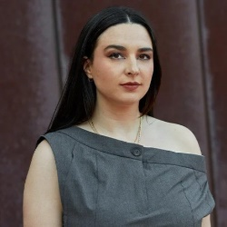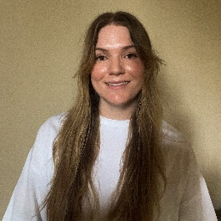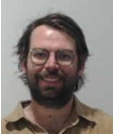

Katy  
Audience Engagement Coordinator

Artemis  
Access Advisor

Taran  
Venue Technician

Bart  
Technical Coordinator

Tony  
Production Manager

Jordyn  
Business Support Officer

Trudy  
Business Support Officer

Bas  
Business Administrator

Brian  
Business Manager

# **Running Order**

10.15am Doors Open & light refreshments available from Asylum Seeker Resource Catering

10:30am Event commences

(50 minutes) Hosts presenting to attendees (this will include an Acknowledgement of Country, staff introductions, co-host introductions and a program overview of Arts House’s Season 1, 2025

11:20am Hosts and attendees will move from Studio 2 downstairs to Arts House’s Main Hall for a behind-the-scenes excerpt of Terrapin’s *Goldfish*

(30 minutes) Attendees view behind-the-scenes excerpt of Goldfish (this may include some questions from the hosts to the artists)

11:55am Farewell from hosts

12:00pm Event concludes

# **Sensory Elements**

## **Sound**

Soft background music will be playing in the venue foyer as people arrive and depart.

The first part of this event is conversational and the co-hosts will use microphones.

During the behind-the-scenes excerpt of *Goldfish*, there may be dynamic sound involving loud music, effects and noises.

## **Lighting**

The Neighbourhood Gathering conversation will be standard interior building lighting with no flashing or moving lights.

The behind-the-scenes excerpt of *Goldfish* will take place during their technical rehearsal. Lighting states will likely change and may involve flashing lights, abrupt lighting changes, low lighting and moments of black out. Lighting may change in colour and intensity.

## **Physical**

The venue has heating and air conditioning. The rooms maintain an ambient temperature.

The behind-the-scenes excerpt of *Goldfish* may contain smoke effects and haze.

## **Smell**

The Neighbourhood Gathering will have an assortment of vegetarian catering available in the space from Asylum Seeker Resource Centre that will include the smell of spices, fruit and other ingredients. Vegan and GF options available.   
  
Full list:

• Feta and spinach triangles

• (Vegan, GF) Tunisian spiced rolls

• Oven baked danishes

• (Vegan, GF) Chocolate bliss ball

• Chocolate chip cookies.

The behind-the-scenes excerpt of *Goldfish* may contain smoke effects and haze.

## **Visual**

The speakers will sit in a row of chairs facing the attendees, marked out by a rug. Behind the speakers, there will be a large screen playing a slideshow of images from our Season 1, 2025 program.

There will be rows of standard seats in the space and high bar tables available for guests to use, these will face toward the speakers.

For behind-the-scenes excerpt of *Goldfish*, a standard seating bank will be set up and available for guests to sit in. The performers and crew members from Goldfish will be present throughout the Main Hall, in the performance space, seating bank and sitting at technical desks.

Audience Experience

## **Entry to space**

The first part of the event will take place in Studio 2. Front of House staff will guide you to this space from the foyer.

Access to Studio 2 space:

* Studio 2 can be accessed via an elevator in the foyer or the staircase behind the reception desk.
* Entry to Studio 2 is through large double doors down a corridor. The doors open inwards.

The excerpt of *Goldfish* will take place in The Main Hall. This space is located off the ground floor foyer.

**Door to Studio 2**

The Neighbourhood Gathering is in Studio 2, located on level 1. You can access this space via stairs with hand-railing or the lift.

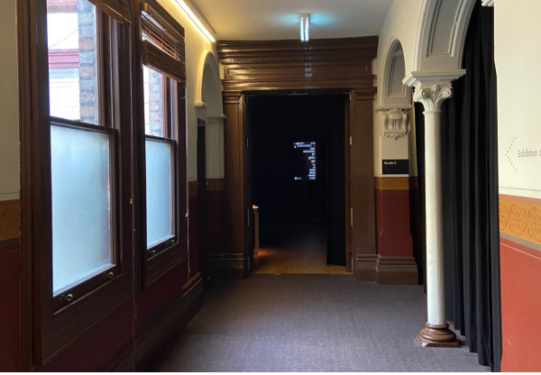

Image: A corridor with windows on the left side and curtains on the right side. At the end of the hall there is the doorway entrance into Studio 2. The doors are open and inside is dark, showing a slight display of a projected artwork inside.

**Door to The Main Hall**

The performance of *Goldfish* will be in the Main Hall. If taking the elevator back to the ground floor, you will turn right into the foyer area. There you will see the large brown doors opened for you to enter. This doors open outwards towards you.

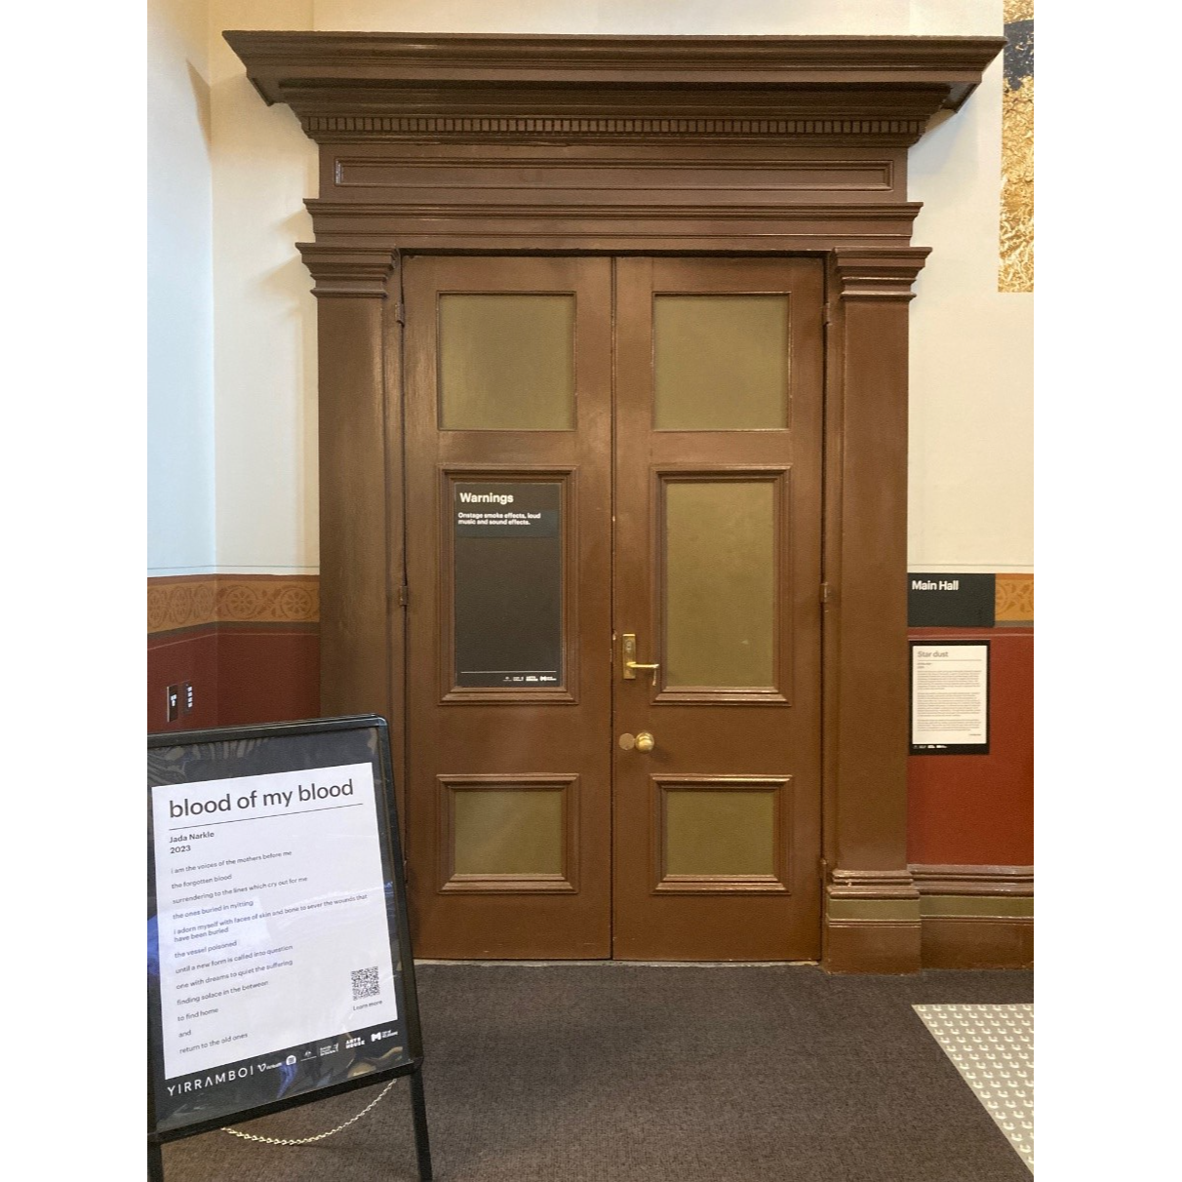If taking the staircase down, the entrance to the Main Hall is at the bottom of the stairs landing.

Image: Large wooden brown doors that are closed.

## **Shocks or surprises**

Goldfish may contain smoke effects, haze, loud music, effects and noises, flashing lights, abrupt lighting changes, low lighting and moments of black out. The lights change in colour and intensity.

## **Audience experience**

The Neighbourhood Gathering involves optional light social interaction with other members of the public and Arts House staff.

The rehearsal excerpt of *Goldfish* is ideal for children aged 8+ and their families.

**Social expectations**

Due to The Neighbourhood Gathering primarily being a social event, Arts House does offer the use of our Quite Space for people to come and go as they please.

There will be a variety of seating options at the Neighbourhood Gathering. There is no allocated seating – you are welcome to sit or stand anywhere you like in the room.

Audience members are welcome to come and go in the space and have a cuppa or snack whilst the session is happening.

The rehearsal excerpt of *Goldfish* is a seated experience.

# **Other**

## Content Warnings

Goldfish is ideal for children aged 8+ and their families.

Goldfish may contain smoke effects, haze, loud music, effects and noises, flashing lights, abrupt lighting changes, low lighting and moments of black out. The lights change in colour and intensity.

## **General Notes**

The session begins with an Acknowledgement of Country.

# **The Venue**

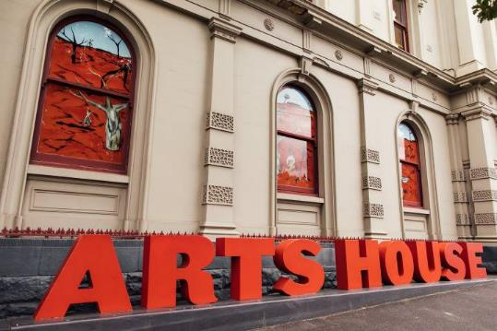

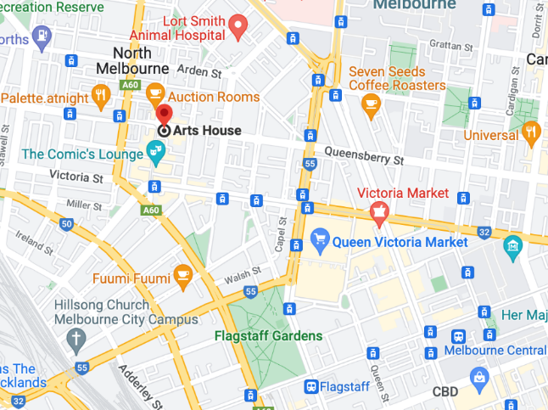

Image: North Melbourne Town Hall features giant red letters that say ARTS HOUSE out the front of it.

Image: a map of Arts House and its surrounding area. [LINK TO MAP](https://www.google.com/maps/place/Arts+House/@-37.802973,144.9486818,17z/data=!4m5!3m4!1s0x0:0x64c465ac7ef21cff!8m2!3d-37.803239!4d144.9498609?shorturl=1)

## **Front Entrance**

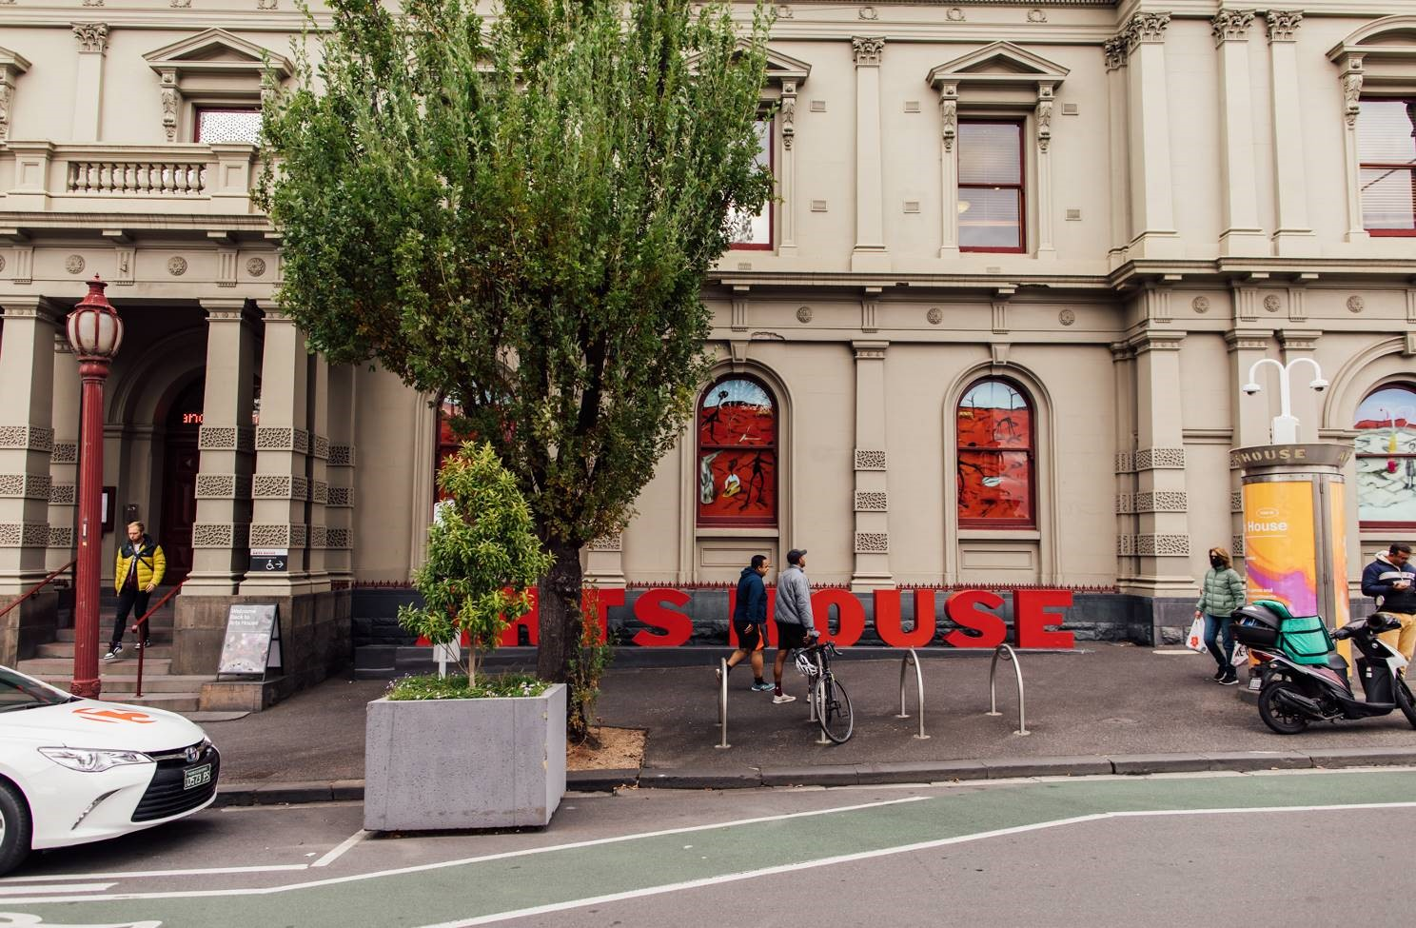

## **Accessible Entrances**



There are two Accessible Entrances. The first is on Errol St next to the Post Office.

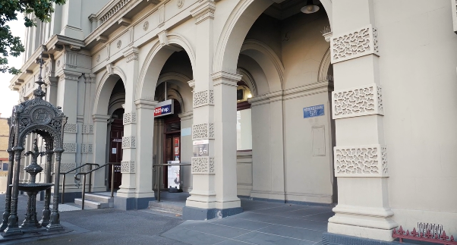

Image: Errol Street entrance next to the Post office with wheelchair accessible ramp or two steps with grab rails.

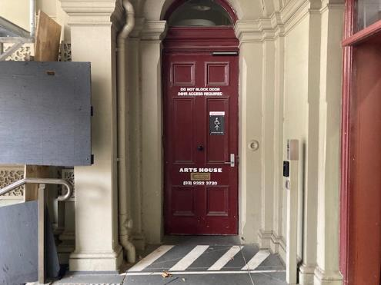

Image: View of door entrance.

The second Accessible Entrance is towards the end of George Johnson Lane.

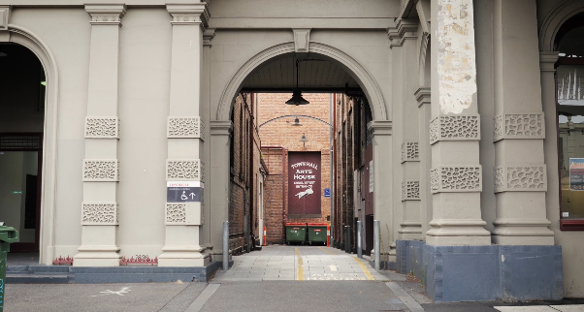

Image: View of George Johnson Lane from Errol St. The laneway passes through an archway with a brick wall at the end.

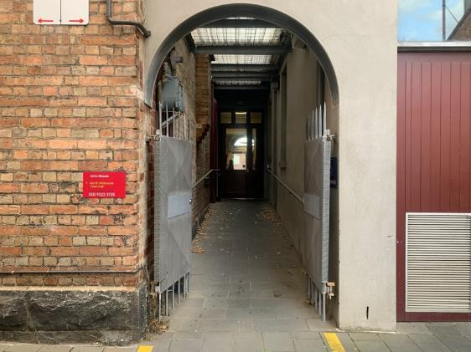

Image: view of the ramp leading from George Johnson Lane to the automated door which opens into the Arts House foyer.

## **Reception**

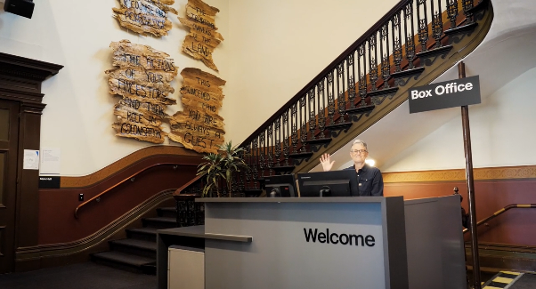

Image: The reception desk, showing one of our Arts House staff waving and smiling. To the left of the reception desk is the main stair case, showcasing some art work on the walls. Reception is located in the foyer at reception under the stairwell.

## **Ushers**

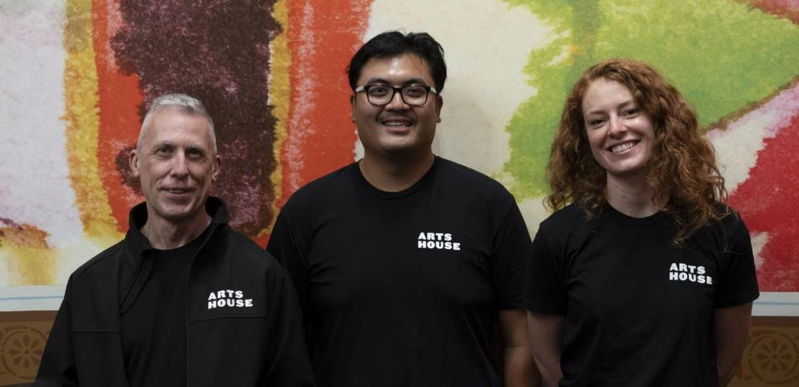

Image: Three Ushers standing in front of artwork on the wall, wearing their Arts House shirts.  
  
Ushers will be wearing black with an Arts House Logo on the left hand shoulder

## **Quiet Space**



Arts House Quiet Space is located on Ground Level and is nearby reception and opposite the accessible bathrooms. It includes a range of seating options including soft furnishings, dimmable lights, sensory and stim objects. It is open during venue opening hours and events as a quiet space, prayer or parenting space.

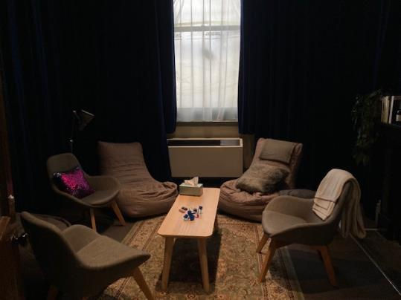

Image: Quiet space with lights dimmed

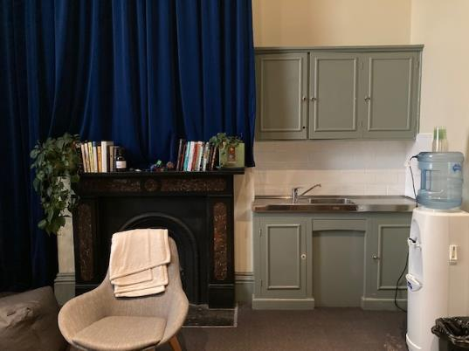

Image: Quiet space kitchenette and book shelf

## **Bathrooms**

All bathrooms have Dyson hand dryers with sensor activation. There is an accessible bathroom that is single use on ground level opposite the Quiet Space. There is another accessible bathroom upstairs – this is accessible via lift or stairs.

# **Transport**

## **Tram**

Route 57 (High Floor trams only)

Stop 12, North Melbourne Town Hall.

Please note, this is not a wheelchair accessible tram

[GETTING TO ARTS HOUSE VIDEO LINK](https://vimeo.com/544169506)

## **Train**

Arts House is 1.1km from   
North Melbourne Train Station,   
approximately 16 minute walk

[North Melbourne Station Information](https://www.ptv.vic.gov.au/stop/1144/north-melbourne-station/0/train/)

1.2km from Flagstaff Station,   
approximately 15 minute walk

[Flagstaff Station Information](https://www.ptv.vic.gov.au/stop/1068/flagstaff-station/0/train/#StopPage:::datetime=2023-04-06T04%3A41%3A27.669Z&directionId=-1&showAllDay=false&_auth=408ac3b1e97f4b0beb5bdf00c2f797057d10dd6e6cf2ad40a69334c4dfdf5e21)

## **Bus**

Bus number: 216

## **Parking**

There is limited paid on-street parking on Queensberry Street and Errol Street.

There are two accessible on street car parking spaces on Queensberry Street (150m to our accessible Errol Street entrance) for holders of a Parking Permit for Disabled people.

# **COVID Safety**

If you have a cough, sore throat, fever, shortness of breath or flu-like symptoms, you must not attend our venue or programs in person.

To minimise the risk of COVID-19 transmission, we advise all patrons, artists and staff to:

* Practise physical distancing where possible
* Practise good hygiene by washing and or sanitising your hands often
* Wear a mask as directed by Victorian Government guidelines

Throughout the venue you will find:

* hand sanitiser stations available
* masks available (ask one of our staff for assistance)​
* increased signage to direct patron movement and avoid crowd congestion

We also ensure that spaces are well ventilated.

Staying COVID-safe remains important. We must all follow these steps:

* Follow the [Victorian Government’s measures on how to stay safe.](https://www.betterhealth.vic.gov.au/coronavirus-covid-19-victoria)
* Wear[face masks](https://www.betterhealth.vic.gov.au/coronavirus-covid-19-victoria) where required or when you cannot safely socially distance.
* Practise [COVID-safe hygiene protocols.](https://www.health.gov.au/news/health-alerts/novel-coronavirus-2019-ncov-health-alert/how-to-protect-yourself-and-others-from-coronavirus-covid-19/good-hygiene-for-coronavirus-covid-19)
* Test for COVID