**Goldfish**

By Terrapin in association with Aichi Prefectural Art Theater

Access Guide



Image description: A young person wearing bright orange high vis vest, raincoat and safety goggles, stares directly at the camera. They puff out their cheeks with tightly closed lips as they hold their breath with a slight smile on their face. They are contrasted against a bright blue background.

Image credit: courtesy of Terrapin/Peter Mathew.

# **Updates to this document**

Please note this is a new performance and changes are being made by artists until opening. We will endeavour to provide the latest access information on performances to ticket holders across key stages of rehearsal and presentation.

Arts House website will contain the most up to date version of this document and all ticket holders will be notified of any revisions made 3 days and 1 day prior to the event.

This document was created: 16/01/2025

**Contents**

**Updates to this document** 2

**Where** 4

**When** 4

**Access Services** 5

**Sensory Elements** 9

Sound 9

Lighting 9

Physical **Error! Bookmark not defined.**

Smell **Error! Bookmark not defined.**

Visual 9

**Audience Experience** 9

Entry to space **Error! Bookmark not defined.**

Shocks or surprises 10

Audience experience 10

Social expectations 10

Performance expectations 10

**Other** 11

Content Warnings 11

General Notes **Error! Bookmark not defined.**

**The Venue** 12

Front Entrance 12

Accessible Entrances 13

Box Office 14

Ushers 14

Bar 15

Quiet Space 16

Bathrooms 17

Door to Main Hall 18

Lift 18

**Transport** 20

Tram 20

Train 20

Bus 20

Parking 20

**COVID Safety** 21

# **Where**

Arts House

521 Queensberry Street

North Melbourne VIC

# **When**

Wednesday 26 February – Sunday 2 March 2025

Wednesday – Friday, 7.30pm

Saturday, 1pm & 7.30pm

Sunday, 5pm  
**School shows** - Thursday & Friday, 11am

Duration: 60 minutes, no interval

Artist Talk: Thu 27 Feb, post-show for all ticket holders hosted by Faye Bendrups, SES

# **Access Services**



Tactile Tour - Friday 28 February, 6.30pm (Commences 1 hour before performance).  
Offered in conjunction with Audio Description, this service invites patrons who are blind or have low vision and their companions to explore the set, props and costumes prior to the performance.



Audio Described Performance - Friday 28 February, 7.30pm   
Audio describers provide verbal descriptions of actions, costumes, scenery and other visual elements of performances via personal headsets.



Relaxed performance - Saturday 1 March, 1pm

This performance focus on adapting sensory elements like lighting and sound, making the show more accessible for a range of audiences. Everyone is free to respond, move, speak, or self-soothe in whatever way they need to enjoy the show. This show will commence with a short introduction.



Assistance Animals are welcome.



Visual Rating 50% – this performance has music and sounds in the background.



This performance is fully wheelchair accessible. More information is provided further below in this guide about the accessible entrances at Arts House and bathrooms.  
  


Quite Space Available - The quiet space will be available for you to use before and after the show. More information about the quiet space can be found later in this guide.

  
Companion Card - Arts House supports the Companion Card program.

**Performers**

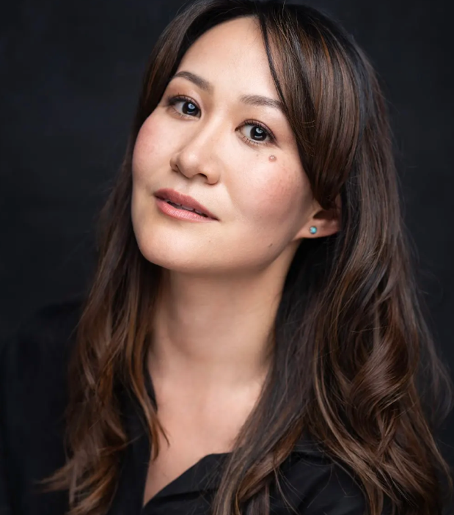

Performer: Mayu Iwasaki

Role within Goldfish: Storyteller

Image description: A professional headshot of a woman with long, wavy brown hair, wearing a black top and turquoise earrings. She has a soft expression, with a slight tilt of her head and a confident gaze. The background is dark, contrasting with her fair complexion.

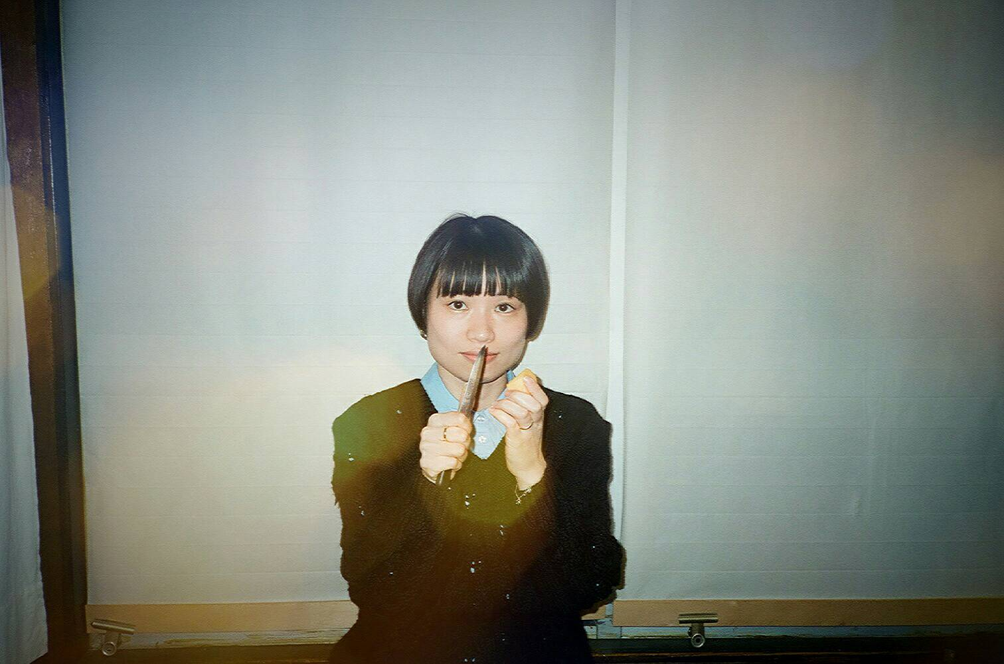

Performer: Rino Daidoji

Role within Goldfish: Goldfish and Manager

Image description: A portrait of a woman with a short bob haircut and blunt bangs, wearing a black sweater over a light blue collared shirt. She is holding something upright in one hand and what appears to be a small piece of food in the other, with a calm and direct expression. The background features white blinds, and the image has a slightly nostalgic, film-like quality with light flares.

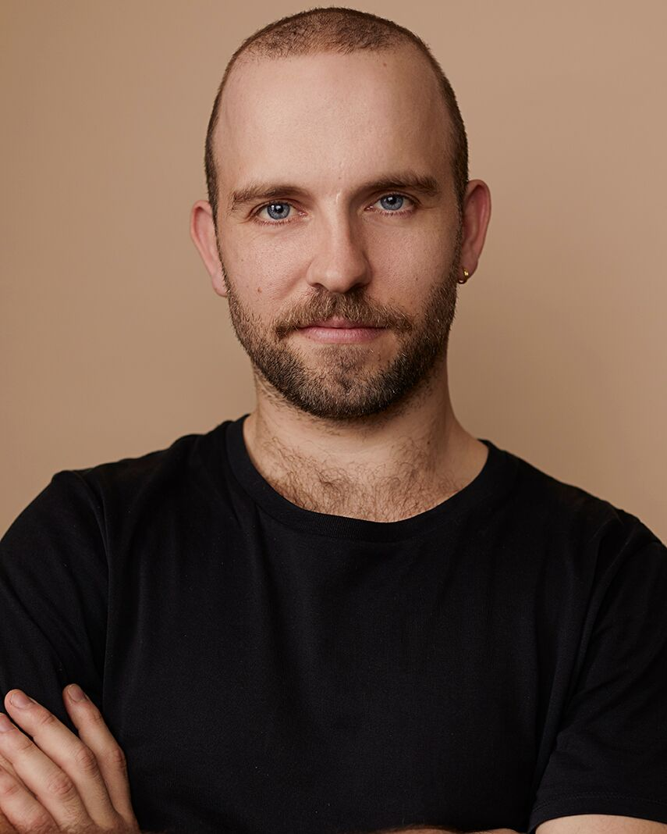

Performer: Marcus McKenzie

Role within Goldfish: Apprentice

Image description: A professional headshot of a man with a shaved head, short beard, and blue eyes, wearing a black t-shirt. He has a confident and approachable expression, with his arms crossed. The background is a warm beige tone, complementing his skin tone and creating a clean, minimalist look.

# **Sensory Elements**

## **Sound**

Throughout this performance the audience can expect background noise, sudden noise, overlapping voices, and at times loud voices. One character has a microphone, but two others don't. They might be harder to hear, but don't worry if you can't catch every word–what they do is more important than what they say.

## **Lighting**

The lighting changes throughout this performance, where lights will be turned off and on, there will then be light from the back of the auditorium. Lighting will change quickly however there is no strobe lighting. There is a mirror within this performance so the mirror surface will reflect light.

At the start of the performance, while a narrator tells the story, the lighting makes the room feel intimate. Then two new characters enter. When this happens, the lighting changes quickly, which makes the room feel much bigger.

## **Visual**

The visual experience of this performance is one where the set is made of unusual items, items most required by relevant disaster recovery organisations – this is because at the end of each season we will donate those set materials back to the relevant recovery organisations. This means that set materials will likely be made from many boxes, food, but also a ladder, mirror and a tarp, the tarp will signify a surging ocean.

The performance has two visual parts. The first is the shortest. This is where the narrator is telling her story. She's using her voice and shadow puppetry to tell the story. The second part of the story starts with two characters entering suddenly. They are "disaster-recovery" workers. This section of the play is more visually chaotic.

# **Audience Experience**

## **Shocks or surprises**

It might be a surprise when the two additional characters enter after the first part. In one part, a character falls. It is relatively slow.

## **Audience experience**

Not all of the play happens on a stage. At one point, the narrator is kicked off the stage by the other characters. She enters the seating bank and continues to tell her story. There may be a length of rope running from the stage to the narrator in the audience. At another point two characters sit in the audience!

## **Social expectations**

You will sit in a seating bank. You won't have an assigned seat. Once the show starts, you're welcome to vocalise or stim as you need. The characters might talk to you directly and acknowledge any sounds in the space.

You're welcome to come and go from the theatre as you need to.

Please let others vocalise, stim or have snacks as they need. Please let the ushers know if you have any questions or problems.

## **Performance expectations**

There are two competing storylines. During the show they merge.

There is a show within the show. The first storyline is of a storyteller who is in the space when you arrive, she then tells a traditional-style tale about a society that does away night and day. She tells the story with shadow puppets and her narration.

The second storyline starts when the storyteller tells us that the society got rid of night and day, which causes a flood. At this point, two disaster recovery workers burst into the theatre and interrupt the show. They are trying to turn the theatre into an emergency evacuation centre. They go about their work while the storyteller tries to continue her narrative.

Eventually, the disaster workers start to take part in the storytellers narrative.

There are three performers. They look different to the other staff because of their colourful clothes and/or makeup. The theatre and production staff will be wearing black.

# **Other**

## **Content Warnings** Goldfish is an intergenerational work for adults and children (8+) alike. Goldfish may contain smoke effects, haze, loud music, effects and noises, flashing lights, abrupt lighting changes, low lighting and moments of black out. The lights change in colour and intensity.

# **The Venue**

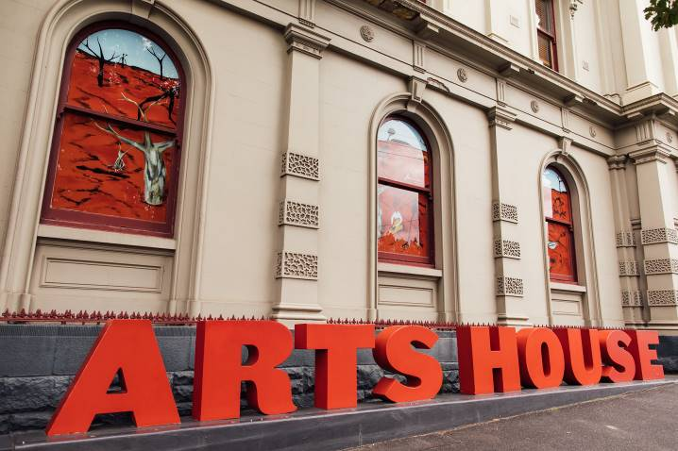

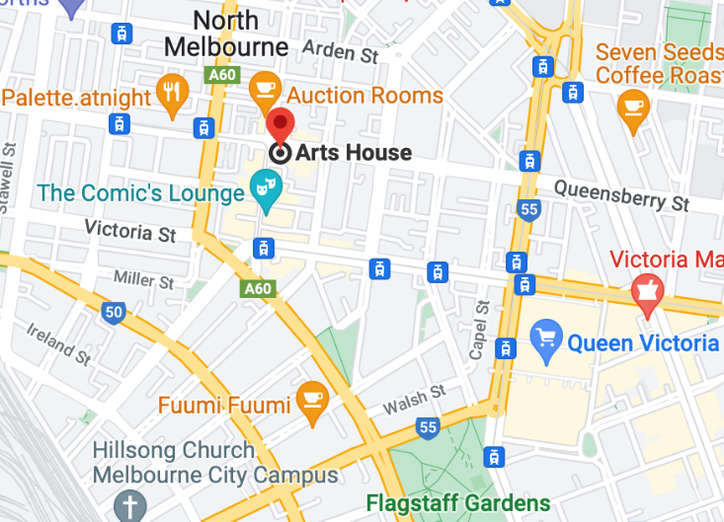

Image: North Melbourne Town Hall features giant red letters that say ARTS HOUSE out the front of it.

Image: a map of Arts House and its surrounding area. [LINK TO MAP](https://www.google.com/maps/place/Arts+House/@-37.802973,144.9486818,17z/data=!4m5!3m4!1s0x0:0x64c465ac7ef21cff!8m2!3d-37.803239!4d144.9498609?shorturl=1)

## **Front Entrance**

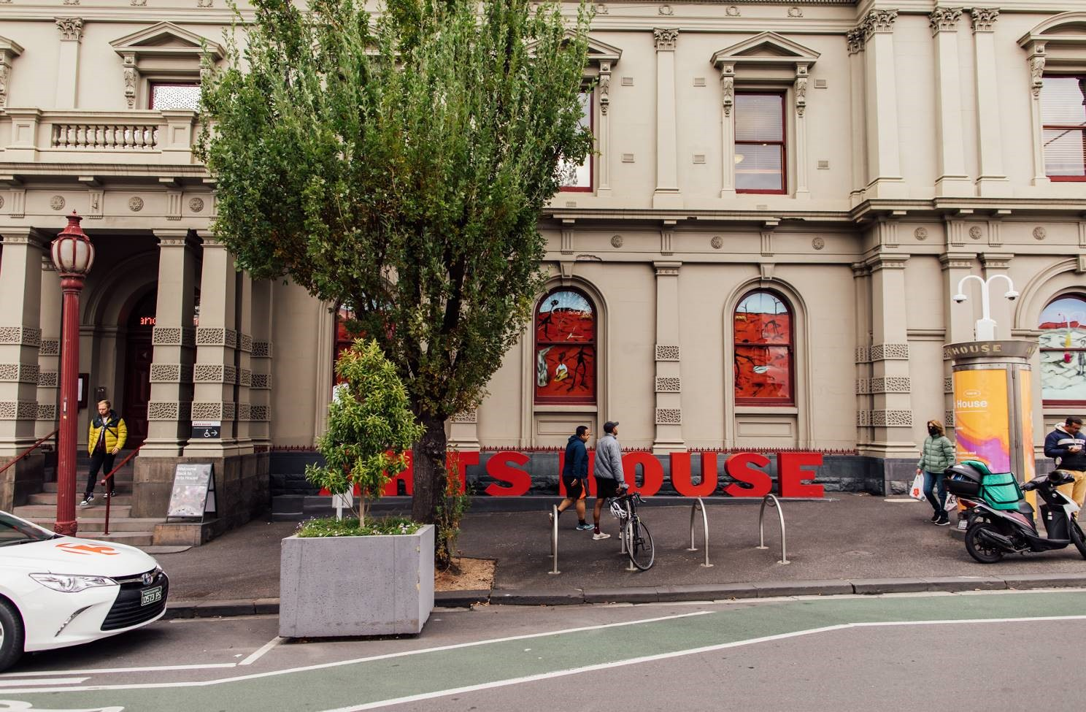

## **Accessible Entrances**



There are two Accessible Entrances. The first is on Errol St next to the Post Office.

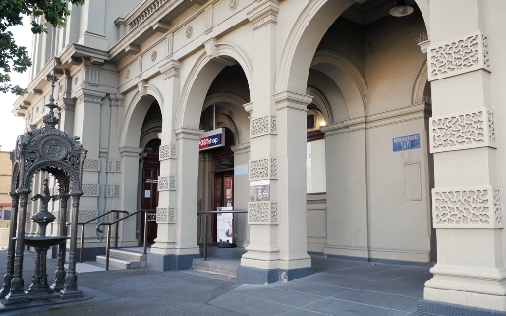

Image: Errol Street entrance next to the Post office with wheelchair accessible ramp or two steps with grab rails.

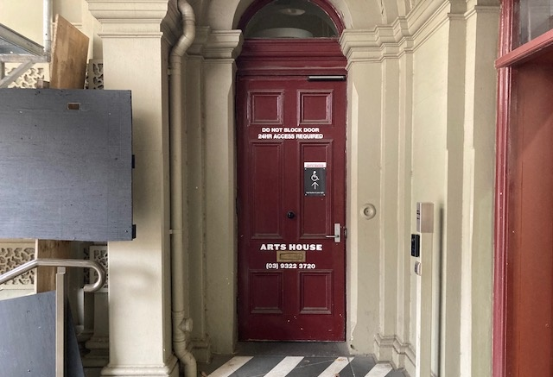

Image: View of door entrance.

The second Accessible Entrance is towards the end of George Johnson Lane.

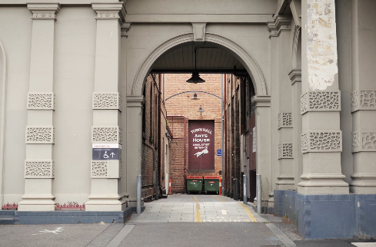

Image: View of George Johnson Lane from Errol St. The laneway passes through an archway with a brick wall at the end.

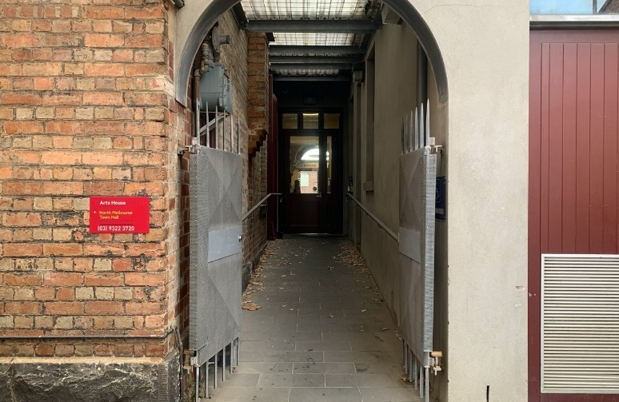

Image: view of the ramp leading from George Johnson Lane to the automated door which opens into the Arts House foyer.

## **Box Office**

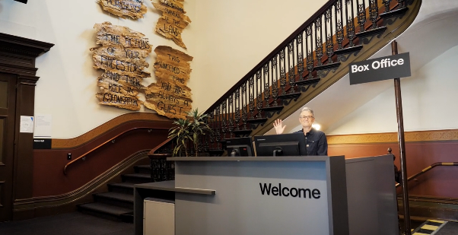

Image: Reception desk. Box Office / Reception Desk is located in the foyer under the stairwell.

## **Ushers**

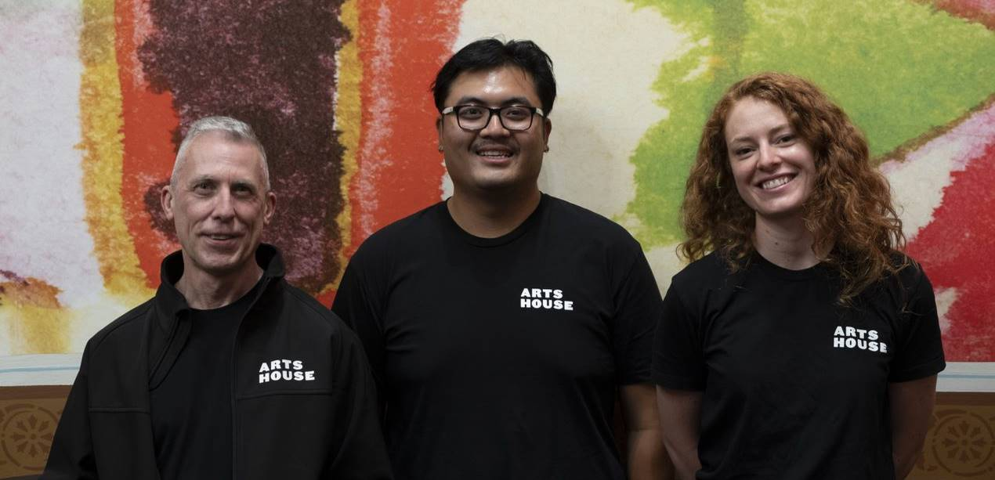

Image: Three Arts House Ushers.

Ushers will be wearing black with an Arts House Logo on the left hand shoulder.

## **Bar**

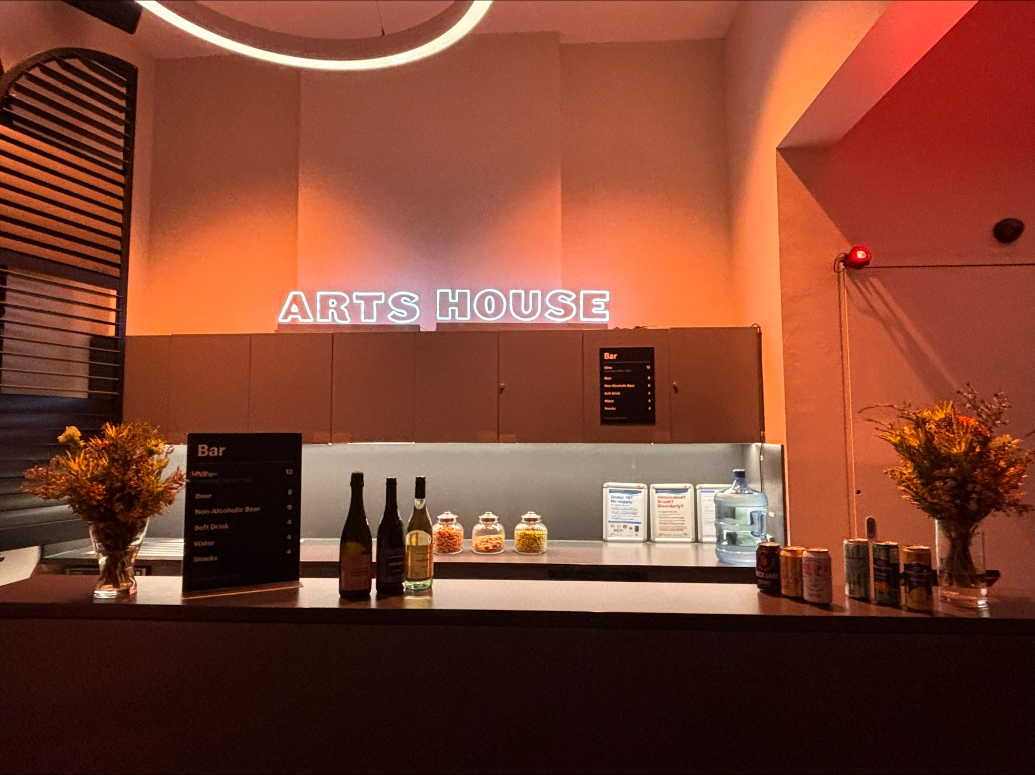

Image Description: Arts House Bar

Bar staff will be wearing black with an Arts House Logo.

We have a range of alcoholic and non-alcoholic beverages for sale.

We are a cashless venue and accept EFTPOS, Visa and Mastercard payments.

## **Quiet Space**



Arts House Quiet Space is located on Ground Level and is nearby reception and opposite the accessible bathrooms. It includes a range of seating options including soft furnishings, dimmable lights, sensory and stim objects. It is open during venue opening hours and events as a quiet space, prayer or parenting space.

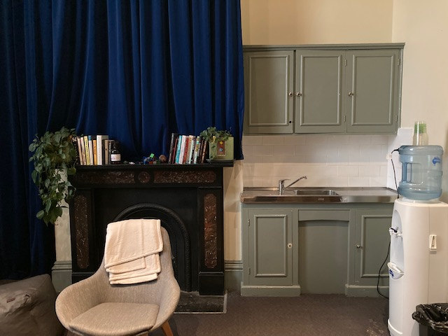

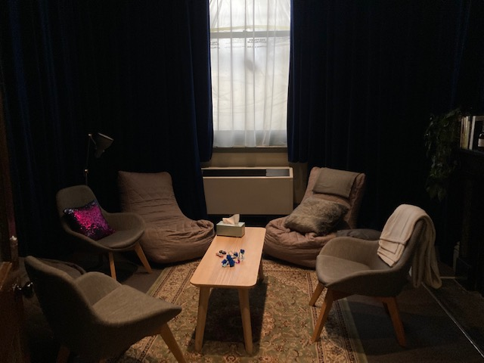 Image: Quiet Space kitchenette and shelf



Image: Quiet Space with lights dimmed

## **Bathrooms**

All bathrooms have Dyson hand dryers with sensor activation. There is an accessible bathroom that is single use on ground level opposite the Quiet Space. There is another accessible bathroom upstairs – this is accessible via lift or stairs.

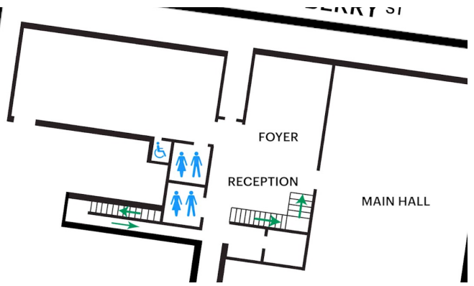

Image: Map of ground floor bathroom locations.

## **Door to Main Hall**

The Performance is in the Main Hall.

It is on the ground floor.

It is to the left of the box office desk and right of the bar.

An artist statement is available on a QR code and warnings on the door.

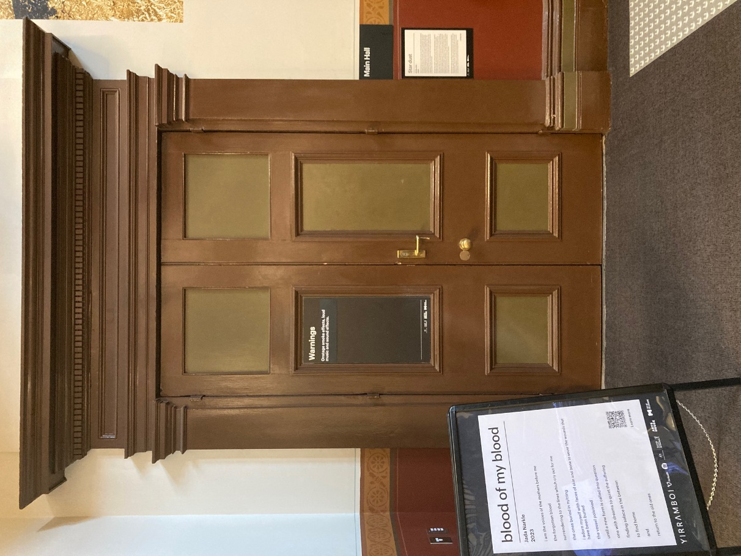

Image description: Photo of the Main Hall doorway.

## **Lift**

The lift is located behind reception desk in the foyer.

The closest entry to the lift is via George Johnson Lane.

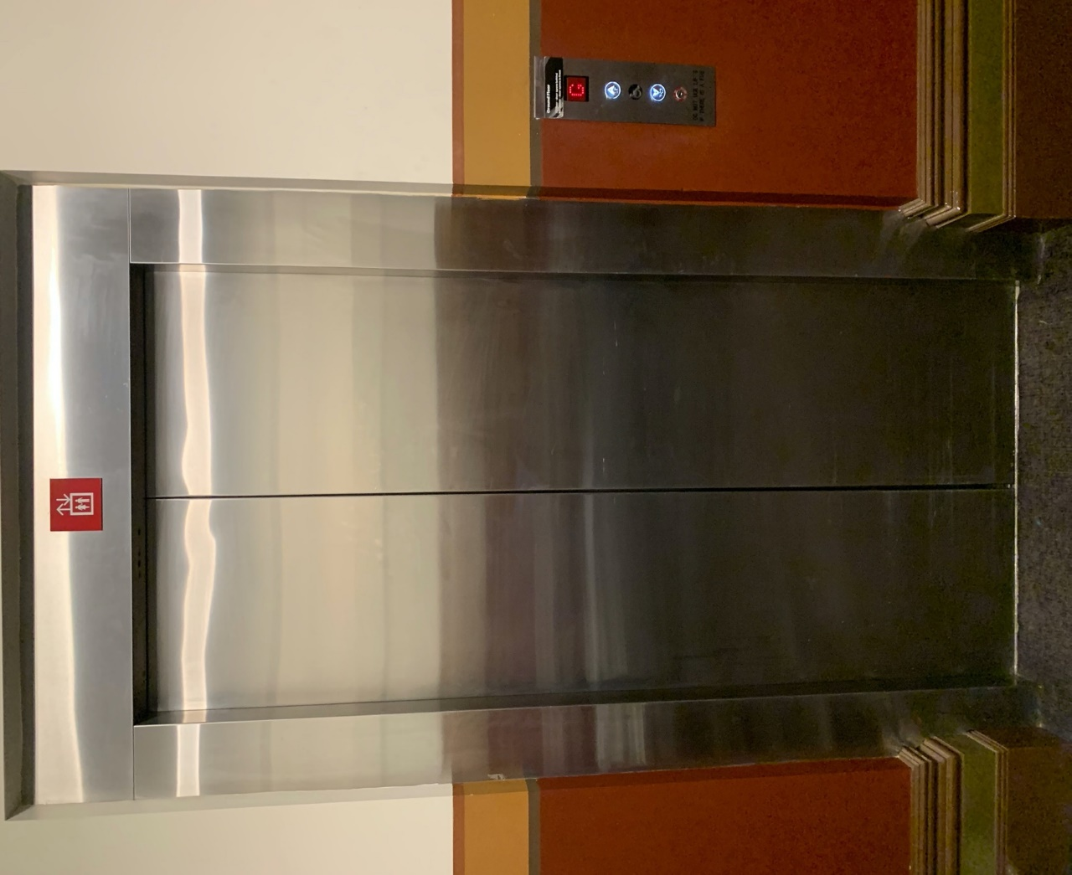

Image description: Doors of the elevator.

# **Transport**

## **Tram**

Route 57 (High Floor trams only)

Stop 12, North Melbourne Town Hall.

Please note, this is not a wheelchair accessible tram

[GETTING TO ARTS HOUSE VIDEO LINK](https://vimeo.com/544169506)

## **Train**

Arts House is 1.1km from   
North Melbourne Train Station,   
approximately 16 minute walk

[North Melbourne Station Information](https://www.ptv.vic.gov.au/stop/1144/north-melbourne-station/0/train/)

1.2km from Flagstaff Station,   
approximately 15 minute walk

[Flagstaff Station Information](https://www.ptv.vic.gov.au/stop/1068/flagstaff-station/0/train/#StopPage:::datetime=2023-04-06T04%3A41%3A27.669Z&directionId=-1&showAllDay=false&_auth=408ac3b1e97f4b0beb5bdf00c2f797057d10dd6e6cf2ad40a69334c4dfdf5e21)

## **Bus**

Bus number: 216

## **Parking**

There is limited paid on-street parking on Queensberry Street and Errol Street.

There are two accessible on street car parking spaces on Queensberry Street (150m to our accessible Errol Street entrance) for holders of a Parking Permit for Disabled people.

# **COVID Safety**

Please note: If you have a cough, sore throat, fever, shortness of breath or flu-like symptoms, you must not attend our venue or programs in person.

We will provide a refund if you need to cancel your attendance due to illness. Please [contact us](mailto:ArtsHouse.Ticketing@melbourne.vic.gov.au) by 9am on the day of the event.

To minimise the risk of COVID-19 transmission, we advise all patrons, artists and staff to:

* Practise physical distancing where possible
* Practise good hygiene by washing and or sanitising your hands often
* Wear a mask as directed by Victorian Government guidelines

Throughout the venue you will find:

* hand sanitiser stations available
* masks available (ask one of our staff for assistance)​

We also ensure that spaces are well ventilated.

Staying COVID-safe remains important. We must all follow these steps:

* Follow the [Victorian Government’s measures on how to stay safe.](https://www.betterhealth.vic.gov.au/coronavirus-covid-19-victoria)
* When you cannot safely socially distance it is recommended to wear a well fitted mask where required.
* Practise [COVID-safe hygiene protocols.](https://www.health.gov.au/news/health-alerts/novel-coronavirus-2019-ncov-health-alert/how-to-protect-yourself-and-others-from-coronavirus-covid-19/good-hygiene-for-coronavirus-covid-19)