EDGING

By APHIDS

Access Guide

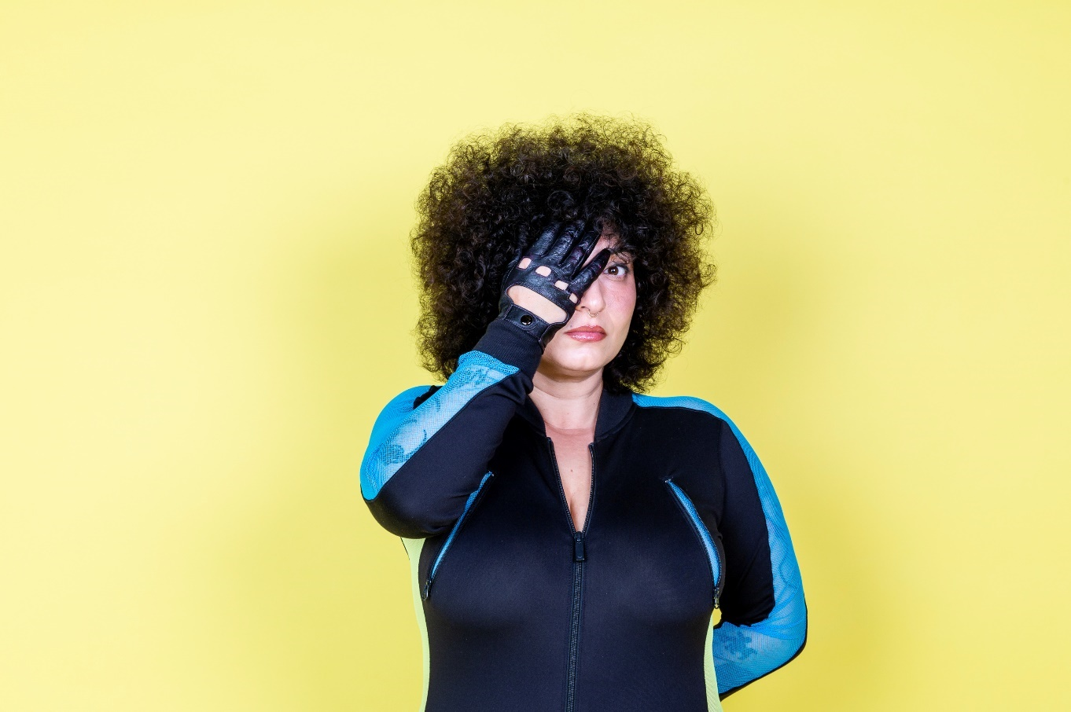

Image description: Sammaneh stands in front of a pale lemon-yellow background. Their hair is a halo of dark brown curls and they are covering one eye with a leather-gloved hand, staring at us with the other eye. They wear black eyeliner, shiny rouge lipstick, a blushed pink cheek, and a silver circular septum piercing. They wear a long black lycra top which has panels of blue lace along the top of the arms highlighting sleeves of black tattoos beneath.

Image credit: Bryony Jackson

Updates to this document

Please note, this performance is a new work and changes are being made by artists until opening. We will endeavour to provide the latest access information on performances to ticket holders across key stages of rehearsal and presentation.

Arts House website will contain the most up to date version of this document and all ticket holders will be notified of any revisions made 3 days and 1 day prior to the event.

This document was created: 13 November 2024

Contents
Updates to this document 2
Where 4
When 4
Access Services 5
Performers 7
Sensory Elements 8
Sound 8
Lighting 8
Physical 8
Smell 8
Visual 8
Entry to space 8
Shocks or surprises 9
Audience experience 9
Social expectations 9
Performance expectations 9
Other 9
Content Warnings 9
General Notes 10
The Venue 11
Front Entrance 11
Accessible Entrances 12
Box Office 13
Ushers 14
Bar 15
Quiet Space 16
Bathrooms 17
Lift 18
The Warehouse 19
The Warehouse Bathrooms 21
Transport 22
Tram 22
Train 22
Bus 22
Parking 22
COVID Safety 23

Where

Arts House
521 Queensberry Street
North Melbourne VIC

When

Wednesday 27 November – Sunday 1 December 2024
Wednesday to Saturday, 7pm
Sunday, 5pm
Duration: 60 Minutes

Post-show Artist Talk - Thursday 28 November

Access Services
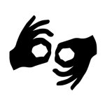
Auslan Interpreted Performance Thursday 28 November, 7pm

Assistance Animals are welcome.

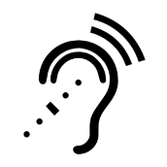
Assistive Listening is available free of charge. Ask staff for assistance on arrival.

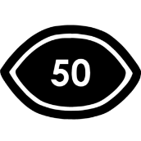
Visual Rating 50% – this performance has music and sounds in the background.



Aural Rating 50% – contains both sound and visual components, but sight is not essential to be able to engage with the event.

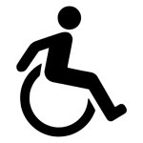
This performance is fully wheelchair accessible. More information is provided further below in this guide about the accessible entrances at Arts House and bathrooms.
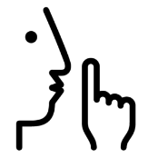
Quiet Space Available - The quiet space will be available for you to use before, during and after the show. More information about the quiet space can be found later in this guide.

Companion Card - Arts House supports the Companion Card program.

Performers

Sammaneh Pourshafighi
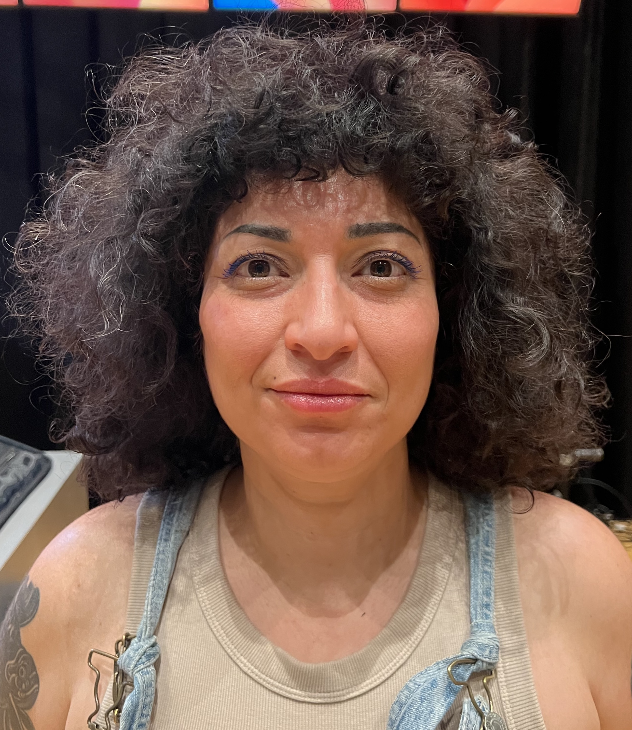

Image description: Sammaneh in front of a black background. Their hair is a halo of dark brown curls, with some greys, and they wear a vibrant blue eyeliner which frames their brown eyes. They wear a beige top with denim overalls over the top. They have black tattoos on their bare arms.

Eden Falk

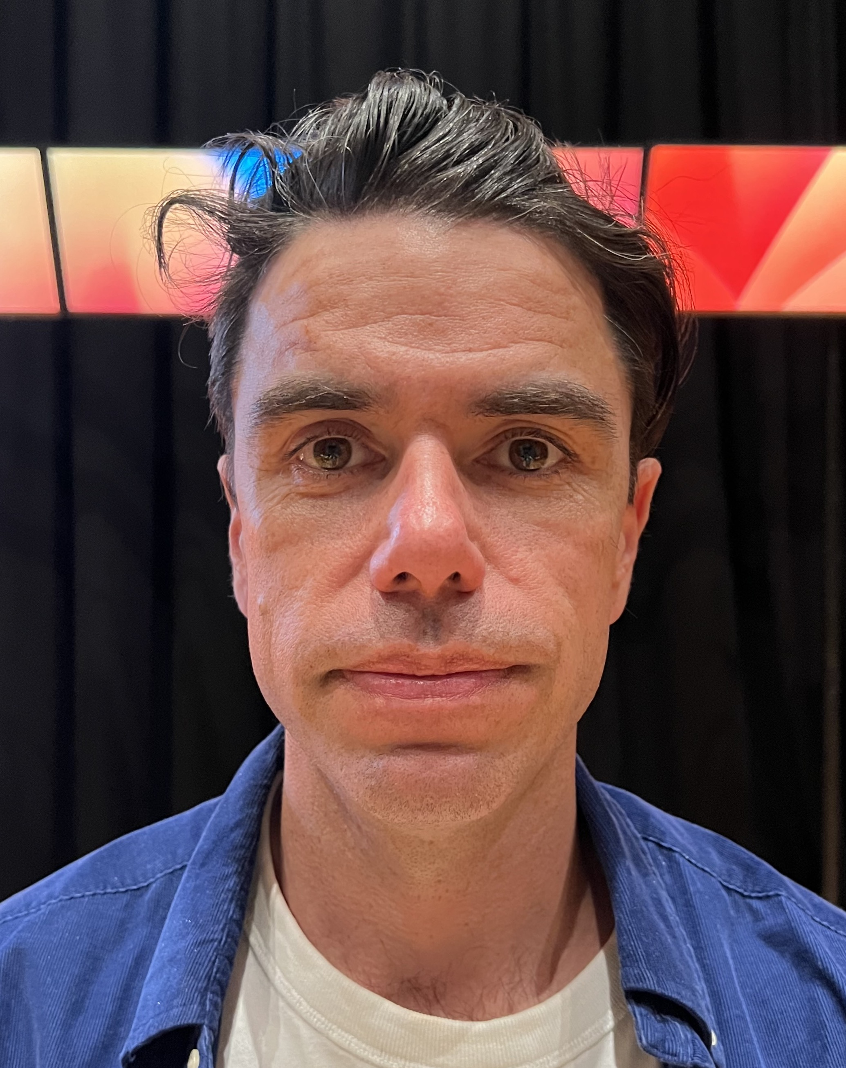

Image description: Eden in front of a black background and television screens. He has short dark hair, thick dark eyebrows, and brown eyes. He wears a bright blue collared shirt open over a white T shirt.

Sensory Elements

Sound

There will be loud music. The performers’ voices will be manipulated to be deeper in pitch and, at times, voices will overlap. Background white noise (airport noise) will play at a low level throughout the performance.

Lighting

The lighting changes in colour and intensity, including moments of flashing lights and strobe. The lighting states sometimes change quickly. There are large television screens which face the audience and emit light.

Physical

Due to the intimate nature of The Warehouse, performers and audience are in close proximity.

Smell

Some props used in the performance may have a faint or atmospheric smell such as sunscreen, a lighter striking, a lit and blown out birthday cake candle, liquid butter, a dog, and a dry dog treat. Smells of fresh popcorn and beer served during the performance will also be present.

Visual

The performance space contains large television screens which face the audience. The imagery on the screens changes constantly throughout the performance. There is a conveyor belt which has items placed on it throughout the performance. The dog on stage may move unpredictably.

Audience Experience

Entry to space

On arrival, audience members will enter via the main Arts House building. The front of house team will guide people through an outdoor alleyway over to The Warehouse for the performance.

Entry is by the rear of the building via an accessible ramp. Images of the entrance are further below in this guide.

Shocks or surprises

There are moments of loud sound, drug use, flashing lights, partial nudity, sexual references and performed interrogation.

Audience experience

The seating bank is close to the performance space, and audience are in close proximity to the performers. At times, the performers make eye contact and there is some audience participation. Questions are asked to a few select audience members in the front row. You may respond if you feel comfortable doing so. Fresh popcorn is served in bags to select audience members who do not have to eat it.

Social expectations

The audience is seated in tiered seating banks.

Audiences are welcome to bring stim toys.

There are no breaks in the show. There will be a lockout once the show begins. If you need to leave, you will not be allowed to re-enter. Please speak to the front of house staff for assistance.

Performance expectations

There are two human performers and a dog.

This performance has dialogue and different scenes which are demarcated with music, dialogue, and different intonation.

Other

Content Warnings

This performance contains mentions of border security procedures and coarse language, nudity, loud music, very loud effects, sudden loud noises, flashing lights, abrupt lighting changes, low lights, lighting black out, a live dog, and lights that change colour and intensity.

General Notes

A recorded Acknowledgement of Country will play at the beginning of the performance

Please note there is a strict lockout for Cliffhanger. No latecomers will be admitted.
Toilets in The Warehouse will not be in use, but toilets in the Main Building will be accessible before and after the performance.

The Venue

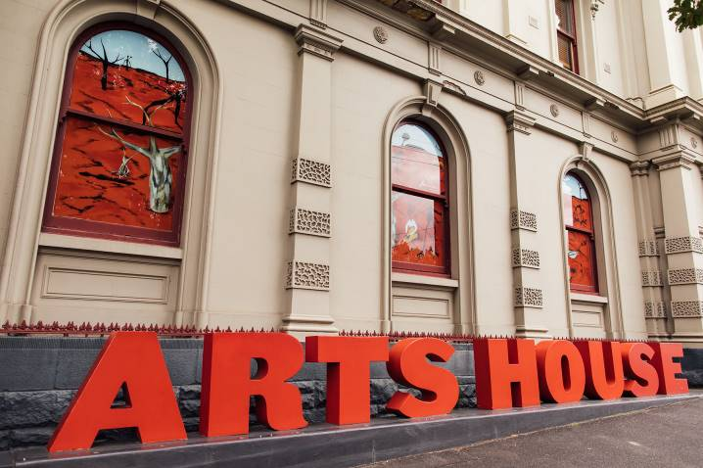
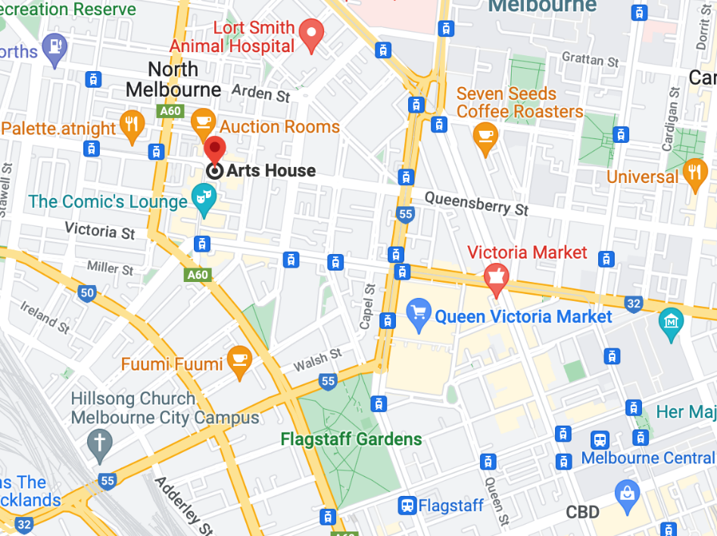

Image: North Melbourne Town Hall features giant red letters that say ARTS HOUSE out the front of it.

Image: a map of Arts House and its surrounding area. LINK TO MAP

Front Entrance

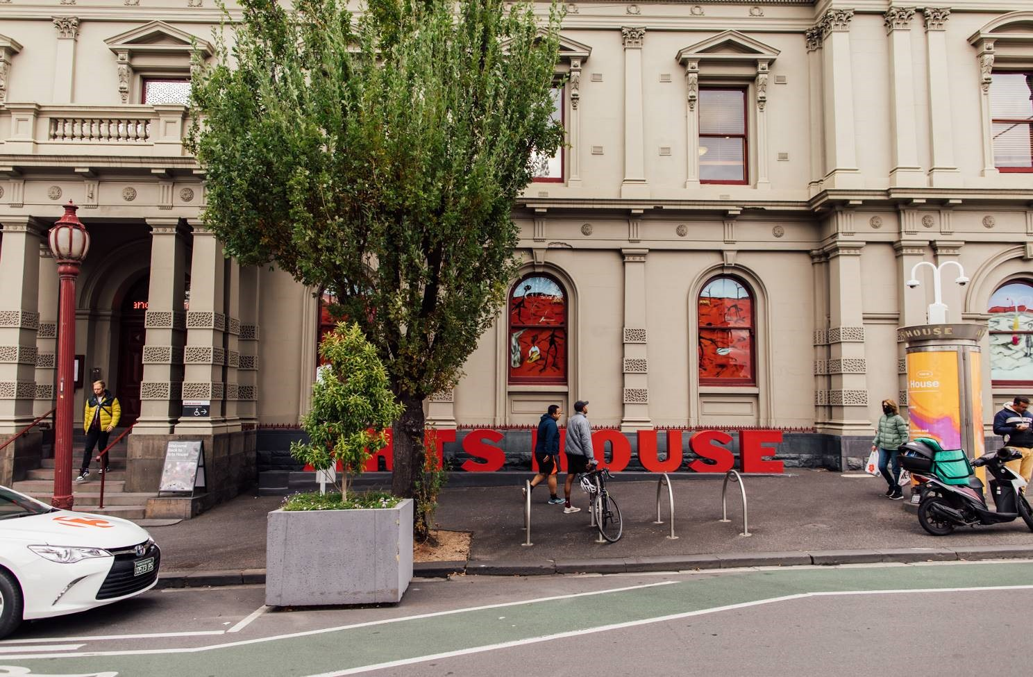

Accessible Entrances

There are two Accessible Entrances. The first is on Errol St next to the Post Office.

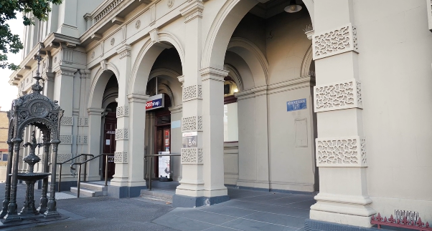

Image: Errol Street entrance next to the Post Office with wheelchair accessible ramp and hand rails.
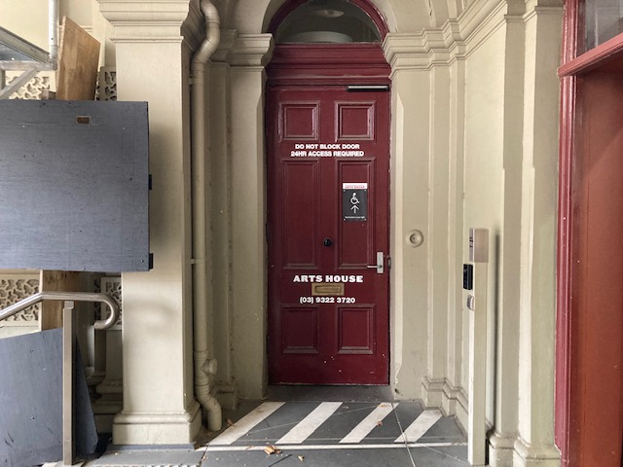
Image: View of door entrance via Errol St. The door is maroon with Arts House displayed on the door.

The second Accessible Entrance is towards the end of George Johnson Lane.

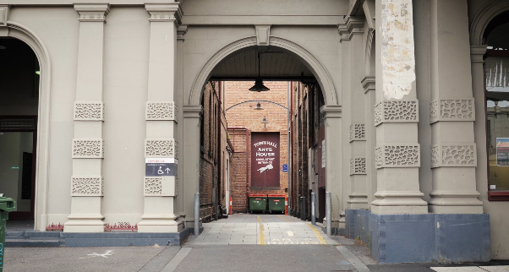

Image: View of George Johnson Lane from Errol St.
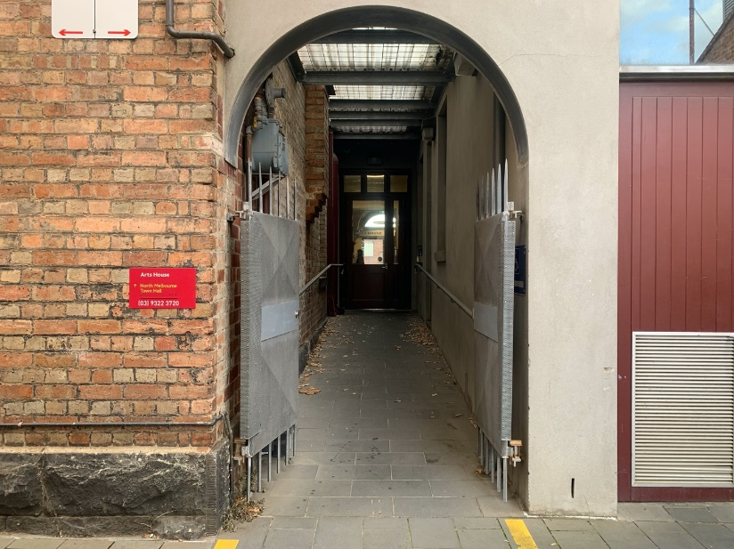

Image: View of the ramp leading from George Johnson Lane to the automated door which opens into the Arts House foyer.

Box Office

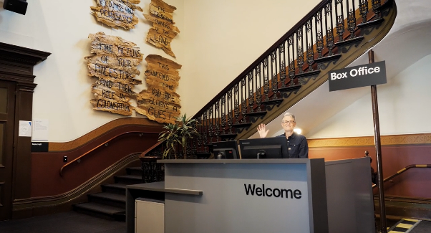

Image Description: Image is of reception desk, showing one of our receptionist's waving. To the left of the reception desk is the main stair case, showcasing some art work on the walls.

Box Office is in the foyer under the stairwell.

Ushers

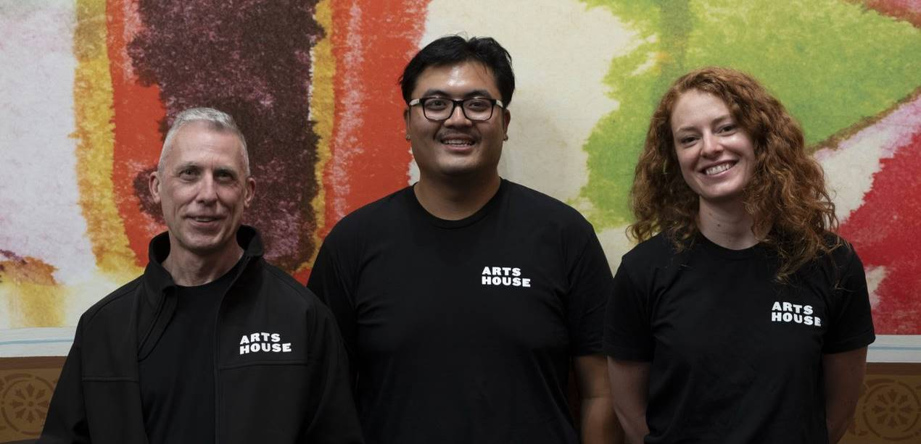

Image Description: Three Ushers wearing black with an Arts House Logo on the left-hand shoulder.

Arts House Ushers can be identified by their Arts House logo uniforms. They are there to assist with any access requirements and getting people safely seated into the performance space. For any access needs, please approach our friendly team.

Bar

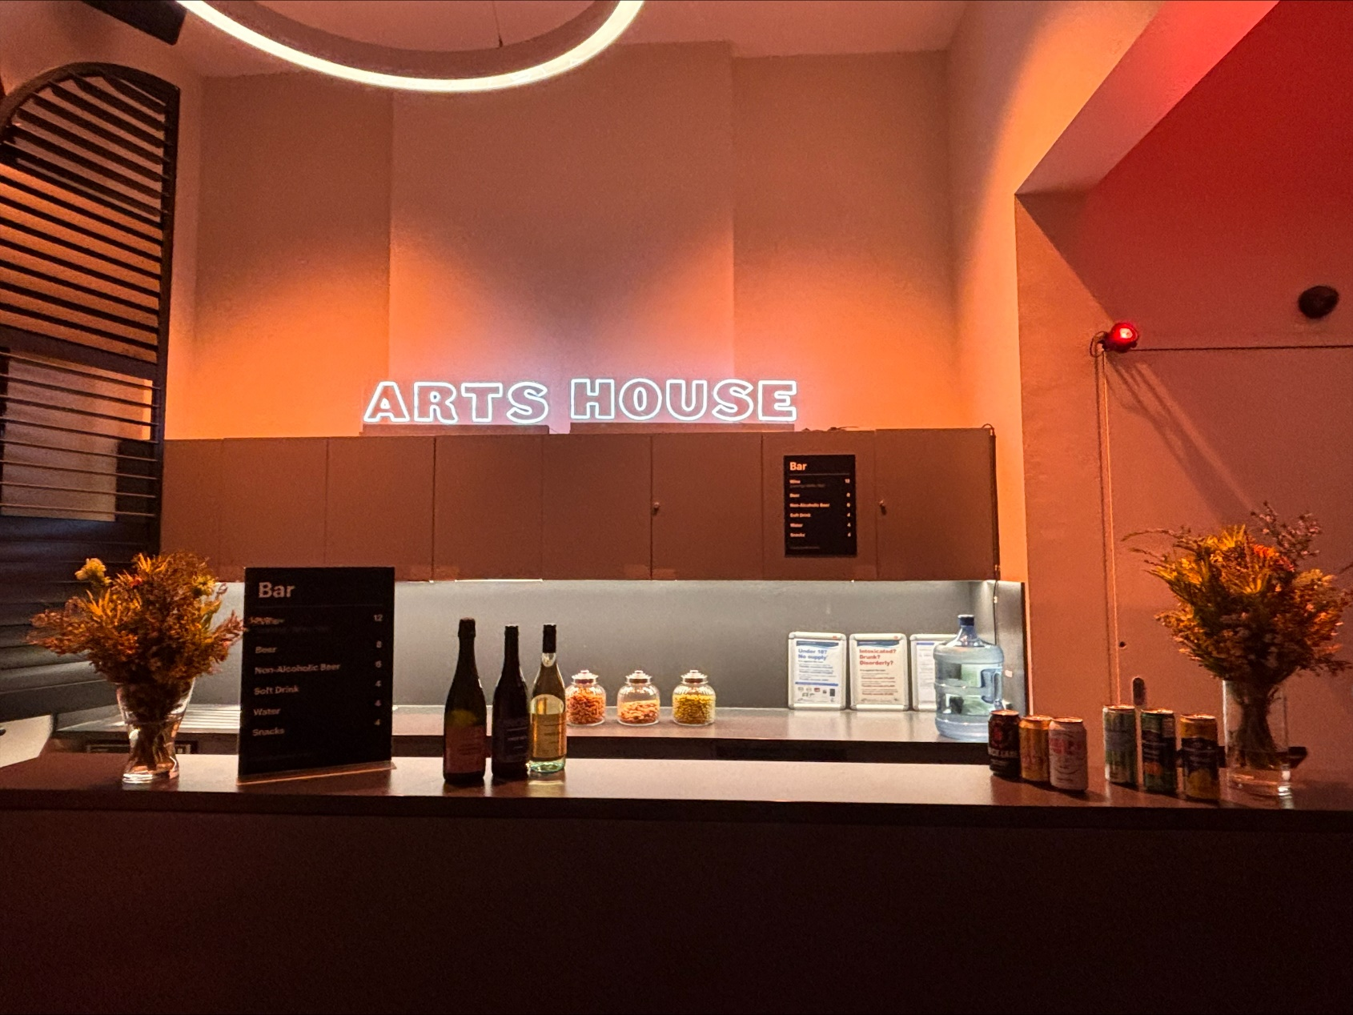

Image Description: The Arts House Bar with vases on each side of the bar filled with flowers. In the centre there is a bar menu displayed with drinks set up on the top level on the bar. Towards the back wall there is a Arts House sign that is lit up. The lighting of the space is lit up orange.
Bar staff will be wearing black with an Arts House Logo.

We have a range of alcoholic and non-alcoholic beverages for sale.

We are a cashless venue and accept EFTPOS, Visa and Mastercard payments.

Quiet Space

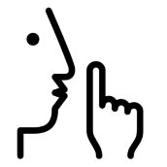

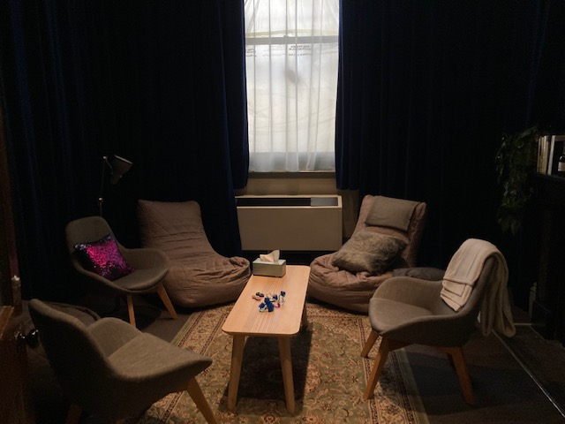
Arts House Quiet Space is located on Ground Level and is nearby reception and opposite the accessible bathrooms. It includes a range of seating options including soft furnishings, dimmable lights, sensory and stim objects. It is open during venue opening hours and events as a quiet space, prayer or parenting space.

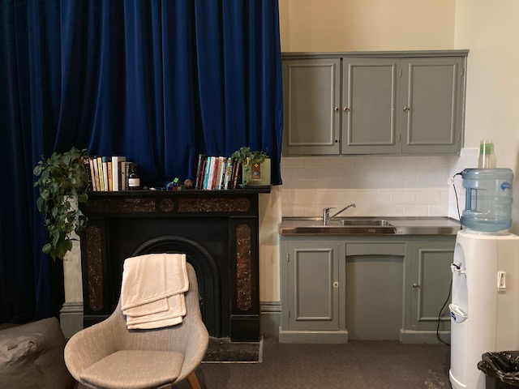
Image: Quiet space with lights dimmed and chairs in a circle

Image: A corner of the Quiet Space, showing the kitchenette and book shelf.

Bathrooms

All bathrooms have Dyson hand dryers with sensor activation. There is an accessible bathroom that is single use on ground level opposite the Quiet Space. There is another accessible bathroom upstairs – this is accessible via lift or stairs.

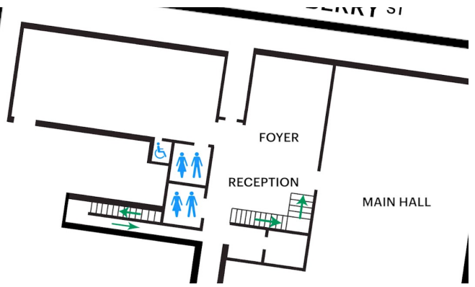

Image: Map of ground floor bathroom locations, including entrances and locations with stairs.

Lift

The lift is located behind reception desk in the foyer.
The closest entry to the lift is via George Johnson Lane.

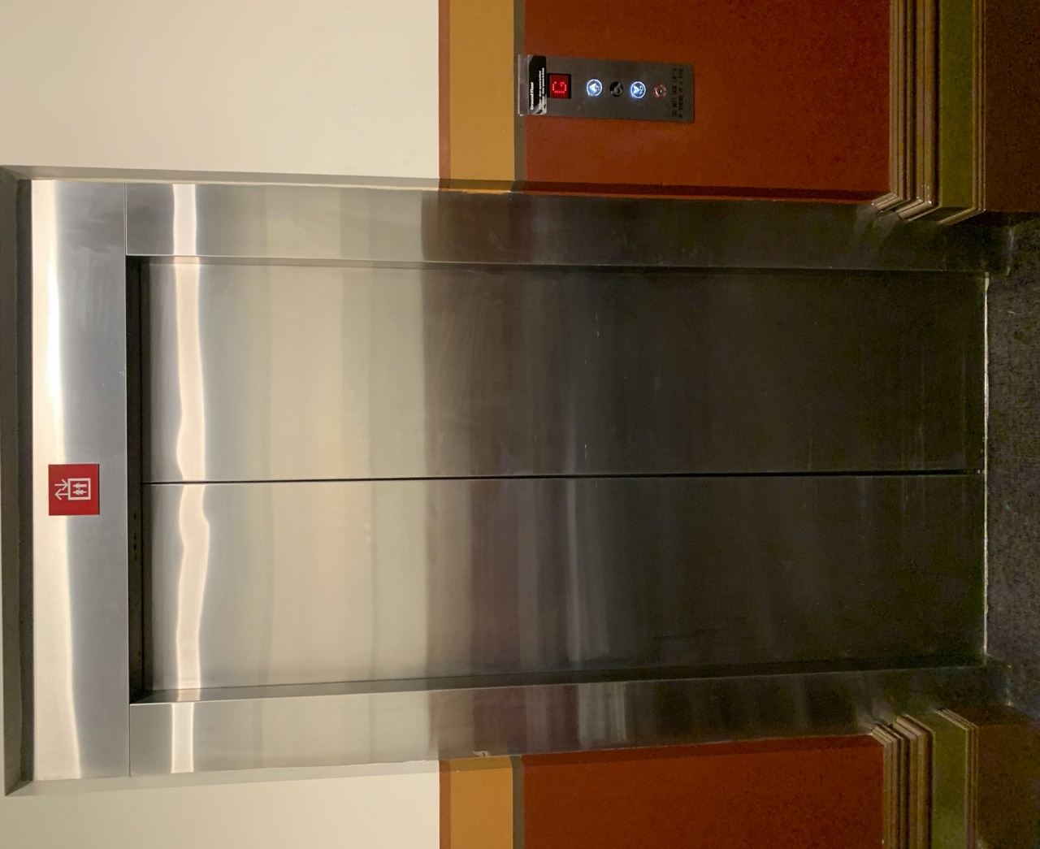

The Warehouse
The Warehouse is separate to the main building of Arts House. You can find the Warehouse by following George Johnson Lane as it snakes around the back of the main Arts House building.

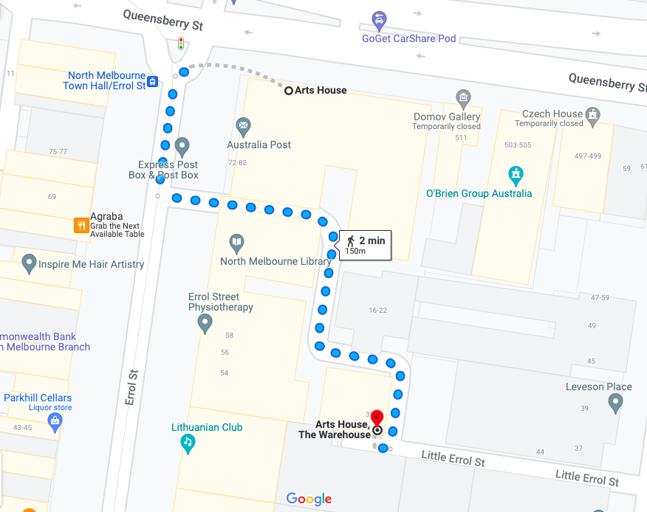

Image: A screenshot of a map with walking directions from the front of the main building of Arts House to the Warehouse behind it.

Warehouse Entrance
The main Warehouse entrance has a wheelchair accessible ramp that is 1150mm wide. The bottom section of the ramp has a gradient of 1:6 and has no handrails. The upper section has a gradient of 1:12 and has handrails on both sides. This main entry to the Warehouse is through an automated, glass sliding door.
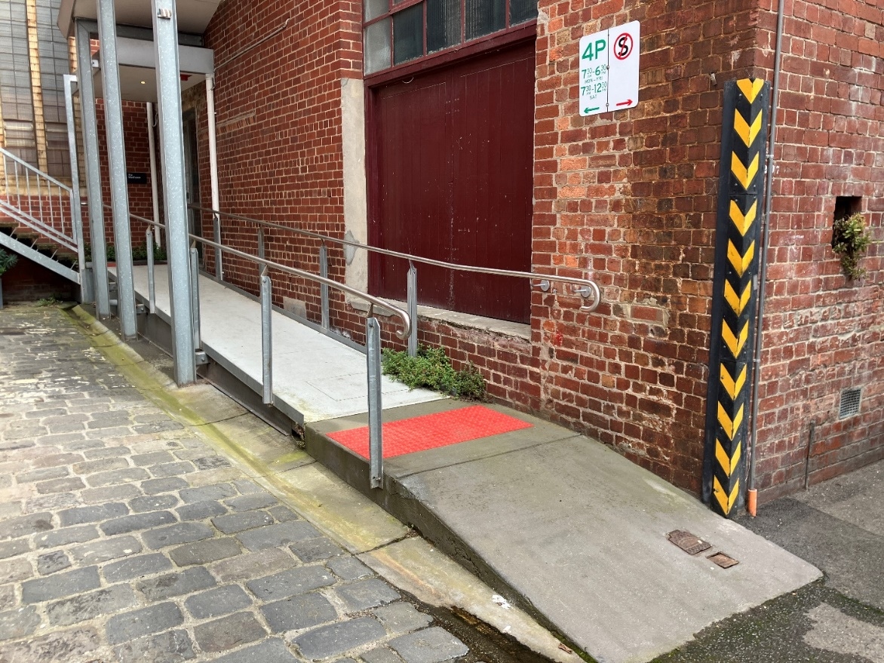
Image description: View of the ramp leading to the main entrance of the Warehouse. The bottom section has no handrails. There are handrails either side of the ramp at the top section and a large red tactile surface indicator on the flat middle section. The door to Warehouse is on the right at the top of this ramp.

The Warehouse Bathrooms

The Warehouse space has three separate bathrooms located on the opposite, far right corner from the main entrance. These are all self-contained and fully enclosed spaces, accessible from a corridor which leads off the main Warehouse space.

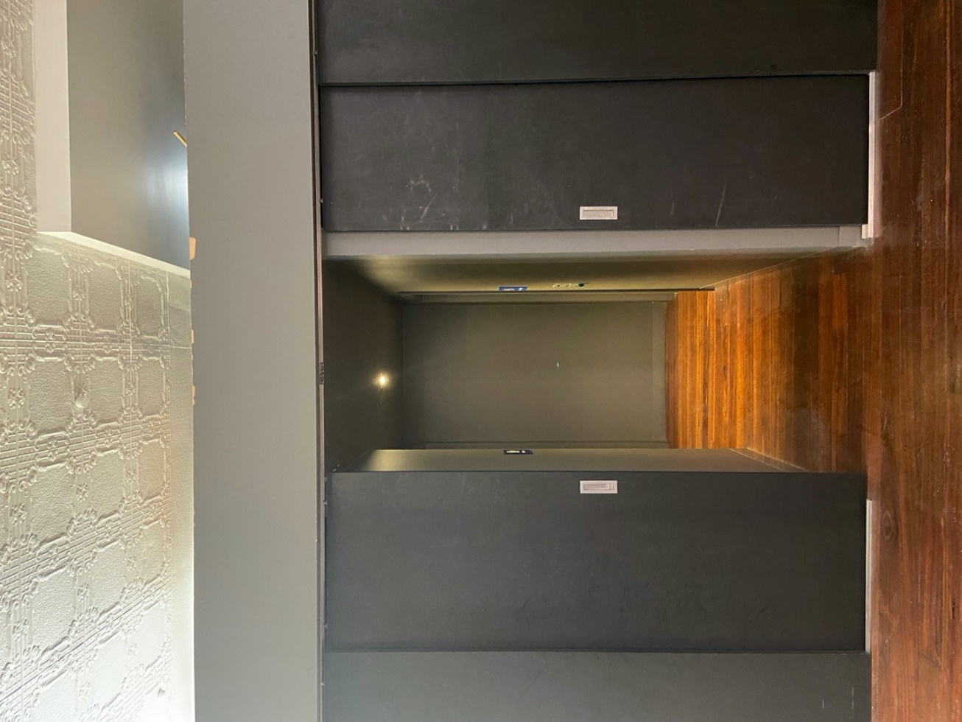

Image Description: Dark grey sliding doors leading to a block of three toilets. Two toilets are on the left hand side and the accessible toilet to the right.

Transport

Tram

Route 57 (High Floor trams only)
Stop 12, North Melbourne Town Hall.
Please note, this is not a wheelchair accessible tram
GETTING TO ARTS HOUSE VIDEO LINK

Train

Arts House is 1.1km from
North Melbourne Train Station,
approximately 16 minute walk
North Melbourne Station Information
1.2km from Flagstaff Station,
approximately 15 minute walk
Flagstaff Station Information

Bus

Bus number: 216

Parking

There is limited paid on-street parking on Queensberry Street and Errol Street.

There are two accessible on street car parking spaces on Queensberry Street (150m to our accessible Errol Street entrance) for holders of a Parking Permit for Disabled people.

COVID Safety

Please note: If you have a cough, sore throat, fever, shortness of breath or flu-like symptoms, you must not attend our venue or programs in person.
We will provide a refund if you need to cancel your attendance due to illness. Please contact us by 9am on the day of the event.
To minimise the risk of COVID-19 transmission, we advise all patrons, artists and staff to:
- Practise physical distancing where possible
- Practise good hygiene by washing and or sanitising your hands often
Throughout the venue you will find:
- hand sanitiser stations available
- masks available (ask one of our staff for assistance)​
We also ensure that spaces are well ventilated.
Staying COVID-safe remains important. We must all follow these steps:
- Follow the Victorian Government’s measures on how to stay safe.
- When you cannot safely socially distance it is recommended to wear a well fitted mask where required.
- Practise COVID-safe hygiene protocols.

