**Digital Echoes**

By Aaron Wyatt with Speak Percussion

Access Guide

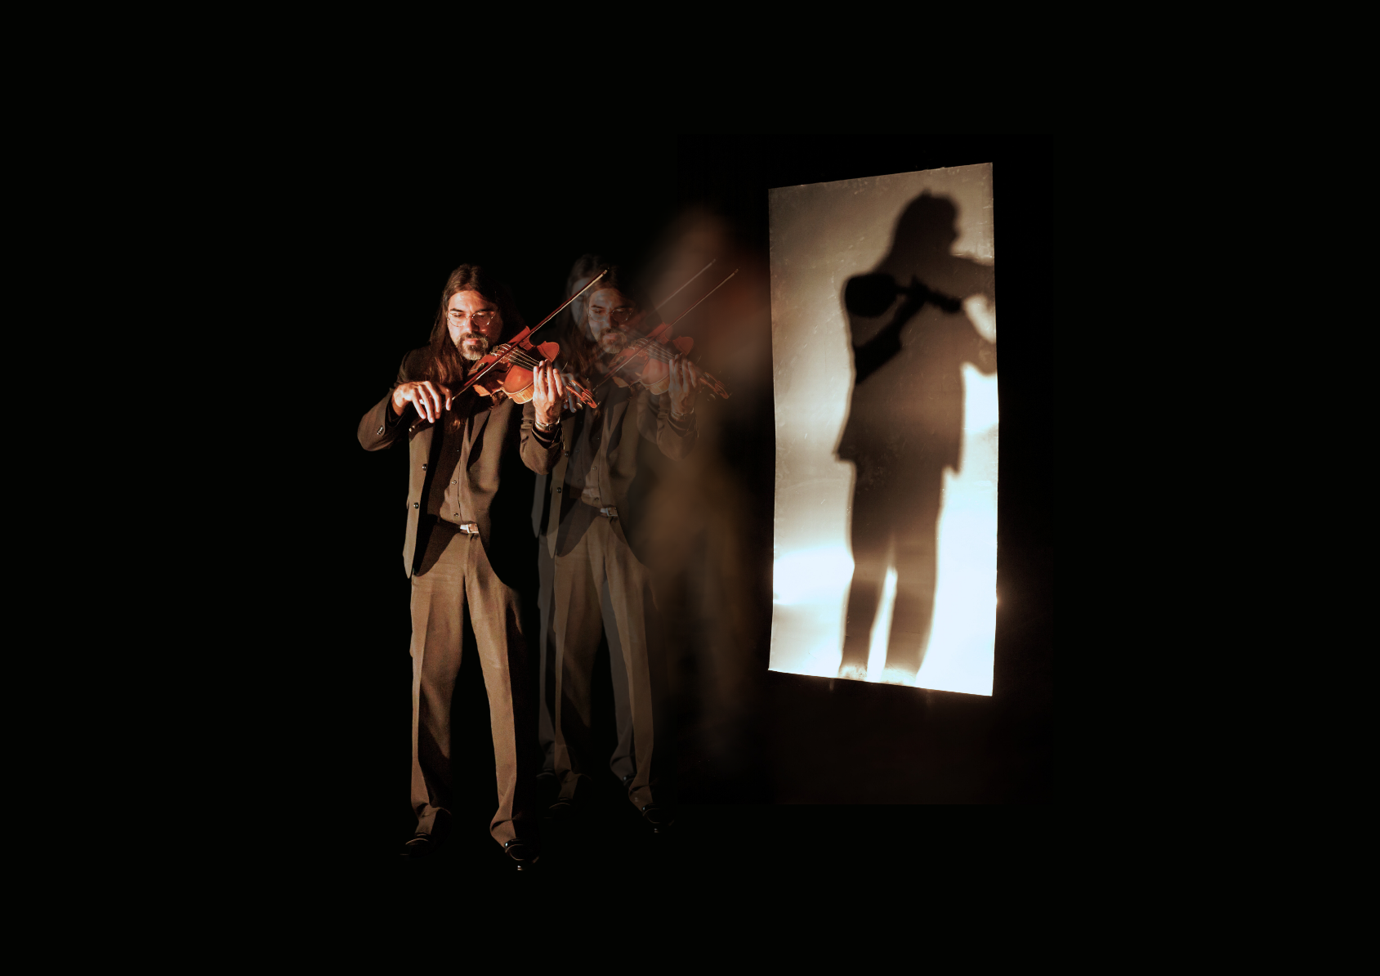

Image credit: Darren Gill  
  
Image description: A performer plays a viola on a dark stage. The image has been digitally altered so that there is a semi-transparent second version of them in an identical stance. Their silhouette fills a screen behind them.

# **Updates to this document**

Please note, this performance is a new work and changes are being made by artists until opening. We will endeavour to provide the latest access information on performances to ticket holders across key stages of rehearsal and presentation.

Arts House website will contain the most up to date version of this document and all ticket holders will be notified of any revisions made 3 days and 1 day prior to the event.

This document was created: 18 September 2024

Revision 1: 14 October

Contents

Updates to this document 2

Where 4

When 4

Access Services 4

Performers 7

Sensory Elements 8

Sound 8

Lighting 8

Physical 9

Smell 9

Visual 9

Entry to space 9

Shocks or surprises 9

Audience experience 9

Social expectations 10

Performance expectations 10

Other 10

General Notes 10

The Venue 11

Front Entrance 11

Accessible Entrances 12

Box Office 13

Ushers 14

Bar 15

Quiet Space 16

Bathrooms 17

Door to Main Hall 18

Lift 19

Transport 20

Tram 20

Train 20

Bus 20

Parking 20

COVID Safety 21

# **Where**

Arts House

521 Queensberry Street

North Melbourne VIC

# **When**

Thursday 17 – Sunday 20 October 2024   
  
Thursday – Saturday, 7.30pm

Sunday, 5pm 

Duration: 50 minutes

# **Access Services**



Assistance Animals are welcome.



Visual Rating 50% – This performance has music and sounds in the background.

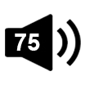

Aural Rating 75%– mainly sound-based with visuals only incidental to the work, so blind or low vision audiences can have close to the full experience of the event.

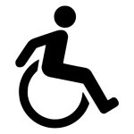

This performance is fully wheelchair accessible. More information is provided further below in this guide about the accessible entrances at Arts House and bathrooms.  
  


Quite Space Available - The quiet space will be available for you to use before and after the show. More information about the quiet space can be found later in this guide.

**Tactile  Access Symbol**

Tactile Tour - Friday 20 October 6.30pm (1 hour prior to the show).

  
Companion Card - Arts House supports the Companion Card program.

# **Performers**

There are two performers in this show.

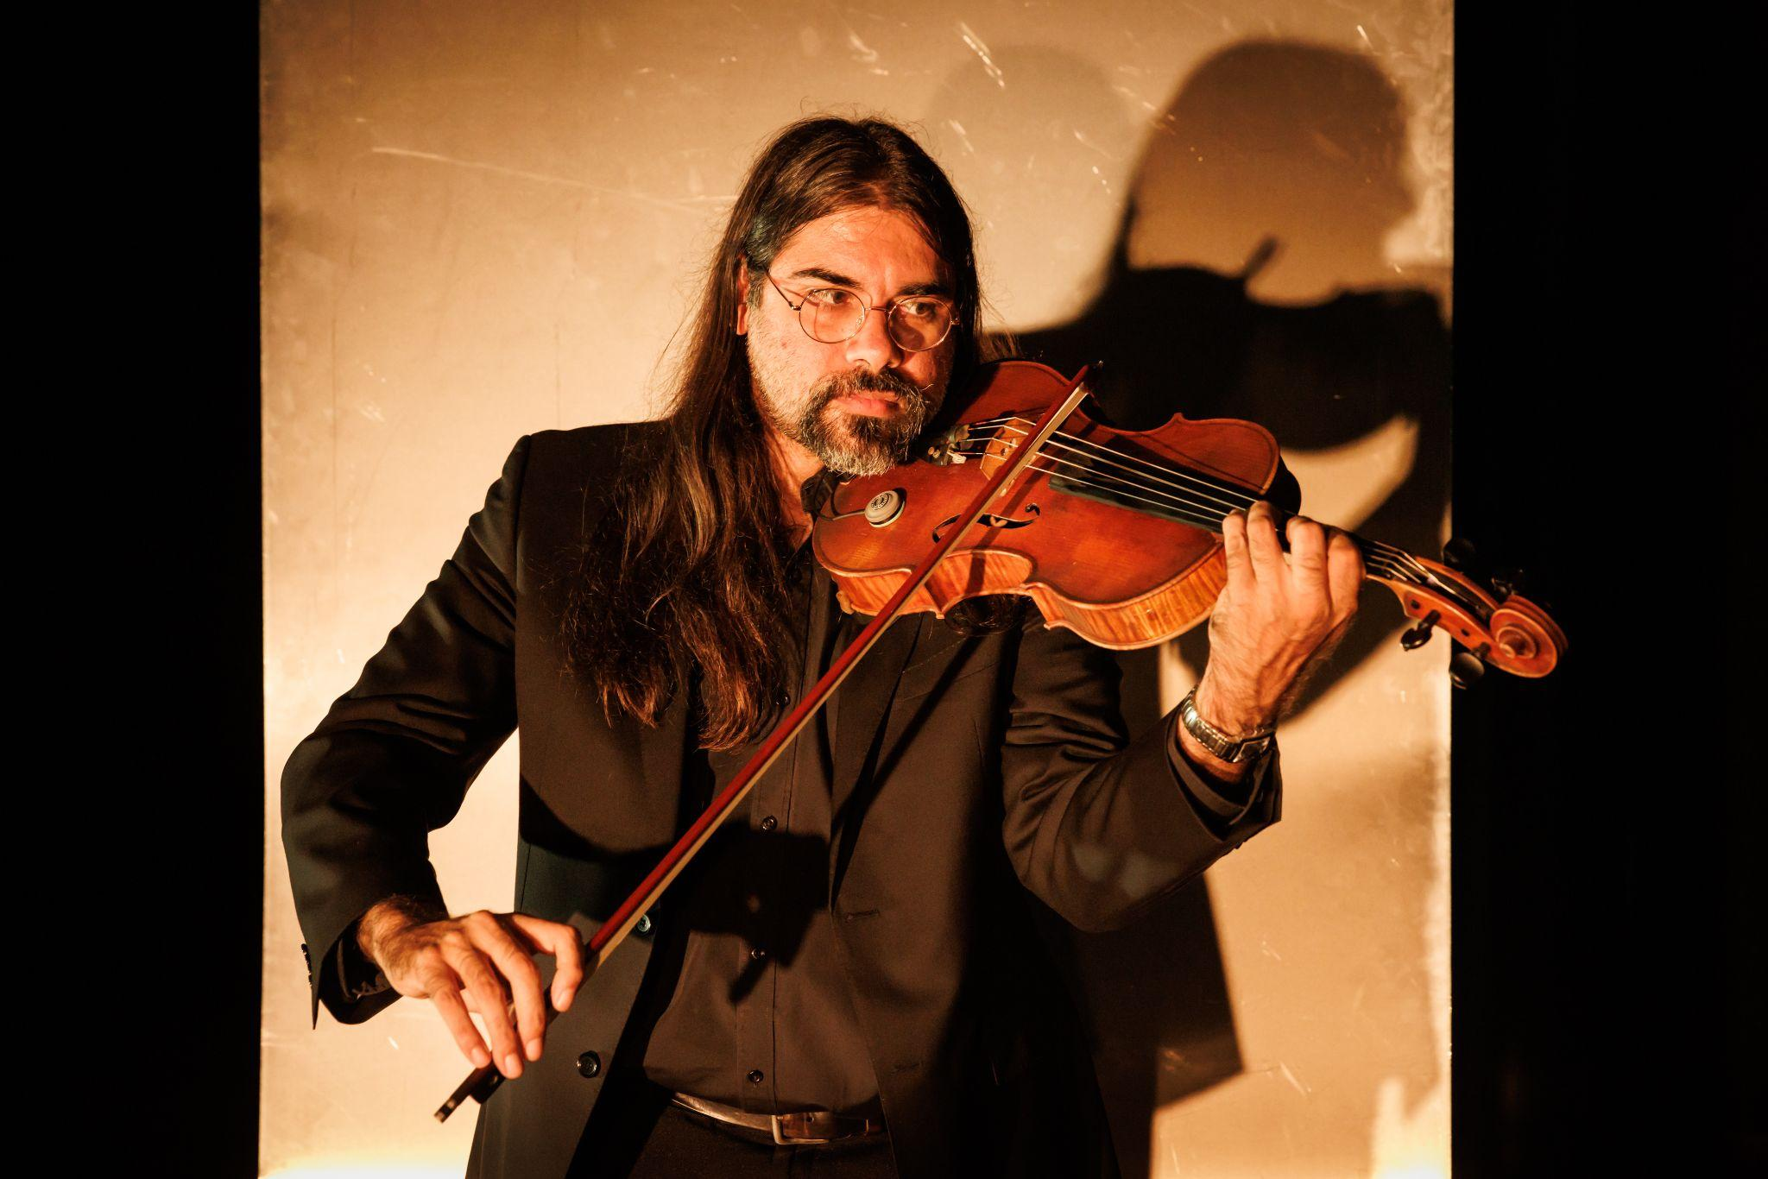

Image Description: A headshot of Aaron Wyatt, a Noongar man.

Image Credit: Photo by Darren Gill

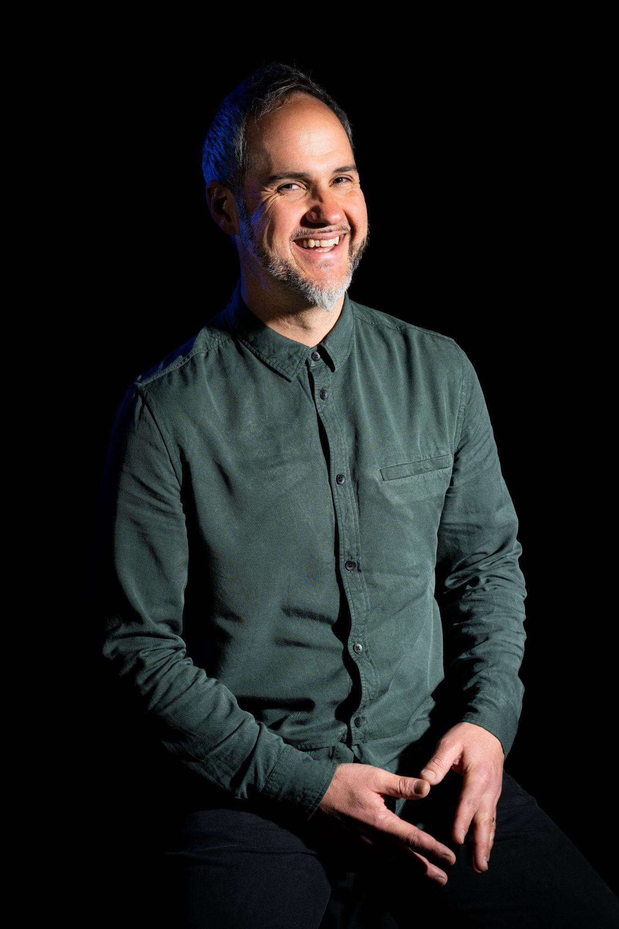

Image Description: A headshot of Eugene Ughetti.

Image Credit: Photo by Devika Bilimoria

# **Sensory Elements**

## Sound

Sound plays a prominent role in this performance. The viola and percussion instruments are not amplified, though at times there will be loud sound, low frequencies, vibrations and sudden noises. Each of the 5 percussion stations has one instrument with a transducer microphone attached to it. These are receiving sounds from the viola and will be sound amplified.

## Lighting

Lighting will change in colour and intensity throughout the performance, as well as there being some darkness at times. Some of the percussion instruments have a reflective surface and this may reflect light onto the audience. There may be some haze used in section of the show.

## Physical

There is no audience interaction. You may feel vibrations through the floor from the instruments and when the transducers are activating instruments with low frequencies and during certain points in the music.

## Smell

There are no scents or smells used in the show. If haze is used, there might be a light scent from the smoke machine.

## Visual

Both of the performers will be wearing black outfits. The audience is seated in a circle shape around the performers.

Aaron Wyatt plays the viola from the centre. There are 5 sections and 5 percussion stations. During the performance, Eugene Ughetti moves to a different percussion station around Aaron for each section of the piece.

Audience Experience

## Entry to space

The audience will enter from the main doors of the foyer. There will be an Acknowledgement of Country before each show in the foyer. Following this, the performance space will open for audiences to enter and take their seats.

## Shocks or surprises

There are loud moments of music, but these sounds will be built up rather than be sudden or shocking.

## Audience experience

The audience are seated around the performers, in close proximity but there is no interaction between the audience and the performers.

## Social expectations

There is no allocated seating for this performance. Please let Front of House staff know if you have any access requirements or where you would be most comfortable in the area before the doors open.

There are no breaks in the show. There will be a lockout once the show begins. If you need to leave during the performance, you won’t be able to re-enter.

## Performance expectations

There is no storyline to follow. There are 2 performers onstage, they will both be wearing black outfits.

# **Other**

## General Notes

There is a strict lockout for Digital Echoes. No latecomers will be admitted.

# **The Venue**

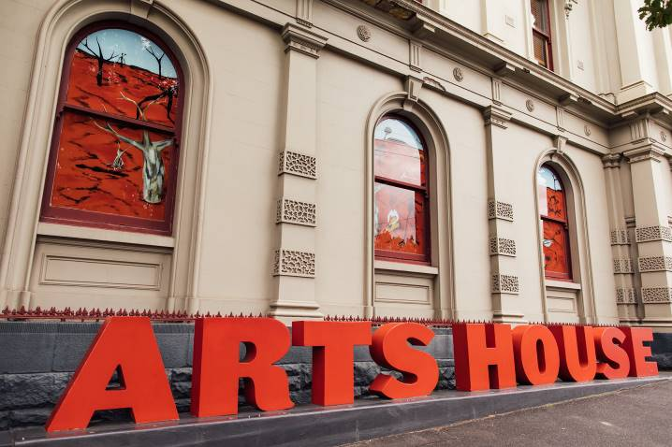

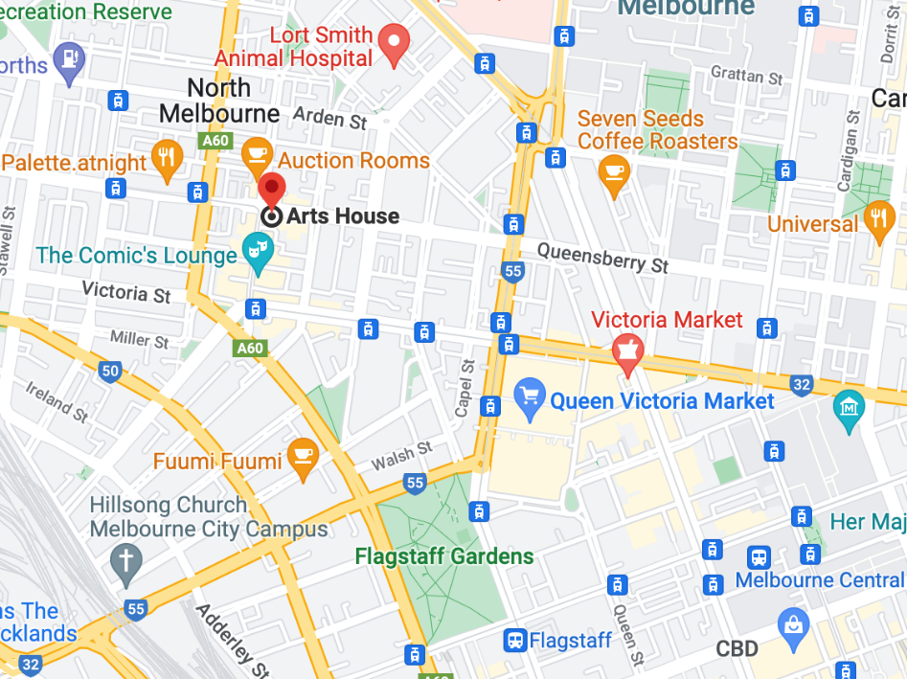

Image: North Melbourne Town Hall features giant red letters that say ARTS HOUSE out the front of it.

Image: a map of Arts House and its surrounding area. [Link to map.](https://www.google.com/maps/place/Arts+House/@-37.802973,144.9486818,17z/data=!4m5!3m4!1s0x0:0x64c465ac7ef21cff!8m2!3d-37.803239!4d144.9498609?shorturl=1)

## **Front Entrance**

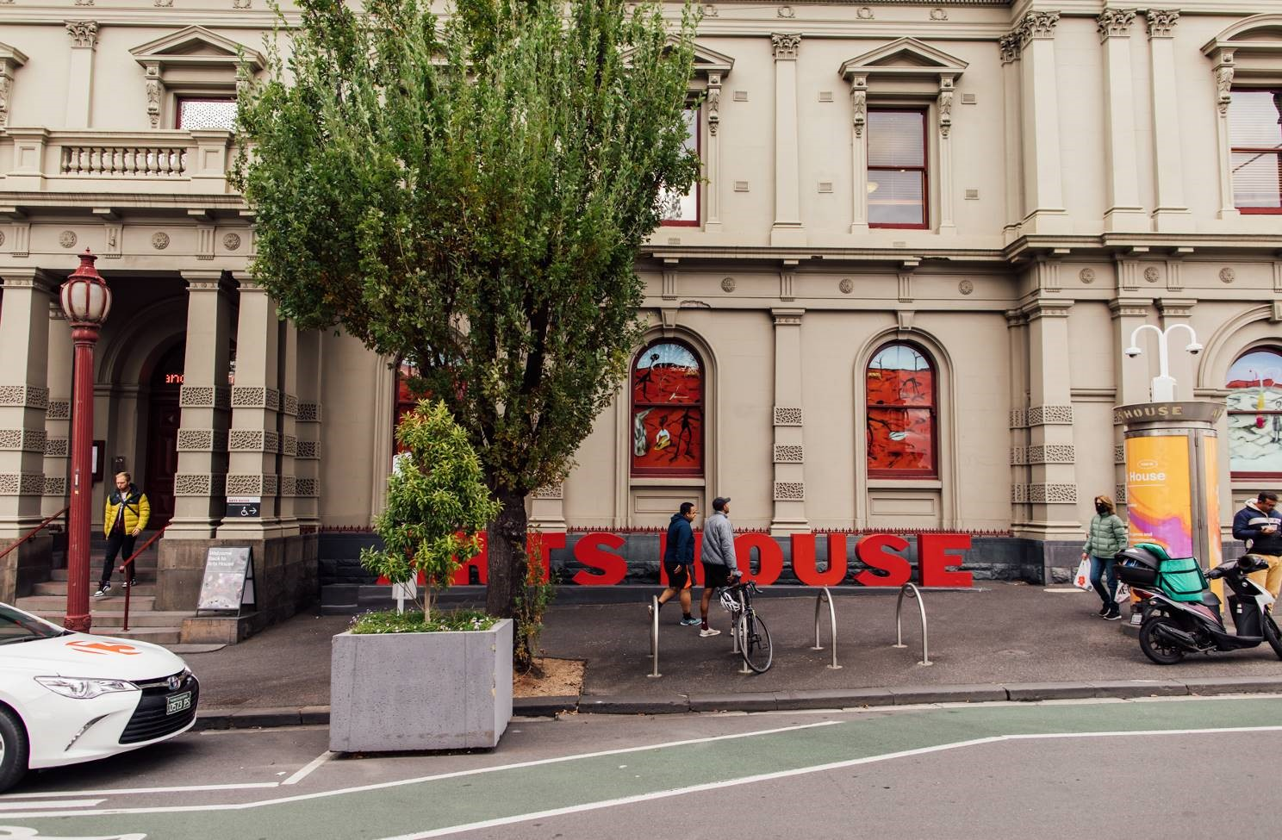

## **Accessible Entrances**



There are two Accessible Entrances. The first is on Errol St next to the Post Office.

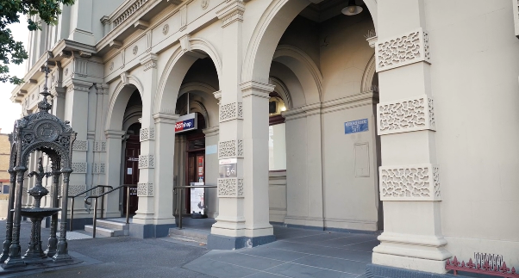

Image: Errol Street entrance next to the Post office. Ramp and handrails.

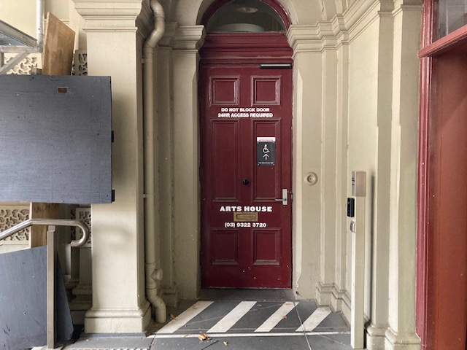

Image: View of door entrance.

The second Accessible Entrance is towards the end of George Johnson Lane.

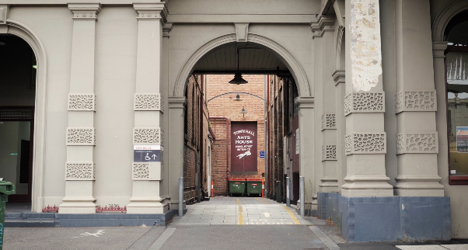

Image: View of George Johnson Lane from Errol St. The laneway passes through an archway with a brick wall at the end.

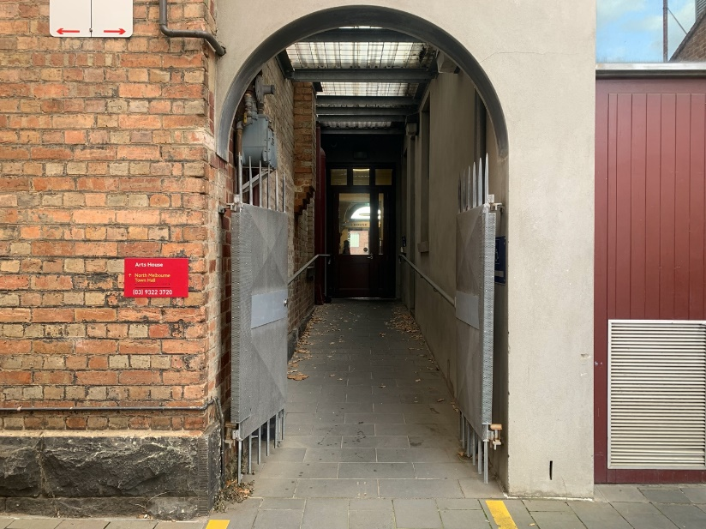

Image: view of the ramp leading from George Johnson Lane to the automated door which opens into the Arts House foyer.

## **Box Office**

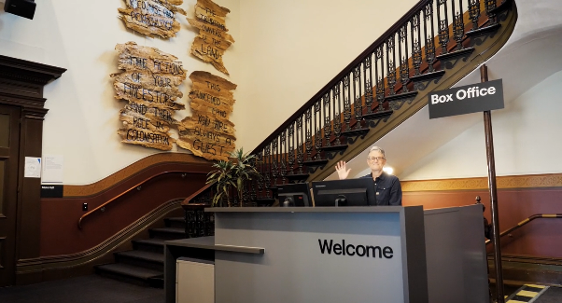

Image: Reception desk. Box Office / Reception Desk is located in the foyer under the stairwell.

## **Ushers**

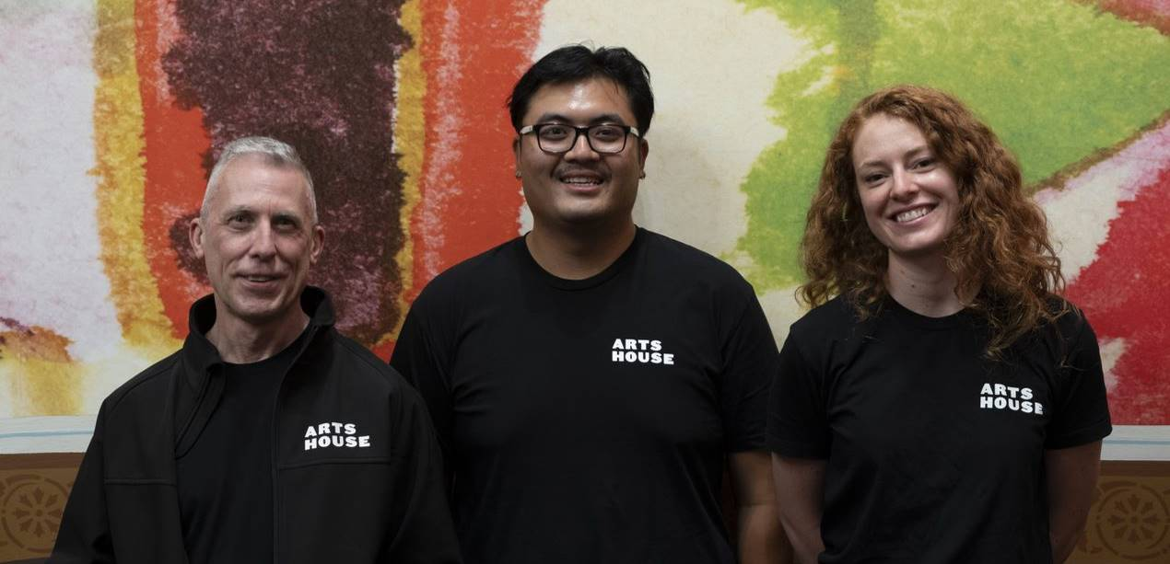Image: Three Arts House Ushers.

Ushers will be wearing black with an Arts House Logo on the left hand shoulder.

## **Bar**

Image is of reception desk, showing one of our receptionist's waving and smiling. To the left of the reception desk is the main stair case, showcasing some art work on the walls. 


Image Description: Arts House Bar

Bar staff will be wearing black with an Arts House Logo.

We have a range of alcoholic and non-alcoholic beverages for sale.

We are a cashless venue and accept EFTPOS, Visa and Mastercard payments.

## **Quiet Space**



Arts House Quiet Space is located on Ground Level and is nearby reception and opposite the accessible bathrooms. It includes a range of seating options including soft furnishings, dimmable lights, sensory and stim objects. It is open during venue opening hours and events as a quiet space, prayer or parenting space.

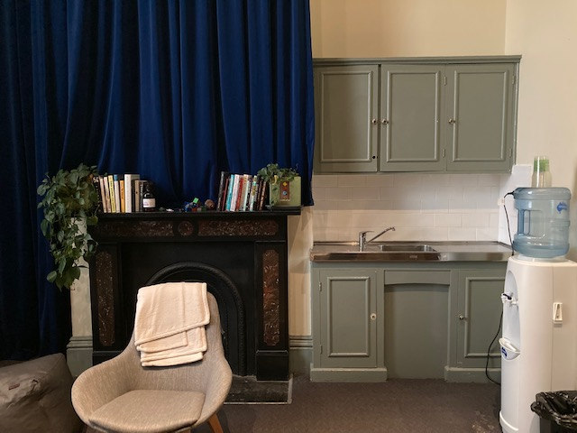

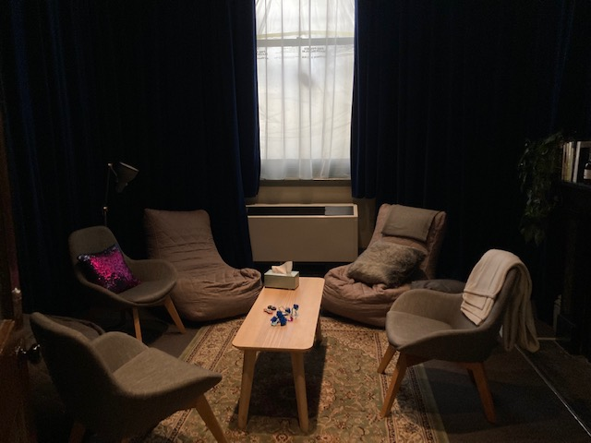 Image: Quiet Space kitchenette and shelf

Image: Quiet Space with lights dimmed

## **Bathrooms**

All bathrooms have Dyson hand dryers with sensor activation. There is an accessible bathroom that is single use on ground level opposite the Quiet Space. There is another accessible bathroom upstairs – this is accessible via lift or stairs.

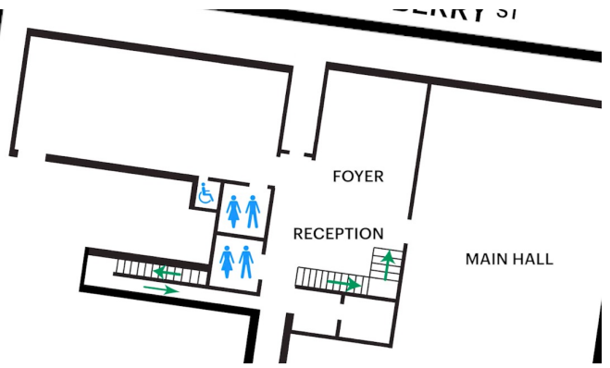

Image: Map of ground floor bathroom locations.

## **Door to Main Hall**

The Performance is in the Main Hall. It is on the ground floor. It is to the left of the box office desk and right of the bar.

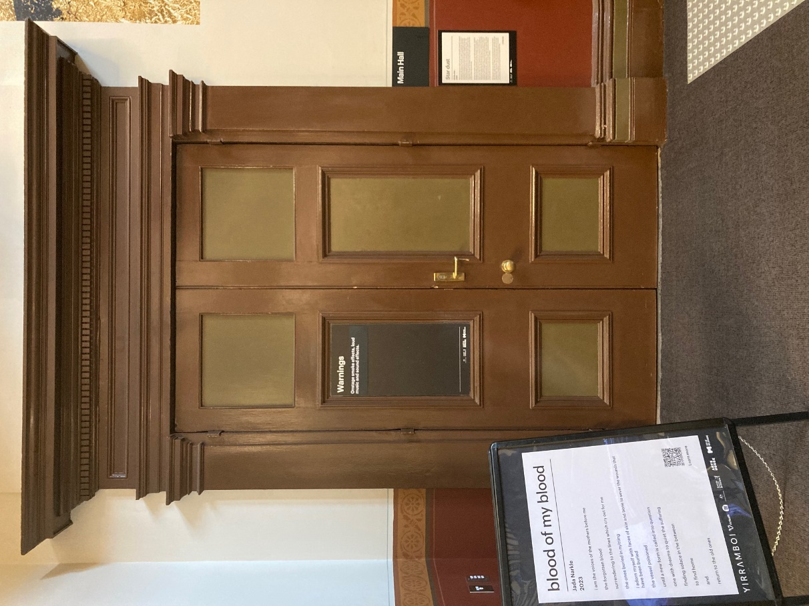

Image description: Photo of the Main Hall doorway. An artist statement is available on signage and warnings on the door.

## **Lift**

The lift is located behind reception desk in the foyer.

The closest entry to the lift is via George Johnson Lane.

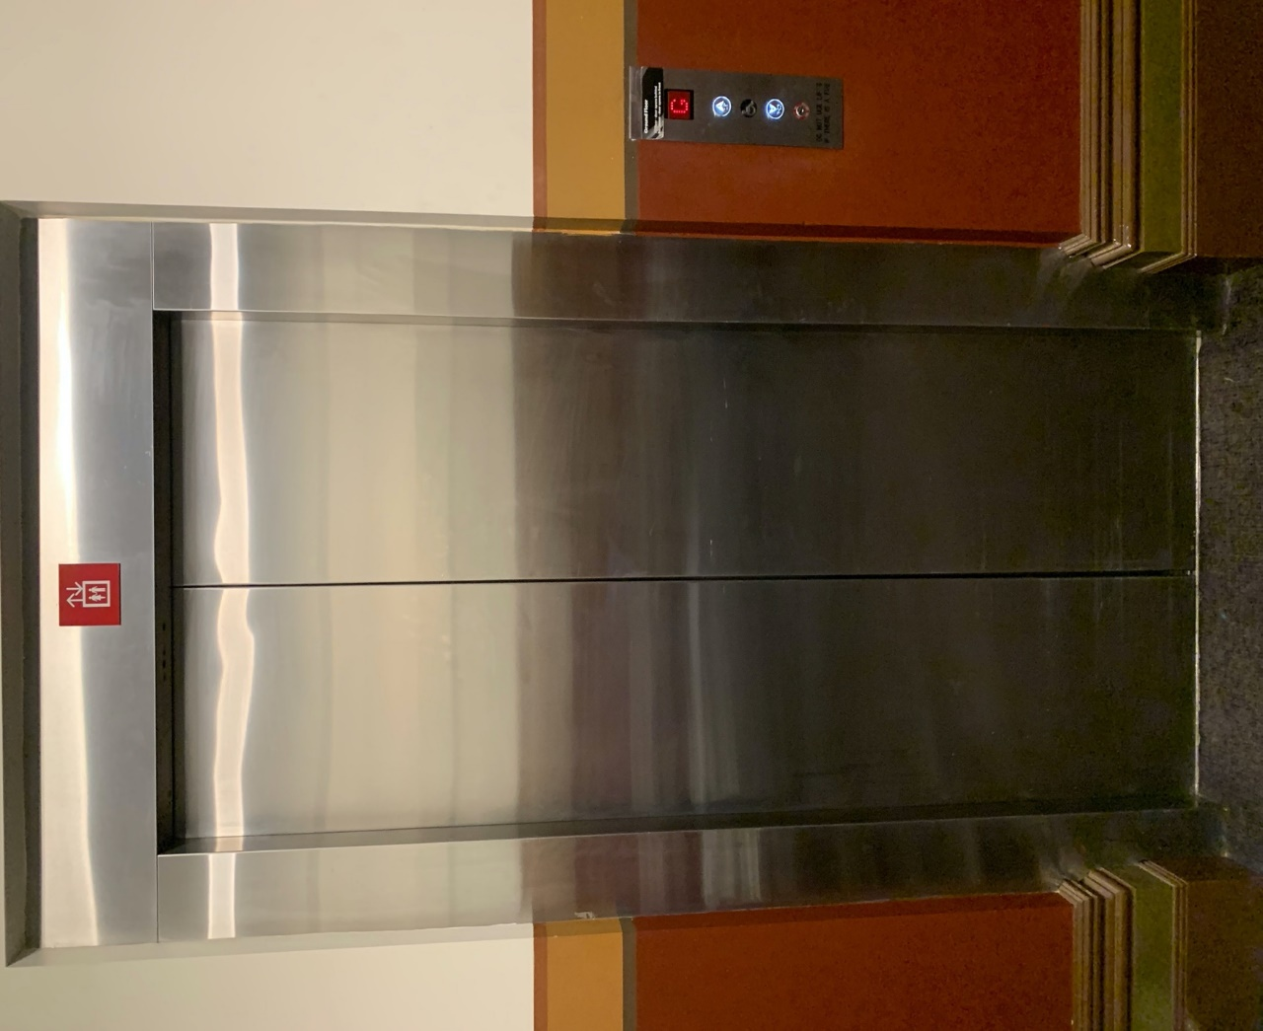

Image description: Doors of the elevator.

# **Transport**

## **Tram**

Route 57 (High Floor trams only)

Stop 12, North Melbourne Town Hall.

Please note, this is not a wheelchair accessible tram

[GETTING TO ARTS HOUSE VIDEO LINK](https://vimeo.com/544169506)

## **Train**

Arts House is 1.1km from   
North Melbourne Train Station,   
approximately 16 minute walk

[North Melbourne Station Information](https://www.ptv.vic.gov.au/stop/1144/north-melbourne-station/0/train/)

1.2km from Flagstaff Station,   
approximately 15 minute walk

[Flagstaff Station Information](https://www.ptv.vic.gov.au/stop/1068/flagstaff-station/0/train/#StopPage:::datetime=2023-04-06T04%3A41%3A27.669Z&directionId=-1&showAllDay=false&_auth=408ac3b1e97f4b0beb5bdf00c2f797057d10dd6e6cf2ad40a69334c4dfdf5e21)

## **Bus**

Bus number: 216

## **Parking**

There is limited paid on-street parking on Queensberry Street and Errol Street.

There are two accessible on street car parking spaces on Queensberry Street (150m to our accessible Errol Street entrance) for holders of a Parking Permit for Disabled people.

# **COVID Safety**

Please note: If you have a cough, sore throat, fever, shortness of breath or flu-like symptoms, you must not attend our venue or programs in person.

We will provide a refund if you need to cancel your attendance due to illness. Please [contact us](mailto:ArtsHouse.Ticketing@melbourne.vic.gov.au) by 9am on the day of the event.

To minimise the risk of COVID-19 transmission, we advise all patrons, artists and staff to:

* Practise physical distancing where possible
* Practise good hygiene by washing and or sanitising your hands often
* Wear a mask as directed by Victorian Government guidelines

Throughout the venue you will find:

* hand sanitiser stations available
* masks available (ask one of our staff for assistance)​
* increased signage to direct patron movement and avoid crowd congestion

We also ensure that spaces are well ventilated.

Staying COVID-safe remains important. We must all follow these steps:

* Follow the [Victorian Government’s measures on how to stay safe.](https://www.betterhealth.vic.gov.au/coronavirus-covid-19-victoria)
* When you cannot safely socially distance it is recommended to wear a well fitted mask where required.
* Practise [COVID-safe hygiene protocols.](https://www.health.gov.au/news/health-alerts/novel-coronavirus-2019-ncov-health-alert/how-to-protect-yourself-and-others-from-coronavirus-covid-19/good-hygiene-for-coronavirus-covid-19)