**Conduit Bodies**

By Melinda Smith

Access Guide

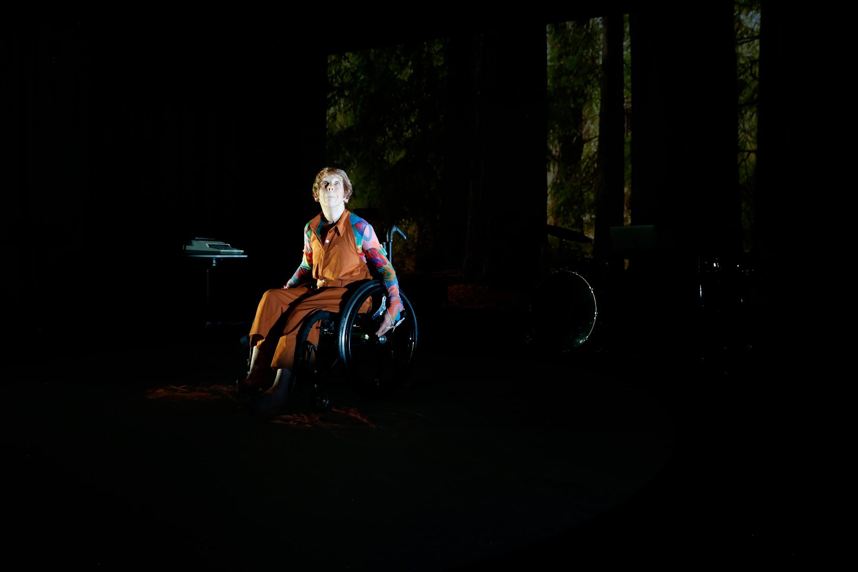

Image: Promotional image for the show  
Image description: A photo of Melinda on stage, sitting in her wheelchair. She has short, sandy blonde hair, pale skin and is looking up towards the ceiling. She is wearing an orange jumpsuit and a long-sleeved top underneath with an abstract pattern in blue, pink, purple and orange. She sits in front of a dark, projected background image of a forest with tall trees. There is a typewriter on a stand to the left and a partially visible drumkit to the right. 

# **Updates to this document**

Please note, this performance is a new work, and changes are being made by artists until opening. We will endeavour to provide the latest access information on performances to ticket holders across key stages of rehearsal and presentation. Arts House website will contain the most up to date version of this document and all ticket holders will be notified of any revisions made 3 days and 1 day prior to the event.

This document was created: 1 October 2024  
Revision 1: 7 October 2024

**Contents**

**Updates to this document** 1

**Where** 3

**When** 3

**Access Services** 4

**Digital** 6

**Performers** 7

**Sensory Elements** 2

Sound 2

Lighting 2

Physical 2

Smell 3

Visual 3

Shocks or surprises 4

Audience experience 4

Social expectations 4

Performance expectations 5

**Other** 6

Content Warnings 6

General Notes 6

**The Venue** 7

Front Entrance 7

Accessible Entrances 8

Box Office 9

Ushers 9

Bar 10

Quiet Space 11

Bathrooms 11

Door to Main Hall 12

Lift 13

**Transport** 14

Tram 14

Train 14

Bus 14

Parking 14

**COVID Safety** 15

# **Where**

Arts House

521 Queensberry Street

North Melbourne VIC

# **When**

Wednesday 9 – Sunday 13 October 2024   
  
Times:

Wednesday – 7:30pm  
Thursday – 7:30pm  
Friday – 7:30pm  
Saturday – 7:30pm

Sunday – 2.00pm

Duration: 55 minutes

# **Access Services**

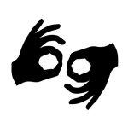Auslan Interpreted Performance - Thursday 10 October, 7:30pm

Haptic vests available for this performance

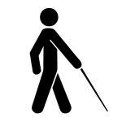

Tactile Tour   
Friday 11 October, 6:30pm. Commences 1 hour prior to 7:30pm performance  
Available upon request for all performances with 48 hours’ notice

  
Audio Described Performances

Friday 11 October, 7:30pm  
Available upon request for all performances with 48 hours’ notice



Assistance Animals are welcome.



Assistive Listening is available free of charge. Ask staff for assistance on arrival.

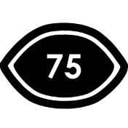

Visual Rating 75%– has minimal dialogue and some background music or sounds, or may be fully subtitled, so Deaf and hard of hearing audiences can have close to the full experience of the event.

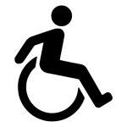

This performance is fully wheelchair accessible. More information is provided further below in this guide about the accessible entrances at Arts House and bathrooms.  
  
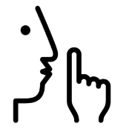

Quite Space Available - The quiet space will be available for you to use before/during/ and after the show. More information about the quiet space can be found below.

  
Companion Card - Arts House supports the Companion Card program.

**Captioning is not available for this show, however visible text of all spoken words is creatively embedded as part of visual media.**

# **Digital**

Available via Digital Fringe 14th - 20th October. Captioned and audio described versions both available.



Audio Described

Auslan Interpreted



Open Captions

# **Performers**

**Melinda Smith**

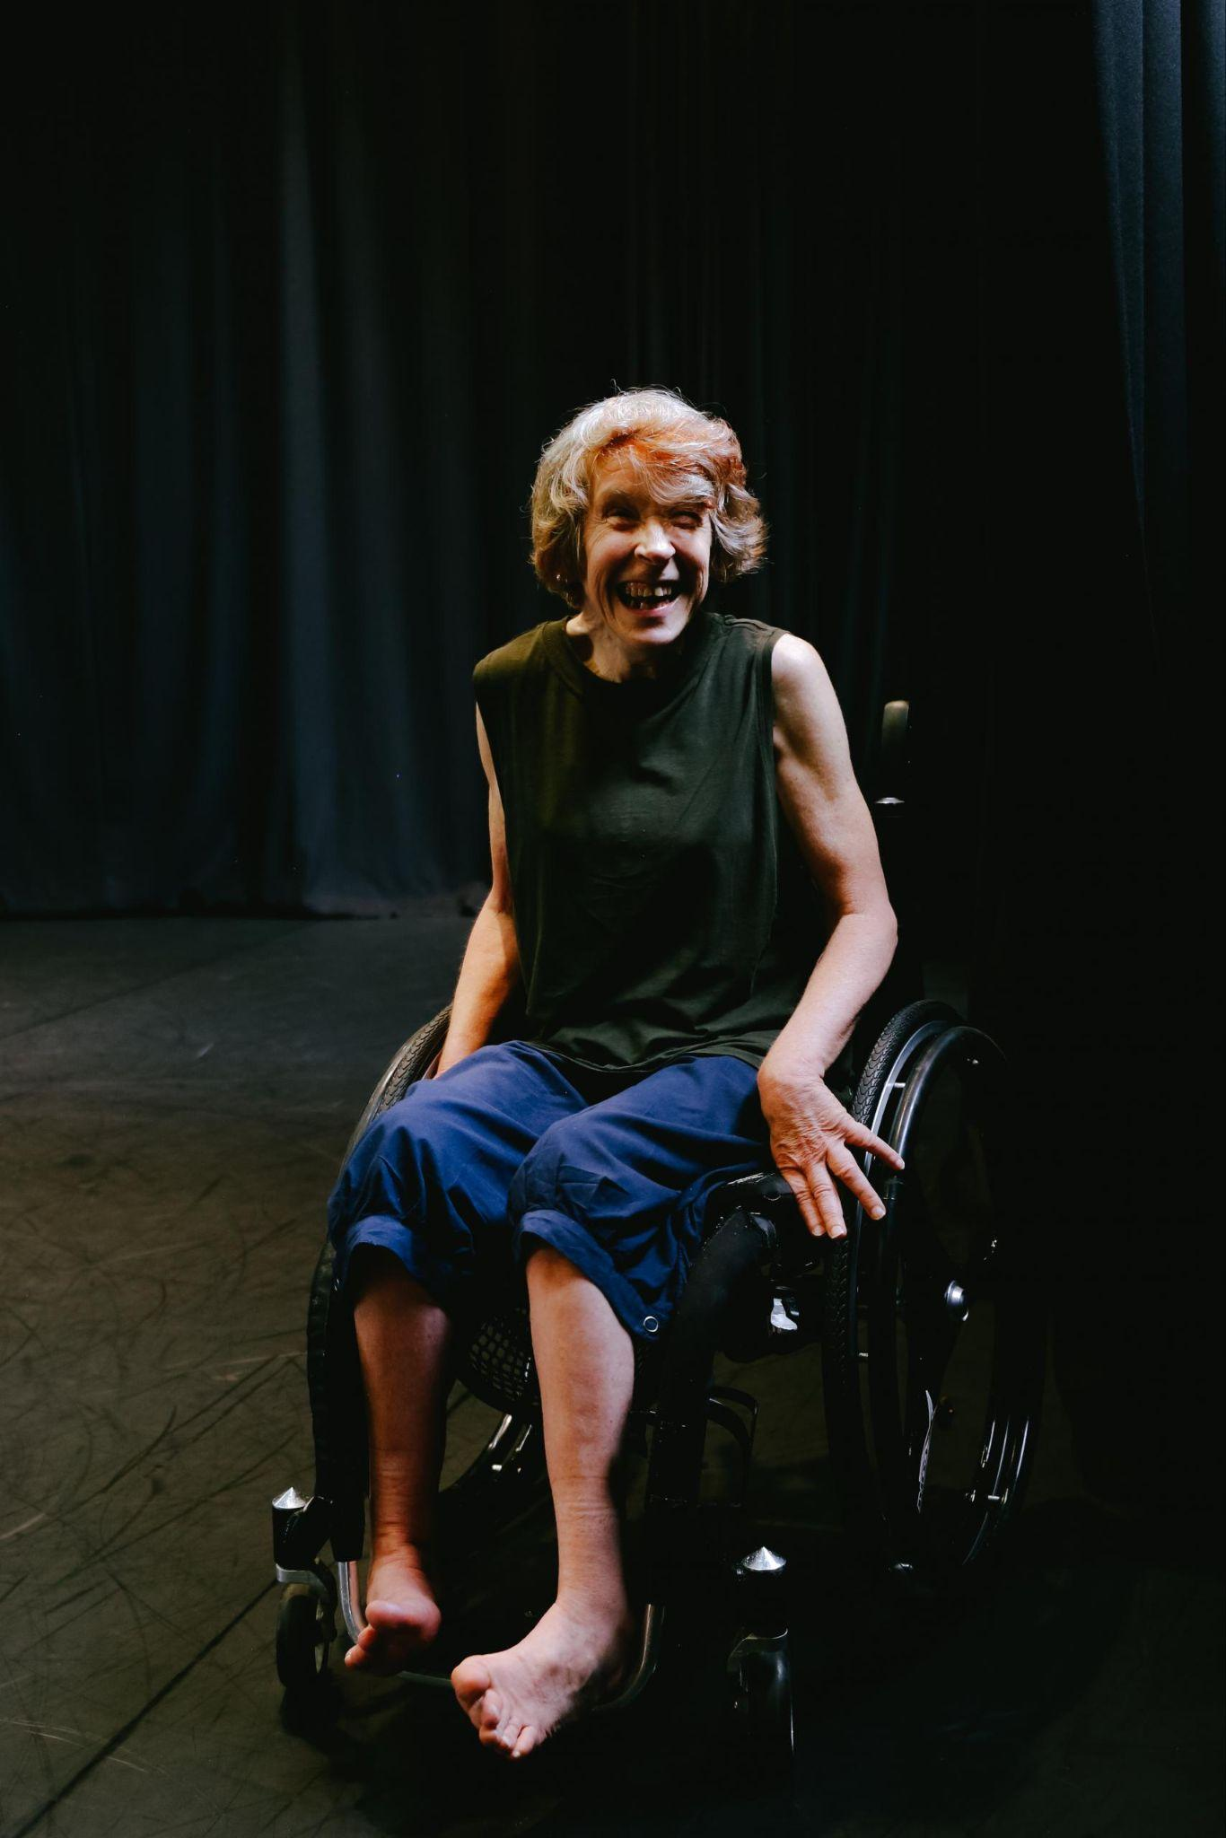

Image Description: A photo of Melinda sitting in a black manual wheelchair, in a theatre studio with black floor and walls. She has short blonde hair, pale skin and is in her 60s. She is wearing a sleeveless black tank top, dark blue pants which finish just below her knee and has bare feet. She is smiling broadly.

Photo by Nicole Tsourlenes

**Alon Ilsar**

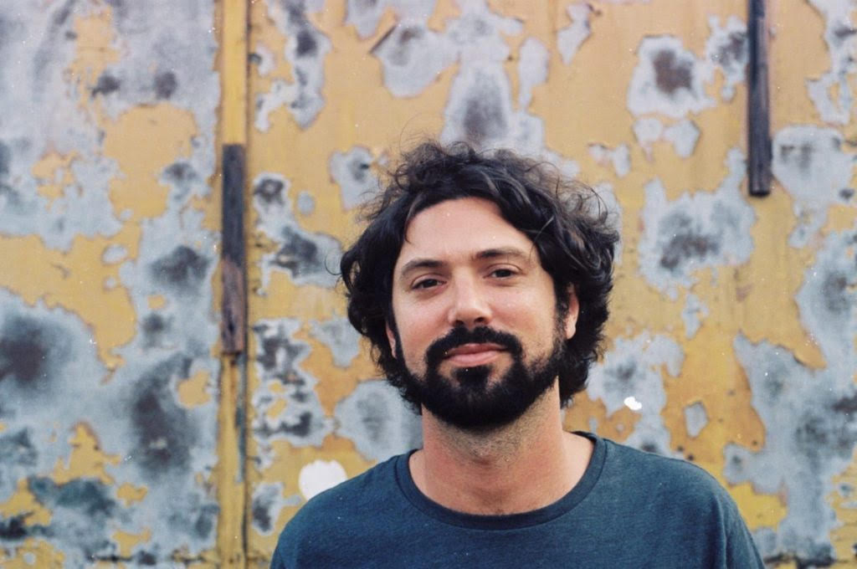

Image Description: A head and shoulders photo of Alon Ilsar, looking directly into the camera with a slight smile. He has curly dark hair and a beard, olive skin and brown eyes. He is wearing a dark blue t-shirt and standing in front of a weathered yellow and grey wall.

# **Sensory Elements**

## **Sound**

Sound is very prevalent in this show, varies in levels and is quite loud at times. The soundscape is amplified from multiple directions in the space and includes low rumbles which can be felt as vibrations, sustained droning sounds which vary in pitch, typewriter noises, bird song, high pitched dings, harsh scratching and whistling sounds, electronic beats and live drumming and cymbals. Pre-recorded voice and computer generated speech is used in broken words which sometimes overlap and create staccato rhythms.

Please feel free to wear your own headphones in the space. Ear plugs will also be available at the front desk in the foyer.

## **Lighting**

This show heavily uses moving digital projections on both the floor and rear wall. The projections are visually dominant in the space throughout most of the show, whilst the stage lighting is relatively soft. There is a section in the show where the entire back wall is lit with bright colours which change. These colour changes happen less than 3 times per second. There is no use of strobe or lights which flash on and off.

Please feel free to wear sunglasses in the space and get in touch with Zoe Boesen at Loom if you would like prior warning before certain effects.

## **Physical**

Physical vibrations from the sound may be felt at times.

A water based haze is used at one point during the show.

The floor leading into the theatre changes from low pile carpet to floorboards and back to carpet at the front of the seating bank. The seating bank is raked with steps and grab rails on either side. The front row seats can be easily removed to make space for wheelchairs.

Please contact Arts House Box Office if you would like to reserve a particular location in the audience to make the show more accessible for you.

11am – 4pm, Monday to Friday

03 9322 3720

[artshouse@melbourne.vic.gov.au](mailto:artshouse@melbourne.vic.gov.au)

## **Smell**

There is no smell used in the show.

## **Visual**

This show heavily uses moving digital projections on both the floor and rear wall. The projections are visually dominant in the space throughout most of the show and frequently change in colour and shape. Any dominant colour changes occur less than 3 times per second.

Please feel free to wear sunglasses in the space and get in touch with Zoe Boesen if you would like prior warning before certain effects.

If you would like more detailed information about the sensory elements of the work please contact:

Zoe Boesen, Producer

email: [zoe@loom.org.au](mailto:zoe@loom.org.au) or phone: 0402 331 448

**Audience Experience**

Entry to the performance space is via the Arts House foyer on the ground floor. The floor leading into the theatre changes from low pile carpet to floorboards and back to carpet at the front of the seating bank.

## **Shocks or surprises**

Although often the sound is quite loud and dynamic, the volume builds over time as opposed to sudden loud noises without warning.

There is one sudden physical change in the space which may come as a surprise. Please get in touch with Zoe Boesen if you would like more information or warning prior to this moment.

There is also a moment where Melinda may look like she is falling out of her wheelchair. Please note this is a rehearsed part of the show.

# **Audience experience**

## **Social expectations**

Once the doors to the theatre are open by Arts House staff, the audience are welcome to enter and choose any seat. There is a raked seating bank with steps and grab rails on either side which is just inside the entrance and to the left.

Please contact Arts House Box Office if you would like to reserve a particular location in the audience to make the show more accessible for you.

11am – 4pm, Monday to Friday

03 9322 3720

[artshouse@melbourne.vic.gov.au](mailto:artshouse@melbourne.vic.gov.au)

These are not relaxed performances in the usual sense, but audience members are welcome to come and go as they please, be themselves, make noise, stim, and respond to the work in whatever way feels comfortable for them.

Please feel free to bring anything with you which will make your experience more accessible. This might include stim toys, headphones, sunglasses, cushions or anything else that makes you feel comfortable.

If you would like space to stand, stim or move around during the show, please let Arts House front of house staff know. You are welcome to access a small space beside the seating bank.

There will also be a quiet room available.

## **Performance expectations**

There will be two performers on stage during this performance. Melinda Smith who is a wheelchair user in her 60s, and Alon Ilsar who is a man in his mid 30s. He will sit behind the drum kit for most of the show. Although they don’t speak to each other, they do interact with eye contact, facial expressions and gestures.

This show is an abstract retelling of Melinda’s journey from feeling restricted and disabled by the world to finding freedom and joy through self expression. There isn’t a traditional storyline or narrative to follow.

If you would like more detailed information about audience experience and expectations of the work please contact:

Zoe Boesen, Producer

email: [zoe@loom.org.au](mailto:zoe@loom.org.au) or phone: 0402331448

# **Other**

## **Content Warnings**

This performance contains heightened audio-visual content. There is unpredictable sound and visual projection throughout which may quickly change in volume, tone, brightness, and colour.   
  
Sound sensitive audience members are encouraged to bring headphones. Earplugs available at the venue.

There are no dominant light flashes or colour changes which occur more frequently than 3 per second.

## **General Notes**

This performance will commenced with Acknowledgment of Country played in the space.

# **The Venue**

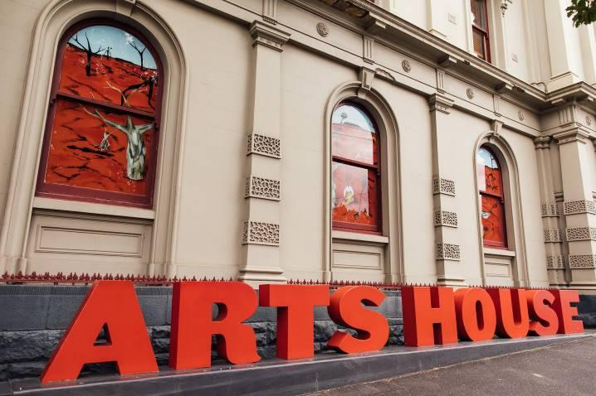

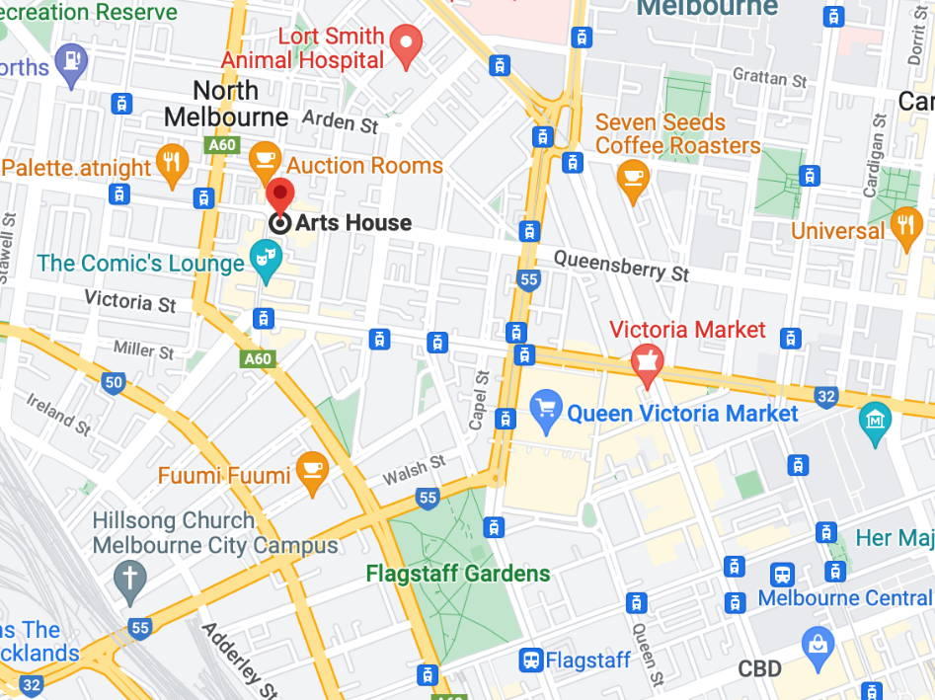

Image: North Melbourne Town Hall features giant red letters that say ARTS HOUSE out the front of it.

Image: a map of Arts House and its surrounding area. [LINK TO MAP](https://www.google.com/maps/place/Arts+House/@-37.802973,144.9486818,17z/data=!4m5!3m4!1s0x0:0x64c465ac7ef21cff!8m2!3d-37.803239!4d144.9498609?shorturl=1)

## **Front Entrance**

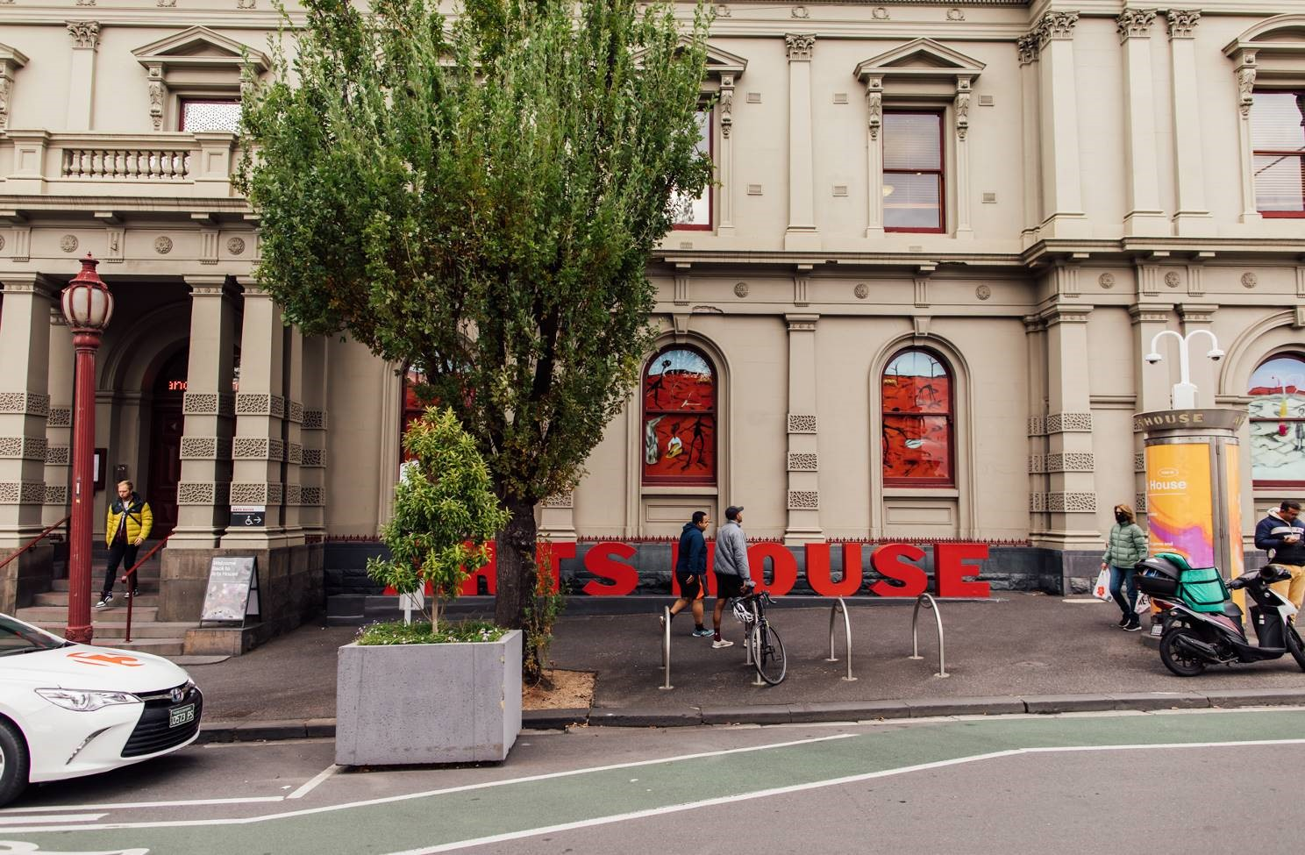

## **Accessible Entrances**



There are two Accessible Entrances. The first is on Errol St next to the Post Office.

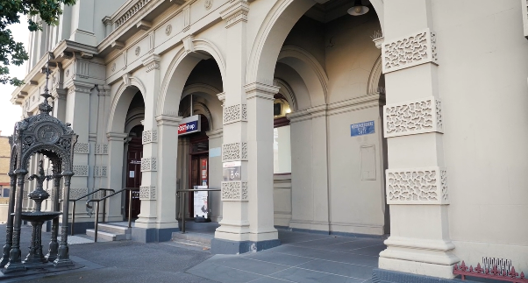

Image: Errol Street entrance next to the Post office with wheelchair accessible ramp or two steps with grab rails.

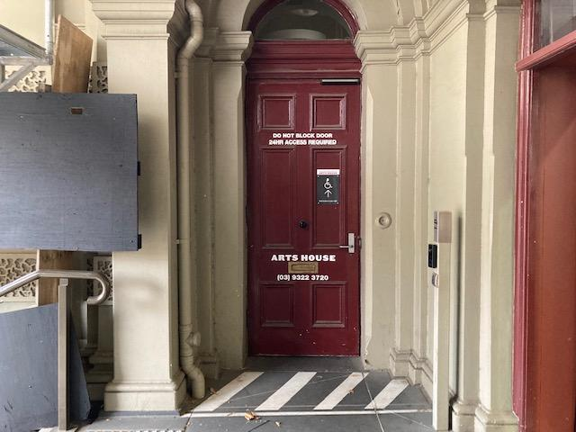

Image: View of door entrance.

The second Accessible Entrance is towards the end of George Johnson Lane.

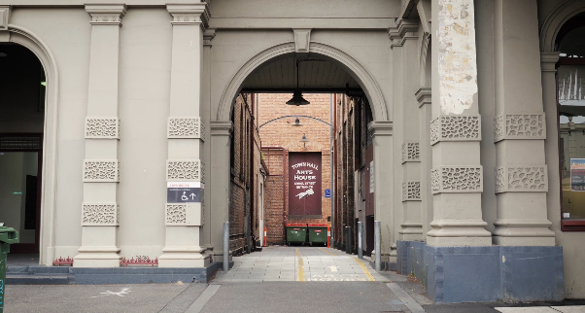

Image: View of George Johnson Lane from Errol St. The laneway passes through an archway with a brick wall at the end.

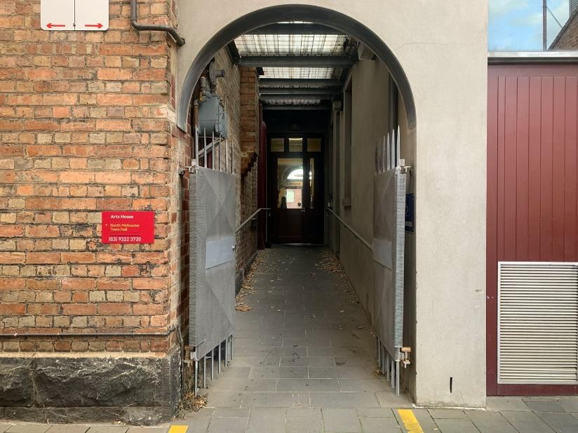

Image: view of the ramp leading from George Johnson Lane to the automated door which opens into the Arts House foyer.

## **Box Office**

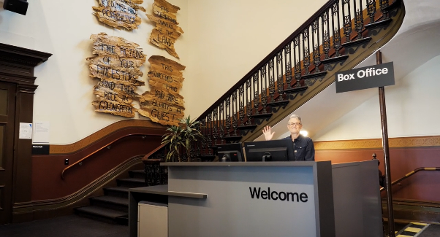

Image: reception desk, showing one of our receptionist's waving and smiling. To the left of the reception desk is the main staircase, showcasing some artwork on the walls.

Box Office is located in the foyer under the stairwell.

## **Ushers**

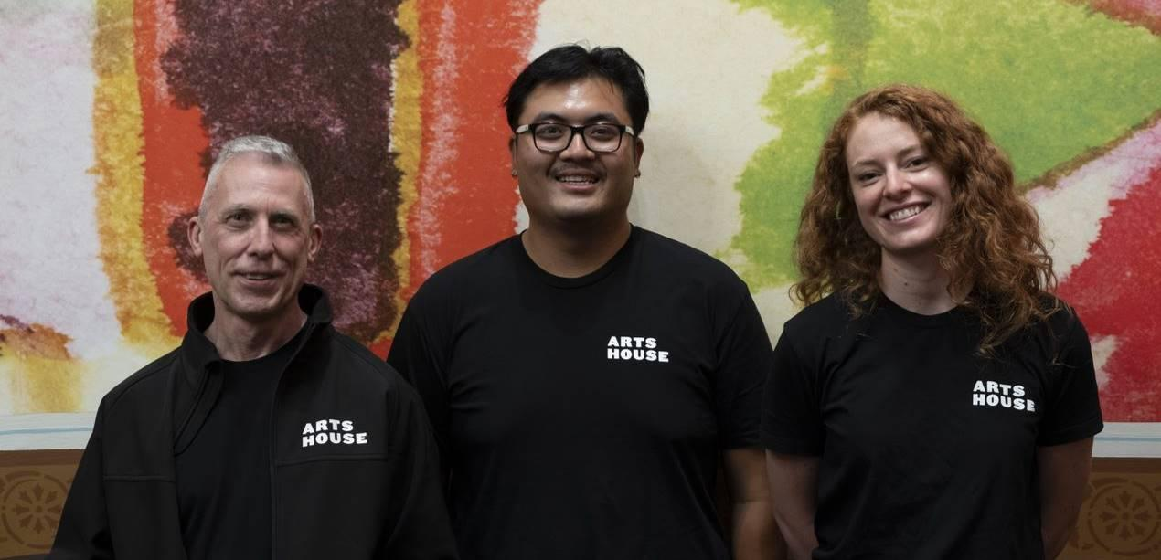

Ushers will be wearing black with an Arts House Logo on the left-hand shoulder.

## **Bar**

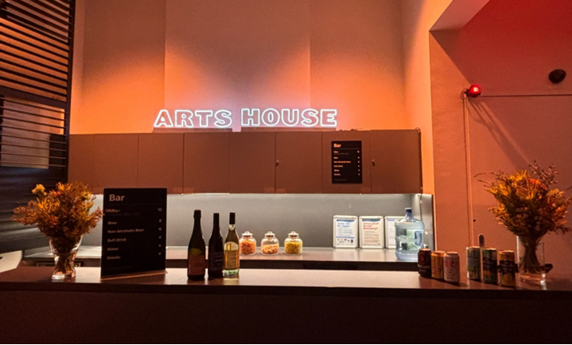

Description: A bar with vases on each side of the bench filled with native flowers. In the centre there is a bar menu displayed with drinks set up on the top level on the bar. Towards the back wall there is an Arts House sign that is lit up. The lighting of the space is lit up orange. 

Bar staff will be wearing black with an Arts House Logo.

We have a range of alcoholic and non-alcoholic beverages for sale.

We are a cashless venue and accept EFTPOS, Visa and Mastercard payments.

## **Quiet Space**

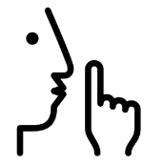

Arts House Quiet Space is located on Ground Level and is nearby reception and opposite the accessible bathrooms. It includes a range of seating options including soft furnishings, dimmable lights, sensory and stim objects. It is open during venue opening hours and events as a quiet space, prayer or parenting space.

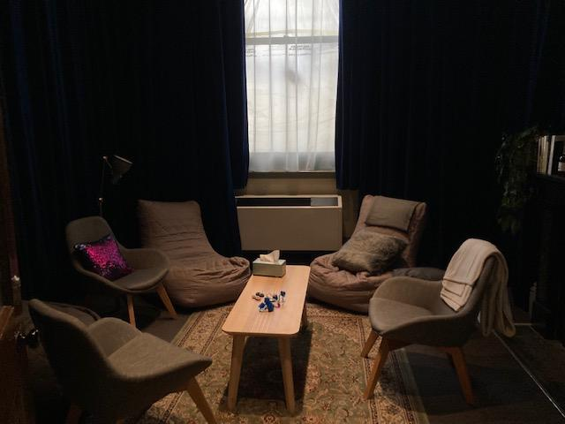

Image: Quiet space with lights dimmed

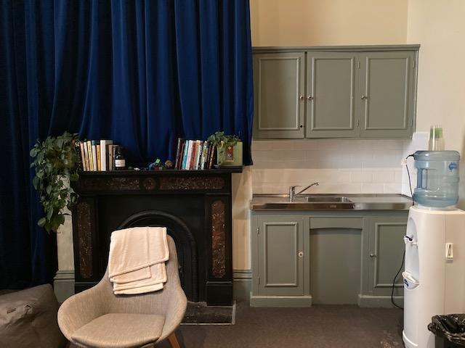

Image: Quiet space kitchenette and book shelf

## **Bathrooms**

All bathrooms have Dyson hand dryers with sensor activation. There is an accessible bathroom that is single use on ground level opposite the Quiet Space. There is another accessible bathroom upstairs – this is accessible via lift or stairs.

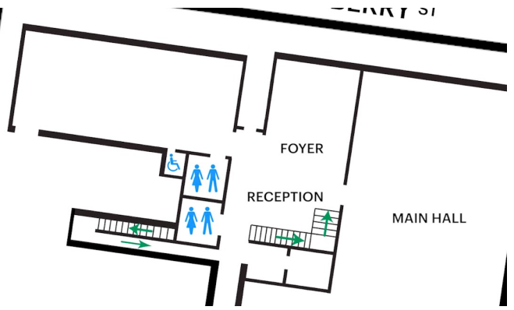

## **Door to Main Hall**

The Performance is in the Main Hall.

It is on the ground floor.

It is to the left of the box office desk and right of the bar.

An artist statement is available on a QR code and warnings on the door.

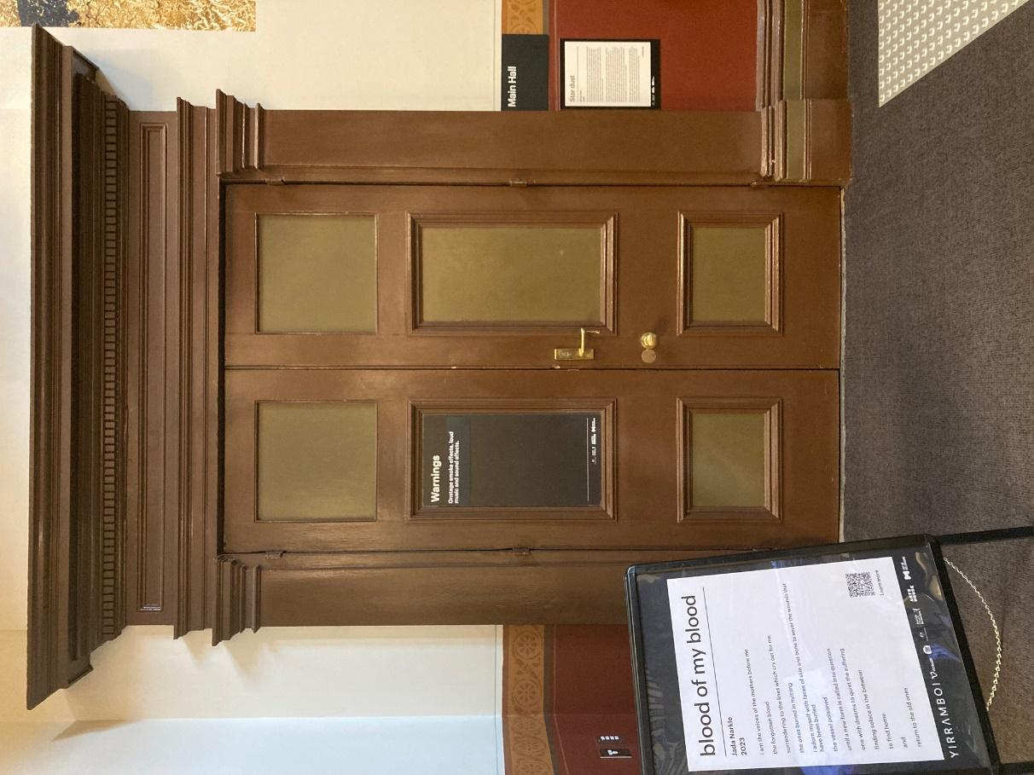

## **Lift**

The lift is located behind reception desk in the foyer.

The closest entry to the lift is via George Johnson Lane.

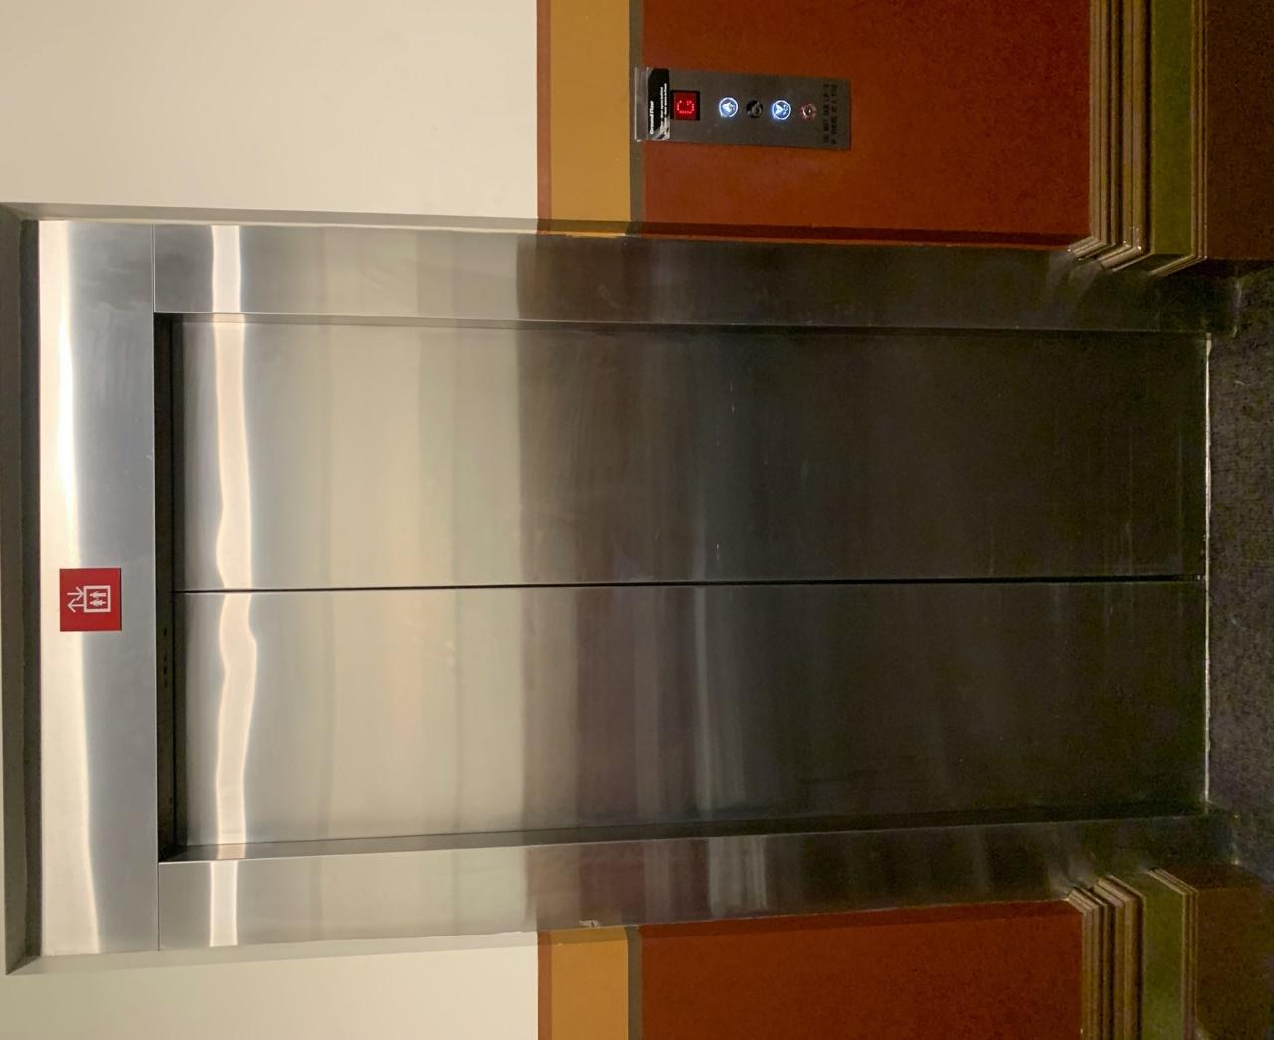Image: external view of the lift from the ground floor foyer. The lift has silver metal automated doors and a button mount to the right of the doorframe.

# **Transport**

## **Tram**

Route 57 (High Floor trams only)

Stop 12, North Melbourne Town Hall.

Please note, this is not a wheelchair accessible tram

[GETTING TO ARTS HOUSE VIDEO LINK](https://vimeo.com/544169506)

## **Train**

Arts House is 1.1km from   
North Melbourne Train Station,   
approximately 16 minute walk

[North Melbourne Station Information](https://www.ptv.vic.gov.au/stop/1144/north-melbourne-station/0/train/)

1.2km from Flagstaff Station,   
approximately 15 minute walk

[Flagstaff Station Information](https://www.ptv.vic.gov.au/stop/1068/flagstaff-station/0/train/#StopPage:::datetime=2023-04-06T04%3A41%3A27.669Z&directionId=-1&showAllDay=false&_auth=408ac3b1e97f4b0beb5bdf00c2f797057d10dd6e6cf2ad40a69334c4dfdf5e21)

## **Bus**

Bus number: 216

## **Parking**

There is limited paid on-street parking on Queensberry Street and Errol Street.

There are two accessible on street car parking spaces on Queensberry Street (150m to our accessible Errol Street entrance) for holders of a Parking Permit for Disabled people.

# **COVID Safety**

Please note: If you have a cough, sore throat, fever, shortness of breath or flu-like symptoms, you must not attend our venue or programs in person.

We will provide a refund if you need to cancel your attendance due to illness. Please [contact us](mailto:ArtsHouse.Ticketing@melbourne.vic.gov.au) by 9am on the day of the event.

To minimise the risk of COVID-19 transmission, we advise all patrons, artists and staff to:

* Practise physical distancing where possible
* Practise good hygiene by washing and or sanitising your hands often
* Wear a mask as directed by Victorian Government guidelines

Throughout the venue you will find:

* hand sanitiser stations available
* masks available (ask one of our staff for assistance)​
* increased signage to direct patron movement and avoid crowd congestion

We also ensure that spaces are well ventilated.

Staying COVID-safe remains important. We must all follow these steps:

* Follow the [Victorian Government’s measures on how to stay safe.](https://www.betterhealth.vic.gov.au/coronavirus-covid-19-victoria)
* When you cannot safely socially distance it is recommended to wear a well fitted mask where required.
* Practise [COVID-safe hygiene protocols.](https://www.health.gov.au/news/health-alerts/novel-coronavirus-2019-ncov-health-alert/how-to-protect-yourself-and-others-from-coronavirus-covid-19/good-hygiene-for-coronavirus-covid-19)