**Specials! Development Showing**

By Kath Duncan

Access Guide  
  
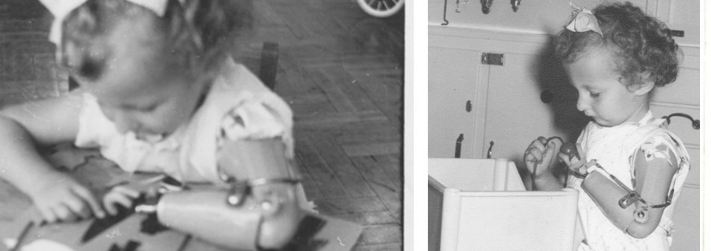

Image: courtesy of the artist

Description: A series of two square vintage photos circa 1960 of a young child with short curly hair and a prosthetic arm. The photos are black and white showing the girl holding a half-eaten apple and engaging with a toy.

# **Updates to this document**

Please note, this development showing is of a new work in progress and changes are being made by artists. We will endeavour to provide the latest access information on performances to ticket holders across key stages of rehearsal.

Arts House website will contain the most up to date version of this document and all ticket holders will be notified of any revisions made 3 days and 1 day prior to the event.

This document was created: 04 September 2024

Revision 1: 20 September 2024

**Contents**

**Updates to this document** 1

**Where** 3

**When** 3

**Access Services** 3

**Performers** 6

**Sensory Elements** 8

Sound 8

Lighting 8

Physical 8

Smell 8

Visual 8

Entry to space 9

Shocks or surprises 9

Audience experience 9

Social expectations 9

Performance expectations 9

**Other** 10

Content Warnings 10

General Notes 11

**The Venue** 12

Front Entrance 12

Accessible Entrances 13

Box Office 14

Ushers 14

Quiet Space 15

Bathrooms 15

The Warehouse 16

**Transport** 19

Tram 19

Train 19

Bus 19

Parking 19

**COVID Safety** 20

# **Where**

Arts House

521 Queensberry Street

North Melbourne VIC

# **When**

Tuesday 8 and Saturday 12 October 2024

Tues 8 October, 6.30pm

Sat 12 October, 4pm

Duration: 2 hours including artist talk and refreshments

# **Access Services**

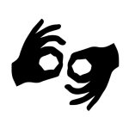Auslan Interpreted Performance  
  
Tuesday 8 October, 6:30pm

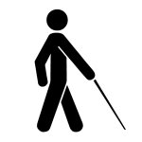

Tactile Tour   
Saturday 12 October   
Tactile tour commences at 3pm, 1 hour prior to the 4pm showing.  
  
  
Audio Described - Personal describer guides available for meet & greet on arrival and one-on-one live descriptions of the performance.  
Saturday 12 October, 4pm.



Assistance Animals are welcome.



Assistive Listening is available free of charge. Ask staff for assistance on arrival.



Visual Rating 50% – this performance has music and sounds in the background.



This performance is fully wheelchair accessible. More information is provided further below in this guide about the accessible entrances at Arts House and bathrooms.  


Quite Space Available - The quiet space will be available for you to use before and after the show. More information about the quiet space can be found later in this guide.

  
Companion Card - Arts House supports the Companion Card program.

# **Performers**

Kath Duncan – Writer/Director

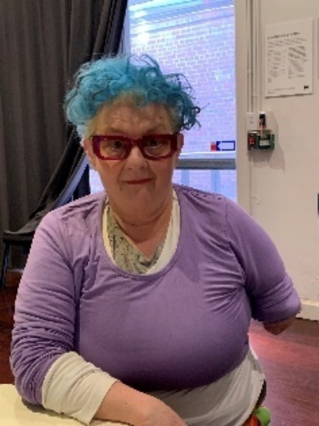

Description: A photo of Kath with short blue hair, red rimmed glasses and a lilac top.

Veronica Pardo – Producer

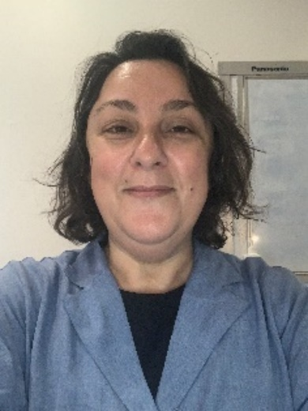

Description: A photo of Veronica with shoulder length brown hair and a light blue shirt.

Angel Leggas – Film Maker

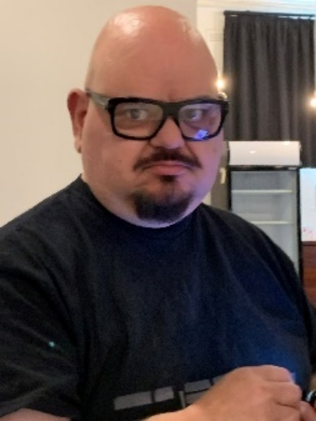

Description: A photo of Angel sporting a bald head and goatee, dark rimmed glass and black t-shirt.

Tansy Gorman – Director

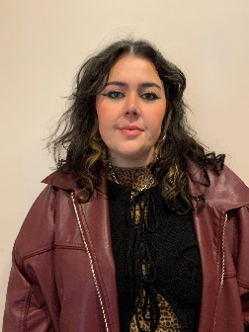

Description: A photo of Tansy with shoulder length brown wavy hair, wearing a black top and a burgundy leather jacket.

Sarah Houbolt – Performer

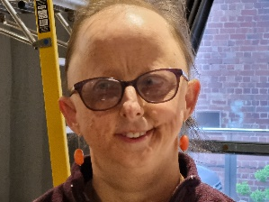

Description: Sarah is standing in front of a ladder. She has sparse hair and purple rimmed glasses.

Nicole Smith – Actor (Cheryl)

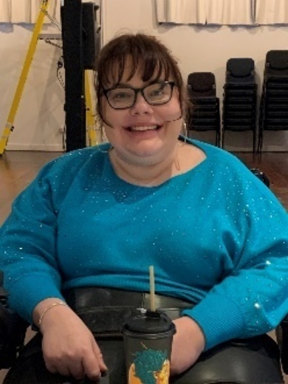

Description: A photo of Nicole smiling at the camera, brown hair in a bun, dark rimmed glassed and teal blue jumper.

Anthony Julian – Performer

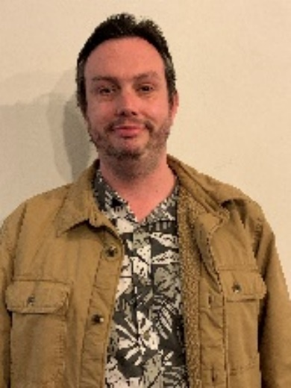

Description: Anthony is sporting light brown hair, a light colour jacket and a green flowery shirt.

Sonia Marcon – Performer

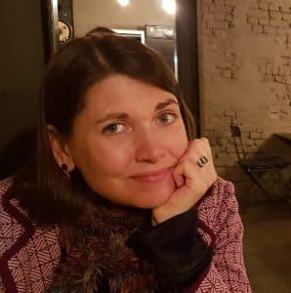

Description: Sonia is smiling at the camera, wearing shoulder length brown hair and a checkered pink jacket.

All photo credits: Veronica Pardo

# **Sensory Elements**

## Sound

The sound is loud in the work, including the performers’ voices as they will be wearing microphones. The noises are mostly rumbly-rhythmic type noises rather than high pitched. There are overlapping voices and whispering. There are repetitive base sounds in the background, including a BEAT track adding momentum towards the finale. There is a sharp whistle sound throughout the performance which can startle.

## Lighting

There are no strobe or flashing lights. Projections are used throughout, but only onto the screens on stage. Lighting does change, but not abruptly or quickly. There are no moments where the audience is completely in the dark.

## Physical

There are no vibrations. Floors are even. The heater will be set at 19 degrees leading up to the performance but will be switched off during the performances themselves. There is no air blowing on people. There is no contact with the audience in the performance. Mr Ginger and the Headmistress come into the audience space but do not touch or otherwise interact with the audience.

## Smell

There will be no food in the Warehouse space during the performances. There are no smells/scents used in the performance, though we cannot guarantee that audience members may use perfumes or other scented products.

Catering will be served after the performance. There will be smells of food. The list of food will be available closer to the event.

## Visual

The overall visual experience is gothic, surrealist horror. The work itself is loud and angry, with performers frequently in conflict. There is nothing on stage which could fall or move unexpectedly. Images of children from the 1950-60s are present, however, these are de-identified.

Audience Experience

## Entry to space

On arrival audience members will enter into the main Arts House building. Front of House Team will guide people through an outdoor alleyway over to The Warehouse for the performance. Entry is by the rear of the building via an accessible ramp. Images of the entrance are further below in this guide.

## Shocks or surprises

There are loud noises and loud vocalisations. One of the characters, Mr. Ginger repeatedly blows a whistle throughout the performance. There are no strobe or flashing lights. There are projections of ghosts and other images.

There are moments that are shocking as the treatment of disabled children is interrogated in this work. In particular, there is a scene where a character is restrained on a toilet. The language in general used to refer to the children can be shocking as reflecting institutional practice of the time.

## Audience experience

The audience is close to the performers due to the size of the space, however, the performers will not come in contact with audience members. There is no physical engagement with the audience (no touching or conversation with the audience).

## Social expectations

The audience will sit in three rows of seats. The seats are flexible and are able to be moved to a limited extent. The audience will not be moving around. There is no audience participation required. There is a preference for no food in the space, unless it is an access requirement. Stim toys are welcome.

## Performance expectations

There is dialogue throughout the performance. The performance features dialogue, monologue, poetry and song. Text will also be projected onto the stage at various points.

There are five performers, all of whom perform on stage, sometimes in front and sometimes behind a black scrim curtain. Their pictures are included above. They are distinguishable from staff by their costumes. Staff will be wearing black.

Relaxed space 

These are not relaxed performances in the usual sense, but audience members are welcome to come and go as they please, be themselves, make noise, stim, and respond to the work for the duration.

# **Other**

## Content Warnings

The overall imagery reflects an exaggerated surrealist nightmare scenescape.

Images and audio of ghosts appear in the work.

Images of special education settings appear throughout the work that reflect the conditions in which children were educated. This includes images of aids and equipment that are no longer deemed acceptable.

Images of institutions appear in the work.

The language used to describe disabilities reflects the historical period of the work, which is the 1950-60, such as:

* Retard
* Spastic
* Cripple
* Deformed
* the handicapped
* the normal
* the congenital cripple
* Hopelessly incurable
* Psycho
* Slavery
* Freak
* Stupid
* Physically handicapped
* Remove or eradicate the handicapped
* Imbeciles
* Torture
* Hellhole
* Deficient
* Jabbering
* Ugly
* Witless
* Rejects
* Misshapen
* Damaged
* Mercy killing
* Disability is shameful and hideous

There is use of physical restraint in the work reflecting a common practice of the period.

## **General Notes**

There will be an acknowledgement to country by Veronica Prado at the beginning of the showing.

Auslan interpreters will be present on stage for Tuesday 8 October.

At the end of the showing there will be an artist discussion led by Kath Duncan involving the performers. The audience is invited to ask questions.

# **The Venue**

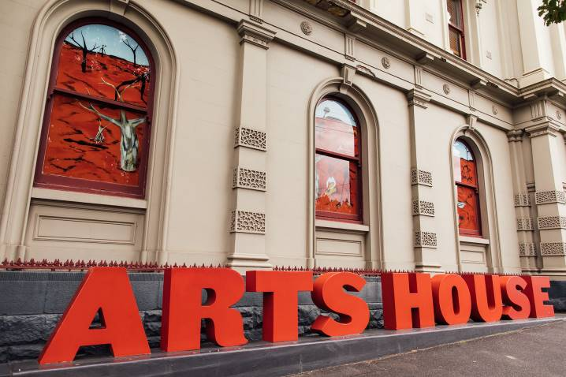

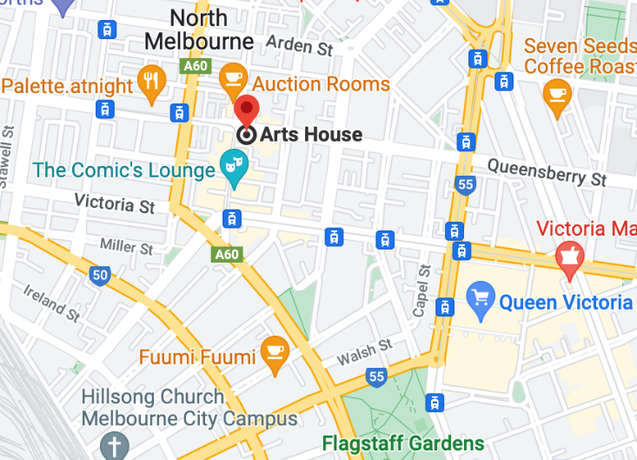

Description: North Melbourne Town Hall features giant red letters that say ARTS HOUSE out the front of it.

Description: a map of Arts House and its surrounding area. [LINK TO MAP](https://www.google.com/maps/place/Arts+House/@-37.802973,144.9486818,17z/data=!4m5!3m4!1s0x0:0x64c465ac7ef21cff!8m2!3d-37.803239!4d144.9498609?shorturl=1)

## **Front Entrance**

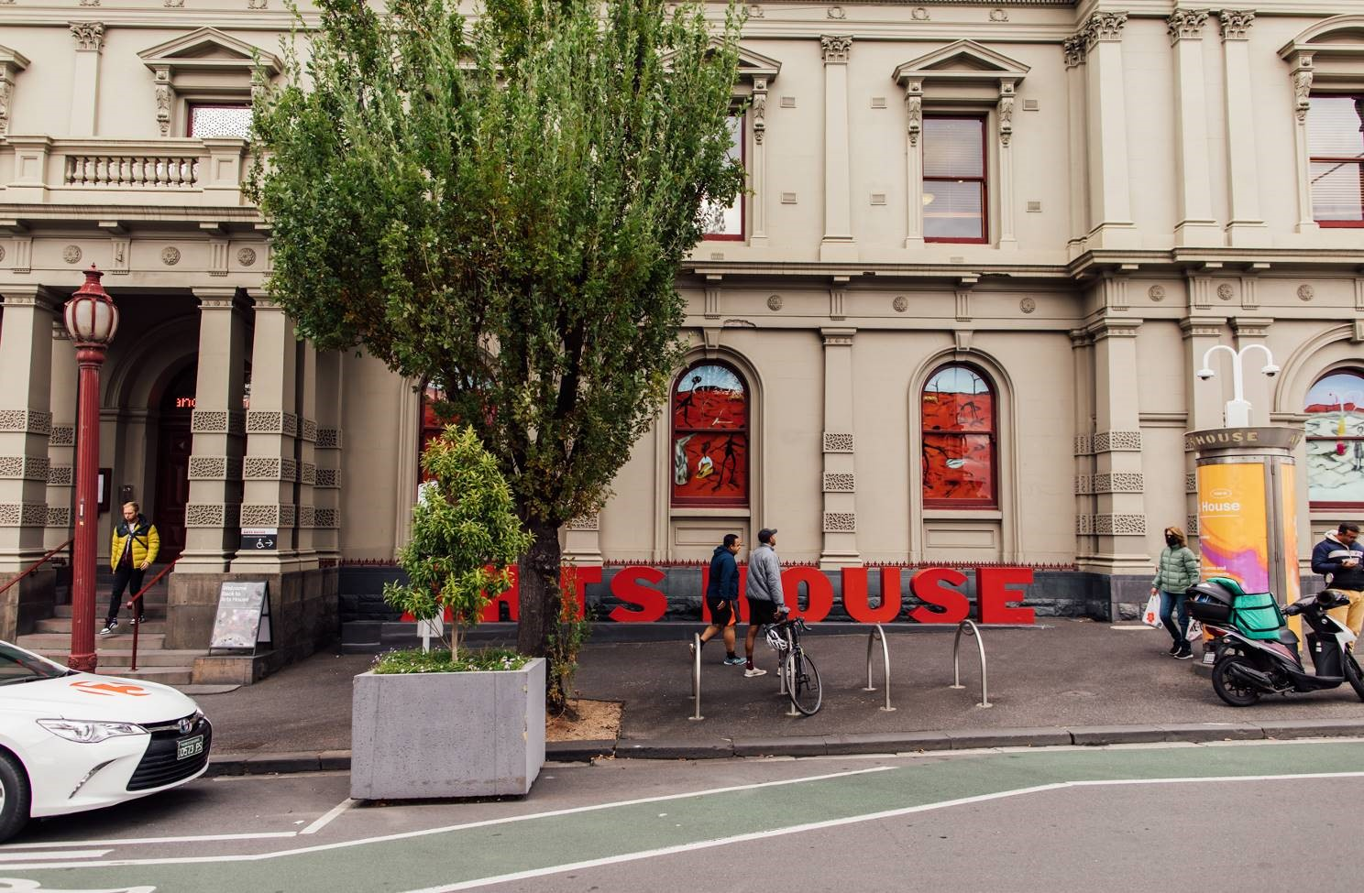

## **Accessible Entrances**



There are two Accessible Entrances. The first is on Errol St next to the Post Office.

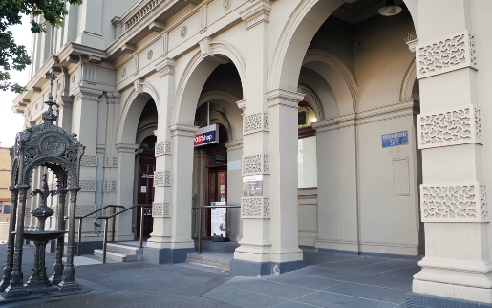

Description: Errol Street entrance next to the Post office with wheelchair accessible ramp or two steps with grab rails.

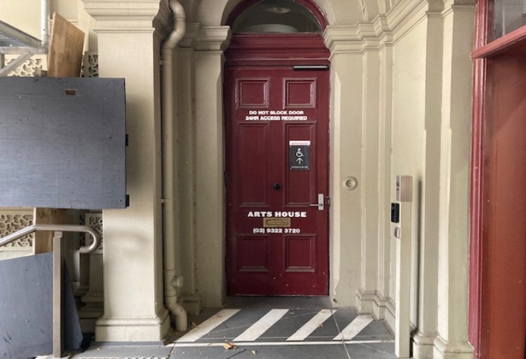

Description: View of door entrance next to Post Office.

The second Accessible Entrance is towards the end of George Johnson Lane.

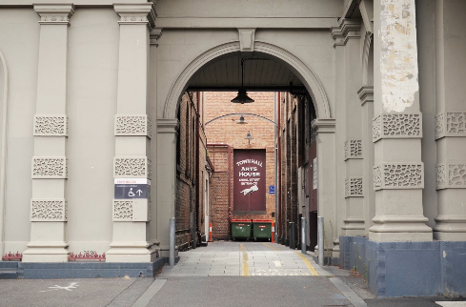

Description: View of George Johnson Lane from Errol St. The laneway passes through an archway with a brick wall at the end.

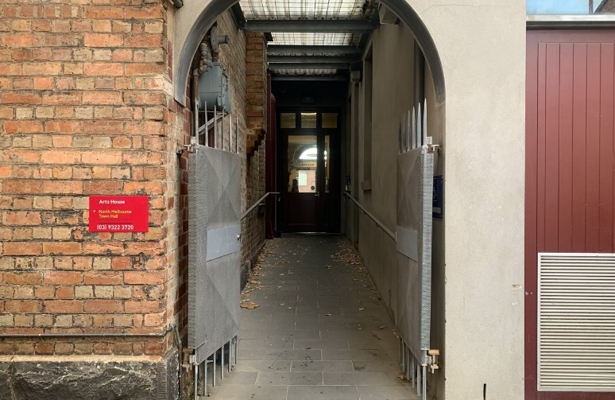

Description: view of the ramp leading from George Johnson Lane to the automated door which opens into the Arts House foyer.

## **Box Office**

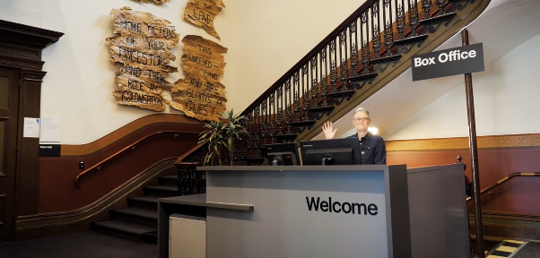

Box Office is located in the foyer under the stairwell.

## **Ushers**

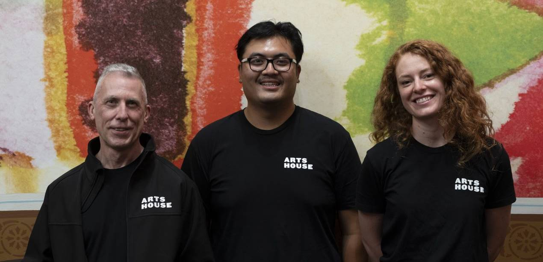

Ushers will be wearing black with an Arts House Logo on the left hand shoulder.

## **Quiet Space**

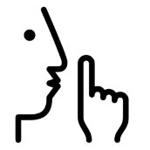

Arts House Quiet Space is located on Ground Level and is nearby reception and opposite the accessible bathrooms. It includes a range of seating options including soft furnishings, dimmable lights, sensory and stim objects. It is open during venue opening hours and events as a quiet space, prayer or parenting space.

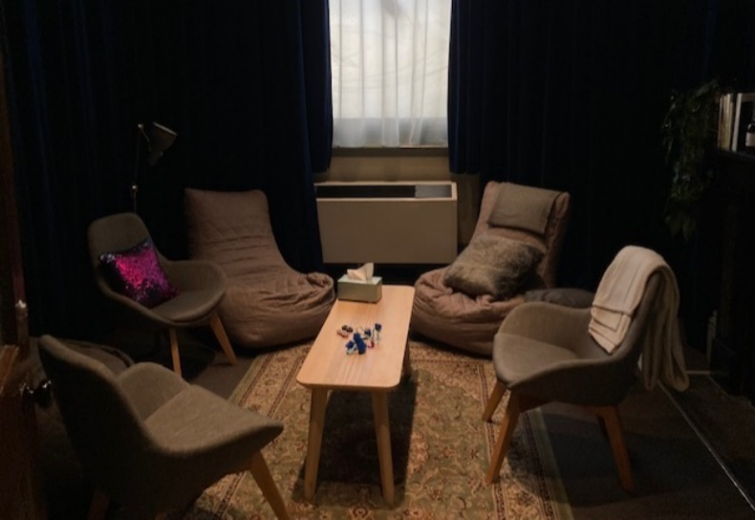

Description: Quiet space with lights dimmed

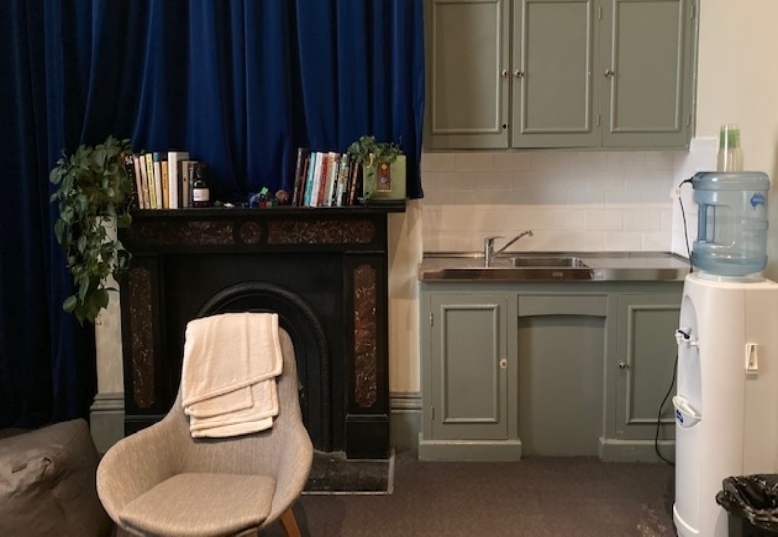

Description: Quiet space kitchenette, book shelf, chair and water coolre

## **Bathrooms**

All bathrooms have Dyson hand dryers with sensor activation. There is an accessible bathroom that is single use on ground level opposite the Quiet Space. There is another accessible bathroom upstairs – this is accessible via lift or stairs.

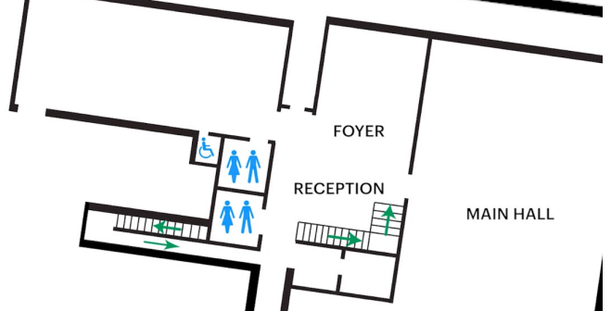

## **The Warehouse**

The Warehouse is separate to the main building of Arts House. You can find the Warehouse by following George Johnson Lane as it snakes around the back of the main Arts House building.

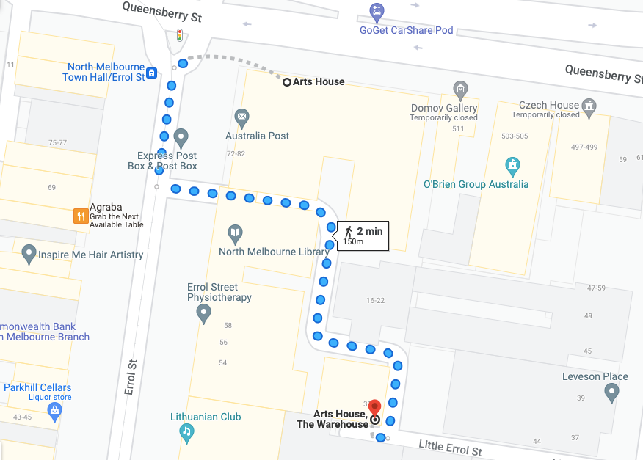

Image: a screenshot of a map with walking directions from the front of the main building of Arts House to the Warehouse behind it. The map indicates a 2 minute walk.The path to the Warehouse from George Johnson Lane is a smooth asphalt surface with a cobblestone strip in the centre for part of the journey.

**Warehouse Entrance**The main Warehouse entrance has a wheelchair accessible ramp that is 1150mm wide. The bottom section of the ramp has a gradient of 1:6 and has no handrails. The upper section has a gradient of 1:12 and has handrails on both sides. This main entry to the Warehouse is through an automated, glass sliding door.

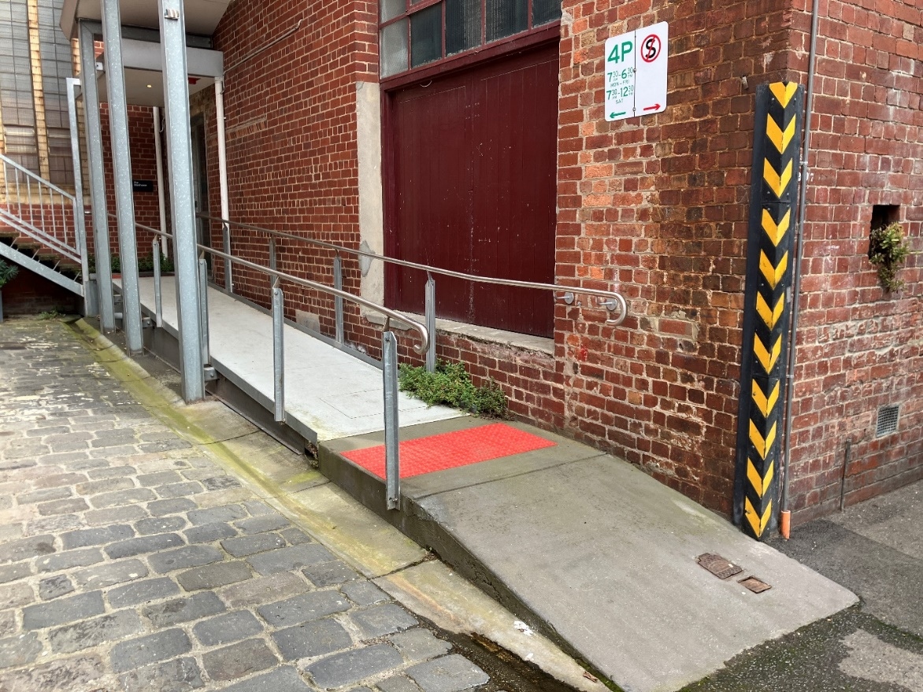

Image: view of the ramp leading to the main entrance of the Warehouse. The bottom section has no handrails. There are handrails either side of the ramp at the top section and a large red tactile surface indicator on the flat middle section. The door to Warehouse is on the right at the top of this ramp.

**Warehouse Bathrooms**

The Warehouse space has three separate bathrooms located on the opposite, far right corner from the main entrance. These are all self-contained and fully enclosed spaces, accessible from a corridor which leads off the main Warehouse space.

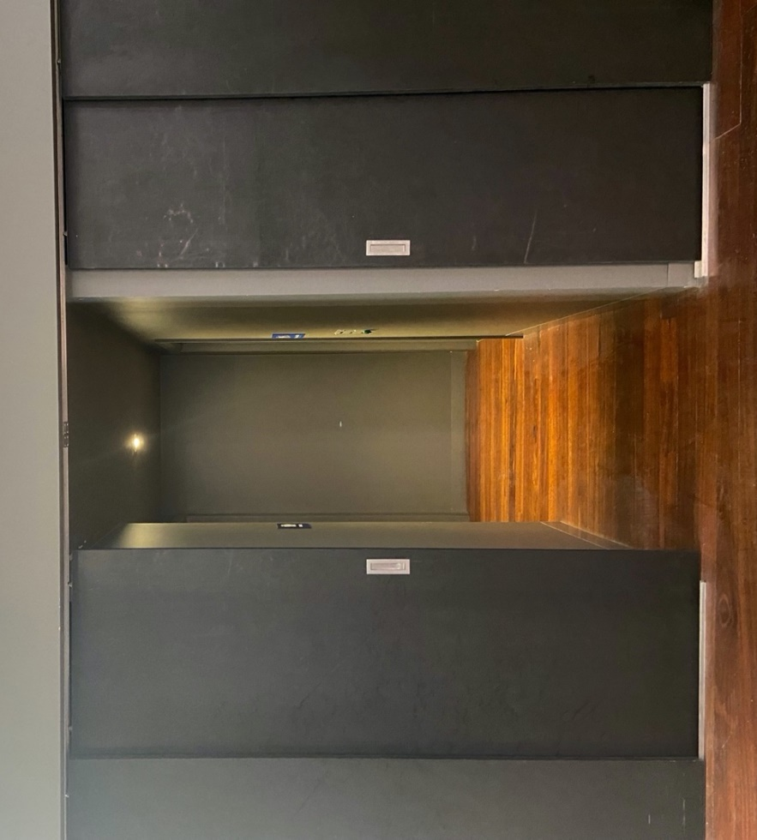

Image: Entrance to the block of toilets off the main area of the Warehouse space.

The first bathroom on the left of this corridor is a small room with a toilet, sink and mirror. This toilet area does not feature grab rails and is not wheelchair or mobility aid accessible.

The second bathroom on the left has a urinal only with a sink and mirror.

The toilet on the right is an accessible bathroom with an automatic door which is operated by a push button. The panel with the button to open the door is to the right of the doorframe and features raised print and braille signage. The door to this toilet opens inwards and remains in its open position for around 20 seconds. This toilet cubicle features an accessible toilet with grab rails, a sink and mirror and has enough turning room for a wheelchair or mobility aid.

# **Transport**

## **Tram**

Route 57 (High Floor trams only)

Stop 12, North Melbourne Town Hall.

Please note, this is not a wheelchair accessible tram

[GETTING TO ARTS HOUSE VIDEO LINK](https://vimeo.com/544169506)

## **Train**

Arts House is 1.1km from   
North Melbourne Train Station,   
approximately 16 minute walk

[North Melbourne Station Information](https://www.ptv.vic.gov.au/stop/1144/north-melbourne-station/0/train/)

1.2km from Flagstaff Station,   
approximately 15 minute walk

[Flagstaff Station Information](https://www.ptv.vic.gov.au/stop/1068/flagstaff-station/0/train/#StopPage:::datetime=2023-04-06T04%3A41%3A27.669Z&directionId=-1&showAllDay=false&_auth=408ac3b1e97f4b0beb5bdf00c2f797057d10dd6e6cf2ad40a69334c4dfdf5e21)

## **Bus**

Bus number: 216

## **Parking**

There is limited paid on-street parking on Queensberry Street and Errol Street.

There are two accessible on street car parking spaces on Queensberry Street (150m to our accessible Errol Street entrance) for holders of a Parking Permit for Disabled people.

# **COVID Safety**

Please note: If you have a cough, sore throat, fever, shortness of breath or flu-like symptoms, you must not attend our venue or programs in person.

We will provide a refund if you need to cancel your attendance due to illness. Please [contact us](mailto:ArtsHouse.Ticketing@melbourne.vic.gov.au) by 9am on the day of the event.

To minimise the risk of COVID-19 transmission, we advise all patrons, artists and staff to:

* Practise physical distancing where possible
* Practise good hygiene by washing and or sanitising your hands often
* Wear a mask as directed by Victorian Government guidelines

Throughout the venue you will find:

* hand sanitiser stations available
* masks available
* increased signage to direct patron movement and avoid crowd congestion

We also ensure that spaces are well ventilated.

Staying COVID-safe remains important. We must all follow these steps:

* Follow the [Victorian Government’s measures on how to stay safe.](https://www.betterhealth.vic.gov.au/coronavirus-covid-19-victoria)
* When you cannot safely socially distance it is recommended to wear a well fitted mask where required.
* Practise [COVID-safe hygiene protocols.](https://www.health.gov.au/news/health-alerts/novel-coronavirus-2019-ncov-health-alert/how-to-protect-yourself-and-others-from-coronavirus-covid-19/good-hygiene-for-coronavirus-covid-19)