**EOI Venue Tour and Morning Tea**

By Arts House

Access Guide

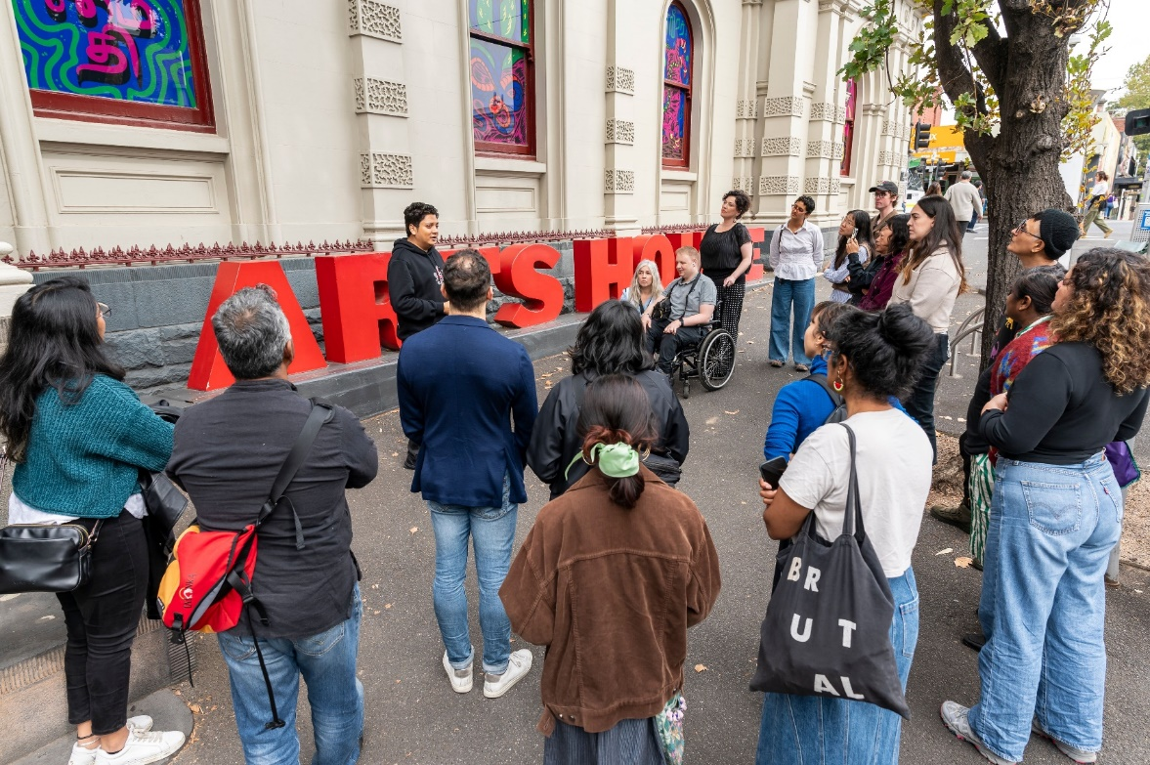

Image Credit: ಒಡಲಾಳ Odalala curator tour, photo by Tiffany Garvie

Image Description: People gather on the street outside Arts House, looking up at artworks on the building’s windows as they listen to a curator speaking.

# **Updates to this document**

Please note, we will endeavour to provide the latest access information on this event.

Arts House website will contain the most up to date version of this document and all ticket holders will be notified of any revisions made 3 days and 1 day prior to the event.

This document was created: 16 September 2024

**Contents**

**Updates to this document** 1

**Where** 3

**When** 3

**Access Services** 3

**Host** 4

**Running Order** 6

**Sensory Elements** 6

Sound 6

Lighting 6

Physical 7

Smell 7

Visual 7

Entry to space 8

Shocks or surprises 10

Audience experience 10

Social expectations 11

**Other** 11

Content Warnings 11

General Notes 11

**The Venue** 12

Front Entrance 12

Building Access Information 13

Accessible Entrances 13

Reception 14

Quiet Space 15

Bathrooms 16

Lift 17

**Transport** 18

Tram 18

Train 18

Bus 18

Parking 18

**COVID Safety** 19

# **Where**

Arts House

521 Queensberry Street

North Melbourne VIC

# **When**

**Thursday 26 September, 10am – 11.30am**

Duration: 1.5 hours

# **Access Services**



Assistance Animal are welcome.



This session is wheelchair accessible.



Quite Space Available - The quiet space will be available for you to use during the event. More information about the quiet space can be found later in this guide.

# **Host**

This session will be hosted by Olivia Anderson, Acting Artistic Director of Arts House

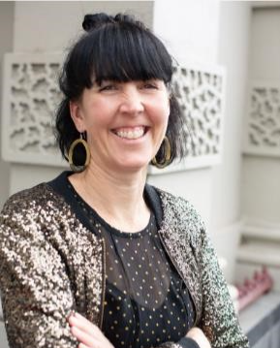

Description: Olivia smiling with her arms folded.

Approximately 15 members of the Arts House staff will also be in attendance at this session.

|  |  |  |
| --- | --- | --- |
|  |  |  |
| Photo of Amrit Gill  **Creative Program Lead**  Amrit Gill | Photo of Sarah Rowbottam  **Program Manager**  Sarah Rowbottam | Photo of Louana Sainsbury  **Creative Producer**  Louana Sainsbury |
| Photo of Tish Brennan-Steer  **Associate Producer**  Tish Brennan-Steer | **(Acting) Creative Producer**  Varsha Ramesh | Photo of Artemis Munoz  **Access Advisor**  Artemis Munoz |
| Photo of Brian Horder  **Business Manager**  Brian Horder | Photo of Bas **Business Administrator** Bas Van De Kraats | Photo of Jordyn  **Business Support Officer**  Jordyn McGeachin |
| Photo of Tony  **Production Manager**  Tony MacDonald    **Technical Coordinator**  Bart Mangan | Photo of Adam   **Front of House Manager**  Adam Seymour    **Venue Technician**  Taran Ablitt | Photo of Jake Davies  **Marketing Manager**  Jake Davies |

# **Running Order**

9.45am Arrive & light refreshments available

10.10am Acknowledgement of Country, Introduction to Arts House and programs, how the morning will run – hosted by Olivia Anderson

10.15am Some of the Arts House staff will introduce themselves and share why they like working at Arts House

10.25am An introduction into the ways Production and Creative Team work with artists, focusing on during development - led by Sarah Rowbottam.

10.30am Venue tour commences – we will split into two separate groups, with each group hosted by a different Arts House staff member

Journey for each group:

Group 1 – Hosted by Louana, Olivia and Bart: Main Hall, Studio 1, Studio 2, Terrace, Warehouse, Supper Room

Group 2 – Hosted by Sarah, Varsha and Tony: Main Hall, Warehouse, Studio 1, Studio 2, Terrace, Supper Room

11.10am Q&A discussion hosted by Olivia and staff in Supper Room

11.30am End

# **Sensory Elements**

## **Sound**

This information session is predominantly speaking. Speakers won’t use microphones. Soft background music will be playing in the venue foyer and meeting space as people arrive.

## **Lighting**

Standard interior building lighting throughout the foyer, Main Hall and The Warehouse. When on a venue tour, there will be coloured and flashing lights outside of Studio 1 as a part of the current exhibition. This space is quite dim, with the space lit up with screens showing moving images. In Studio 2, the space is lit to focus on the artworks. There is a large screen playing a video when coming into the space. The Warehouse will have standard interior building lighting.

## **Physical**

The venue has heating and air conditioning. The rooms maintain an ambient temperature. When we move from Arts House main building to the Warehouse building, we will be outside for a short period of time and the weather may be inclement.

## **Smell**

There will be light vegetarian catering available in the space from Asylum Seeker Resource Centre that will include the smell of spices, fruit and other ingredients.

The menu includes:

* Feta and spinach triangles baked with sesame seeds and sumac (Veg)
* Tunisian Spiced Rolls – contains Spiced pumpkin, corn and cauliflower pastries. (GF/Vegan)
* Ganache filled profiterole
* Chocolate Bliss Balls - chocolate, coconut, vanilla and dates in our delectable treat. (GF/Vegan/Contains Nuts)

## **Visual**

This session does not include any visual presentations on screens. When we move into the tour component of the venue you will see different development and performance spaces.

The Supper Room is in the basement level of the building. This space has no windows and no natural light. The room will be well lit with standard interior lighting.

The Warehouse is a separate self-contained venue and involves walking outside the building for approximately 2 minutes. It has a large open area, a small kitchenette and bathrooms located behind a black wall. This room will be lit with standard interior lighting. There are two large projection screens and tables with tech gear on it set-up for a development.

The Main Hall is a large performance space on the ground floor in the foyer. It has a high ceiling with heritage fixtures on the roof. There will be a row of seating banks towards the back of the room, facing towards the stage. The walls are covered with black curtains. The space will be well lit with standard interior lighting.

Audience Experience

## **Entry to space**

The first part of the event will take place in the Supper Room at Arts House. This space is located in the basement of the main building.

Access to the space:

The Supper Room can be accessed either via lift or stairs from the foyer area.

There are 20 stairs to the Supper Room with grab rails either side. Please note - the staircase has a low archway, and it is wide, so grab rails are not able to be used on both sides at the same time

Entry to Supper Room is through a glass door which is 150cm wide.

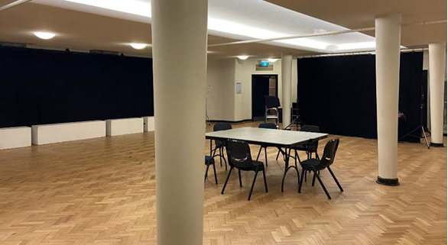

Description: View of Supper Room from main doorway.

We can see 3 concrete pillars, evenly spaced across the parquetry floor. There is a table with chairs surrounding it in the middle of the room.

As a part of the tour, you will be taken to The Warehouse, which is separate to the main building of Arts House. You can find the Warehouse by following George Johnson Lane as it snakes around the back of the main Arts House building. Staff will guide you to this

space.

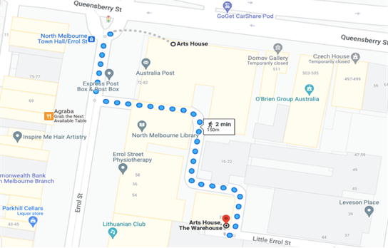

Image: a screenshot of a map with walking directions from the front of the main building of Arts House to the Warehouse behind it. The map indicates a 2 minute walk.

**Entry to the Warehouse:**

Entry is via a ramp and through a sliding glass door .

The main Warehouse entrance has a wheelchair accessible ramp that is 1150mm wide.

The bottom section of the ramp has a gradient of 1:6 and has no handrails.

The upper section has a gradient of 1:12 and has handrails on both sides.

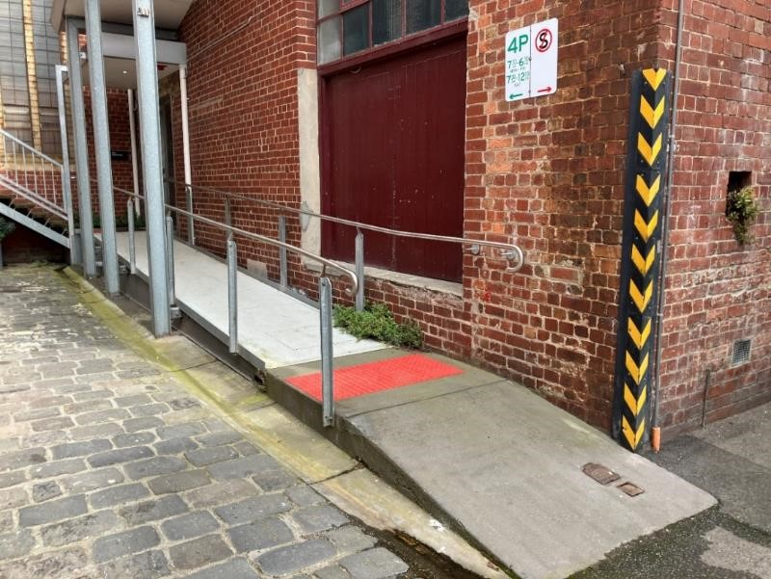

Description: view of the ramp leading to the main entrance of the Warehouse. There are handrails either side of the ramp at the top section and a large red tactile surface indicator on the flat middle section. The door to Warehouse is on the right at the top of this ramp.

## **Shocks or surprises**

There are no shocks or surprises.

## **Audience experience**

This session involves light social interaction with other artists and Arts House staff and moving around the venue.

## **Social expectations**

The first part of this session is seated around circular tables with 3 – 5 other guests.

You are welcome to sit anywhere you like in the room or stand if you prefer.

You are welcome to come and go in the space and have a cuppa or snack whilst we are doing introductions.

# **Other**

## **Content Warnings**

No warnings.

## **General Notes**

The session will commence with an Acknowledgment of Country.

# **The Venue**

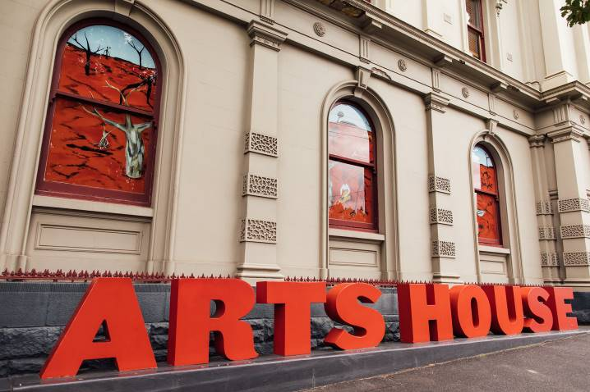

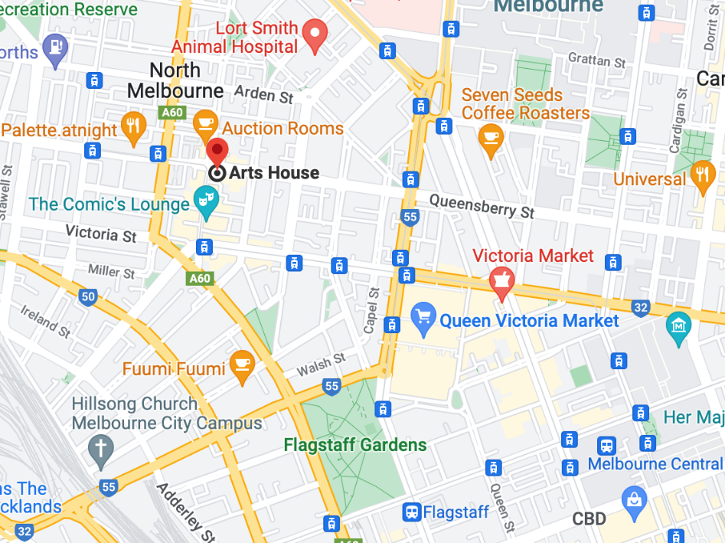

Image: North Melbourne Town Hall features giant red letters that say ARTS HOUSE out the front of it.

Image: a map of Arts House and its surrounding area. [LINK TO MAP](https://www.google.com/maps/place/Arts+House/@-37.802973,144.9486818,17z/data=!4m5!3m4!1s0x0:0x64c465ac7ef21cff!8m2!3d-37.803239!4d144.9498609?shorturl=1)

## **Front Entrance**

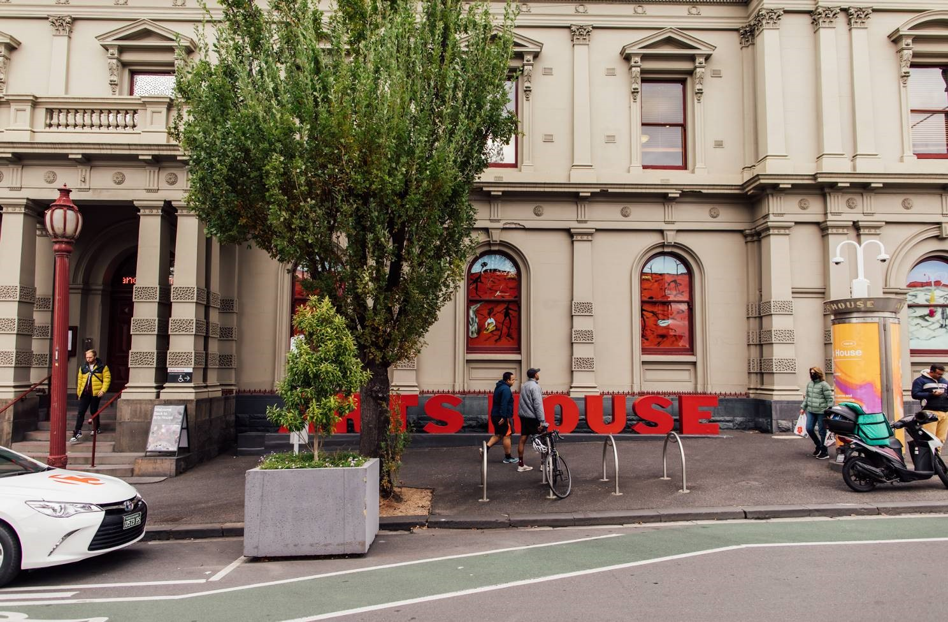

## **Building Access Information**

To familiarise yourself with the space before you arrive, explore Arts House virtually through a 3D scan of the building by clicking [here](https://tourmkr.com/F1jsn73hDg/36140818p&49.3h&89.59t).

To download a verbal map to help with navigation throughout the building, please click [here](https://www.artshouse.com.au/wp-content/uploads/2022/11/Verbal_Map_of_Arts_House_2022.docx).

To download a building document that outlines detailed information on amenities, access, navigation, parking and drop-off, please click [here](https://www.artshouse.com.au/wp-content/uploads/2022/11/Arts_House_Building_Information_2022.docx).

## **Accessible Entrances**



There are two Accessible Entrances. The first is on Errol St next to the Post Office.

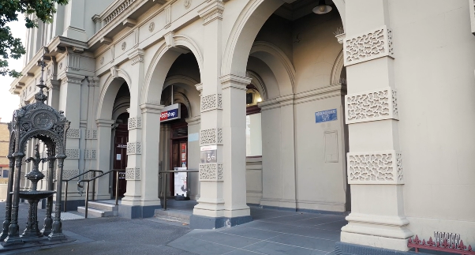

Image: Errol Street entrance next to the Post office with wheelchair accessible ramp or two steps with grab rails.

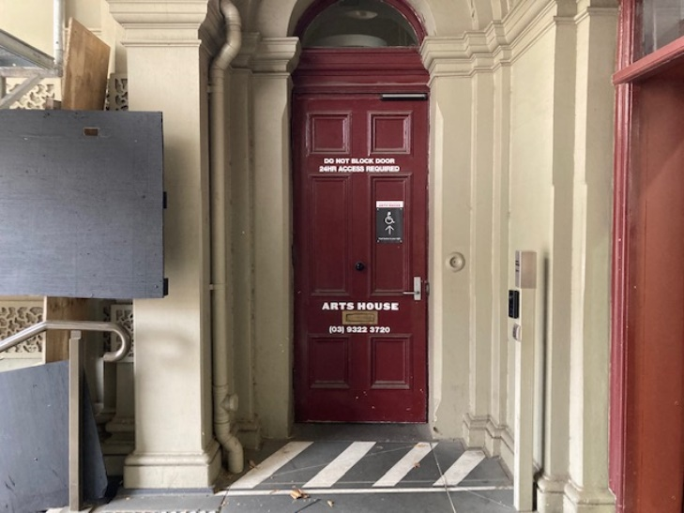

Image: View of door entrance.

The second Accessible Entrance is towards the end of George Johnson Lane.

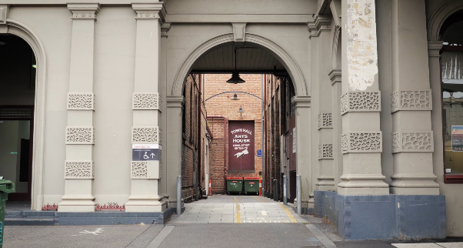

Image: View of George Johnson Lane from Errol St. The laneway passes through an archway with a brick wall at the end.

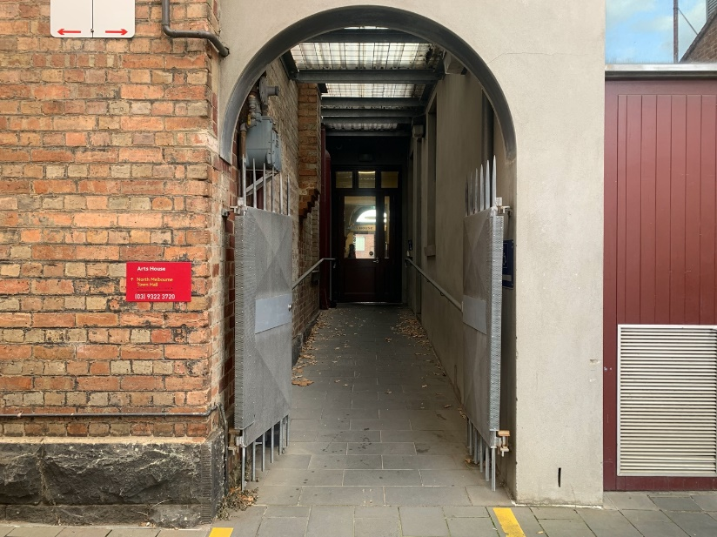

Image: view of the ramp leading from George Johnson Lane to the automated door which opens into the Arts House foyer.

## **Reception**

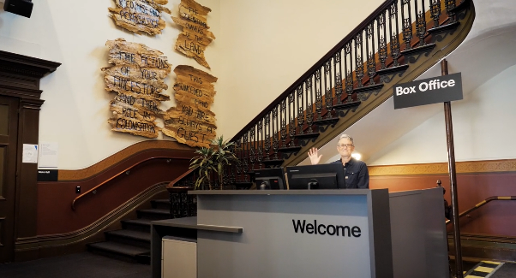

Reception is located in the foyer under the stairwell.

Image description: The Arts House reception desk, showing one of our receptionist's waving and smiling. To the left of the reception desk is the main stair case, showcasing some art work on the walls.

## **Quiet Space**



Arts House Quiet Space is located on Ground Level and is nearby reception and opposite the accessible bathrooms. It includes a range of seating options including soft furnishings, dimmable lights, sensory and stim objects. It is open during venue opening hours and events as a quiet space, prayer or parenting space.

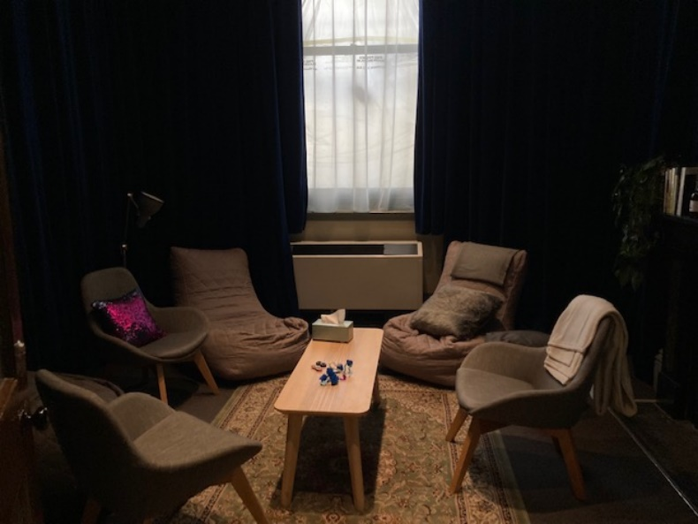

Image: Quiet space with lights dimmed

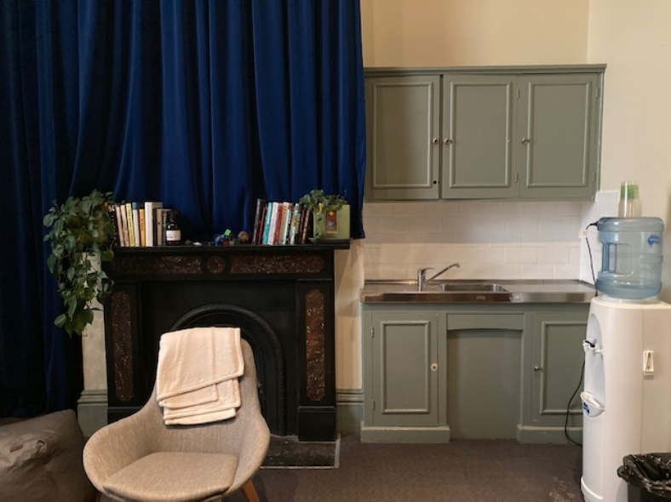

Image: Quiet space kitchenette and shelf

## **Bathrooms**

All bathrooms have Dyson hand dryers with sensor activation. There is an accessible bathroom that is single use on ground level opposite the Quiet Space. There is another accessible bathroom upstairs – this is accessible via lift or stairs.

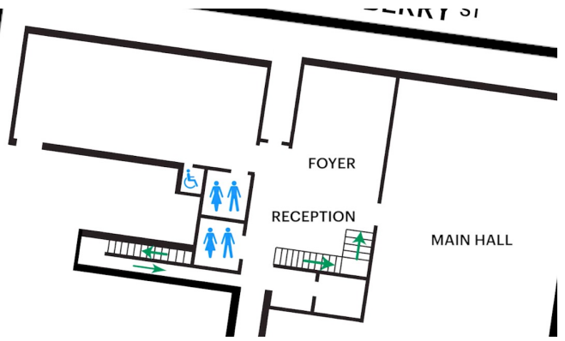

Description: A map of the bathrooms located on the ground floor of Arts House.

## **Lift**

The lift is located behind reception desk in the foyer.

The closest entry to the lift is via George Johnson Lane.

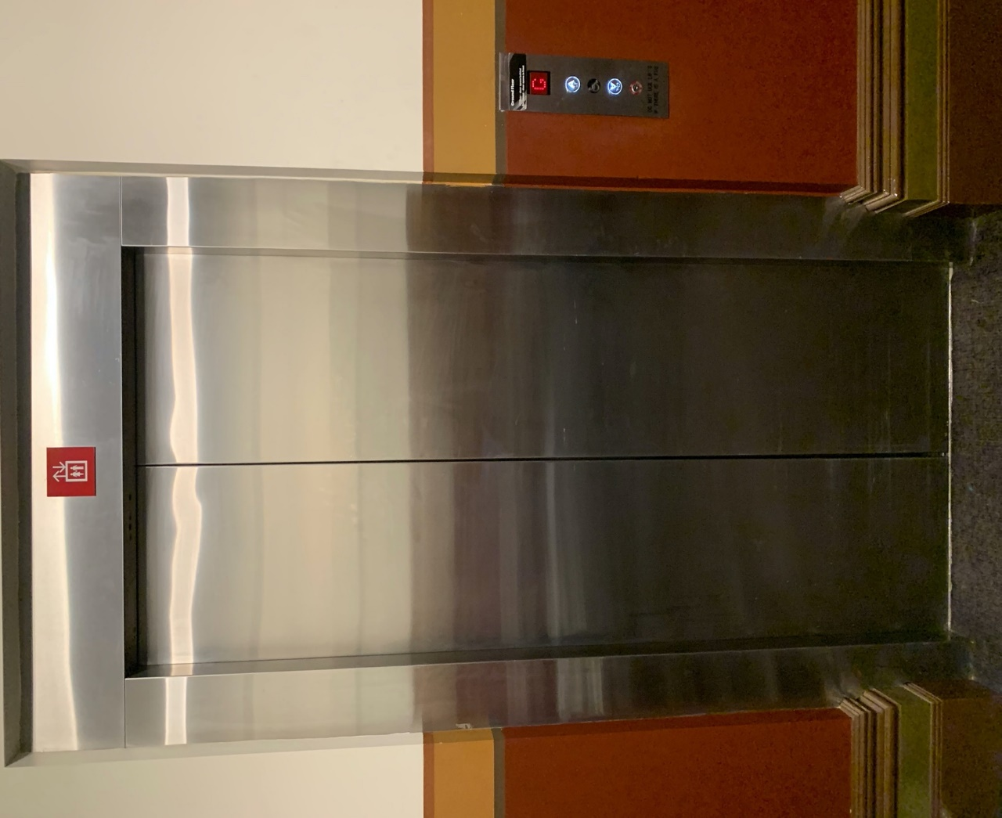

Image description: External view of the lift from the ground floor foyer. The lift has silver metal automated doors and a button mount to the right of the doorframe.

# **Transport**

## **Tram**

Route 57 (High Floor trams only)

Stop 12, North Melbourne Town Hall.

Please note, this is not a wheelchair accessible tram

[GETTING TO ARTS HOUSE VIDEO LINK](https://vimeo.com/544169506)

## **Train**

Arts House is 1.1km from   
North Melbourne Train Station,   
approximately 16 minute walk

[North Melbourne Station Information](https://www.ptv.vic.gov.au/stop/1144/north-melbourne-station/0/train/)

1.2km from Flagstaff Station,   
approximately 15 minute walk

[Flagstaff Station Information](https://www.ptv.vic.gov.au/stop/1068/flagstaff-station/0/train/#StopPage:::datetime=2023-04-06T04%3A41%3A27.669Z&directionId=-1&showAllDay=false&_auth=408ac3b1e97f4b0beb5bdf00c2f797057d10dd6e6cf2ad40a69334c4dfdf5e21)

## **Bus**

Bus number: 216

## **Parking**

There is limited paid on-street parking on Queensberry Street and Errol Street.

There are two accessible on street car parking spaces on Queensberry Street (150m to our accessible Errol Street entrance) for holders of a Parking Permit for Disabled people.

# **COVID Safety**

If you have a cough, sore throat, fever, shortness of breath or flu-like symptoms, you must not attend our venue or programs in person.

To minimise the risk of COVID-19 transmission, we advise all patrons, artists and staff to:

* Practise physical distancing where possible
* Practise good hygiene by washing and or sanitising your hands often
* Wear a mask as directed by Victorian Government guidelines

Throughout the venue you will find: 

* hand sanitiser stations available
* masks available (ask one of our staff for assistance)​
* increased signage to direct patron movement and avoid crowd congestion

We also ensure that spaces are well ventilated. 

Staying COVID-safe remains important. We must all follow these steps: 

* Follow the [Victorian Government’s measures on how to stay safe.](https://www.betterhealth.vic.gov.au/coronavirus-covid-19-victoria)
* Wear[face masks](https://www.betterhealth.vic.gov.au/coronavirus-covid-19-victoria) where required or when you cannot safely socially distance.
* Practise [COVID-safe hygiene protocols.](https://www.health.gov.au/news/health-alerts/novel-coronavirus-2019-ncov-health-alert/how-to-protect-yourself-and-others-from-coronavirus-covid-19/good-hygiene-for-coronavirus-covid-19)