**Soft Connections**

By Amy Claire Mills

Access Guide

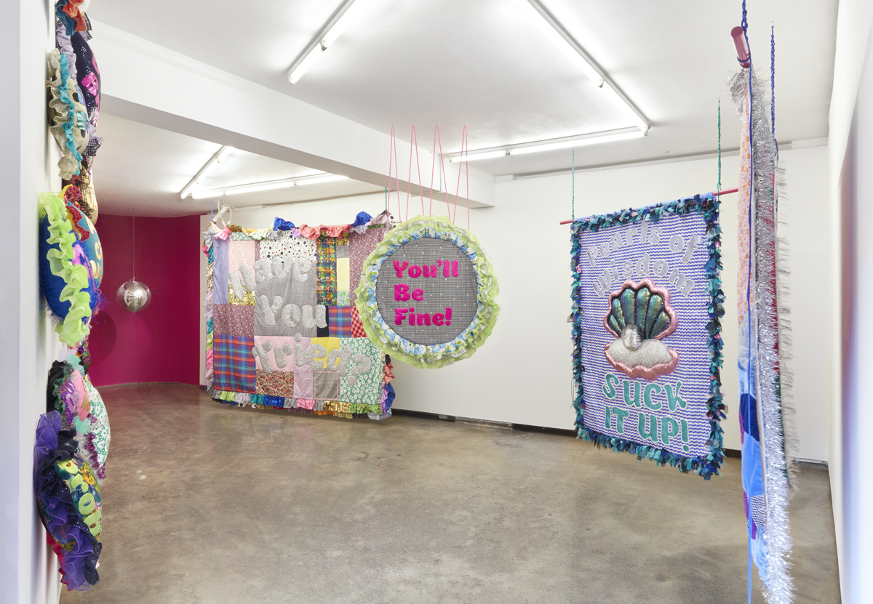

Image: Promotional image for the exhibition.

Image description: The image shows an installation of various colourful quilts hanging in a gallery. Each quilt is a unique size and shape, made from a patchwork of different materials. At the back of the gallery space, there is a pink curved wall with a disco ball hanging in the centre.

# **Updates to this document**

Please note, this exhibition has not been installed in the venue. Arts House website will contain the most up to date version of this document. Revisions can be made 3 days and prior to the exhibition opening.

This document was created: 20 September 2024

**Contents**

**Updates to this document** 1

**Where** 3

**When** 3

**Access Services** 3

**Sensory Elements** 4

Sound 4

Lighting 4

Physical 4

Smell 4

Visual 4

Entry to space 5

Shocks or surprises 5

Audience experience 5

Social expectations 5

**Other** 5

Content Warnings 5

Disabled and Sexy – Alter State Closing Event 6

**The Venue** 8

Front Entrance 8

Accessible Entrances 9

Box Office 10

Ushers 10

Bar 11

Quiet Space 12

Bathrooms 13

Lift 14

**Transport** 15

Tram 15

Train 15

Bus 15

Parking 15

**COVID Safety** 16

# **Where**

Arts House

521 Queensberry Street

North Melbourne VIC

# **When**

Tuesday 1 October – Saturday 12 October 2024

Monday – Friday, 11am – 4pm

# **Access Services**



Assistance Animals are welcome.

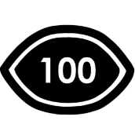

Visual Rating 100%– contains no sound, music, or dialogue so Deaf or hard of hearing audiences can engage fully with the event.

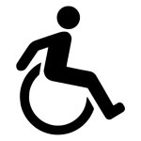

This performance is fully wheelchair accessible. More information is provided further below in this guide about the accessible entrances at Arts House and bathrooms.

# **Sensory Elements**

## Sound

This work contains no sound and is 100% visual. It is exhibited in the foyer space at Arts House which sometimes plays ambient music and people gathering.

## Lighting

There is no spotlights or direct lighting positioned onto the artwork. The room is standard foyer lighting with natural light through windows.

## Physical

The artworks are installed on walls that surround a stairwell. You can have experience the artworks from different vantage points on the stairwell, landing and level 1 which is accessible via lift and stairs.

## Smell

There is no scent.

## Visual

There are 3 large vibrant quilts in this exhibition. Each quilt is a unique size and shape, made from a patchwork of different materials with unique phrases sewn into them. The artworks are hanging flat to the wall from a railing. Some of the quilts include recycled materials with a variety of textures, patterns, shapes and colours. There is pearl beading and 3D soft sculptural elements on some of the artworks. The edges of the quilts are decorated with different trims—some have ruffled fabric, while others feature ribbons that look like seaweed.

Audience Experience

## Entry to space

This artwork is viewable from Arts House foyer. More details on entry to Arts House can be found below.

## Shocks or surprises

Some of the phrases sewen onto the artworks may contain sensitive themes related to disability, mental health and identity and be surprising to some.

## Audience experience

You are welcome to view these artworks in close proximity. We request you do not touch or pull on the artworks.

## Social expectations

The artworks are in a public foyer, you are welcome to come and go as you please, stim and response to the work as you wish.

# **Other**

## Content Warnings

This exhibition contains sensitive themes related to disability, mental health and identity.

Some of the phrases used include:

* Pearls of Wisdom – Suck it up!
* Have you tried?
* What’s wrong with you?
* Do I Need to Manage Your Grief?

At the Disabled and Sexy - Alter State Closing Event, you will encounter soft sculptures designed to resemble medical tools. These artworks may bring up feelings related to medical experiences, such as anxiety or discomfort. Please engage with them at your own pace, and if you feel overwhelmed, don’t hesitate to step away.

## **Disabled and Sexy – Alter State Closing Event**

A series of Amy’s soft sculptural artworks will be installed in Studio 1, upstairs for Disabled and Sexy – Alter State Closing Party. These soft sculptures replace traditional medical tools, subverting established medical environments’ cold and sterile nature.

These works include:

* 2 large medical gloves
* 1 soft sculpture thermometer
* 1 soft sculpture knee hammer
* 1 soft sculpture bottle and an assortment of pills

There are two large body-sized medical gloves with accompanying pillows. You are welcome to physically get inside these gloves and lay down. The blue glove is the larger of the two, designed to fit everyone, but especially suited for taller people, while the pink glove is smaller. The inside of both gloves is lined with soft velvet.

Phot of the artwork


Image Description: A person sits on the ground; the lower half of her body is inside a large blue glove. They look down at their hands and compare them to the glove.

Soft Sculpture Medical Tools:

An assortment of medical tools, including a thermometer, pills, and pill bottles, will be placed around the space. You’re welcome to touch these items, cuddle them, or rest on them gently. Each piece is handmade and not designed for heavy use, so please don’t throw or jump on them. You can use the pills as a stimming tool, but they must stay in the studio.

A large circular quilt will be hung in the space and can be viewed from both sides. Each side features different colours, materials, and phrases. This artwork cannot be touched.

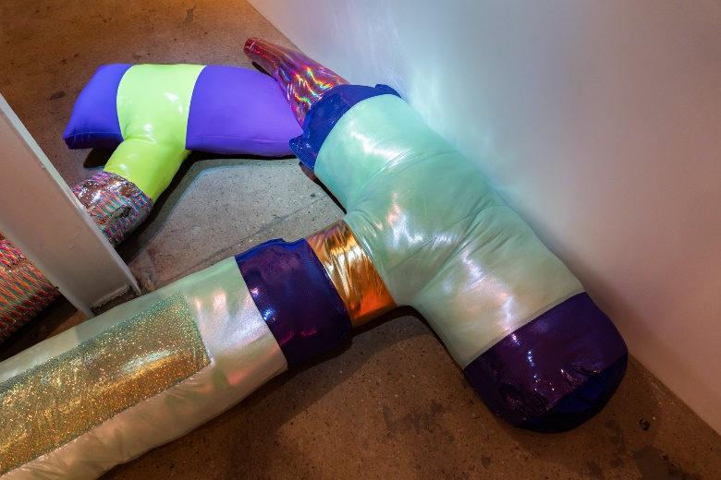   
  
Image description: Large soft sculpture medical tools

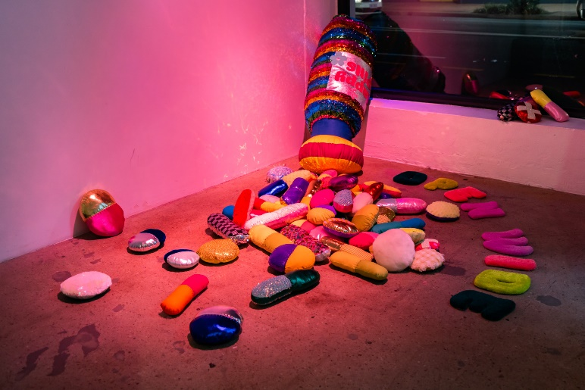

Image description: An assortment of coloured soft sculpture pills surround a large bottle

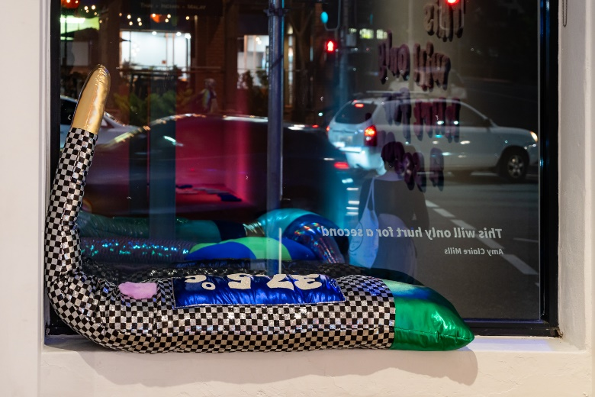  
  
Image description: A large soft sculptural   
thermometer sits on a windowsill

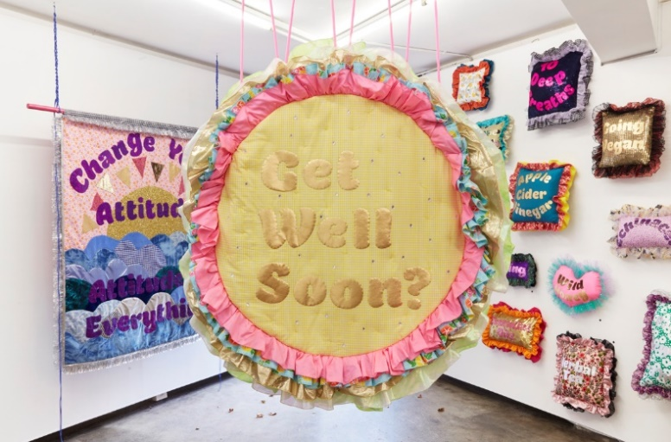

Image description: A circular textile work with “Get Well Soon?” hangs in a gallery

# **The Venue**

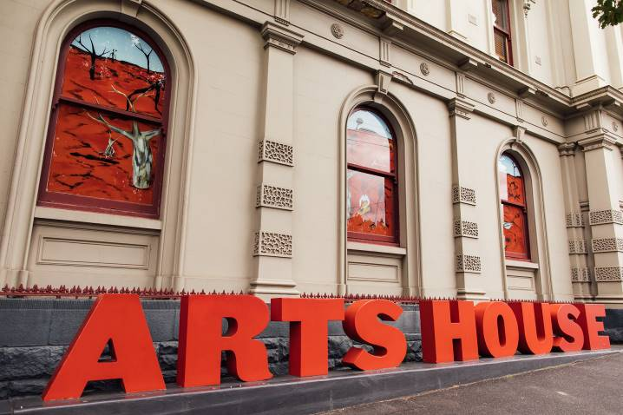

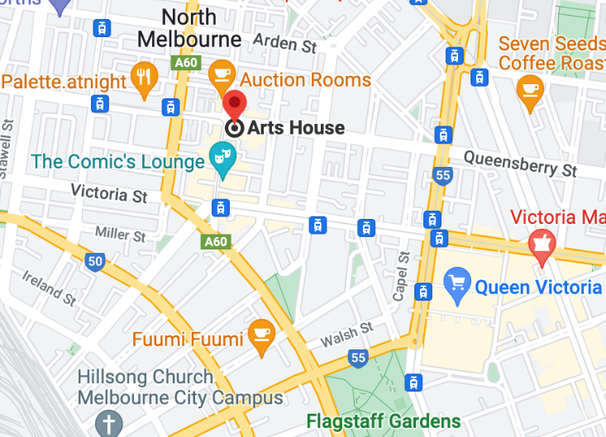

Image: North Melbourne Town Hall features giant red letters that say ARTS HOUSE out the front of it.

Image: a map of Arts House and its surrounding area. [LINK TO MAP](https://www.google.com/maps/place/Arts+House/@-37.802973,144.9486818,17z/data=!4m5!3m4!1s0x0:0x64c465ac7ef21cff!8m2!3d-37.803239!4d144.9498609?shorturl=1)

## **Front Entrance**

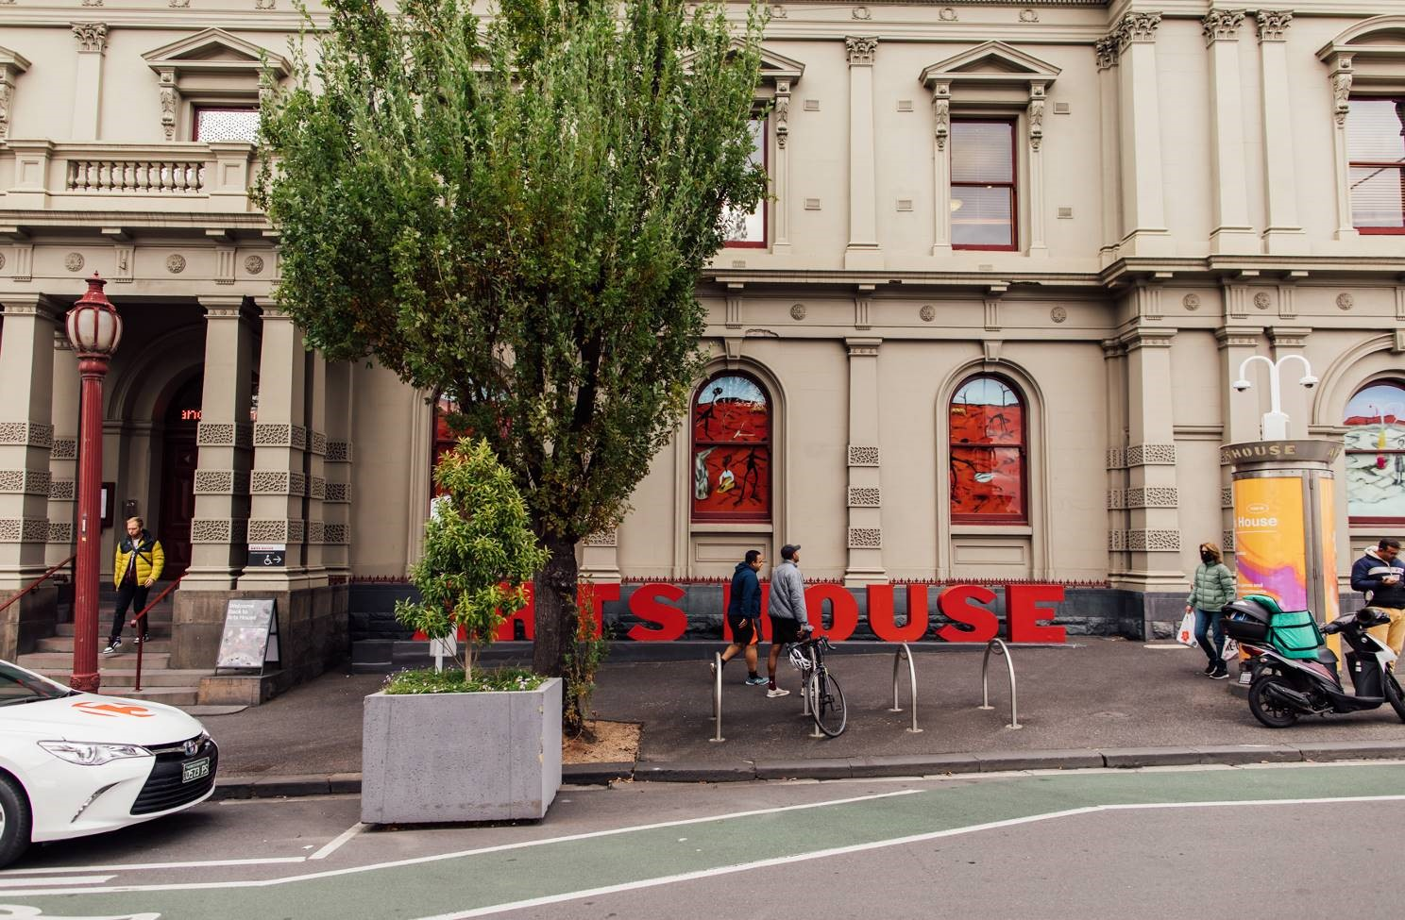

## **Accessible Entrances**



There are two Accessible Entrances. The first is on Errol St next to the Post Office.

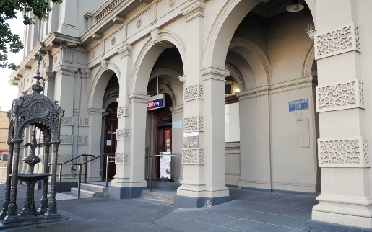

Image: Errol Street entrance next to the Post office with wheelchair accessible ramp or two steps with grab rails.

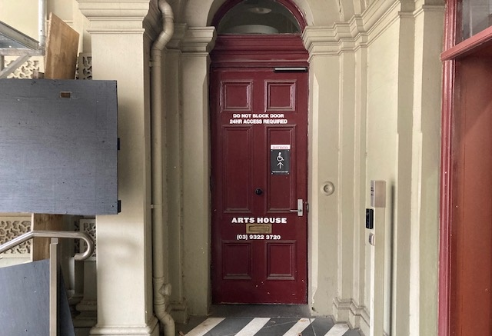

Image: View of door entrance.

The second Accessible Entrance is towards the end of George Johnson Lane.

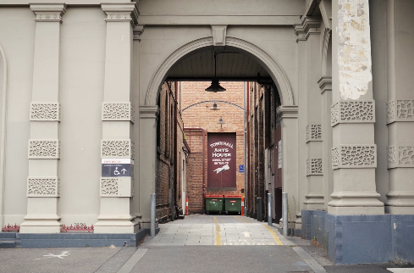

Image: View of George Johnson Lane from Errol St. The laneway passes through an archway with a brick wall at the end.

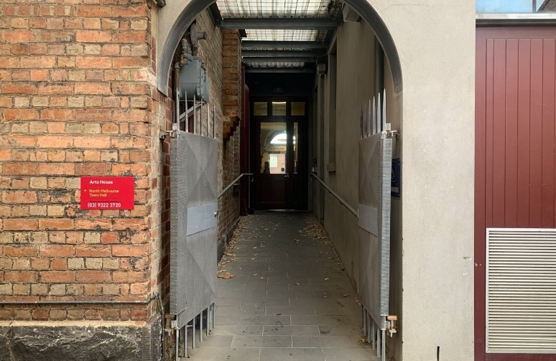

Image: view of the ramp leading from George Johnson Lane to the automated door which opens into the Arts House foyer.

## **Box Office**

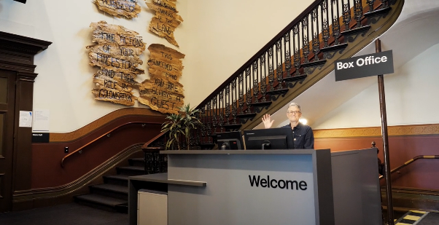

Image description: one of our receptionists is waving and smiling at the reception desk. To the left of the desk is the main staircase, showcasing some artwork on the walls.

Box Office / Reception Desk is located in the foyer under the stairwell.

## **Ushers**

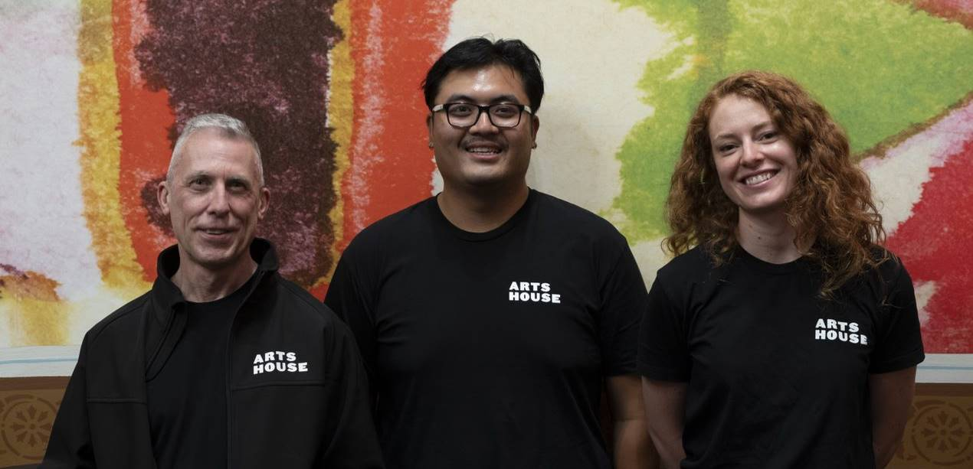

Image description: Three Arts House Ushers

Ushers will be wearing black with an Arts House Logo on the left hand shoulder.

## **Bar**

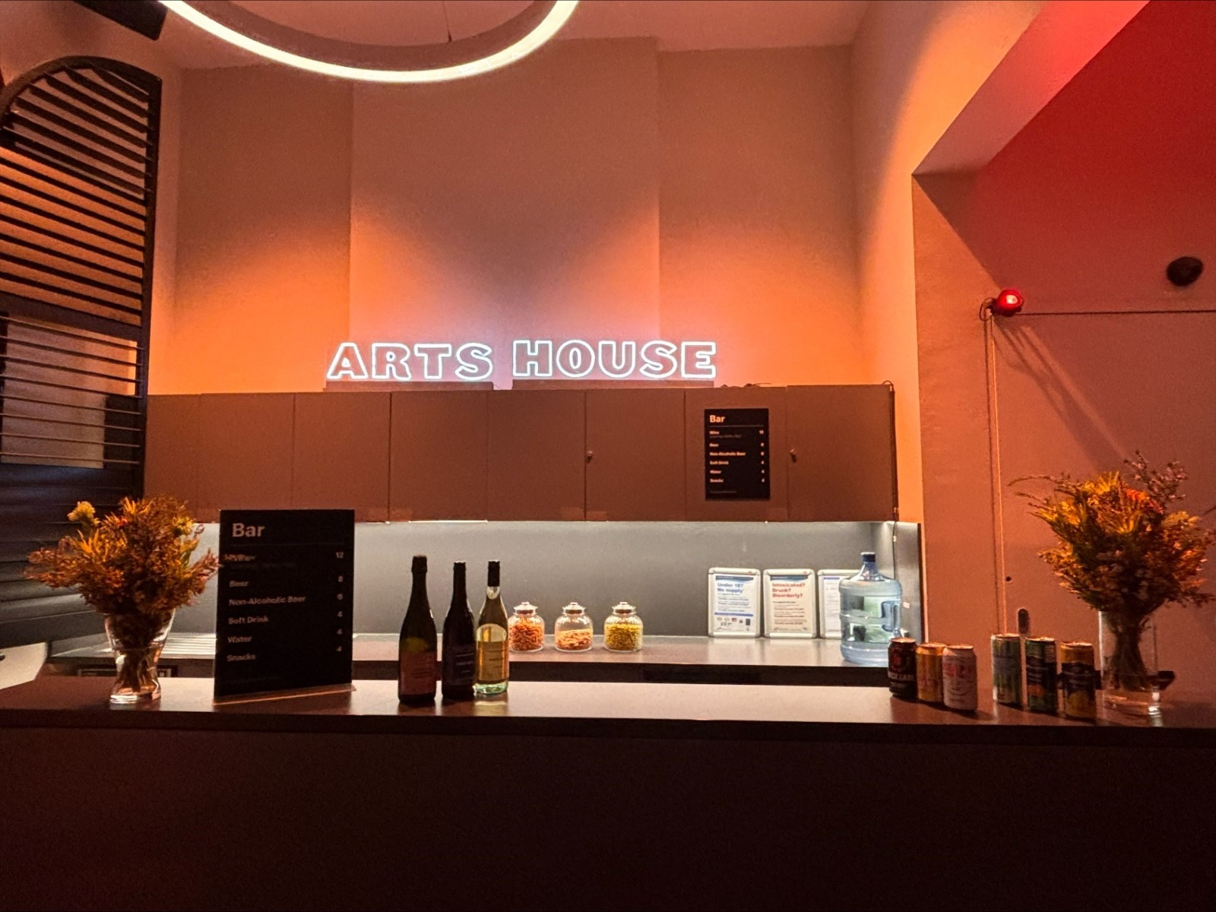

Image Description: The Arts House Bar with vases on each side of the bar filled with native flowers. In the centre there is a bar menu displayed with drinks set up on the top level on the bar. Towards the back wall there is an Arts House sign that is lit up. The lighting of the space is lit up orange.

The bar will be open during events only and not during the day.

Bar staff will be wearing black with an Arts House Logo.

We have a range of alcoholic and non-alcoholic beverages for sale.

We are a cashless venue and accept EFTPOS, Visa and Mastercard payments.

## **Quiet Space**

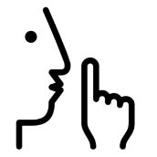

Arts House Quiet Space is located on Ground Level and is nearby reception and opposite the accessible bathrooms. It includes a range of seating options including soft furnishings, dimmable lights, sensory and stim objects. It is open during venue opening hours and events as a quiet space, prayer or parenting space.

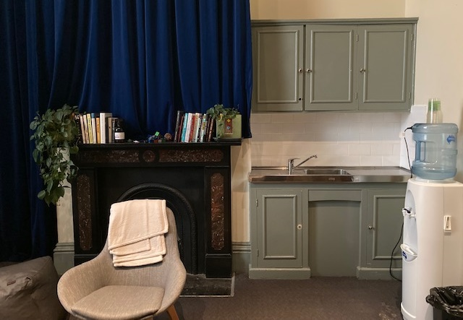

Image: Quiet space kitchenette and bookshelf

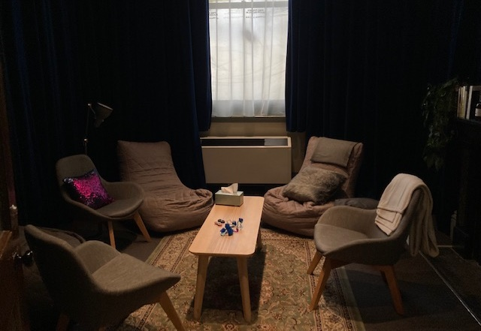

Image: Lightly dimmed space with chairs in a circle and a table in the centre.

**Bathrooms**

All bathrooms have Dyson hand dryers with sensor activation. There is an accessible bathroom that is single use on ground level opposite the Quiet Space. There is another accessible bathroom upstairs – this is accessible via lift or stairs.

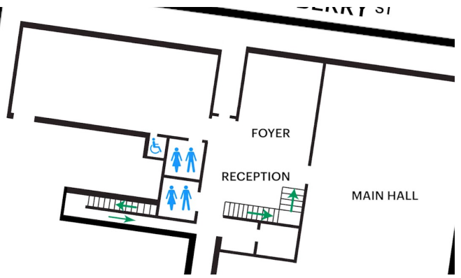

Image: Map of ground floor bathroom locations.

## **Lift**

The lift is located behind reception desk in the foyer.

The closest entry to the lift is via George Johnson Lane.

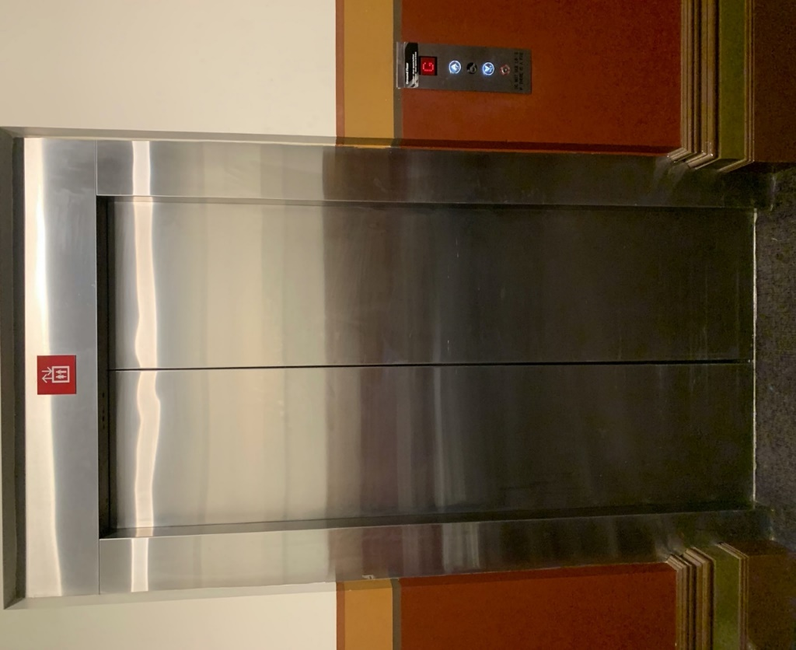

Image description: external view of the lift from the ground floor foyer. The lift has silver metal automated doors and a button mount to the right of the doorframe.

# **Transport**

## **Tram**

Route 57 (High Floor trams only)

Stop 12, North Melbourne Town Hall.

Please note, this is not a wheelchair accessible tram

[GETTING TO ARTS HOUSE VIDEO LINK](https://vimeo.com/544169506)

## **Train**

Arts House is 1.1km from   
North Melbourne Train Station,   
approximately 16 minute walk

[North Melbourne Station Information](https://www.ptv.vic.gov.au/stop/1144/north-melbourne-station/0/train/)

1.2km from Flagstaff Station,   
approximately 15 minute walk

[Flagstaff Station Information](https://www.ptv.vic.gov.au/stop/1068/flagstaff-station/0/train/#StopPage:::datetime=2023-04-06T04%3A41%3A27.669Z&directionId=-1&showAllDay=false&_auth=408ac3b1e97f4b0beb5bdf00c2f797057d10dd6e6cf2ad40a69334c4dfdf5e21)

## **Bus**

Bus number: 216

## **Parking**

There is limited paid on-street parking on Queensberry Street and Errol Street.

There are two accessible on street car parking spaces on Queensberry Street (150m to our accessible Errol Street entrance) for holders of a Parking Permit for Disabled people.

# **COVID Safety**

Please note: If you have a cough, sore throat, fever, shortness of breath or flu-like symptoms, you must not attend our venue or programs in person.

We will provide a refund if you need to cancel your attendance due to illness. Please [contact us](mailto:ArtsHouse.Ticketing@melbourne.vic.gov.au) by 9am on the day of the event.

To minimise the risk of COVID-19 transmission, we advise all patrons, artists and staff to:

* Practise physical distancing where possible
* Practise good hygiene by washing and or sanitising your hands often
* Wear a mask as directed by Victorian Government guidelines

Throughout the venue you will find:

* hand sanitiser stations available
* masks available (ask one of our staff for assistance)​

We also ensure that spaces are well ventilated.

Staying COVID-safe remains important. We must all follow these steps:

* Follow the [Victorian Government’s measures on how to stay safe.](https://www.betterhealth.vic.gov.au/coronavirus-covid-19-victoria)
* When you cannot safely socially distance you can wear a well fitted mask
* Practise [COVID-safe hygiene protocols.](https://www.health.gov.au/news/health-alerts/novel-coronavirus-2019-ncov-health-alert/how-to-protect-yourself-and-others-from-coronavirus-covid-19/good-hygiene-for-coronavirus-covid-19)