Access Guide

**love.exe**

By Jarra Karalinar Steel



**Image:** Jarra Karalinar Steel

**Image description:** A pattern of love hearts and diamonds in purple.  
  
**Finding Pathways to Temahahoi**By Anchi Lin (Ciwas Tahos)

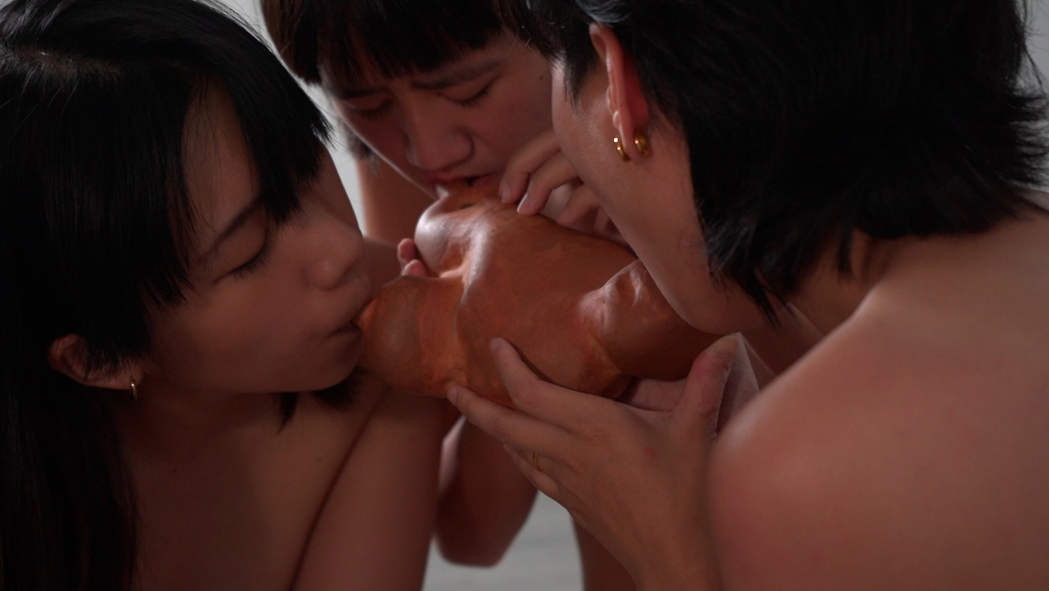

**Image:** courtesy of Anchi Lin (Ciwas Tahos). Pictured Ai-Ling Wang (Paiwan), Sinkuy Katadrepan(Puyuma), Ciwas Tahos (Atayal).   
**Image description:** Three people lean close to a ceramic wind instrument; each is blowing on a mouthpiece.

# **Updates to this document**

Please note, this performance is a new work and changes are being made by artists until opening. We will endeavour to provide the latest access information on performances to ticket holders across key stages of rehearsal and presentation.

Arts House website will contain the most up to date version of this document and all ticket holders will be notified of any revisions made 3 days and 1 day prior to the event.

This document was created: 12/08/2024

Revision 1: 28/08/2024

Contents

Updates to this document 1

Where 3

When 3

Access Services 3

Performers 4

Sensory Elements 5

Sound 5

Lighting 5

Physical 5

Scent 6

Visual 6

Entry to space 6

Audience experience 6

Social expectations 7

Performance expectations 7

Other 7

Content Warnings 7

General Notes 7

The Venue 8

Front Entrance 9

Accessible Entrances 10

Box Office 11

Ushers 12

Quiet Space 13

Bathrooms 13

Door to Studio 1 14

Door to Studio 2 14

Lift 15

Transport 17

Tram 17

Train 17

Bus 17

Parking 17

COVID Safety 18

# **Where**

Arts House

521 Queensberry Street

North Melbourne VIC

# **When**

Friday 30 August – Saturday 28 September 2024

Mon – Fri, 10:30am – 4:30pm

Sat, 11am – 4pm

Closed Sunday and public holidays

Durational Performance:

Saturday 31 August 1:30pm – 3:30pm

Saturday 7 September 1:30pm – 3:30pm

# **Access Services**

 ￼   


Audio Described and Tactile Tour for   
Finding Pathways to Temahahoi:

Saturday 7 September, 12:00pm – 2:00pm



Assistance Animals are welcome.



love.exe   
Visual Rating 50% – this performance has music and sounds in the background.



Finding Pathways to Temahahoi  
Visual Rating 75%– has minimal dialogue and some background music or sounds, or may be fully subtitled, so Deaf and hard of hearing audiences can have close to the full experience of the event.



This performance is fully wheelchair accessible. More information is provided further below in this guide about the accessible entrances at Arts House and bathrooms.



Quite Space Available - The quiet space will be available for you to use at all times. More information about the quiet space can be found later in this guide.

# **Performers**

Durational Performance

Performers: Anchi Lin (Ciwas Tahos), Natalie Tso, Kori Miles  
Performer / Live Sound Coding: Fetle Wondimu

# **Sensory Elements**

## **Sound**

love.exe

There will be a pre-recorded soundscape playing on a loop in the space.

Finding Pathways to Temahahoi

There will be an 8-minute pre-recorded soundscape playing on a loop in the space.

During the Durational Performance on Saturday 31 August and Saturday 7 September, there will be live sound, spoken word poetry and music played with the ceramic instruments.

## **Lighting**

love.exe

The space will be dimly lit. There will be a wall of screens showing video works which will contrast the dim lighting in the room.

Finding Pathways to Temahahoi

The lighting in the space will be static. There are slight differences between lighting for the installation and lighting for the Durational Performance, including perimeter lighting around the canvas.

## **Physical**

love.exe

There will be places in the room for patrons to sit and relax, either on a bench, or on cushions on the floor.

Finding Pathways to Temahahoi

During the Durational Performance, steam (coming from a diffuser) will be part of the installation.

## **Scent**

love.exe

There will be dried flora and live plants in the space.

## **Visual**

love.exe

There is a wall of screens showing bright videos of computer game characters, red draped fabric and pink/purple pop art style printed fabric hung from the ceiling with flora, an altar covered with red LED candles and a fabric draped tent filled with cushions that you can enter.

Finding Pathways to Temahahoi

The ceramic instruments will be displayed on a large piece of canvas fabric that hangs from the ceiling to the floor. The instruments must not be touched and people should not walk on the fabric. Around the room, there are several video screens.

Audience Experience

## **Entry to space**

love.exe

This exhibition is showing in Studio 1, Level 1. Audience members can access this level by either using the stairs or the lift in the ground floor foyer.

Finding Pathways to Temahahoi

This exhibition is showing in Studio 2, Level 1. Audience members can access this level by either using the stairs or the lift in the ground floor foyer.

## **Audience experience**

love.exe

There are designated areas that people are welcome to sit and relax.

Finding Pathways to Temahahoi

Audience members should not touch any elements of the installation.

## **Social expectations**

love.exe

People are free to come and go and can move freely through the space. Stim toys are welcome. No food or drinks are to be brought into the space.

Finding Pathways to Temahahoi

People are free to come and go from the space. There is a large piece of canvas draped from the ceiling to the floor that must not be touched or walked on. Stim toys are welcome. No food or drinks are to be brought into the space.

## **Performance expectations**

Finding Pathways to Temahahoi

During the Durational Performance, there will be 3 performance artists and 1 live coding sound artist performing music with the ceramic instruments, spoken word poetry and other activities. There will be partial nudity.

**Relaxed space**  
  
love.exe and Finding Pathways to Temahahoi

This is not a relaxed performance in the usual sense, but audience members are welcome to come and go as they please, be themselves, make noise, stim, and respond to the work for the duration.

# **Other**

## **Content Warnings**

Love.exe

Contains animated sex scenes and nudity from the Bauldur’s Gate 3 video game.

Finding Pathways to Temahahoi

Contains video footage with nudity. There is partial nudity in the Durational Performance.

## **General Notes**

Explore the full BLEED program, including digital and ECHO offerings [here](https://bleedonline.net/).

# **The Venue**

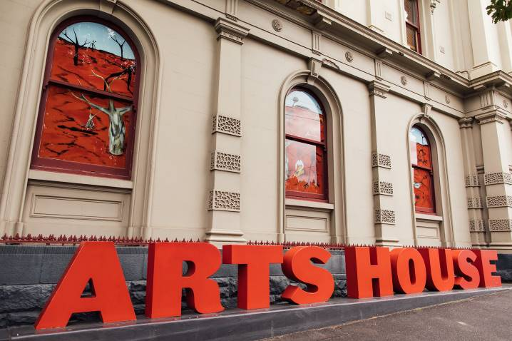

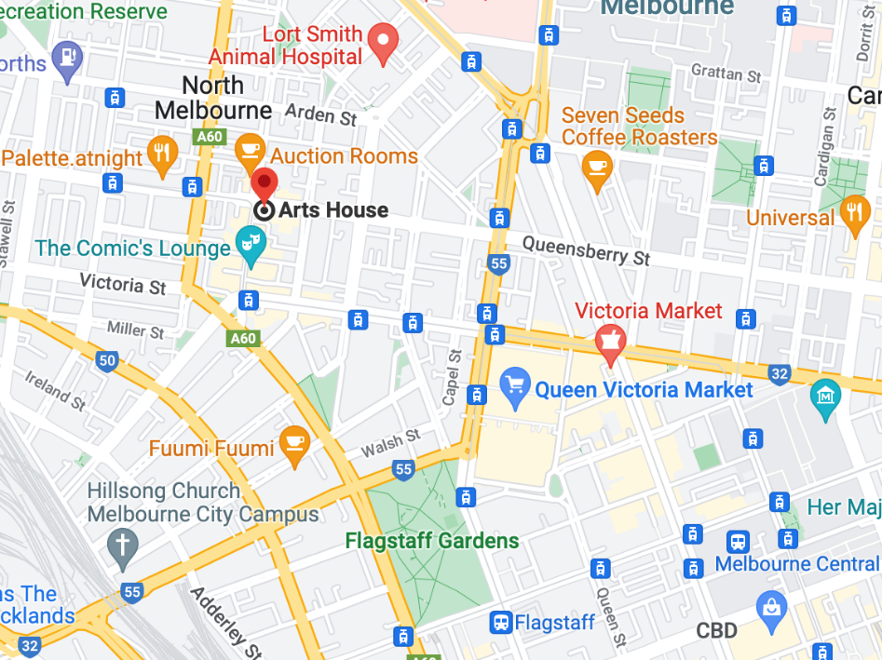

Image: North Melbourne Town Hall features giant red letters that say ARTS HOUSE out the front of it.

Image: a map of Arts House and its surrounding area. [LINK TO MAP](https://www.google.com/maps/place/Arts+House/@-37.802973,144.9486818,17z/data=!4m5!3m4!1s0x0:0x64c465ac7ef21cff!8m2!3d-37.803239!4d144.9498609?shorturl=1)

## **Front Entrance**

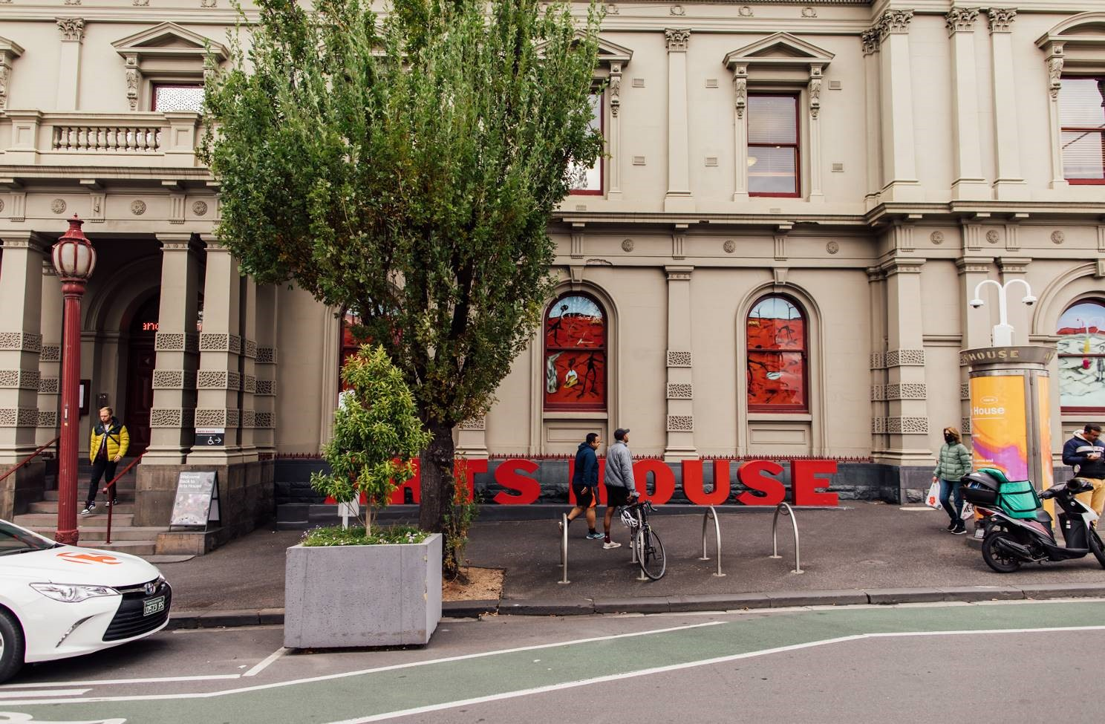

## **Accessible Entrances**



There are two Accessible Entrances. The first is on Errol St next to the Post Office.

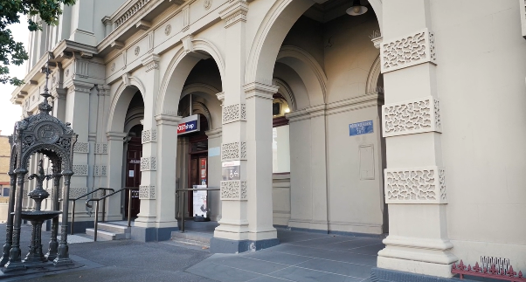

Image: Errol Street entrance next to the Post office with wheelchair accessible ramp or two steps with grab rails.

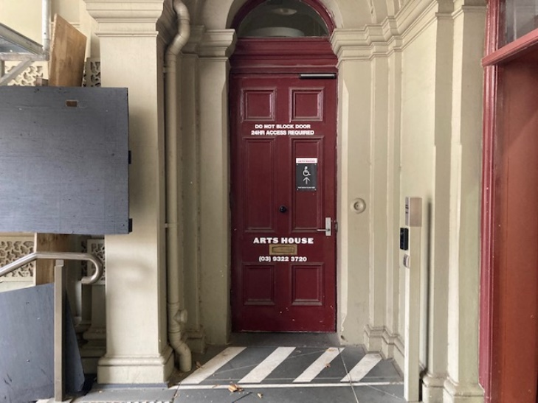

Image: View of door entrance.

The second Accessible Entrance is towards the end of George Johnson Lane.

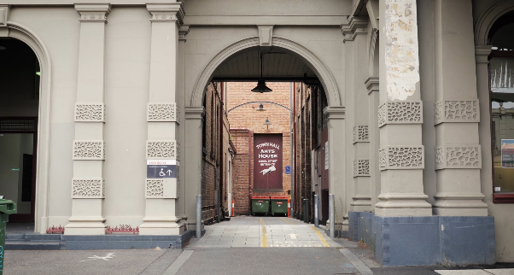

Image: View of George Johnson Lane from Errol St. The laneway passes through an archway with a brick wall at the end.

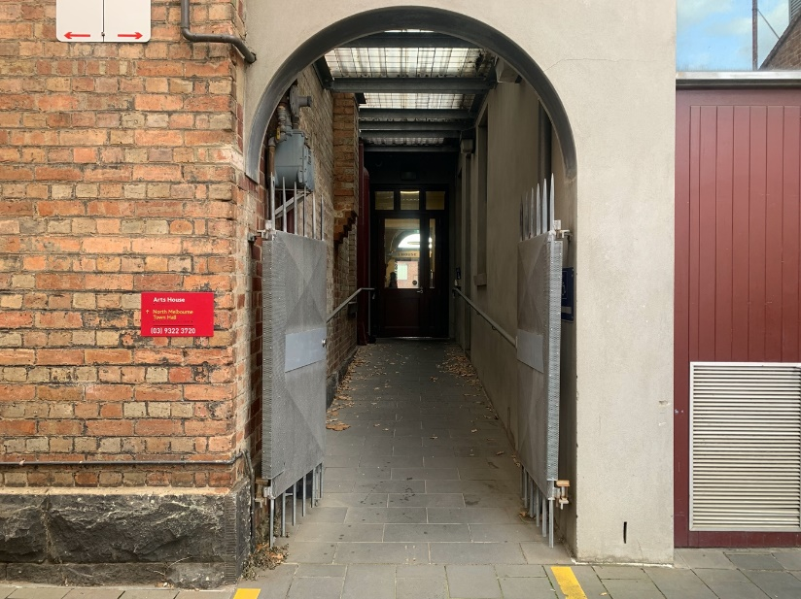

Image: view of the ramp leading from George Johnson Lane to the automated door which opens into the Arts House foyer.

## **Box Office**

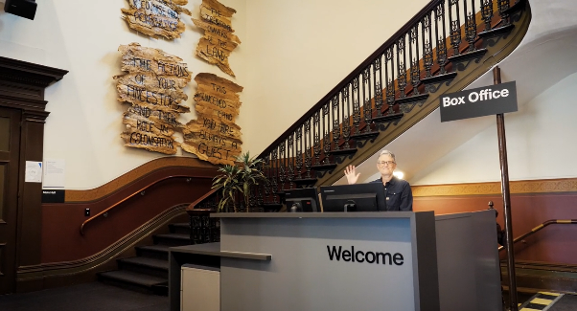

Box Office is located in the foyer under the stairwell.

## **Ushers**

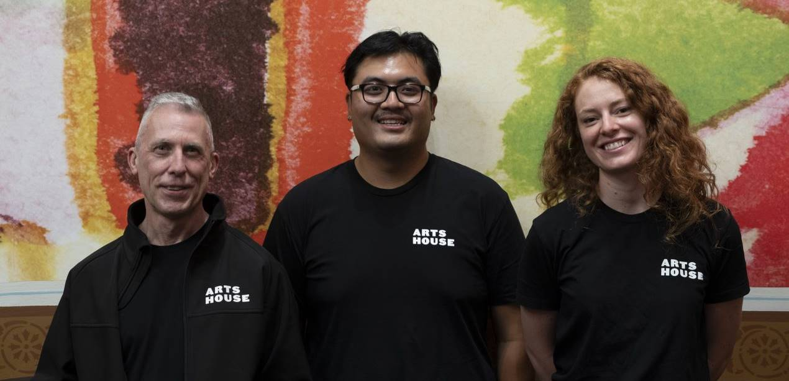

Ushers will be wearing black with an Arts House Logo on the left hand shoulder.

## **Quiet Space**



Arts House Quiet Space is located on Ground Level and is nearby reception and opposite the accessible bathrooms. It includes a range of seating options including soft furnishings, dimmable lights, sensory and stim objects. It is open during venue opening hours and events as a quiet space, prayer or parenting space.

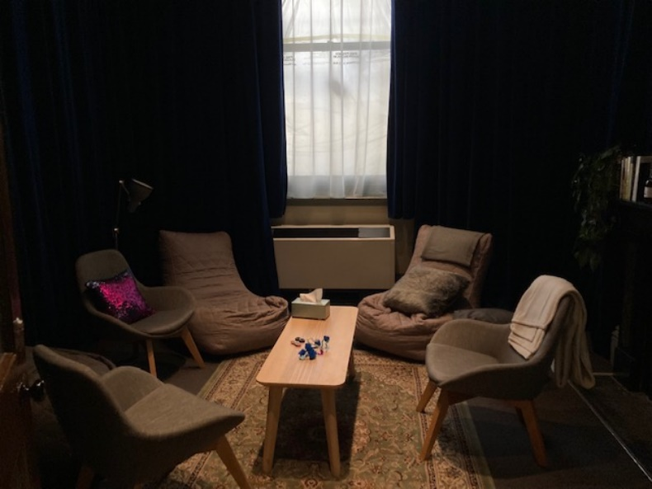

Image: Quiet space with lights dimmed

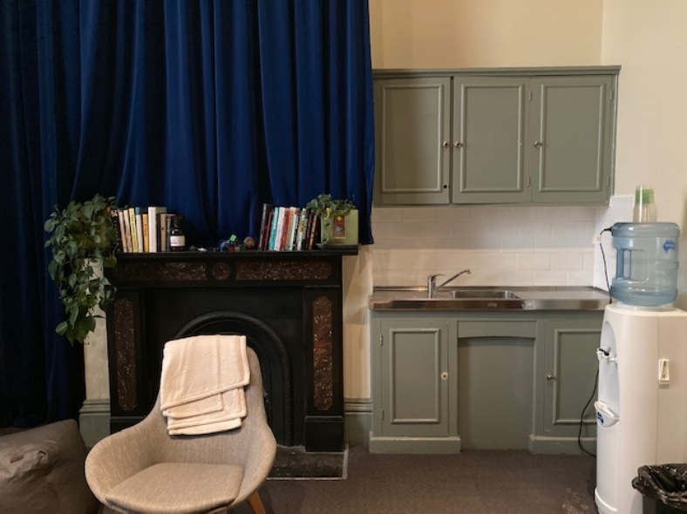

Image: Quiet space kitchenette and book shelf

## **Bathrooms**

All bathrooms have Dyson hand dryers with sensor activation. There is an accessible bathroom that is single use on ground level opposite the Quiet Space. There is another accessible bathroom upstairs – this is accessible via lift or stairs.

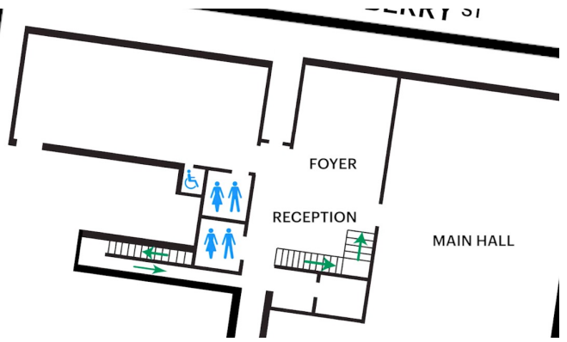

## **Door to Studio 1**

The Performance is in Studio 1.

It is on the first floor.

You can access these spaces via stairs with hand-railing or the lift.

An artist statement is available on signage and warnings on the door.

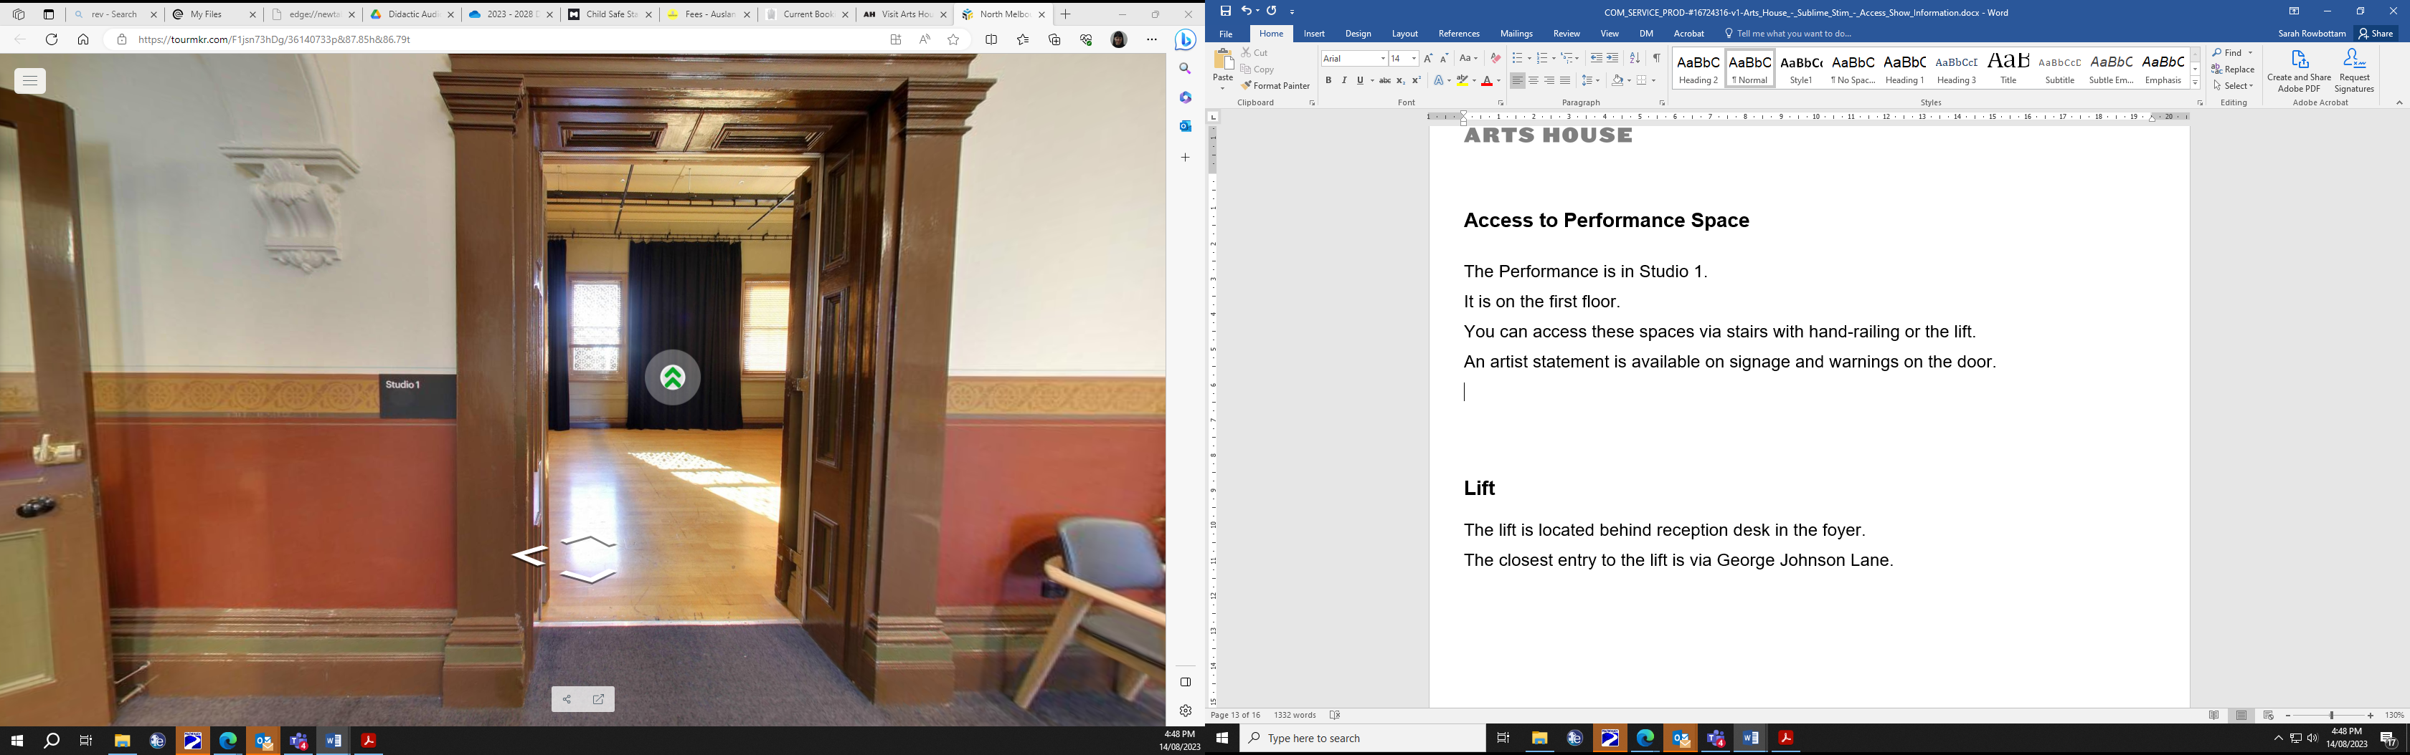

## **Door to Studio 2**

The Performance is in Studio 2.

It is on the first floor.

You can access these spaces via stairs with hand-railing or the lift.

An artist statement is available on signage and warnings on the door.

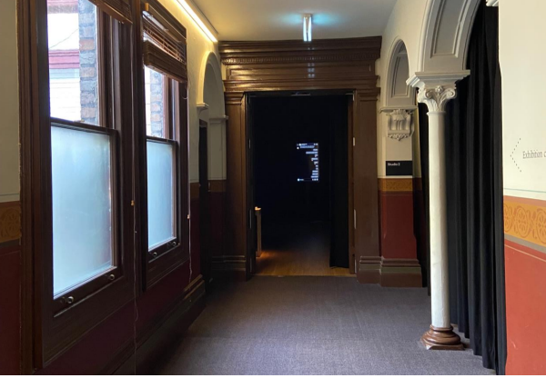

## **Lift**

The lift is located behind reception desk in the foyer.

The closest entry to the lift is via George Johnson Lane.

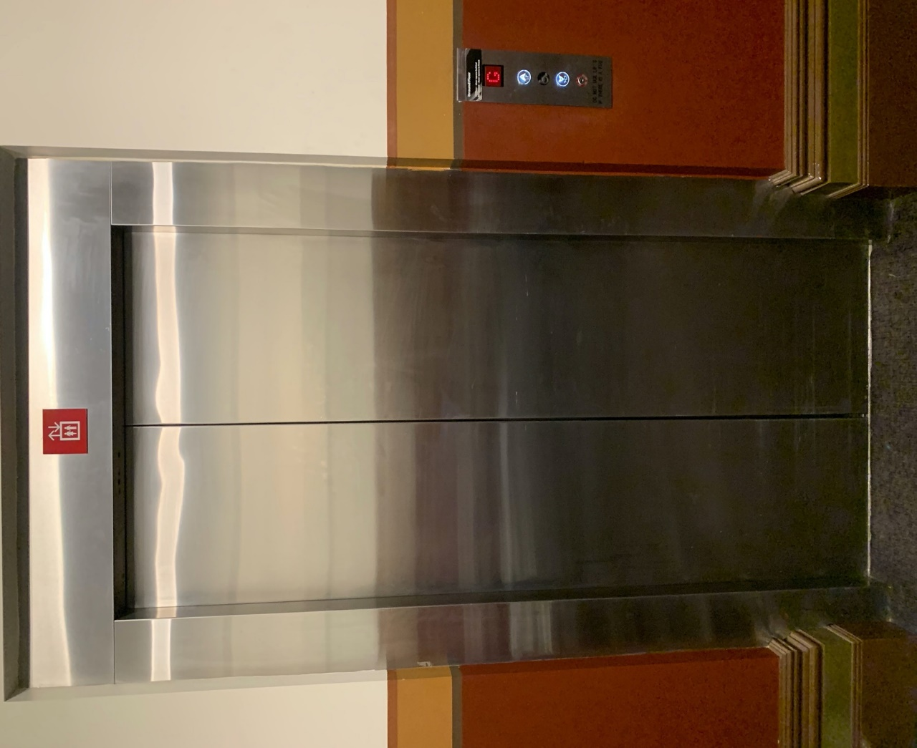

# **Transport**

## **Tram**

Route 57 (High Floor trams only)

Stop 12, North Melbourne Town Hall.

Please note, this is not a wheelchair accessible tram

[GETTING TO ARTS HOUSE VIDEO LINK](https://vimeo.com/544169506)

## **Train**

Arts House is 1.1km from   
North Melbourne Train Station,   
approximately 16 minute walk

[North Melbourne Station Information](https://www.ptv.vic.gov.au/stop/1144/north-melbourne-station/0/train/)

1.2km from Flagstaff Station,   
approximately 15 minute walk

[Flagstaff Station Information](https://www.ptv.vic.gov.au/stop/1068/flagstaff-station/0/train/#StopPage:::datetime=2023-04-06T04%3A41%3A27.669Z&directionId=-1&showAllDay=false&_auth=408ac3b1e97f4b0beb5bdf00c2f797057d10dd6e6cf2ad40a69334c4dfdf5e21)

## **Bus**

Bus number: 216

## **Parking**

There is limited paid on-street parking on Queensberry Street and Errol Street.

There are two accessible on street car parking spaces on Queensberry Street (150m to our accessible Errol Street entrance) for holders of a Parking Permit for Disabled people.

# **COVID Safety**

Please note: If you have a cough, sore throat, fever, shortness of breath or flu-like symptoms, you must not attend our venue or programs in person.

We will provide a refund if you need to cancel your attendance due to illness. Please [contact us](mailto:ArtsHouse.Ticketing@melbourne.vic.gov.au) by 9am on the day of the event.

To minimise the risk of COVID-19 transmission, we advise all patrons, artists and staff to:

* Practise physical distancing where possible
* Practise good hygiene by washing and or sanitising your hands often
* Wear a mask as directed by Victorian Government guidelines

Throughout the venue you will find:

* hand sanitiser stations available
* masks available (ask one of our staff for assistance)​
* increased signage to direct patron movement and avoid crowd congestion

We also ensure that spaces are well ventilated.

Staying COVID-safe remains important. We must all follow these steps:

* Follow the [Victorian Government’s measures on how to stay safe.](https://www.betterhealth.vic.gov.au/coronavirus-covid-19-victoria)
* When you cannot safely socially distance it is recommended to wear a well fitted mask where required.
* Practise [COVID-safe hygiene protocols.](https://www.health.gov.au/news/health-alerts/novel-coronavirus-2019-ncov-health-alert/how-to-protect-yourself-and-others-from-coronavirus-covid-19/good-hygiene-for-coronavirus-covid-19)