**The Splendid Anomaly**

By Ahmarnya Price

Access Guide

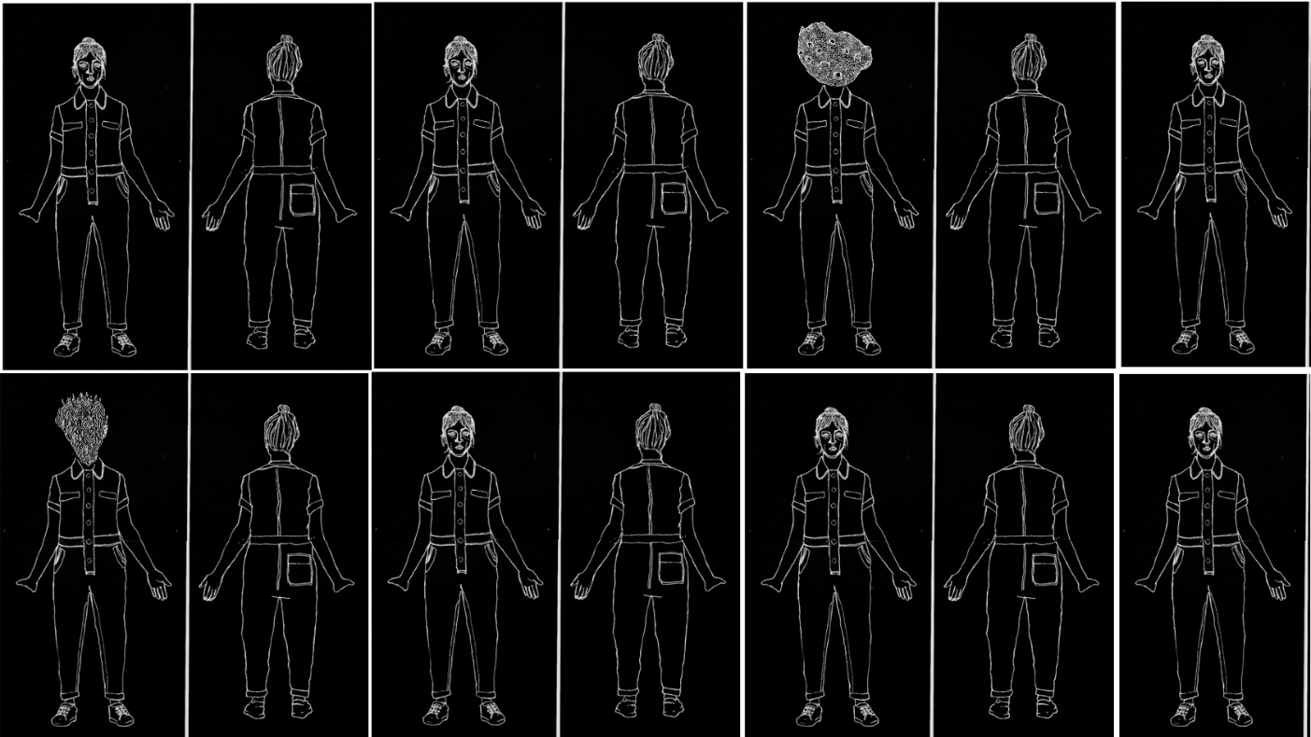

Image credit: Ahmarnya Price

Image description: White lines on a black background. A series of hand drawn images side by side depicting the front and back of a woman. In two images, a sea sponge grows out of her neck.

# **Updates to this document**

Please note, this performance is a new work and changes are being made by artists until opening. We will endeavour to provide the latest access information on performances to ticket holders across key stages of rehearsal and presentation.

Arts House website will contain the most up to date version of this document and all ticket holders will be notified of any revisions made 3 days and 1 day prior to the event.

This document was created: 1 August 2024

Revision 1: 9 August 2024

Revision 2: 28 August 2024

Contents

Updates to this document 1

Where 3

When 3

Access Services 4

Performers 6

Sensory Elements 6

Sound 6

Lighting 7

Physical 7

Smell 7

Visual 7

Entry to space 7

Shocks or surprises 7

Audience experience 8

Social expectations 8

Performance expectations 8

Other 8

Content Warnings 8

General Notes 8

The Venue 9

Front Entrance 9

Accessible Entrances 9

Box Office 11

Ushers 11

Bar 12

Quiet Space 13

Bathrooms 13

Door to Main Hall 14

Lift 15

Transport 16

Tram 16

Train 16

Bus 16

Parking 16

COVID Safety 17

# **Where**

Arts House

521 Queensberry Street

North Melbourne VIC

# **When**

Tuesday 27 August, 7.30pm  
Wednesday 28 August, 7.30pm  
Thursday 29 August, 7.30pm  
Friday 30 August, 7.30pm  
Saturday 31 August, 2pm and 7.30pm

Duration: 40 minutes

# **Access Services**

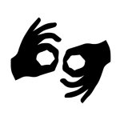

Auslan Interpreted Performance – **Saturday 31 August, 2pm.**

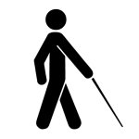

Tactile Tour - **Saturday 31 August, 1pm** (1 hour prior to the show).  


Audio Described Performance – **Saturday 31 August, 2pm.**



Assistance Animals are welcome.

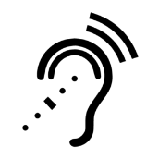

Assistive Listening is available free of charge. Ask staff for assistance on arrival.



Visual Rating 50% – this performance has music and sounds in the background.



This performance is fully wheelchair accessible.



Aural Rating 50%– contains both sound and visual components, but sight is not essential to be able to engage with the event.

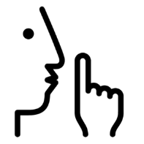

Quite Space Available - The quiet space will be available for you to use before and after the show. More information about the quiet space can be found later in this guide.  

# **Performers**

Image description: Artist Ahmarnya Price. A black and white headshot of Ahmarnya wearing glasses. Her blonde hair is tied up in a messy top notch, her eyes gaze to the right. She smiles slightly.

# **Sensory Elements**

## **Sound**

During the performance, there will be loud sounds and music. Ahmarnya will be wearing a microphone and at times her voice will be distorted. There will be a small speaker at the left side of the front stage which will play three different voices – they will be of recorded phone conversations from Ahmarnya’s Mum, brother Nathan and doctor Steve.

There will be overlapping voices with the music. Sound will also be coming from speakers under the seating bank and behind a paper wall positioned at the back of the Main Hall.

## **Lighting**

The colours and intensity of the lights will change throughout the show. Lights will change from a warmly lit theatrical space, to then bright white to resemble a hospital to then green lit by AV animations. At times, there are sudden changes to lighting in sync with the projections.

## **Physical**

There is one performer, Ahmarnya. She brings out four clear Perspex screens on wheels which are painted on and moved around the space during the performance.

Base speakers are positioned under the seating bank which may cause vibrations in the seats.

## **Smell**

There are no scents or perfumes added to this performance, but non-toxic paint will be used during the performance which may have a faint smell.

## **Visual**

Drawings made by Ahmarnya will be animated and projected onto the performance space. They change in size, turn in circles, multiply, flash and flicker.

Audience Experience

## **Entry to space**

The audience will enter from the main doors of the foyer. There will be an Acknowledgement of Country before each show in the foyer. Following this, the performance space will open for audiences to enter and take their seats.

## **Shocks or surprises**

There will be loud sounds throughout the performance. There will be a quick flash of light and loud sound about 4 times through the performance. Ahmarnya will cough and spit out non-toxic paint, as well as have paint leaking from her head and collar.

## **Audience experience**

One time during the performance, Ahmarnya comes closer to the audience and speaks directly to an audience member. There is no requirement to respond.

## **Social expectations**

There are no breaks in the show. There will be a lockout once the show begins. This

means that once the performance has started, you should stay in your seat and not leave the performance space.

If you need to leave the performance space, you will not be allowed to re-enter. Please speak to the front of house staff for assistance.

## **Performance expectations**

There is a storyline to follow. Ahmarnya is the only performer on stage. At times, she interacts with recorded voices and visuals on a screen.

# **Other**

## **Content Warnings**

The Splendid Anomaly contains themes of environmental and medical crises, nudity (drawn/animated), coarse language, smoke effects, haze, high-pitched frequencies, loud music, very loud effects, sudden loud noises, flashing lights, strobe lighting, abrupt lighting changes, low lighting, lights black out, and lights changing colours and intensity.

## **General Notes**

There is a strict lockout for The Splendid Anomaly. No latecomers will be admitted.

# **The Venue**

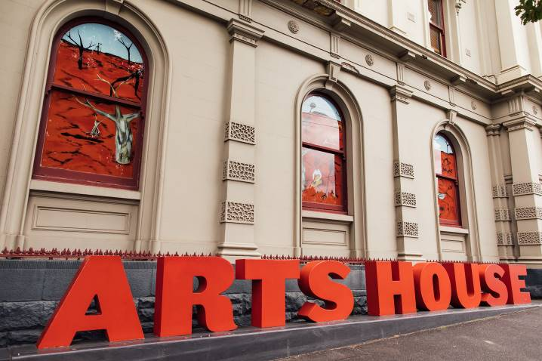

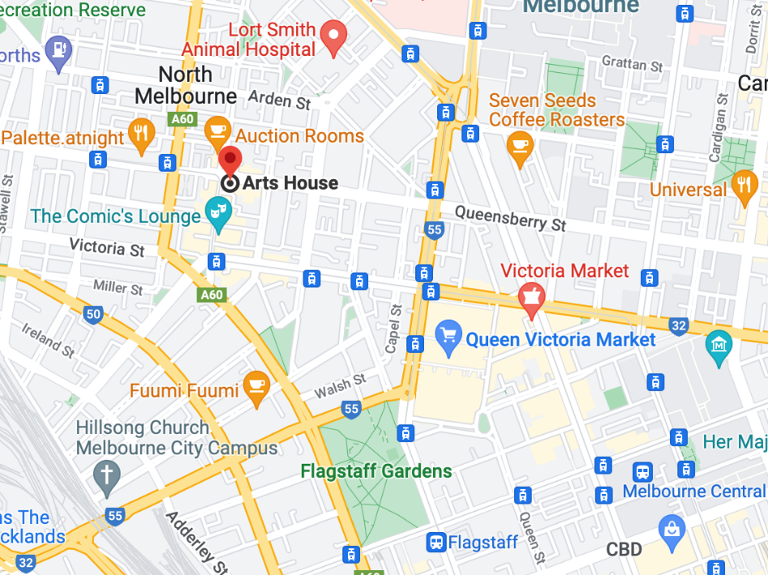

Image: North Melbourne Town Hall features giant red letters that say ARTS HOUSE out the front of it.

Image: a map of Arts House and its surrounding area. [LINK TO MAP](https://www.google.com/maps/place/Arts+House/@-37.802973,144.9486818,17z/data=!4m5!3m4!1s0x0:0x64c465ac7ef21cff!8m2!3d-37.803239!4d144.9498609?shorturl=1)

## **Front Entrance**

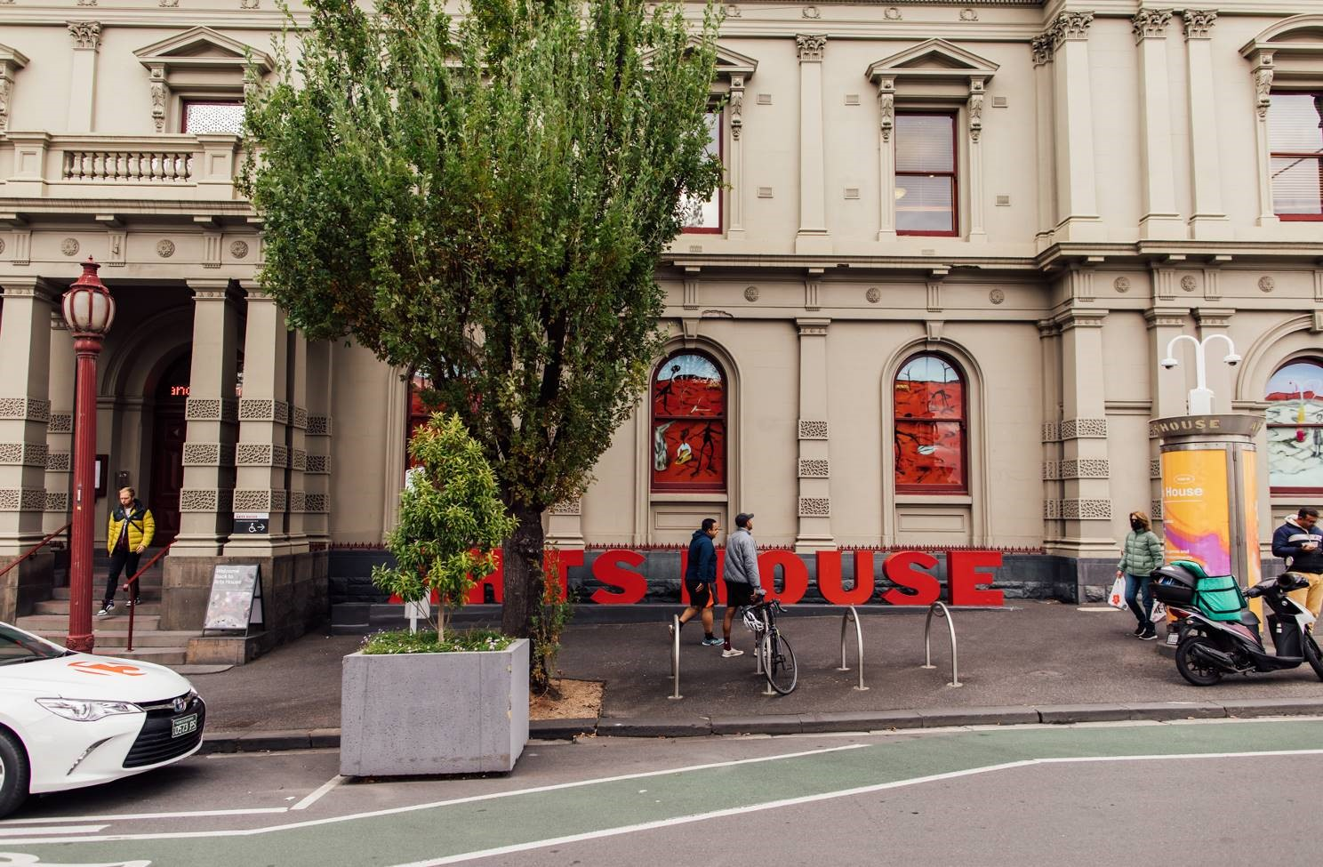

## **Accessible Entrances**



There are two Accessible Entrances. The first is on Errol St next to the Post Office.

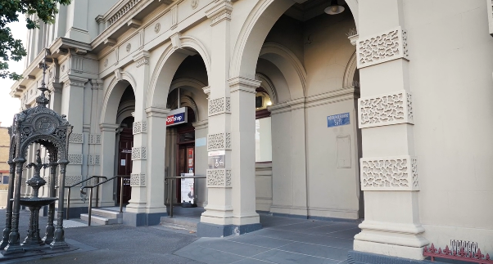

Image: Errol Street entrance next to the Post office with wheelchair accessible ramp or two steps with grab rails.

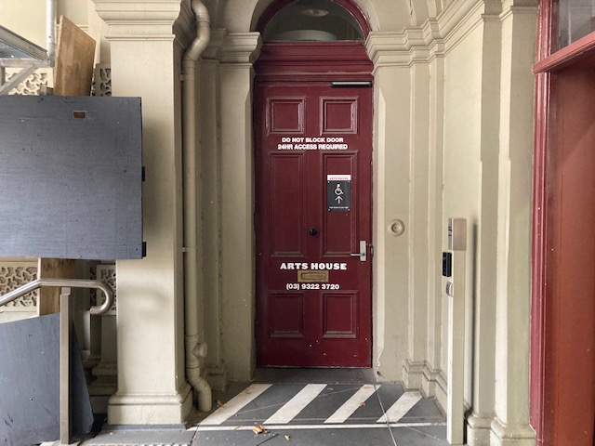

Image: View of door entrance.

The second Accessible Entrance is towards the end of George Johnson Lane.

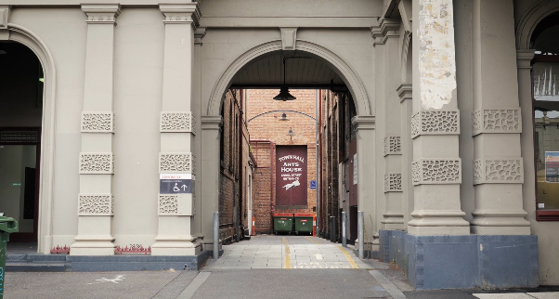

Image: View of George Johnson Lane from Errol St. The laneway passes through an archway with a brick wall at the end.

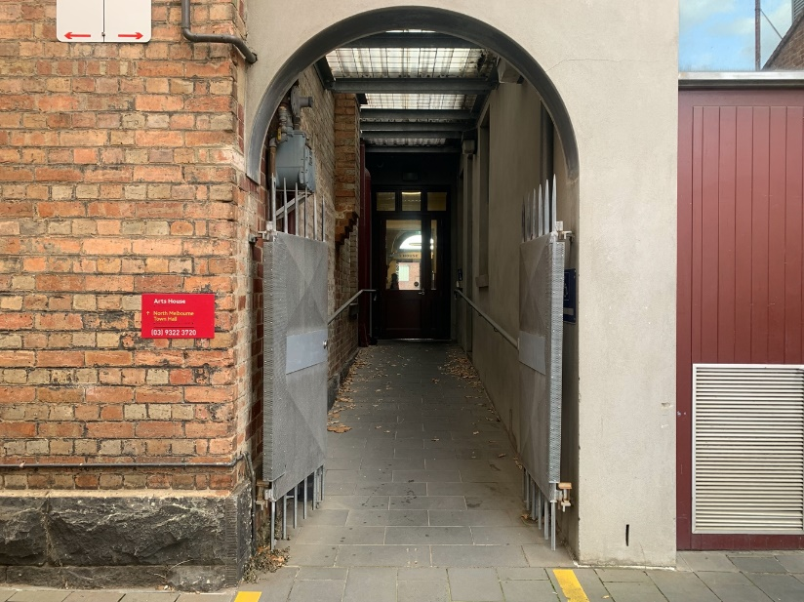

Image: view of the ramp leading from George Johnson Lane to the automated door which opens into the Arts House foyer.

## **Box Office**

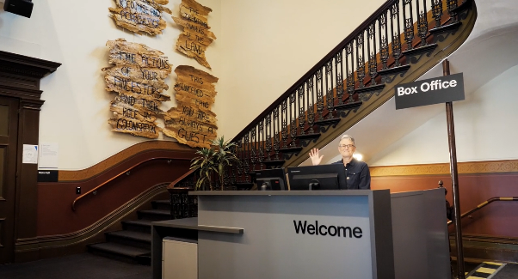

Box Office is located in the foyer under the stairwell.

## **Ushers**

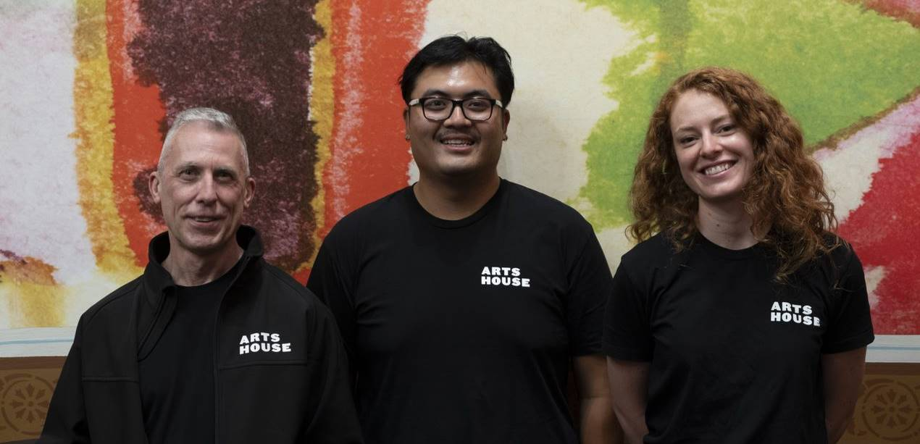

Ushers will be wearing black with an Arts House Logo on the left hand shoulder.

## **Bar**

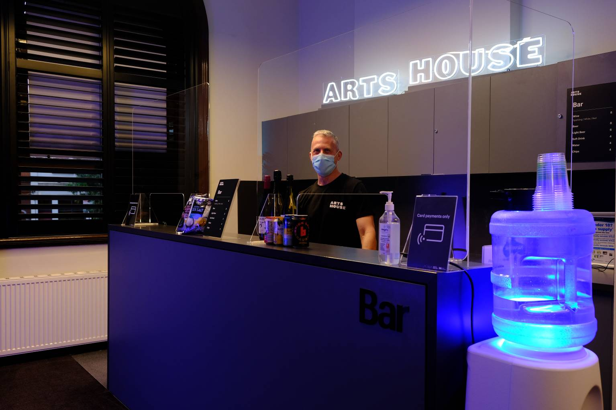

Bar staff will be wearing black with an Arts House Logo.

We have a range of alcoholic and non-alcoholic beverages for sale.

We are a cashless venue and accept EFTPOS, Visa and Mastercard payments.

## **Quiet Space**

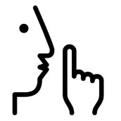

Arts House Quiet Space is located on Ground Level and is nearby reception and opposite the accessible bathrooms. It includes a range of seating options including soft furnishings, dimmable lights, sensory and stim objects. It is open during venue opening hours and events as a quiet space, prayer or parenting space.

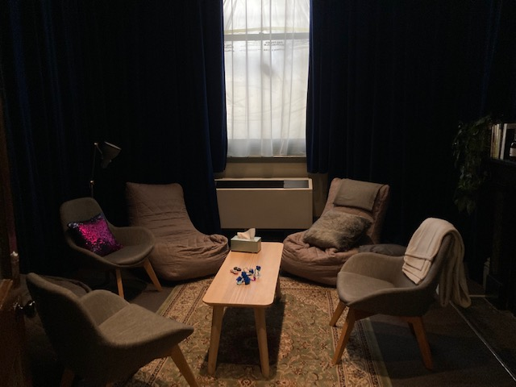

Image: Quiet space with lights dimmed

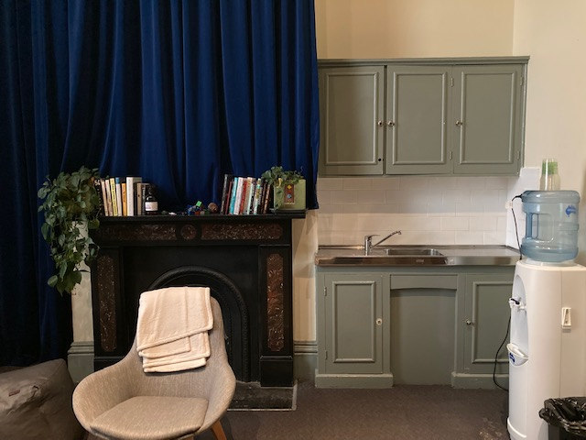

Image: Quiet space kitchenette and book shelf

## **Bathrooms**

All bathrooms have Dyson hand dryers with sensor activation. There is an accessible bathroom that is single use on ground level opposite the Quiet Space. There is another accessible bathroom upstairs – this is accessible via lift or stairs.

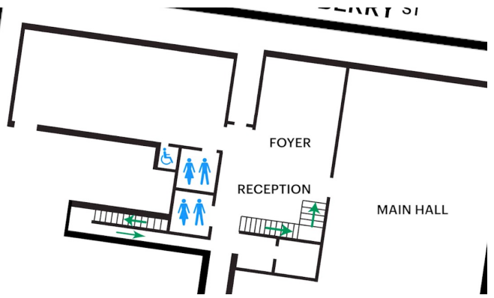

## **Door to Main Hall**

The Performance is in the Main Hall.

It is on the ground floor.

It is to the left of the box office desk and right of the bar.

An artist statement is available on signage and warnings on the door.

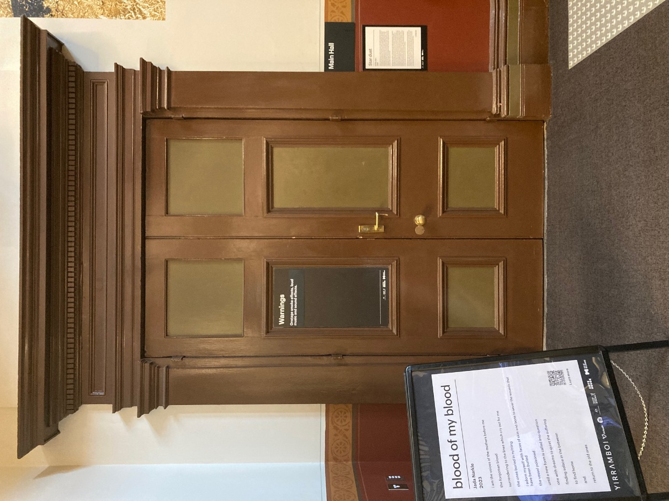

## **Lift**

The lift is located behind reception desk in the foyer.

The closest entry to the lift is via George Johnson Lane.

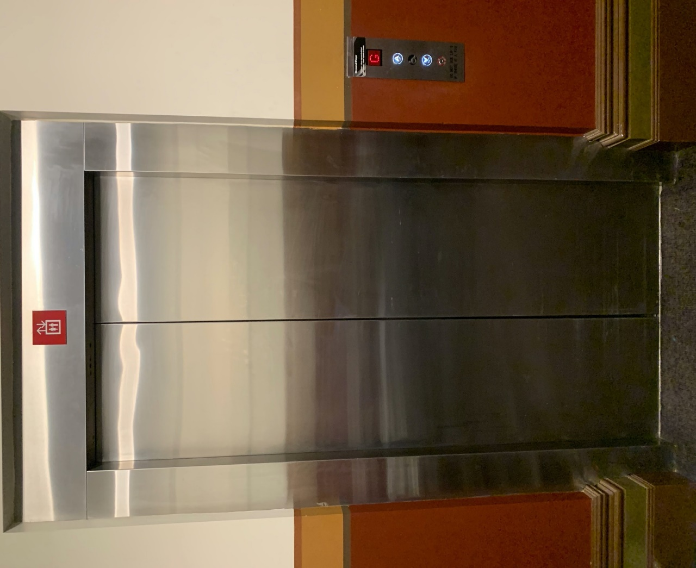

# **Transport**

## **Tram**

Route 57 (High Floor trams only)

Stop 12, North Melbourne Town Hall.

Please note, this is not a wheelchair accessible tram

[GETTING TO ARTS HOUSE VIDEO LINK](https://vimeo.com/544169506)

## **Train**

Arts House is 1.1km from   
North Melbourne Train Station,   
approximately 16 minute walk

[North Melbourne Station Information](https://www.ptv.vic.gov.au/stop/1144/north-melbourne-station/0/train/)

1.2km from Flagstaff Station,   
approximately 15 minute walk

[Flagstaff Station Information](https://www.ptv.vic.gov.au/stop/1068/flagstaff-station/0/train/#StopPage:::datetime=2023-04-06T04%3A41%3A27.669Z&directionId=-1&showAllDay=false&_auth=408ac3b1e97f4b0beb5bdf00c2f797057d10dd6e6cf2ad40a69334c4dfdf5e21)

## **Bus**

Bus number: 216

## **Parking**

There is limited paid on-street parking on Queensberry Street and Errol Street.

There are two accessible on street car parking spaces on Queensberry Street (150m to our accessible Errol Street entrance) for holders of a Parking Permit for Disabled people.

# **COVID Safety**

Please note: If you have a cough, sore throat, fever, shortness of breath or flu-like symptoms, you must not attend our venue or programs in person.

We will provide a refund if you need to cancel your attendance due to illness. Please [contact us](mailto:ArtsHouse.Ticketing@melbourne.vic.gov.au) by 9am on the day of the event.

To minimise the risk of COVID-19 transmission, we advise all patrons, artists and staff to:

* Practise physical distancing where possible
* Practise good hygiene by washing and or sanitising your hands often
* Wear a mask as directed by Victorian Government guidelines

Throughout the venue you will find:

* hand sanitiser stations available
* masks available (ask one of our staff for assistance)​
* increased signage to direct patron movement and avoid crowd congestion

We also ensure that spaces are well ventilated.

Staying COVID-safe remains important. We must all follow these steps:

* Follow the [Victorian Government’s measures on how to stay safe.](https://www.betterhealth.vic.gov.au/coronavirus-covid-19-victoria)
* Wear[face masks](https://www.betterhealth.vic.gov.au/coronavirus-covid-19-victoria) where required or when you cannot safely socially distance.
* Practise [COVID-safe hygiene protocols.](https://www.health.gov.au/news/health-alerts/novel-coronavirus-2019-ncov-health-alert/how-to-protect-yourself-and-others-from-coronavirus-covid-19/good-hygiene-for-coronavirus-covid-19)
* Test for COVID and get [free rapid antigen tests​](https://www.melbourne.vic.gov.au/community/health-support-services/health-services/Pages/free-rapid-antigen-tests.aspx) at nominated City of Melbourne customer service and library sites.