**An Evening of Power: Poetry and Plestia**By Muslim Agenda

Access Guide

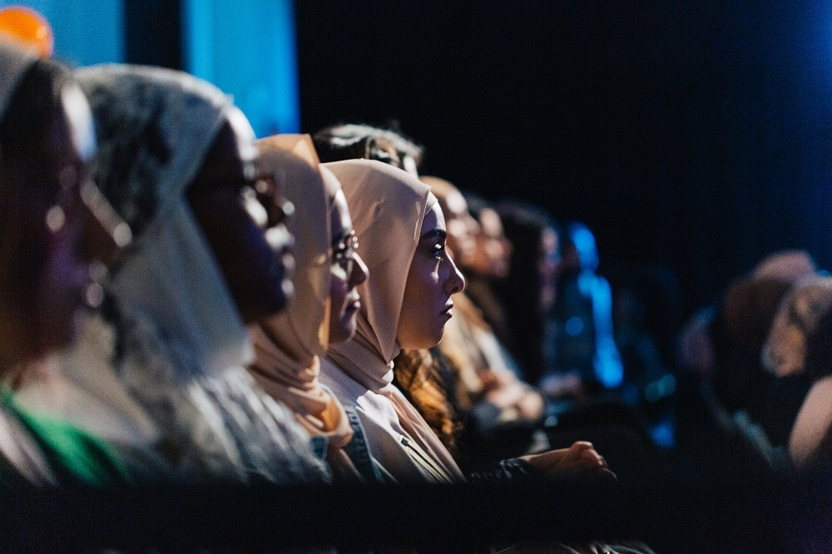

**Image credit:** Z by Zahrah

**Image description**: Four visibly Muslim women of colour seated in a row looking attentively in the direction of a stage. In the foreground are more attendees out of focus.

# **Updates to this document**

Please note, this performance is a new work and changes are being made by artists until opening. We will endeavour to provide the latest access information on performances to ticket holders across key stages of rehearsal and presentation.

Arts House website will contain the most up to date version of this document and all ticket holders will be notified of any revisions made 3 days and 1 day prior to the event.

This document was created: 18 July 2024

**Contents**

Updates to this document 1

Where 3

When 3

Access Services 3

Performers 5

Sensory Elements 8

Sound 8

Lighting 8

Physical 9

Smell 9

Visual 9

Entry to space 9

Shocks or surprises 9

Audience experience 9

Social expectations 9

Other 10

Content Warnings 10

General Notes 10

The Venue 10

Front Entrance 11

Accessible Entrances 11

Box Office 13

Ushers 13

Bar 14

Quiet Space 15

Bathrooms 15

Door to Main Hall 16

Lift 17

Transport 17

Tram 17

Train 18

Bus 18

Parking 18

COVID Safety 18

# **Where**

Arts House

521 Queensberry Street

North Melbourne VIC

# **When**

Friday 9 August 2024, 6pm

Duration: 180 minutes

# **Access Services**



Auslan Interpreted Performance



Assistance Animals are welcome.



Assistive Listening is available free of charge. Ask staff for assistance on arrival.



Visual Rating 50% – this event has music and sounds in the background.

   
Aural Rating 50% - this event is mainly sound-based with visuals only incidental to the work.



This performance is fully wheelchair accessible.

[](https://www.artshouse.com.au/about-us/#access-symbols)   
Quiet Space Available  
  
[](https://www.artshouse.com.au/about-us/#access-symbols)  
Companion Card holders are welcome.

# **Performers**

This event will be hosted by **Sara Mansour**.

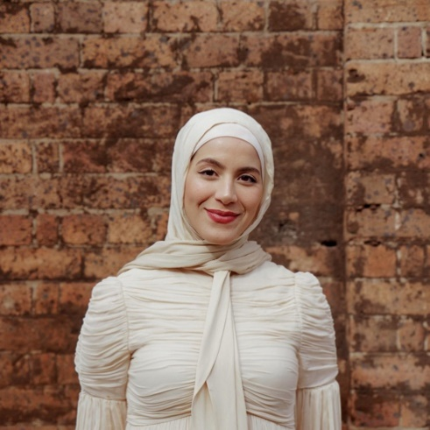

There will be poetry performances by 6 artists.

**Aishah Ali**

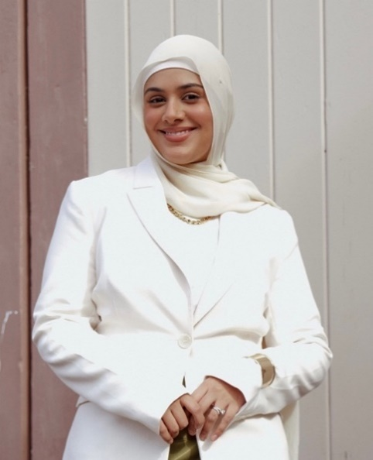

**Zuleyha Gurdag**

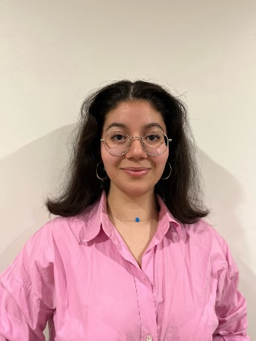

**Zaynab Farah**

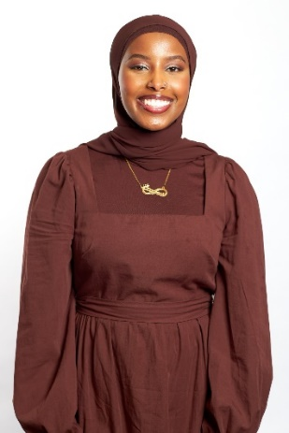

**Sanabil Ramahi**

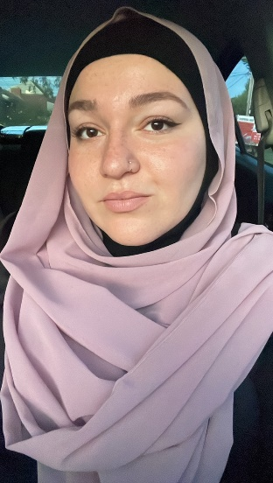

**Hawraa Kash**

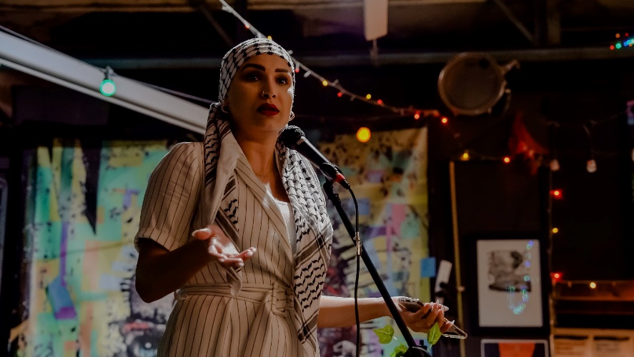

**Charaf Tartoussi**

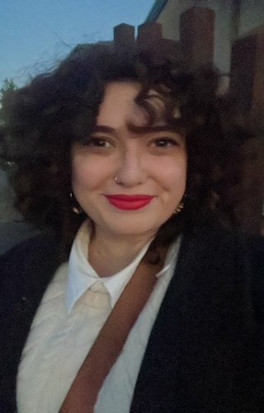

**Idil Ali**

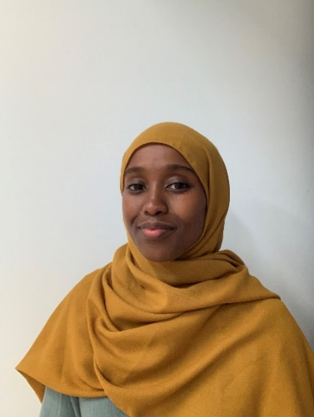

There will also be 3 speakers.

**Miski Omar – Director of ‘WARYA’**

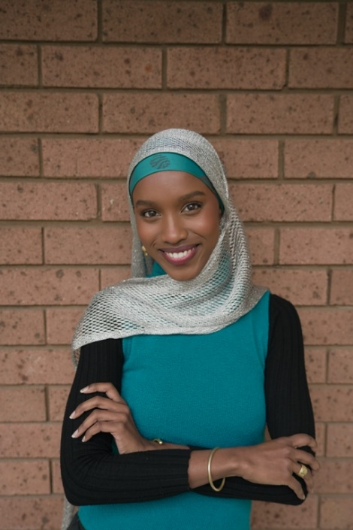

**Plestia Alaqad**

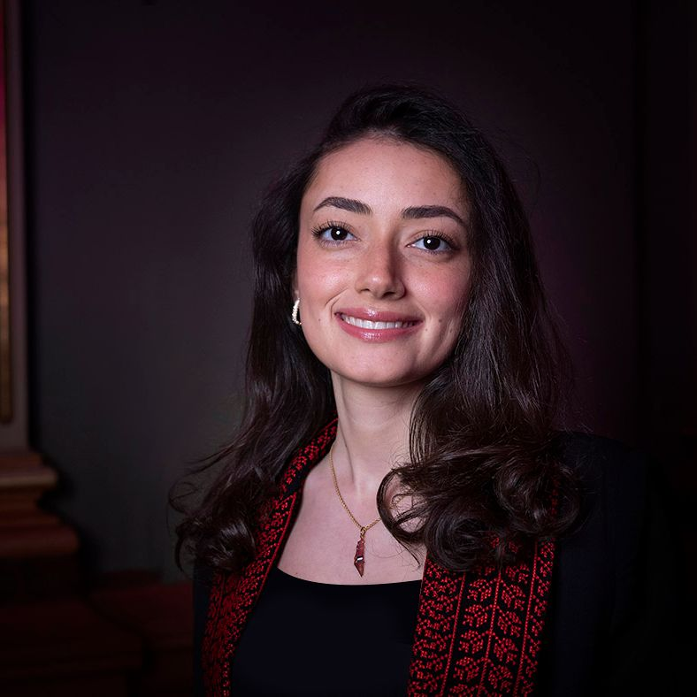

**Nour Haydar**

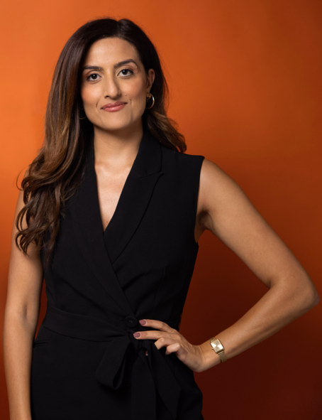

# **Sensory Elements**

## **Sound**

This event will be predominantly speaking. This includes speeches, spoken word poetry a conversational interview. There will also be a short film screening which includes some overlapping voices and sudden noises, but an overall moderate frequency.

## **Lighting**

The Main Hall will have soft, multi-coloured lighting. There are no flashing or moving lights. During the film screening, house lights will be dimmed.

## **Physical**

The venue has air conditioning. Rooms are an adequate temperature.

## **Smell**

There are no smells or scents used in the event. The foyer will be decorated with flowers that are fragrant. Beverages will be available at the bar that will include tea, coffee and mocktails, which may have a faint smell.

## **Visual**

All components of the event will take place on the stage. The stage will feature an arch decorated with flowers, a sofa, and a screen.

The spoken word performers will take the stage one at a time, standing centre stage and speaking into a standing mic.

The short film will be play on a large screen hanging above the stage.

Plestia and Nour will be seated on a large sofa for their conversation.

Audience Experience

## **Entry to space**

Entry to Arts House is via the main entrance on Queensberry Street. Once in the building, audiences can walk through the foyer and straight into the Main Hall.

## **Shocks or surprises**

There are no shocks or surprises in this event.

## **Audience experience**

At the end of the event, the speakers will open to the audience for a Q&A. There is no expectation to speak or participate.

## **Social expectations**

There will be a seating bank as well as rows of chairs at floor level available. As there is no allocated seating for this event, please let the front of house staff know if you would be most comfortable in a particular spot.

Attendees are welcome to utilise the bathrooms and prayer room during the interval.

There is no lock out (or lock in) for this event. Attendees are welcome to come and go as

they please.

# **Other**

## **Content Warnings**

During this event, there may be references to violence, war, and self-harm.

## **General Notes**

This event is alcohol-free. A prayer room is available which is identified as the ‘Quiet Room’. Please speak to our front of house staff for assistance.

# **The Venue**

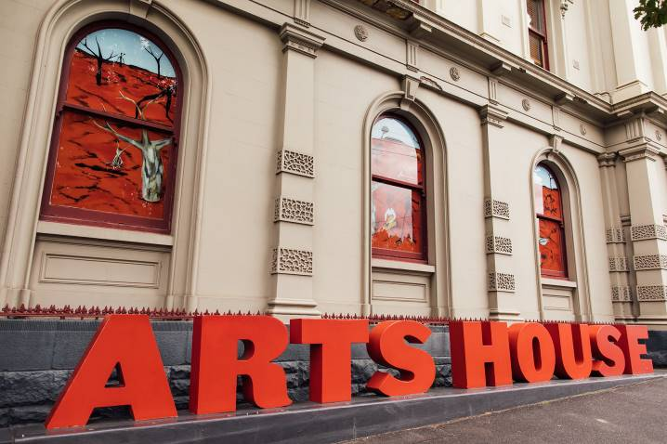

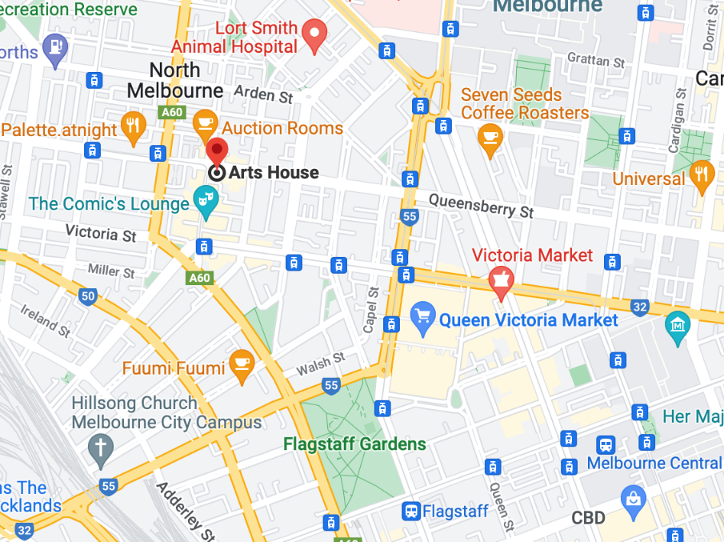

Image: North Melbourne Town Hall features giant red letters that say ARTS HOUSE out the front of it.

Image: a map of Arts House and its surrounding area. [LINK TO MAP](https://www.google.com/maps/place/Arts+House/@-37.802973,144.9486818,17z/data=!4m5!3m4!1s0x0:0x64c465ac7ef21cff!8m2!3d-37.803239!4d144.9498609?shorturl=1)

## **Front Entrance**

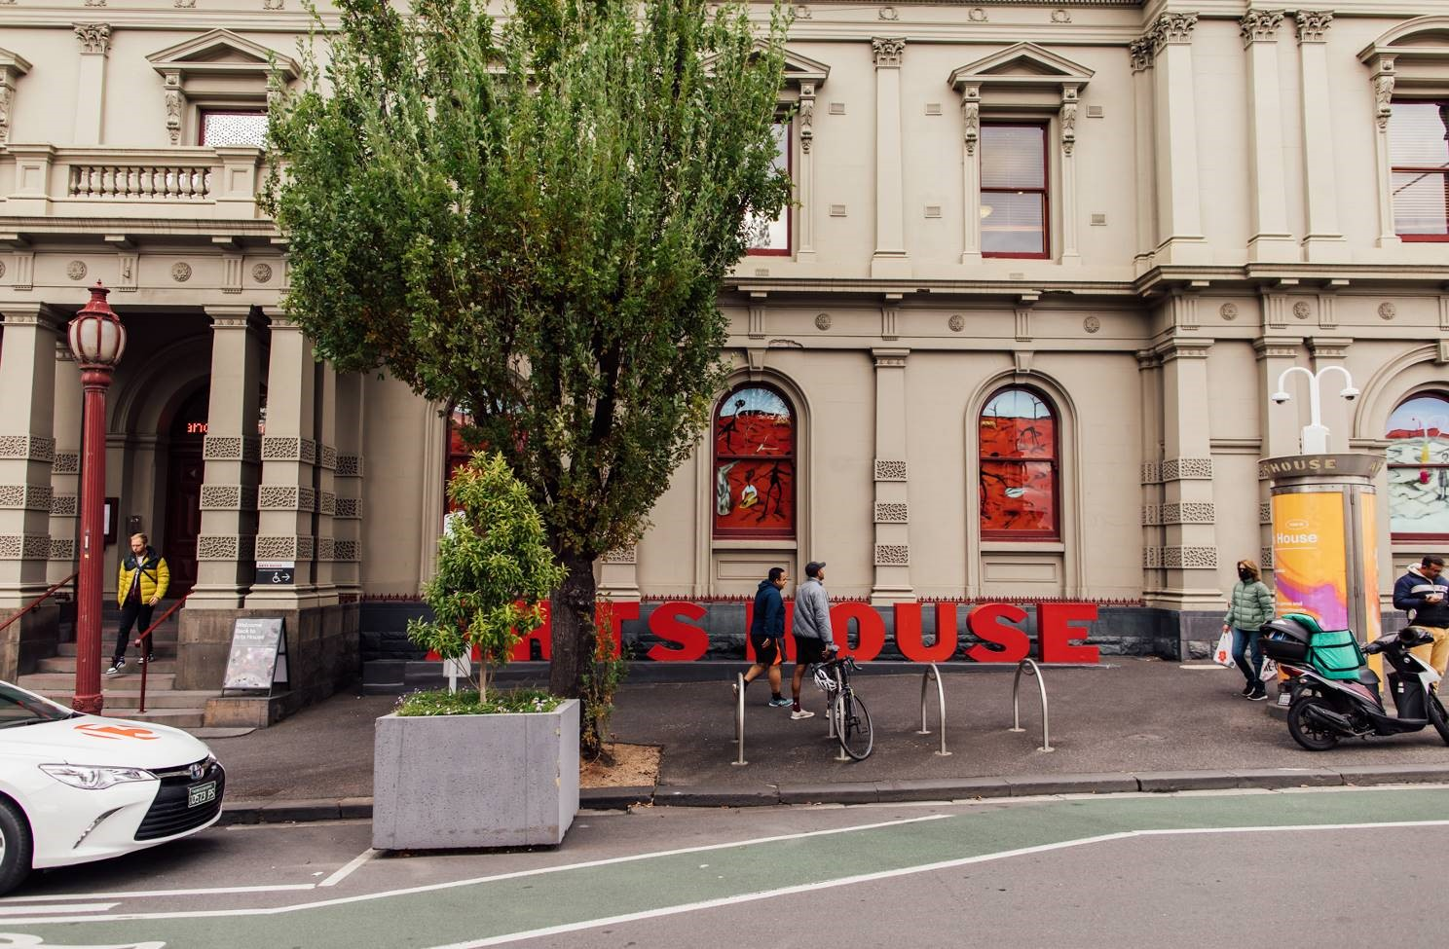

## **Accessible Entrances**



There are two Accessible Entrances. The first is on Errol St next to the Post Office.

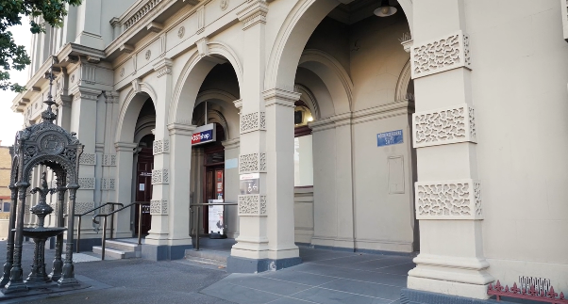

Image: Errol Street entrance next to the Post office with wheelchair accessible ramp or two steps with grab rails.

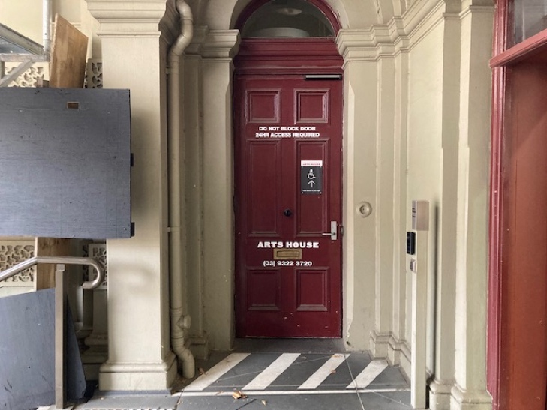

Image: View of door entrance.

The second Accessible Entrance is towards the end of George Johnson Lane.

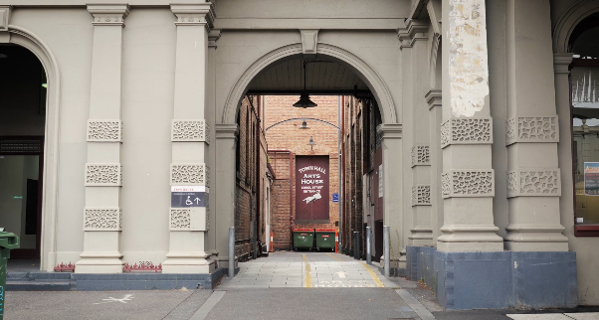

Image: View of George Johnson Lane from Errol St. The laneway passes through an archway with a brick wall at the end.

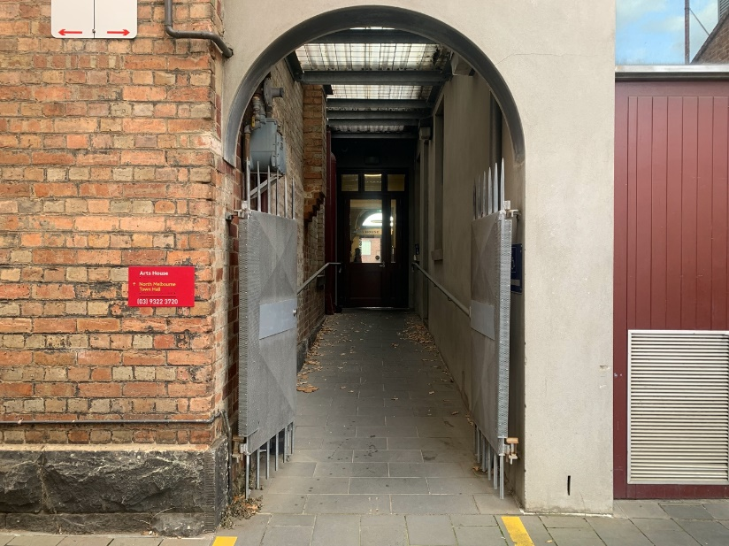

Image: view of the ramp leading from George Johnson Lane to the automated door which opens into the Arts House foyer.

## **Box Office**

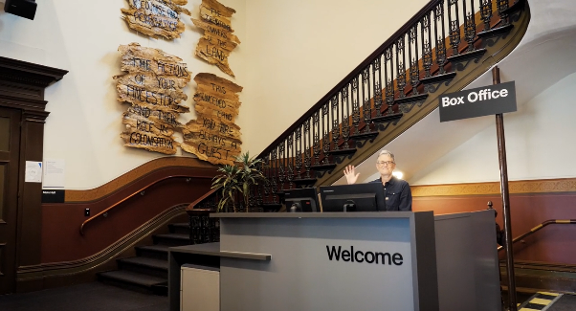

Box Office is located in the foyer under the stairwell.

## **Ushers**

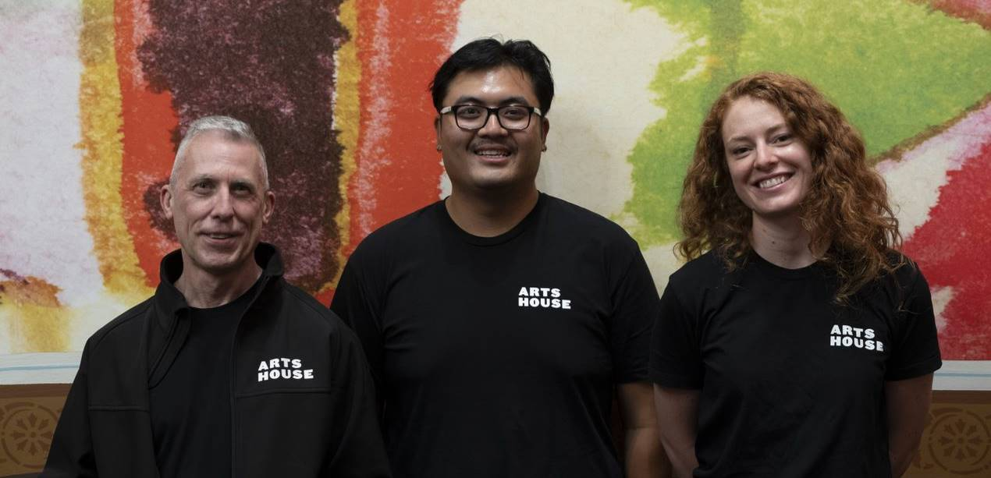

Ushers will be wearing black with an Arts House Logo on the left hand shoulder.

## **Bar**

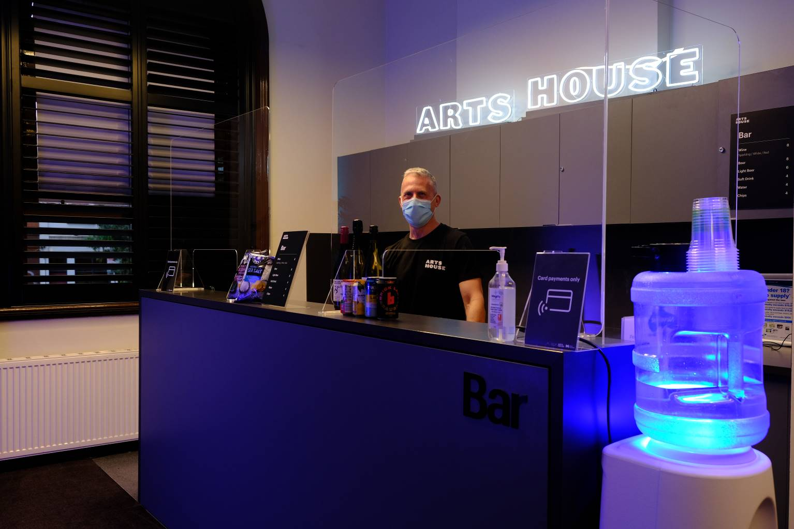

Bar staff will be wearing black with an Arts House Logo.

## **Quiet Space**



Arts House Quiet Space is located on Ground Level and is nearby reception and opposite the accessible bathrooms. It includes a range of seating options including soft furnishings, dimmable lights, sensory and stim objects. It is open during venue opening hours and events as a quiet space, prayer or parenting space.

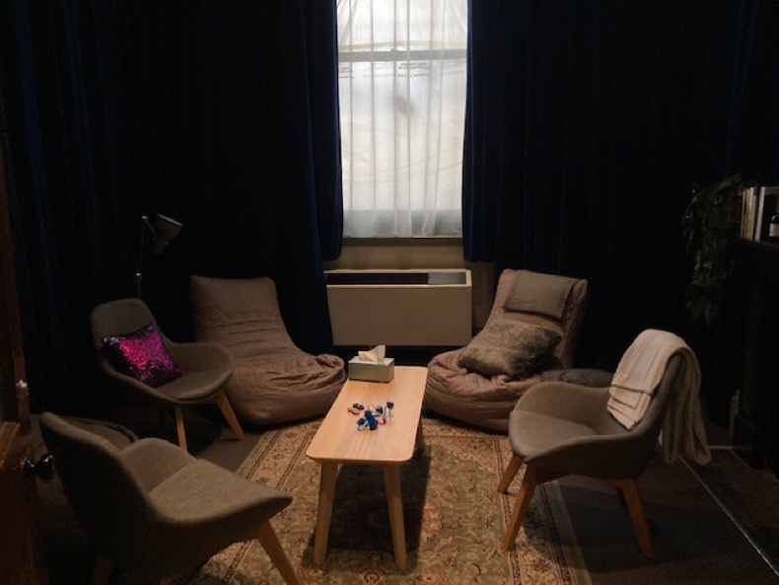

Image: Quiet space with lights dimmed

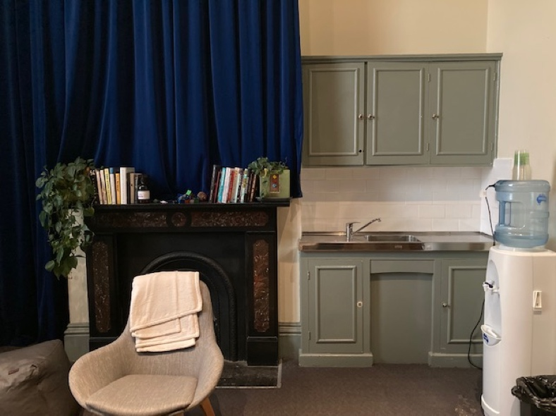

Image: Quiet space kitchenette and book shelf

## **Bathrooms**

All bathrooms have Dyson hand dryers with sensor activation. There is an accessible bathroom that is single use on ground level opposite the Quiet Space. There is another accessible bathroom upstairs – this is accessible via lift or stairs.

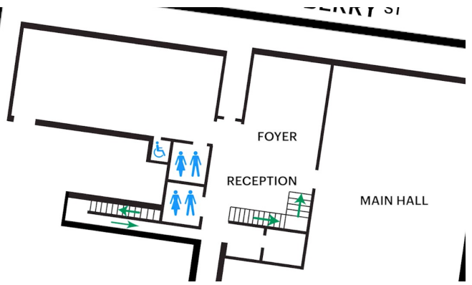

## **Door to Main Hall**

The event is in the Main Hall.

It is on the ground floor.

It is to the left of the box office desk and right of the bar.

A QR code to the artist statement is available on signage and warnings on the door.

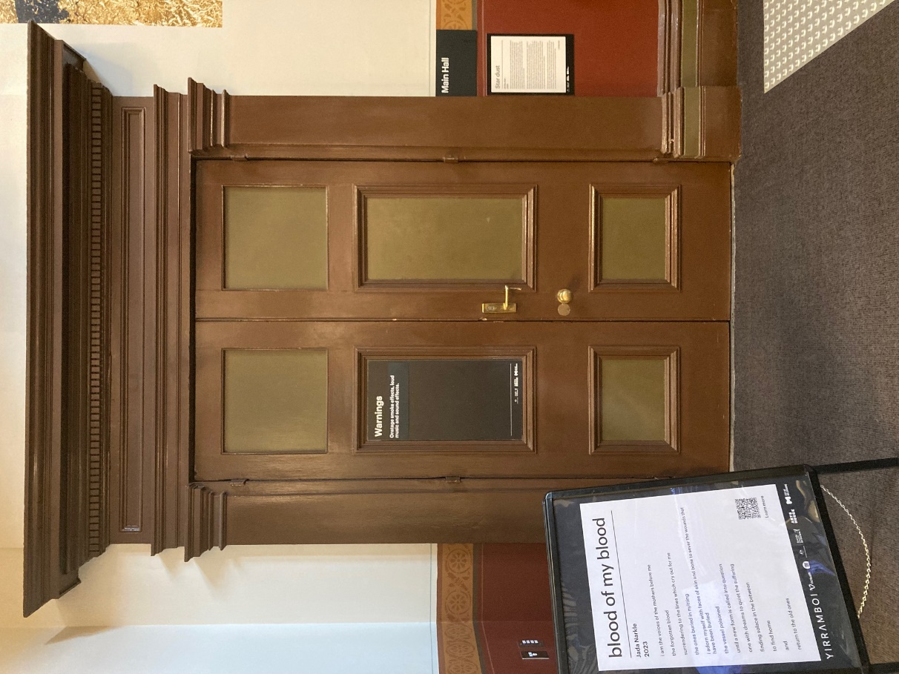

## **Lift**

The lift is located behind reception desk in the foyer.

The closest entry to the lift is via George Johnson Lane.

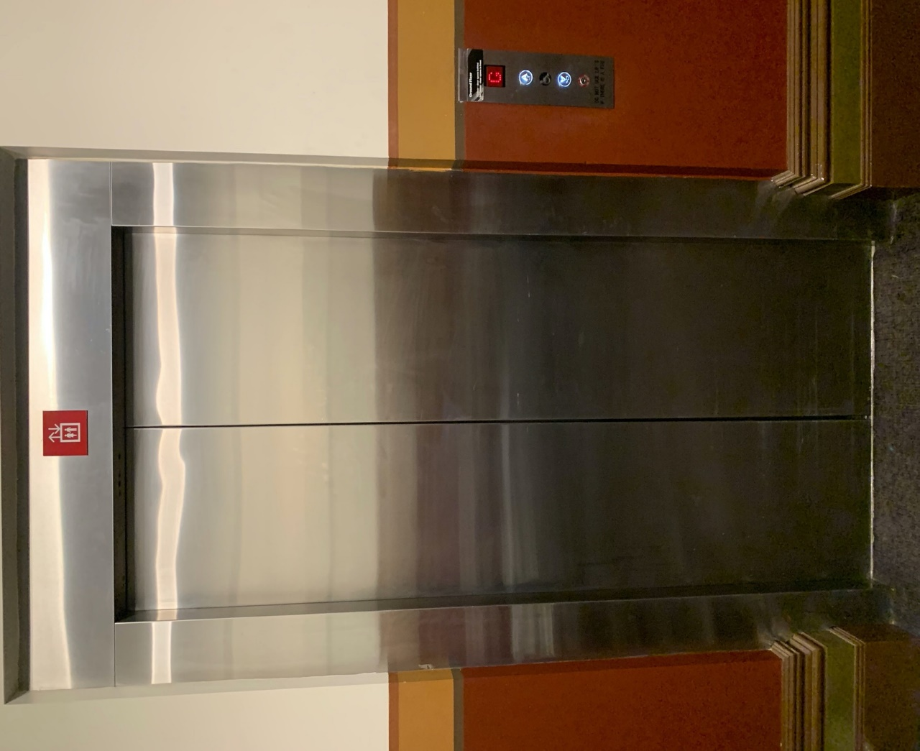

# **Transport**

## **Tram**

Route 57 (High Floor trams only)

Stop 12, North Melbourne Town Hall.

Please note, this is not a wheelchair accessible tram

[GETTING TO ARTS HOUSE VIDEO LINK](https://vimeo.com/544169506)

## **Train**

Arts House is 1.1km from   
North Melbourne Train Station,   
approximately 16 minute walk

[North Melbourne Station Information](https://www.ptv.vic.gov.au/stop/1144/north-melbourne-station/0/train/)

1.2km from Flagstaff Station,   
approximately 15 minute walk

[Flagstaff Station Information](https://www.ptv.vic.gov.au/stop/1068/flagstaff-station/0/train/#StopPage:::datetime=2023-04-06T04%3A41%3A27.669Z&directionId=-1&showAllDay=false&_auth=408ac3b1e97f4b0beb5bdf00c2f797057d10dd6e6cf2ad40a69334c4dfdf5e21)

## **Bus**

Bus number: 216

## **Parking**

There is limited paid on-street parking on Queensberry Street and Errol Street.

There are two accessible on street car parking spaces on Queensberry Street (150m to our accessible Errol Street entrance) for holders of a Parking Permit for Disabled people.

# **COVID Safety**

Please note: If you have a cough, sore throat, fever, shortness of breath or flu-like symptoms, you must not attend our venue or programs in person.

We will provide a refund if you need to cancel your attendance due to illness. Please [contact us](mailto:ArtsHouse.Ticketing@melbourne.vic.gov.au) by 9am on the day of the event.

To minimise the risk of COVID-19 transmission, we advise all patrons, artists and staff to:

* Practise physical distancing where possible
* Practise good hygiene by washing and or sanitising your hands often
* Wear a mask as directed by Victorian Government guidelines

Throughout the venue you will find:

* hand sanitiser stations available
* masks available (ask one of our staff for assistance)​
* increased signage to direct patron movement and avoid crowd congestion

We also ensure that spaces are well ventilated.

Staying COVID-safe remains important. We must all follow these steps:

* Follow the [Victorian Government’s measures on how to stay safe.](https://www.betterhealth.vic.gov.au/coronavirus-covid-19-victoria)
* Wear[face masks](https://www.betterhealth.vic.gov.au/coronavirus-covid-19-victoria) where required or when you cannot safely socially distance.
* Practise [COVID-safe hygiene protocols.](https://www.health.gov.au/news/health-alerts/novel-coronavirus-2019-ncov-health-alert/how-to-protect-yourself-and-others-from-coronavirus-covid-19/good-hygiene-for-coronavirus-covid-19)
* Test for COVID and get [free rapid antigen tests​](https://www.melbourne.vic.gov.au/community/health-support-services/health-services/Pages/free-rapid-antigen-tests.aspx) at nominated City of Melbourne customer service and library sites.