**Neighbourhood Gathering, Season 2 2024**

Hosted by Arts House

Access Guide

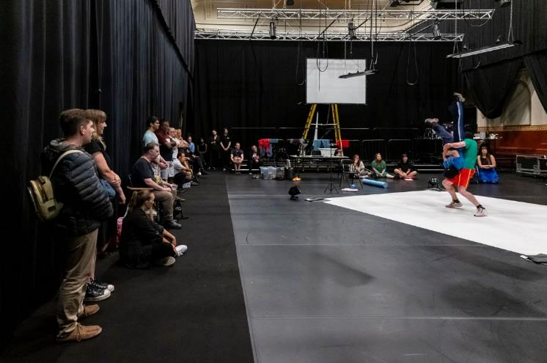

**Image credit:** Tiffany Garvie

**Image description:** Two dancers rehearsing in a large hall. Around them, people sit and stand, watching them perform.

# **Updates to this document**

Please note, this event includes a rehearsal excerpt of a new work and changes are being made by artists until opening. We will endeavour to provide the latest access information across key stages of planning.

Arts House website will contain the most up to date version of this document and all ticket holders will be notified of any revisions made 1 day prior to the event.

This document was created: 19 July 2024

**Contents**

Updates to this document 1

Where 3

When 3

Access Services 3

Co-Hosts 5

Running Order 7

Sensory Elements 7

Sound 7

Lighting 7

Physical 8

Smell 8

Visual 8

Entry to space 8

Shocks or surprises 10

Audience experience 10

Social expectations 10

Other 11

Content Warnings 11

General Notes 11

The Venue 12

Front Entrance 12

Accessible Entrances 13

Reception and Box Office 14

Ushers 14

Quiet Space 15

Bathrooms 15

Door to Main Hall 16

Transport 17

Tram 17

Train 17

Bus 17

Parking 17

COVID Safety 18

# **Where**

Arts House

521 Queensberry Street

North Melbourne VIC

# **When**

Wednesday 24 July 2024  
10:30am

Duration: 90 minutes

# **Access Services**



Interpreted by Auslan Stage Left.



Audio Describer Guides available for meet and assist and one-on-one descriptions of performance excerpt. This service needs to be pre-booked.



Assistance Animal are welcome.



This performance is fully wheelchair accessible.

# **Speakers & Performers**

|  |  |
| --- | --- |
| **Kath Duncan**  Speaker– Neighbourhood Gathering | **Lorna Hannan**  Speaker– Neighbourhood Gathering |

|  |  |
| --- | --- |
| **Olivia Anderson**  MC/Speaker, Arts House  Acting Artistic Director | **Varsha Ramesh**  Speaker, Arts House  Acting Creative Producer |

|  |  |
| --- | --- |
| **Eden Falk**  *EDGING -* Performer | **Sammaneh Pourshafihgi**  *EDGING -* Performer |

Approximately 12 other members of Arts House staff will also be in attendance.

|  |  |  |
| --- | --- | --- |
|  |  |  |
| **Creative Program Lead**  Amrit Gill | **Program Manager**  Sarah Rowbottam | **Creative Producer**  Louana Sainsbury |
| **Associate Producer**  Tish Brennan-Steer | **Marketing Manager**  Jake Davies | **Access Advisor**  Artemis Munoz |
| **Business Manager**  Brian Horder | **Business Support Officer**  Trudy Hayter | **Business Support Officer**  Jordyn McGeachin |
| **Production Manager**  Tony MacDonald | **Technical Coordinator**  Bart Mangan | **Venue Technician**  Taran Ablitt |

# **Running Order**

10.15am Doors Open & light refreshments available from ASRC

10.30am Acknowledgement of Country, Introduction to speakers and what today is all about – hosted by Acting Artistic Director Olivia Anderson

10.40am Some of the Arts House staff will introduce themselves and shares insight into their roles

10.50am Discussion about Season 2, 2024 program between Olivia Anderson, Varsha Ramesh, Kath Duncan and Lorna Hannan

11.30am We will move to the Warehouse, a separate self-contained building to watch a short excerpt from *EDGING* by APHIDS + a short Q&A hosted by Varsha

Ramesh

12.00pm Finish

# **Sensory Elements**

## **Sound**

The first part of this event is conversational and speakers will use microphones. Soft background music will be playing in the venue foyer as people arrive.

Part way through this event we will move to The Warehouse to experience a short performance excerpt from *EDGING* by APHIDS. This rehearsal will involve spoken word, loud music and coarse language. At times sound and voice are overlapping and competitive.

## **Lighting**

The Neighbourhood Gathering conversation will be standard interior building lighting with no flashing or moving lights.

The rehearsal excerpt of *EDGING* will be standard interior building lighting. One moment will include a small flashing light.

## **Physical**

The venue has heating and air conditioning. The rooms maintain an ambient temperature. When we move from Arts House main building to the Warehouse building, we will be outside for a short period of time and the weather may be inclement.

## **Smell**

The Neighbourhood Gathering will have an assortment of vegetarian catering available in the space from Asylum Seeker Resource Centre that will include the smell of spices, fruit and other ingredients.

This menu includes:

* Feta and spinach triangles baked with sesame seeds and sumac
* Ganache filled profiterole
* ASRC selected Danishes

The rehearsal excerpt of *EDGING* involves no scent.

## **Visual**

The speakers will sit in a row of chairs marked out by a rug. At the side of the speakers, there will be a large screen playing a slideshow of images from our Season 2 program. There will be a number of standard seats in the space and high bar tables for guests.

The rehearsal excerpt of *EDGING* includes two performers. The staging set-up includes a white floor cover, large yellow ladder, conveyor belt, large LCD screen with a live video feed of the performers and a camera. There are two microphones on stands which the performers use at times. The performers move around the whole space and make eye contact with the audience.

Audience Experience

## **Entry to space**

The first part of the event will take place in the Main Hall. Front of house staff will guide you to this space from the foyer.

Access to Main Hall space:

* The Main Hall can be accessed on ground level next to reception
* Entry to the main hall is through large double doors in the main foyer. The doors open towards you.

The performance of *EDGING* will take place in The Warehouse. The space is outside of Arts House’s main building and is accessible via George Johnson Lane. Front of House staff will guide you to the space.

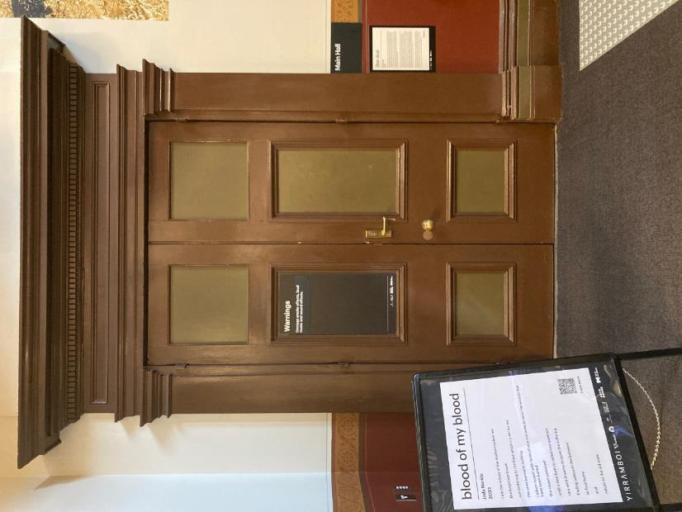

Image: view of main hall wooden doors pictured closed. There is a door handle on the left door, on the right hand side. There is a sign infront of the door.

Access to Warehouse space:

The Warehouse is separate to the main building of Arts House. You can find the Warehouse by following George Johnson Lane as it snakes around the back of the main Arts House building. Staff will guide you to this space.

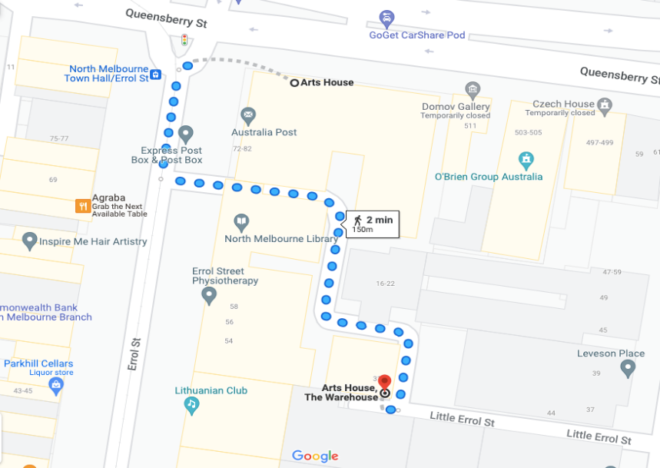

Image: a screenshot of a map with walking directions from the front of the main building of Arts House to the Warehouse behind it. The map indicates a 2 minute walk. The path to the Warehouse from George Johnson Lane is a smooth asphalt surface with a cobblestone strip in the centre for part of the journey.

Entry to the Warehouse:

Entry is via a ramp and through a sliding glass door

The main Warehouse entrance has a wheelchair accessible ramp that is 1150mm wide. The bottom section of the ramp has a gradient of 1:6 and has no handrails. The upper section has a gradient of 1:12 and has handrails on both sides.

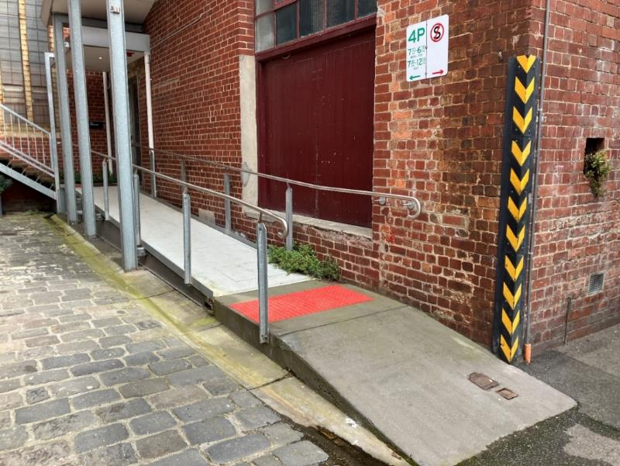

Image: view of the ramp leading to the main entrance of the Warehouse. The bottom section has no handrails. There are handrails either side of the ramp at the top section and a large red tactile surface indicator on the flat middle section. The door to Warehouse is on the right at the top of this ramp.

## **Shocks or surprises**

The rehearsal excerpt of *EDGING* includes sudden loud sounds.

## **Audience experience**

The Neighbourhood Gathering involves optional light social interaction with other members of the public and Arts House staff.

The rehearsal excerpt of *EDGING* involves optional audience participation. Audience will individually be asked questions by a performer. You can choose to respond or not.

If you do not want to be asked a question, the artists recommend you do not sit in the front row.

## **Social expectations**

There will be a variety of seating options at the Neighbourhood Gathering. There is no allocated seating – you are welcome to sit or stand anywhere you like in the room.

Audience members are welcome to come and go in the space and have a cuppa or snack whilst the session is happening.

The rehearsal excerpt of *EDGING* is a seated experience. It is preferred audience do not talk or move around the space during the showing.

# **Other**

## Content Warnings

The rehearsal excerpt of *EDGING* excerpt will contain mentions of border security procedures, coarse language and references to sex and drug taking.

## **General Notes**

The session begins with an Acknowledgement of Country.

There are two Auslan interpreters present in the space from Stage Left interpreting all spoken words.

There is one Audio Describer in the space providing visual descriptions to blind/ low vision audience members. You may overhear them speak softly during the rehearsal.

# **The Venue**

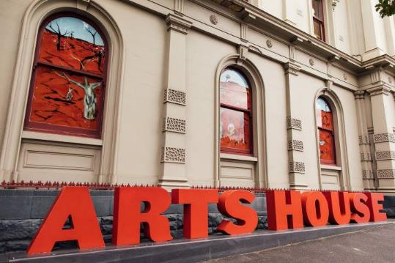

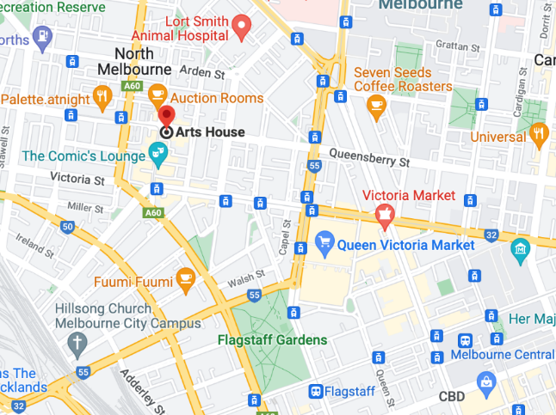

Image: North Melbourne Town Hall features giant red letters that say ARTS HOUSE out the front of it.

Image: a map of Arts House and its surrounding area. [LINK TO MAP](https://www.google.com/maps/place/Arts+House/@-37.802973,144.9486818,17z/data=!4m5!3m4!1s0x0:0x64c465ac7ef21cff!8m2!3d-37.803239!4d144.9498609?shorturl=1)

## **Front Entrance**

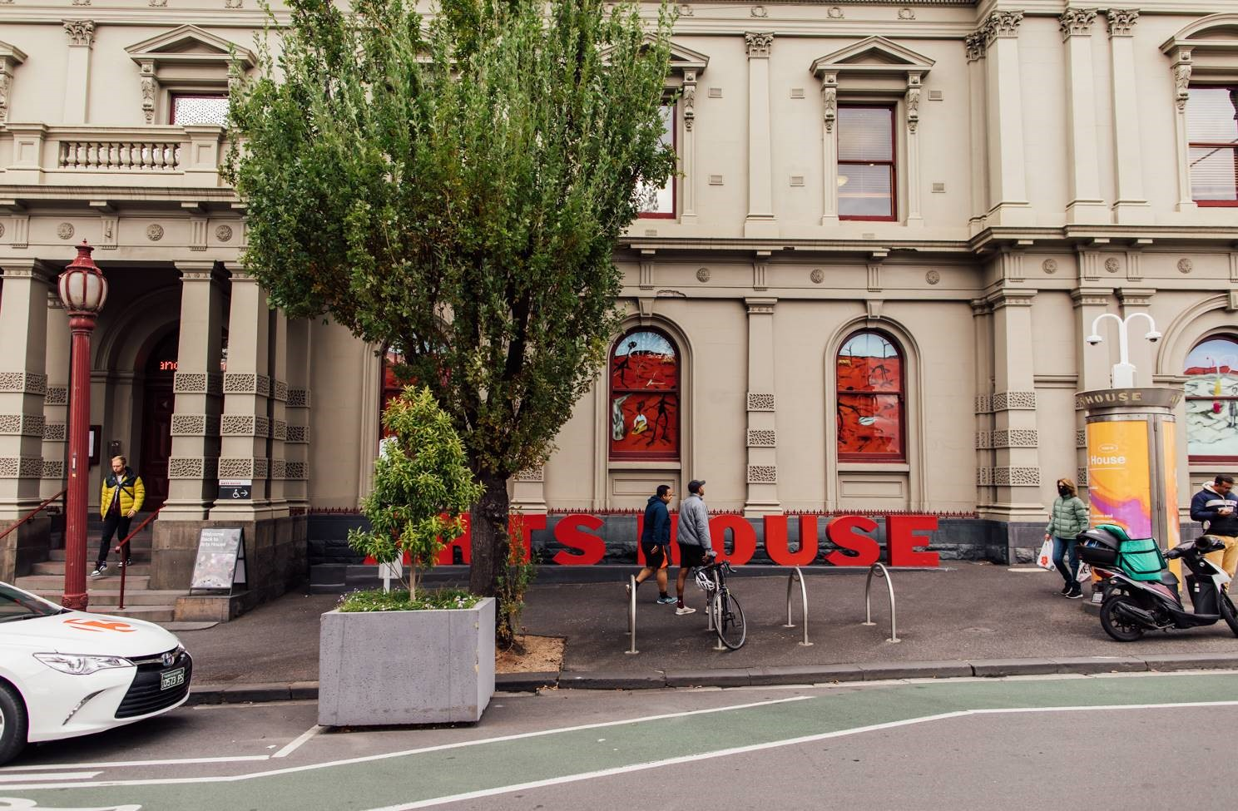

## **Accessible Entrances**



There are two Accessible Entrances. The first is on Errol St next to the Post Office.

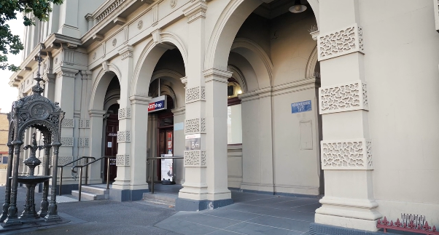

Image: Errol Street entrance next to the Post office with wheelchair accessible ramp or two steps with grab rails.

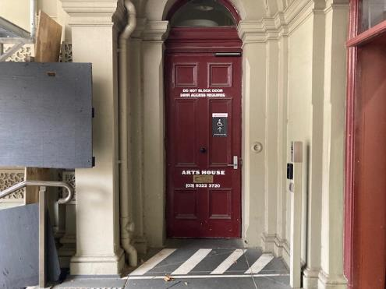

Image: View of door entrance.

The second Accessible Entrance is towards the end of George Johnson Lane.

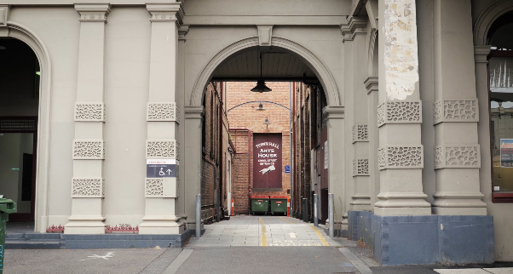

Image: View of George Johnson Lane from Errol St. The laneway passes through an archway with a brick wall at the end.

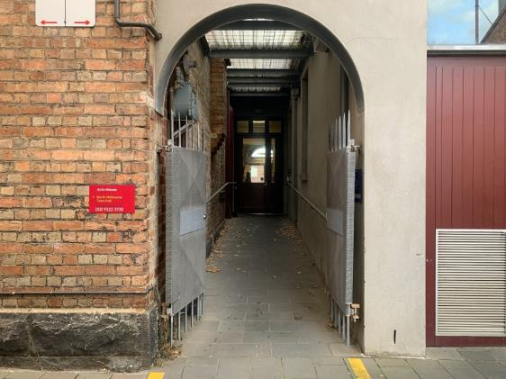

Image: view of the ramp leading from George Johnson Lane to the automated door which opens into the Arts House foyer.

## **Reception and Box Office**

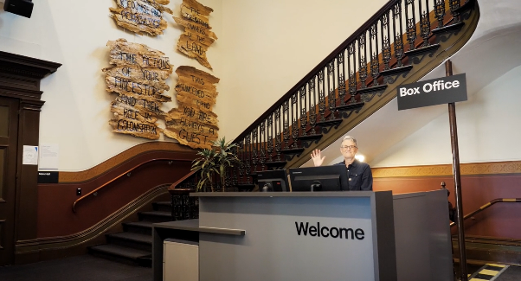

Box Office is located in the foyer at reception under the stairwell.

## **Ushers**

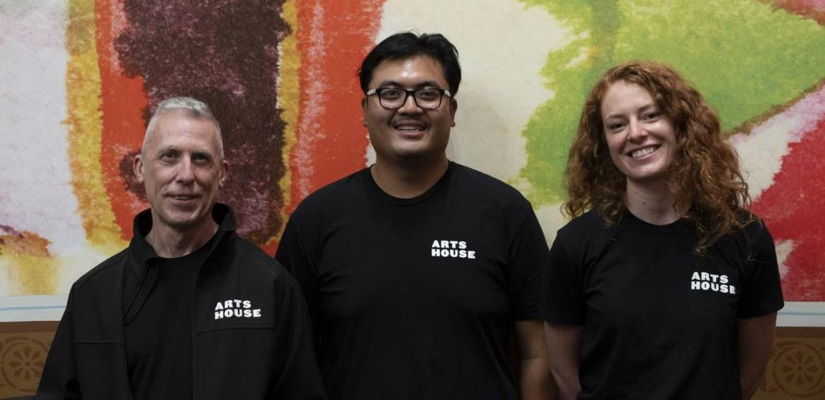

Ushers will be wearing black with an Arts House Logo on the left hand shoulder

## **Quiet Space**



Arts House Quiet Space is located on Ground Level and is nearby reception and opposite the accessible bathrooms. It includes a range of seating options including soft furnishings, dimmable lights, sensory and stim objects. It is open during venue opening hours and events as a quiet space, prayer or parenting space.

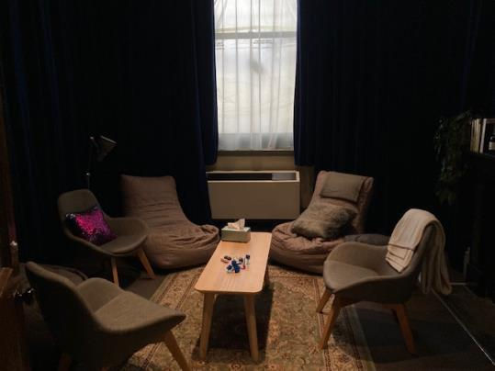

Image: Quiet space with lights dimmed

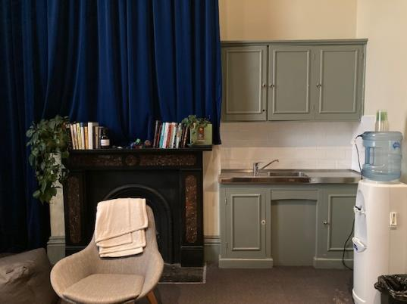

Image: Quiet space kitchenette and book shelf

## **Bathrooms**

All bathrooms have Dyson hand dryers with sensor activation. There is an accessible bathroom that is single use on ground level opposite the Quiet Space. There is another accessible bathroom upstairs – this is accessible via lift or stairs.

# **Transport**

## **Tram**

Route 57 (High Floor trams only)

Stop 12, North Melbourne Town Hall.

Please note, this is not a wheelchair accessible tram

[GETTING TO ARTS HOUSE VIDEO LINK](https://vimeo.com/544169506)

## **Train**

Arts House is 1.1km from   
North Melbourne Train Station,   
approximately 16 minute walk

[North Melbourne Station Information](https://www.ptv.vic.gov.au/stop/1144/north-melbourne-station/0/train/)

1.2km from Flagstaff Station,   
approximately 15 minute walk

[Flagstaff Station Information](https://www.ptv.vic.gov.au/stop/1068/flagstaff-station/0/train/#StopPage:::datetime=2023-04-06T04%3A41%3A27.669Z&directionId=-1&showAllDay=false&_auth=408ac3b1e97f4b0beb5bdf00c2f797057d10dd6e6cf2ad40a69334c4dfdf5e21)

## **Bus**

Bus number: 216

## **Parking**

There is limited paid on-street parking on Queensberry Street and Errol Street.

There are two accessible on street car parking spaces on Queensberry Street (150m to our accessible Errol Street entrance) for holders of a Parking Permit for Disabled people.

# **COVID Safety**

If you have a cough, sore throat, fever, shortness of breath or flu-like symptoms, you must not attend our venue or programs in person.

We will provide a refund if you need to cancel your attendance due to illness. Please [contact us](mailto:ArtsHouse.Ticketing@melbourne.vic.gov.au) by 9am on the day of the event.

To minimise the risk of COVID-19 transmission, we advise all patrons, artists and staff to:

* Practise physical distancing where possible
* Practise good hygiene by washing and or sanitising your hands often
* Wear a mask as directed by Victorian Government guidelines

Throughout the venue you will find:

* hand sanitiser stations available
* masks available (ask one of our staff for assistance)​
* increased signage to direct patron movement and avoid crowd congestion

We also ensure that spaces are well ventilated.

Staying COVID-safe remains important. We must all follow these steps:

* Follow the [Victorian Government’s measures on how to stay safe.](https://www.betterhealth.vic.gov.au/coronavirus-covid-19-victoria)
* Wear[face masks](https://www.betterhealth.vic.gov.au/coronavirus-covid-19-victoria) where required or when you cannot safely socially distance.
* Practise [COVID-safe hygiene protocols.](https://www.health.gov.au/news/health-alerts/novel-coronavirus-2019-ncov-health-alert/how-to-protect-yourself-and-others-from-coronavirus-covid-19/good-hygiene-for-coronavirus-covid-19)
* Test for COVID and get [free rapid antigen tests​](https://www.melbourne.vic.gov.au/community/health-support-services/health-services/Pages/free-rapid-antigen-tests.aspx) at nominated City of Melbourne customer service and library sites.