**GURR ERA OP**

By Ghenoa Gela

Access Guide

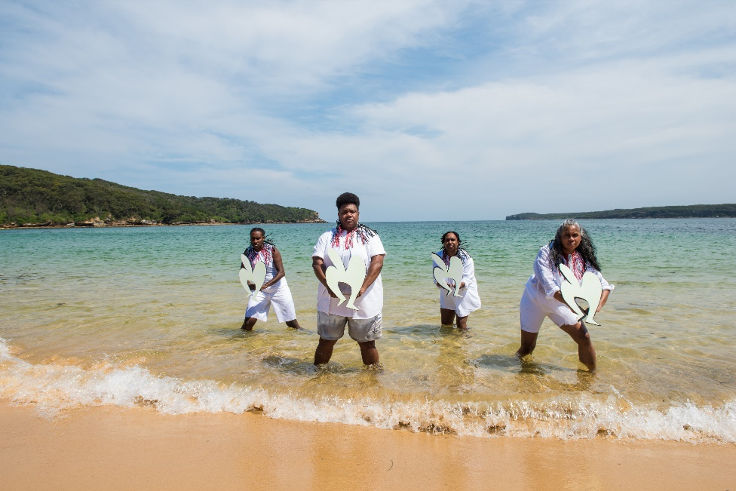

Image Credit: Ashley de Prazer

Image Description: Four Torres Strait Islander women are standing in the shore of the ocean, looking towards the camera. It is daytime with a blue sky with fluffy clouds. The woman are standing strong as the water moves. They are wearing all white with black and red zazi necklaces and holding masks.

# **Updates to this document**

Please note, this performance is a new work and changes are being made by artists until opening. We will endeavour to provide the latest access information on performances to ticket holders across key stages of rehearsal and presentation.

Arts House website will contain the most up to date version of this document and all ticket holders will be notified of any revisions made 3 days and 1 day prior to the event.

This document was created: 6 June 2024

Contents

**Updates to this document** 1

**Where** 3

**When** 3

**Access Services** 4

**Performers** 6

**Sensory Elements** 6

Sound 7

Lighting 7

Smell 7

Visual 8

**Audience Experience** 8

Entry to space 8

Shocks or surprises 9

Audience experience 9

Social expectations 9

Performance expectations 9

Content Warnings 10

**The Venue** 11

Front Entrance 11

Accessible Entrances 11

Box Office 13

Ushers 13

Bar 14

Quiet Space 15

Bathrooms 15

Door to Main Hall 16

Lift 17

**Transport** 17

Tram 17

Train 18

Bus 18

Parking 18

**COVID Safety** 18

# **Where**

Arts House

521 Queensberry Street

North Melbourne VIC

# **When**

Wednesday 12 – Sunday 16 June 2024

Wednesday 12 June, 7.30pm

Thursday 13 June, 7.30pm, followed by a post-show artist talk

Friday 14 June, 7.30pm

Saturday 15 June, 2pm & 7.30pm

Sunday 16 June, 5pm  
  
Duration: 70 minutes

# **Access Services**

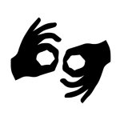

Auslan Interpreted Performance - Thursday 13 June, 5pm



Assistance Animal are welcome.

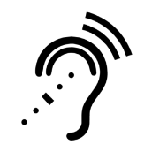

Assistive Listening is available free of charge. Ask staff for assistance on arrival.



Visual Rating 50% – this performance has music and sounds in the background.

    
Aural Rating 50% – this performance has music and sounds in the background.



This performance is fully wheelchair accessible.

     
Companion card holders are welcome.   
   
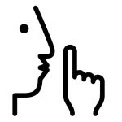

Quiet space available.

[](https://www.artshouse.com.au/about-us/#access-symbols)   
Performance with Relaxed Elements – Sunday 16 June, 5pm.  
   
  
A Relaxed Performance is designed to meet the sensory needs of neurodivergent individuals, including autistic people, ADHD people, anxious and depressed people, traumatised people, and any other person with a diagnosed neurodivergence who needs a little more care to ensure a smooth and considered experience at the theatre. However, this is by no means an exclusive event, and Relaxed Performances are suitable for all audiences. If you are someone with a young family, have an intense or emotional demanding job, feel uncomfortable in a more traditional theatre space, or just want to see a show that isn’t quite so loud, Relaxed Performances are right for you too.

There will be staff assigned to ensure the environment is welcome and safe for your needs.

# **Performers**

There are three performers in this show.

Ghenoa Gela (she/her)

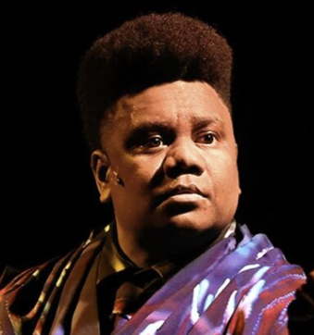

Taryn Beatty (she/her)

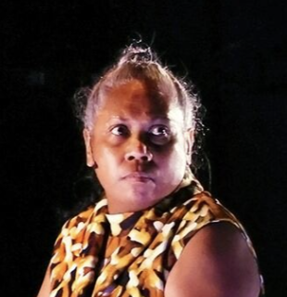

Aba Bero (she/her)

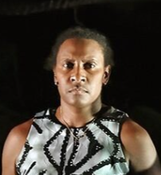

# **Sensory Elements**

## **Sound**

There is sound and music played throughout the performance. This includes moments that are loud, at high and low registers, sections with a repeated beat and use of pre-recorded voices which at times overlap with spoken dialogue. The performers speak in English and at times in Meriam Mir, a traditional language of the Eastern islands of the Torres Strait. At times, you may feel vibrations or rumbles through your seat.

**Timings of all sound warnings:**

Approximately 25 minutes into the show, a repeated drum sound plays, building gradually. Approximately 55 minutes into the show, there are loud ocean and rumble sounds accompanied by a sudden black out. Roughly five minutes later, the crash of a loud wave sounds followed by a repeated reverberated loud bass sound that builds in intensity.

Please note that for the Relaxed Performance on Sun 15 Jun, 5pm, the audio will be limited to reduce sudden changes to fades.

## **Lighting**

The performance contains dynamic lighting in vibrant pinks, blues and yellows. A UV lighting effect is used, giving certain costume and prop elements a coloured glow. Roughly one hour into the performance, a bright light is briefly shone in the direction of the audience.

The performance contains several moments of black out.

A black out is when there will be no lights on in the theatre and sometimes may happen suddenly. The stage and auditorium will not stay dark for long.

Please note that for the Relaxed Performance on Sun 16 Jun, 5pm, the lighting will not include the blinder light and house lights will remain at a low level during the show.

**Physical**

Most of the action of the performers during the show occurs on the stage within the performance space. In the early moments of the performance, the performers will walk up the auditorium stairs alongside the audience.

Please note that the Relaxed Performance on Sun 15 Jun, 5pm will be identical to other shows — all the same words, blocking, music and plot points are going to be performed.

## **Smell**

There are no smells or scents used in the performance.

## **Visual**

The set is made up of over 150 crab pots made of a grey steel frame and netting in colours of fluorescent orange, dark orange, bright blue, dark blue, yellow, white, grey and turquoise. A fish net speckled with blue and yellow hangs from the ceiling behind a wall of crab pots at the back of the stage, and another hangs in a hammock formation to the side stage.

Many of the crab pots are moved around by the performers to create different shapes and structures throughout the performance. They start as one large central pile, before being split by the performers pulling on thick rope. Some are thrown into the hung netting and a few traps make small towers before being distributed into a wall at the front of the stage.

The crab pots are not connected to one another and can very occasionally fall unexpectedly or be dropped by the performers as they are moving them.

The performers have masks that they wear and hold at several points throughout the performance. The costumes worn are colourful and the fabric is patterned like coral that gradually change throughout the performance from vibrant colours to black and white.

* Ghenoa wears a purple and black coral-patterned costume (pants, vest, tie and gloves).
* Aba wears a red and black coral-patterned costume (track pants, jumper and crop top).
* Taryn wears a yellow and black coral-patterned costume (tights, jacket with tails).

# **Audience Experience**

## **Entry to space**

The audience will enter the performance space through the Arts House foyer. In the foyer, a video of the team visiting the Erub islands in the Torres Strait will be playing on a screen and information about the Torres Strait Islands will be available to read. There is a bar in the foyer, and for this performance there will also be a tea station.

There will be an announcement when the doors to the Main Hall are opened, and the audience will be directed to take their seats. There is no allocated seating. Please let the front of house staff know if you require a particular seat prior to the doors opening. Please be mindful of footlights on the ground when entering the performance space. You may have to walk up some stairs to find your seat.

There will be a nature soundscape playing in the theatre before the show starts. When the show begins, the houselights will slowly get darker until there is a blackout and a repetitive beat starts.

## **Shocks or surprises**

There are moments where there is a lighting black out, UV lighting effects on stage, and loud sound effects of waves crashing.

## **Audience experience**

There are storytelling aspects to the performance, and at several points the performers will directly address the audience, ask for a response and make eye contact. This will be directed to the whole audience, not individuals and there is no expectation for audience members to respond unless they want to. The performers are always friendly and conversational when talking to the audience.   
  
2 minutes into the performance, the performers will walk up the seating bank stairs during an invited call and response with the entire audience. Patrons are not pressured to participate if they do not wish to. This lasts for a few minutes.

Approximately halfway through the performance, a question is asked to the entire audience. This section runs for approximately 1 minute. Patrons are not expected to participate if they do not wish to.

At the performance's end, the cast will not appear on stage for a bow as is often expected in theatre productions. The audience can leave the auditorium when they want to. The performers will greet and thank the audience outside in the foyer if you want to meet them. There is no expectation to speak with the performers.

There will be a big banner in the foyer after the show, which will have some information on how audience members can learn more about the issues raised in the show.

## **Social expectations**

If you need to make noise or react during the performance, this is okay.

If you need to stim and/or have stim toys with you during the performance, this is okay.

If you need to leave the theatre, this is okay. There is a designated quiet space available for you before, during and after the performance.

If you leave the theatre, it is okay to return to the theatre with assistance from front of house staff.

## **Performance expectations**

*GURR ERA OP* (meaning “the face of the sea” in Meriam Mir) is a celebratory sharing of Torres Strait Island culture and a call to action in the face of climate devastation. You will see and hear three mainland-born Torres Strait Islander women as they battle against the rising tide threatening their home, culture and identity. This show will have scenes that contain storytelling, dialogue and singing, and scenes that are purely movement and dance.  
  
**Other**

## **Content Warnings**

Suitable for ages 7+

This performance of GURR ERA OP contains themes of colonisation and climate change, strong language, sustaining loud sounds and flashing lights.

Aboriginal and Torres Strait Islander patrons are advised the video playing in the foyer contains the images of people that are deceased.

If you require further information, please locate a staff member at the performance.

If you or anyone you know needs support, you can contact the following services:

[13YARN](https://www.13yarn.org.au/?gclid=Cj0KCQiAm4WsBhCiARIsAEJIEzVgRyB58umlnUhz77b1iBUbuCY4CsZ_6OpK484pUYos-eWin1EQ54YaAudjEALw_wcB) 13 9276

[Lifeline](https://www.lifeline.org.au/) 131 114

**General Notes**A partial lockout applies – latecomers will be seated approximately 13 minutes into the performance. Please arrive early to avoid disappointment.

Please note that during the Relaxed Performance on Sun 16 Jun, 5pm there will be an open-door policy and patrons may enter and leave the auditorium when they like.

Audiences are encouraged to use the QR code that is present in the foyer after the performance. This will guide you to the [Force Majeure web page](https://www.forcemajeure.com.au/take-action-gurr-era-op) with action points on how to help protect the Torres Strait.

Audience should expect the Arts House foyer to be decorated with Torres Strait Islander flags, coloured raffia and information about the Torres Strait Islands and the process of making the show. Come early to have a look and a cuppa.

# **The Venue**

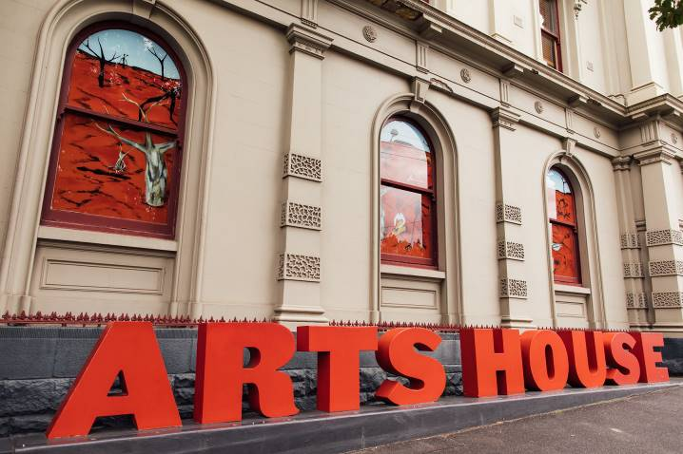

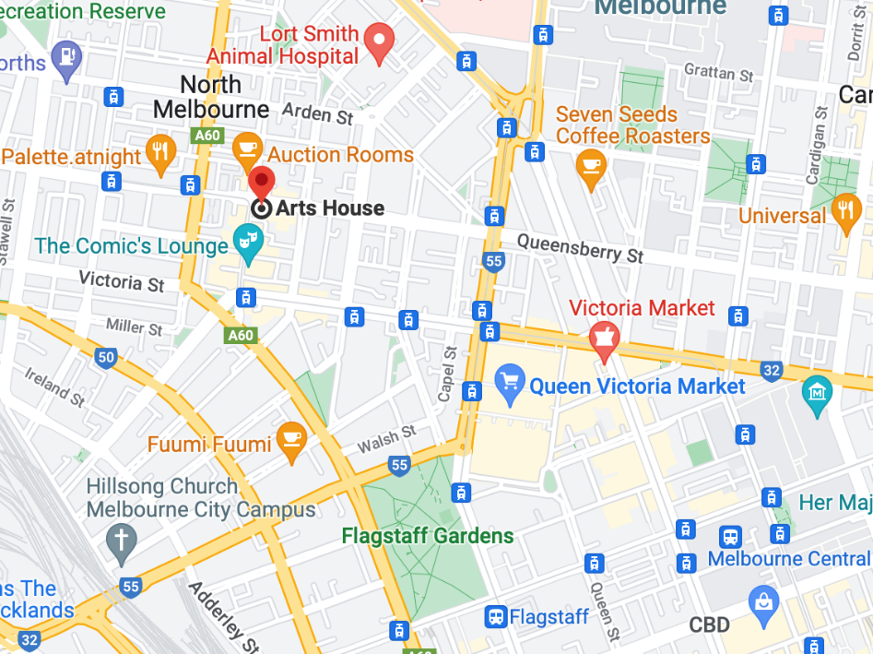

Image: North Melbourne Town Hall features giant red letters that say ARTS HOUSE out the front of it.

Image: a map of Arts House and its surrounding area. [LINK TO MAP](https://www.google.com/maps/place/Arts+House/@-37.802973,144.9486818,17z/data=!4m5!3m4!1s0x0:0x64c465ac7ef21cff!8m2!3d-37.803239!4d144.9498609?shorturl=1)

## **Front Entrance**

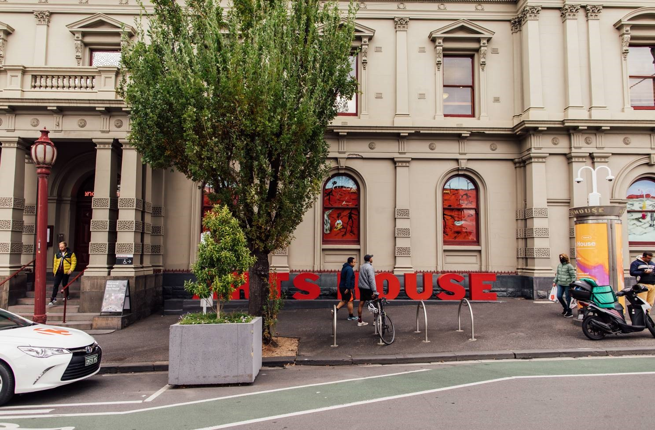

## **Accessible Entrances**



There are two Accessible Entrances. The first is on Errol St next to the Post Office.

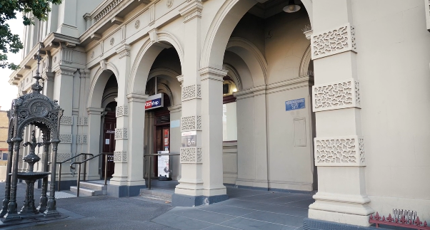

Image: Errol Street entrance next to the Post office with wheelchair accessible ramp or two steps with grab rails.

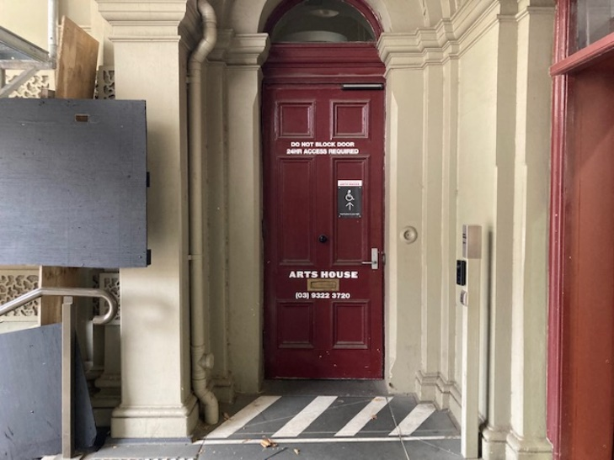

Image: View of door entrance.

The second Accessible Entrance is towards the end of George Johnson Lane.

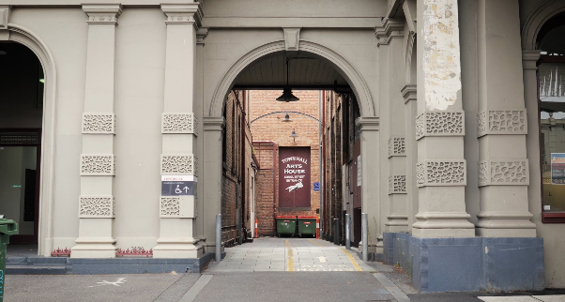

Image: View of George Johnson Lane from Errol St. The laneway passes through an archway with a brick wall at the end.

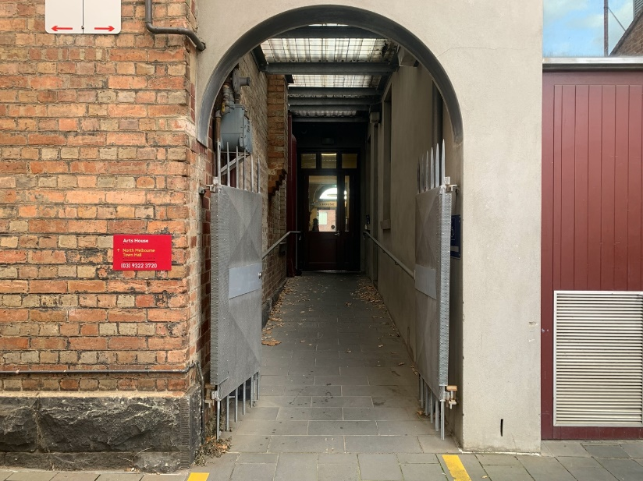

Image: view of the ramp leading from George Johnson Lane to the automated door which opens into the Arts House foyer.

## **Box Office**

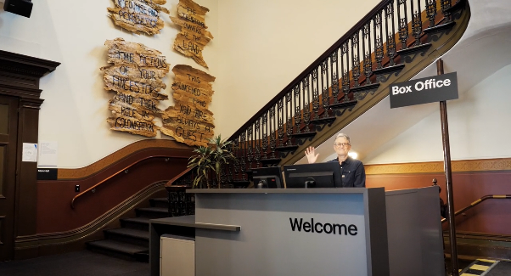

Box Office is located in the foyer under the stairwell.

## **Ushers**

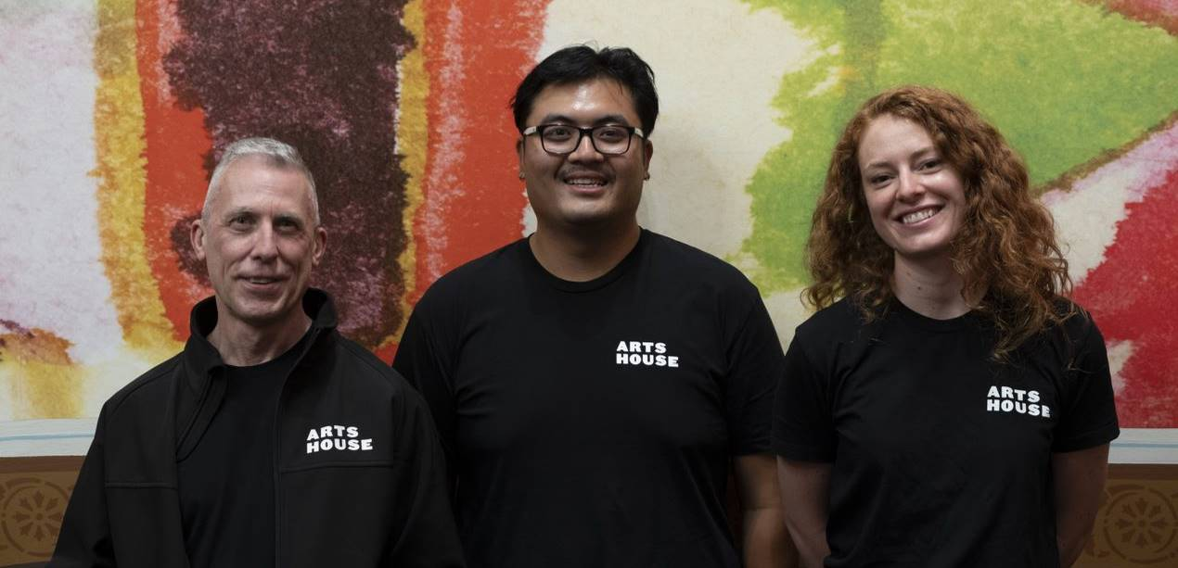

Ushers will be wearing black with an Arts House Logo on the left hand shoulder.

## **Bar**

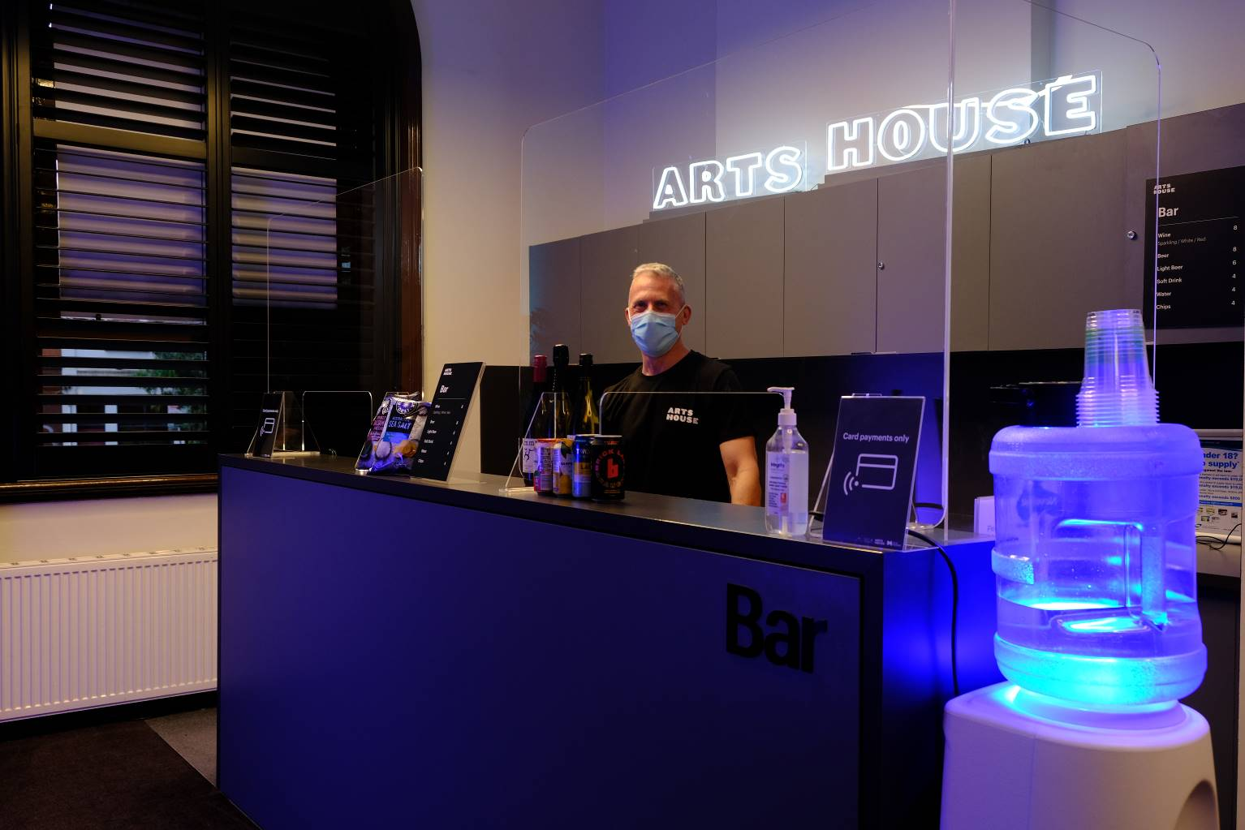

Bar staff will be wearing black with an Arts House Logo.

We have a range of alcoholic and non-alcoholic beverages for sale.

We are a cashless venue and accept EFTPOS, Visa and Mastercard payments.

## **Quiet Space**

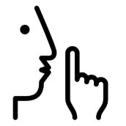

Arts House Quiet Space is located on Ground Level and is nearby reception and opposite the accessible bathrooms. It includes a range of seating options including soft furnishings, dimmable lights, sensory and stim objects. It is open during venue opening hours and events as a quiet space, prayer or parenting space.

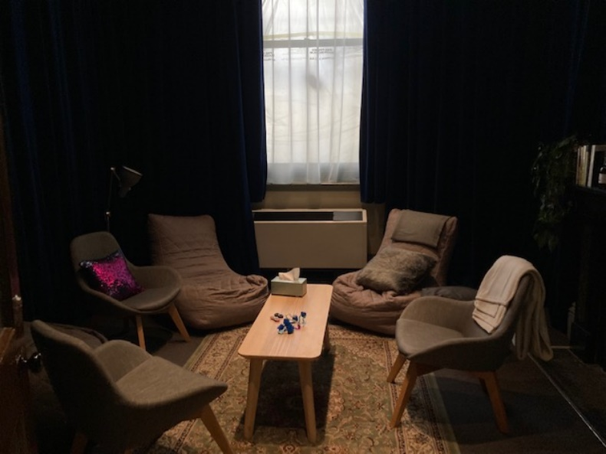

Image: Quiet space with lights dimmed

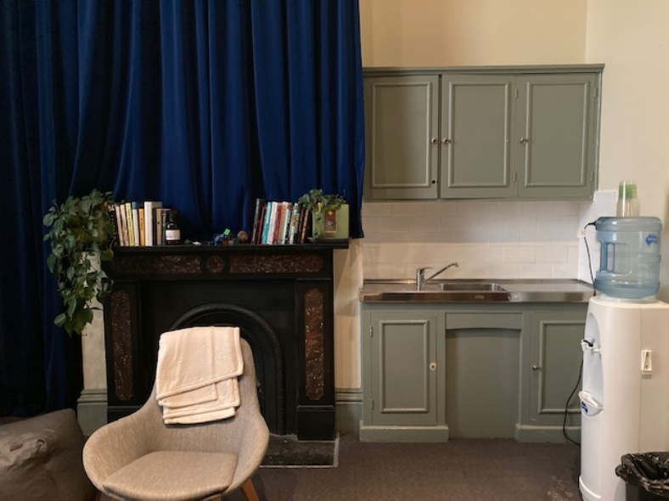

Image: Quiet space kitchenette and book shelf

## **Bathrooms**

All bathrooms have Dyson hand dryers with sensor activation. There is an accessible bathroom that is single use on ground level opposite the Quiet Space. There is another accessible bathroom upstairs – this is accessible via lift or stairs.

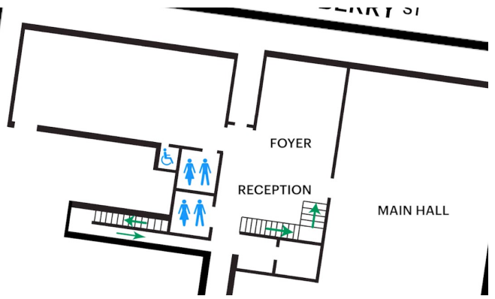

## **Door to Main Hall**

The Performance is in the Main Hall.

It is on the ground floor.

It is to the left of the box office desk and right of the bar.

An artist statement is available on signage and warnings on the door.

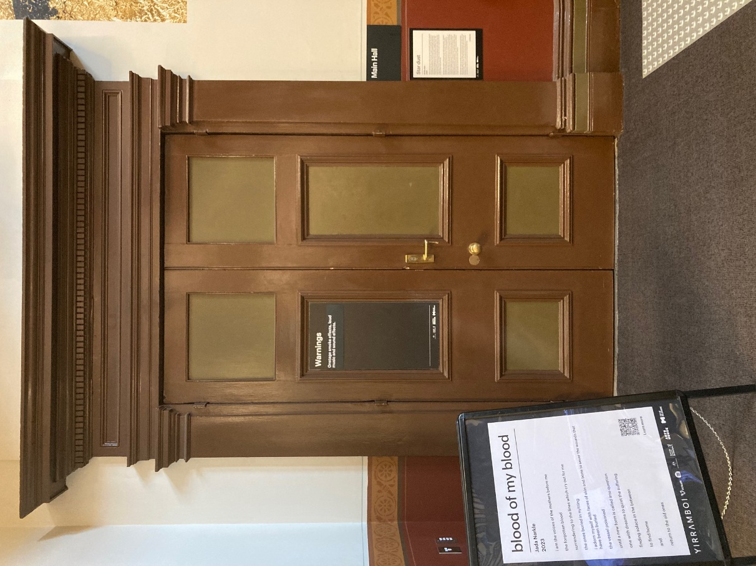

## **Lift**

The lift is located behind reception desk in the foyer.

The closest entry to the lift is via George Johnson Lane.

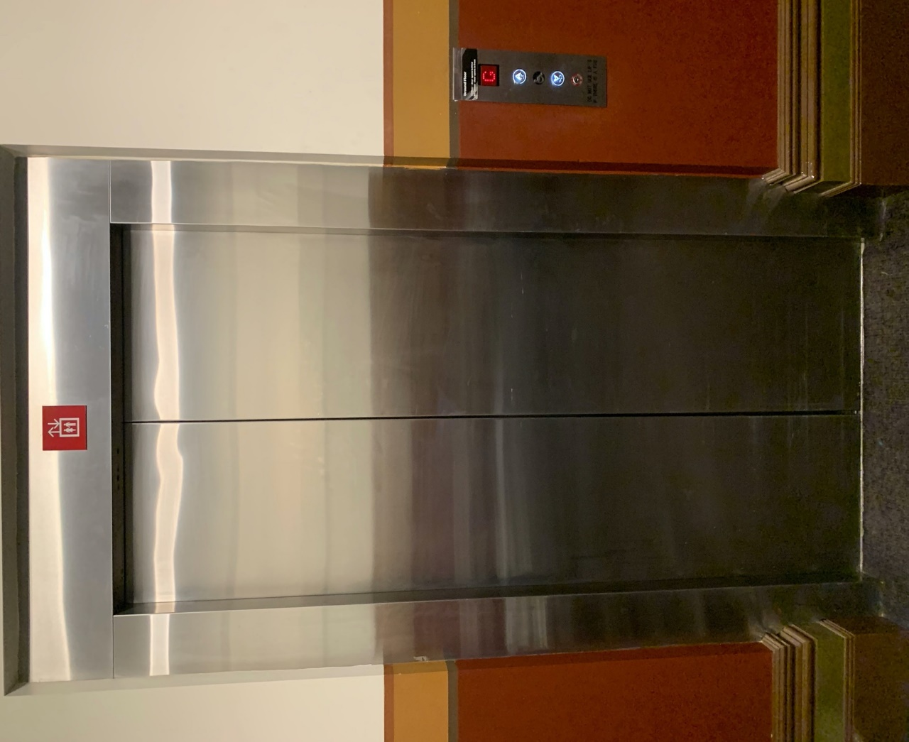

# **Transport**

## **Tram**

Route 57 (High Floor trams only)

Stop 12, North Melbourne Town Hall.

Please note, this is not a wheelchair accessible tram

[GETTING TO ARTS HOUSE VIDEO LINK](https://vimeo.com/544169506)

## **Train**

Arts House is 1.1km from   
North Melbourne Train Station,   
approximately 16 minute walk

[North Melbourne Station Information](https://www.ptv.vic.gov.au/stop/1144/north-melbourne-station/0/train/)

1.2km from Flagstaff Station,   
approximately 15 minute walk

[Flagstaff Station Information](https://www.ptv.vic.gov.au/stop/1068/flagstaff-station/0/train/#StopPage:::datetime=2023-04-06T04%3A41%3A27.669Z&directionId=-1&showAllDay=false&_auth=408ac3b1e97f4b0beb5bdf00c2f797057d10dd6e6cf2ad40a69334c4dfdf5e21)

## **Bus**

Bus number: 216

## **Parking**

There is limited paid on-street parking on Queensberry Street and Errol Street.

There are two accessible on street car parking spaces on Queensberry Street (150m to our accessible Errol Street entrance) for holders of a Parking Permit for Disabled people.

# **COVID Safety**

Please note: If you have a cough, sore throat, fever, shortness of breath or flu-like symptoms, you must not attend our venue or programs in person.

We will provide a refund if you need to cancel your attendance due to illness. Please [contact us](mailto:ArtsHouse.Ticketing@melbourne.vic.gov.au) by 9am on the day of the event.

To minimise the risk of COVID-19 transmission, we advise all patrons, artists and staff to:

* Practise physical distancing where possible
* Practise good hygiene by washing and or sanitising your hands often
* Wear a mask as directed by Victorian Government guidelines

Throughout the venue you will find:

* hand sanitiser stations available
* masks available (ask one of our staff for assistance)​
* increased signage to direct patron movement and avoid crowd congestion

We also ensure that spaces are well ventilated.

Staying COVID-safe remains important. We must all follow these steps:

* Follow the [Victorian Government’s measures on how to stay safe.](https://www.betterhealth.vic.gov.au/coronavirus-covid-19-victoria)
* Wear[face masks](https://www.betterhealth.vic.gov.au/coronavirus-covid-19-victoria) where required or when you cannot safely socially distance.
* Practise [COVID-safe hygiene protocols.](https://www.health.gov.au/news/health-alerts/novel-coronavirus-2019-ncov-health-alert/how-to-protect-yourself-and-others-from-coronavirus-covid-19/good-hygiene-for-coronavirus-covid-19)
* Test for COVID and get [free rapid antigen tests​](https://www.melbourne.vic.gov.au/community/health-support-services/health-services/Pages/free-rapid-antigen-tests.aspx) at nominated City of Melbourne customer service and library sites.