**Good Things Come in Threes**   
Season 1 2024, Equity-Builder and Disability Inclusion Action Plan Launch Event

By Arts House

Access Guide

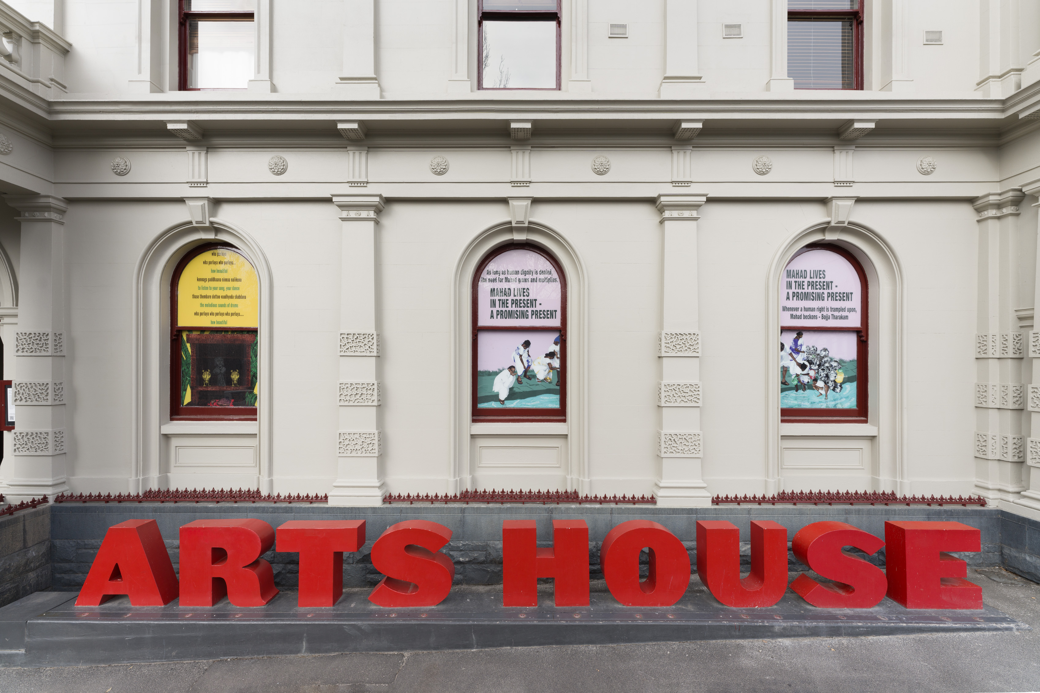

Image: *this way, emancipation,*Shrujana Shridhar, photo: Matthew Stanton

Image description: Three pieces of visual artwork adorn the windows of Arts House, which has been photographed from the exterior.

# **Updates to this document**

Please note, we will endeavour to provide the latest access information on this event.

Arts House website will contain the most up to date version of this document and all ticket holders will be notified of any revisions made 3 days and 1 day prior to the event.

This document was created: 30 November 2023

**Contents**

**Updates to this document** 1

**Where** 3

**When** 3

**Access Services** 3

**Host** 5

**Running Order** 7

**Sensory Elements** 7

Sound 7

Lighting 7

Physical 7

Smell 8

Visual 8

Entry to space 8

Shocks or surprises 8

Audience experience 9

Social expectations 9

**Other** 9

Content Warnings 9

**General Notes** 9

**The Venue** 10

Front Entrance 10

Building Access Information 11

Accessible Entrances 11

Reception 12

Quiet Space 13

Bathrooms 13

Lift 14

**Transport** 15

Tram 15

Train 15

Bus 15

Parking 15

**COVID Safety** 16

# 

# **Where**

Arts House

521 Queensberry Street

North Melbourne VIC

# **When**

**Tuesday 5 December, 6:30pm – 9:00pm**

Duration: 2.5 hours 

# **Access Services**

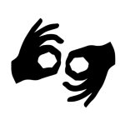

Auslan Interpreted



Assistance Animal are welcome.

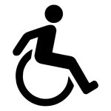

This session is fully wheelchair accessible.

# **Host**

This event will be hosted by Emily Sexton, Artistic Director of Arts House



Image description: Emily sits in front of a textured gold wall. She is wearing a sleeveless dark blue top with a long silver chain.

**Performers**

There are 3 performances in this event.

Artists **Fallon Te Paa and Kaycee Merito** will perform spoken word.

**Rainbow Chan** will perform a pop song in two language – Weitou and English.

**Vidya Rajan** will perform a comedy piece with audio/visual elements.

**Artemis Muñoz** will perform two cabaret-style songs.

**Panellists**

The event includes a panel discussion with four speakers.

They are **Nithya Nagarajan, Jonathan Craig, Aïsha Trambas and Margaret Mayhew.**

# **Running Order**

6:00pm Doors open – snacks and drinks available

6:30pm Event begins – introductions and Welcome to Country

6:40pm Performance 1 - Fallon & Kaycee

6:45pm Introduction to the Season 1 2024 program by Emily and Nithya

6:50pm Performance 2 - Rainbow Chan

6:55pm Performance 3 - Vidya Rajan

7:00pm Panel discussion begins

7:40pm Panel discussion end

7:45pm Performance 4 - Artemis Muñoz

8:00pm DJ General Feelings to play

9:00 Event ends

# **Sensory Elements**

## **Sound**

This event will be predominantly speaking. The performances by Rainbow Chan and Artemis Muñoz will include music. All speakers and performers will use microphones. Soft background music will be playing in the venue foyer as people arrive and a DJ will be playing lively music for the last hour of the event.

## **Lighting**

The Main Hall will have soft, multi-coloured lighting. No flashing or moving lights.

## **Physical**

The venue currently does not have heating. Rooms are an adequate temperature.

## **Smell**

There will be light vegetarian catering available in the space from Moroccan Soup Bar that will include the smell of spices, vegetables and other ingredients.

The menu includes:

* Dips - humous and babaghanouj
* Finger food - marinated olives, grilled haloumi, samboussa with cheese, zaatar bites, falafel, charmoula sticks and vine leaves
* Chickpea bake
* Dessert - flourless orange cake with whipped rose ricotta, backlava and Turkish delight

## **Visual**

There will be photos from our past and upcoming works projected onto fabric hanging from the ceiling. A video promoting upcoming works at the venue will play during one of the speeches.

Vidya Rajan’s performance will include visual elements projected on the screen.

Upon entry to the Main Hall, a small stage will be located to the right wall. A few round tables will be spread out through the space and a mix of chairs and high stools will be available.

A small bar is located to the left side area of the space and snacks will be on a table next to the bar.

Audience Experience

## **Entry to space**

The audience will enter from the main doors off the foyer and will be asked to sit where they feel comfortable. As there is no allocated seating for this performance, please let front of house staff know if you would be most comfortable in a particular spot before the doors open.

## **Shocks or surprises**

There are no shocks or surprises.

## **Audience experience**

The event will include time for social interaction and mingling before and after the formalities with other attendees and Arts House staff.

## **Social expectations**

There will be a variety of seating options including chairs and a limited number of bar stools/high chairs. As there is no allocated seating for this event, please let the front of house staff know if you would be most comfortable in a particular spot before the doors open.

There is no lock out (or lock in) for this event. Attendees are welcome to come and go as they please.

# **Other**

## **Content Warnings**

No warnings.

## **General Notes**

The session will commence with a Welcome to Country in the space.

# **The Venue**

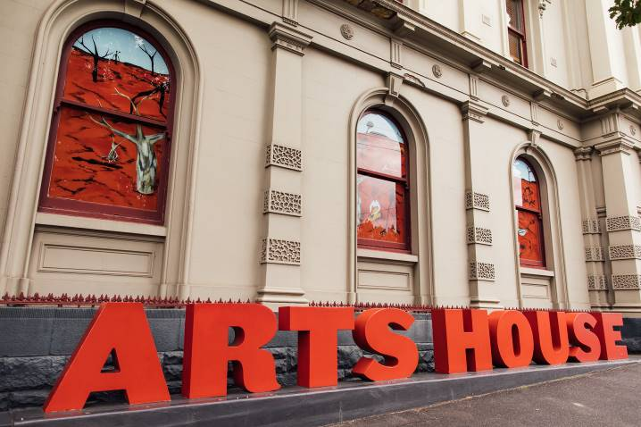

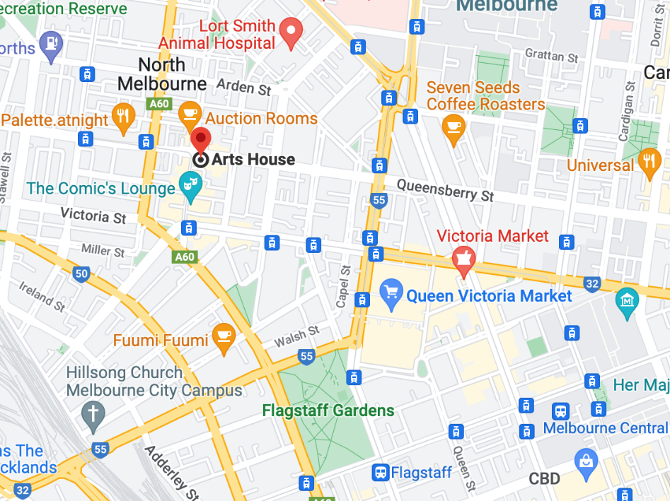

Image: North Melbourne Town Hall features giant red letters that say ARTS HOUSE out the front of it.

Image: a map of Arts House and its surrounding area. [LINK TO MAP](https://www.google.com/maps/place/Arts+House/@-37.802973,144.9486818,17z/data=!4m5!3m4!1s0x0:0x64c465ac7ef21cff!8m2!3d-37.803239!4d144.9498609?shorturl=1)

## **Front Entrance**

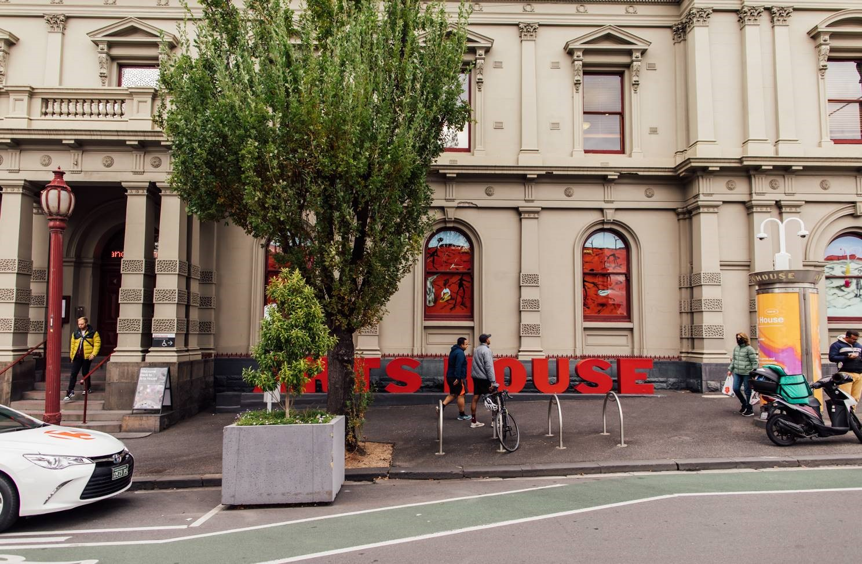

## **Building Access Information**

To familiarise yourself with the space before you arrive, explore Arts House virtually through a 3D scan of the building by clicking [here](https://tourmkr.com/F1jsn73hDg/36140818p&49.3h&89.59t).

To download a verbal map to help with navigation throughout the building, please click [here](https://www.artshouse.com.au/wp-content/uploads/2022/11/Verbal_Map_of_Arts_House_2022.docx).

To download a building document that outlines detailed information on amenities, access, navigation, parking and drop-off, please click [here](https://www.artshouse.com.au/wp-content/uploads/2022/11/Arts_House_Building_Information_2022.docx).

## **Accessible Entrances**



There are two Accessible Entrances. The first is on Errol St next to the Post Office.

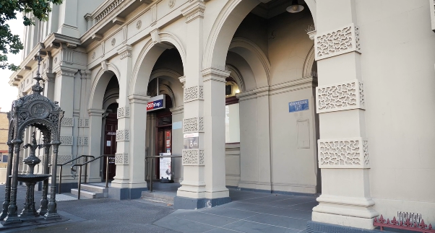

Image: Errol Street entrance next to the Post office with wheelchair accessible ramp or two steps with grab rails.

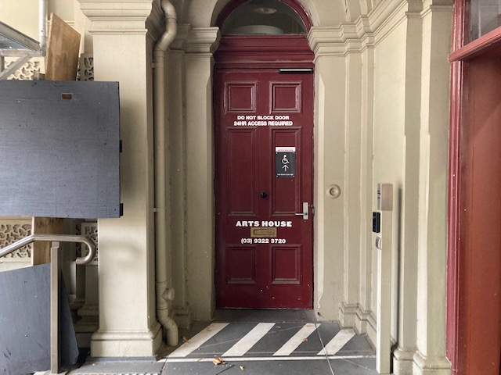

Image: View of door entrance.

The second Accessible Entrance is towards the end of George Johnson Lane.

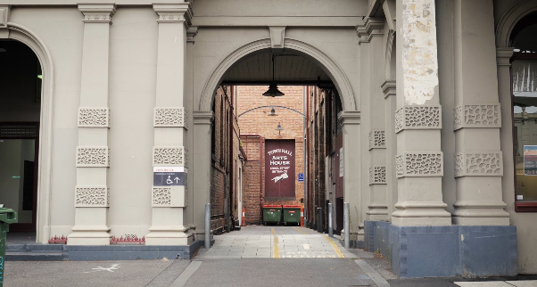

Image: View of George Johnson Lane from Errol St. The laneway passes through an archway with a brick wall at the end.

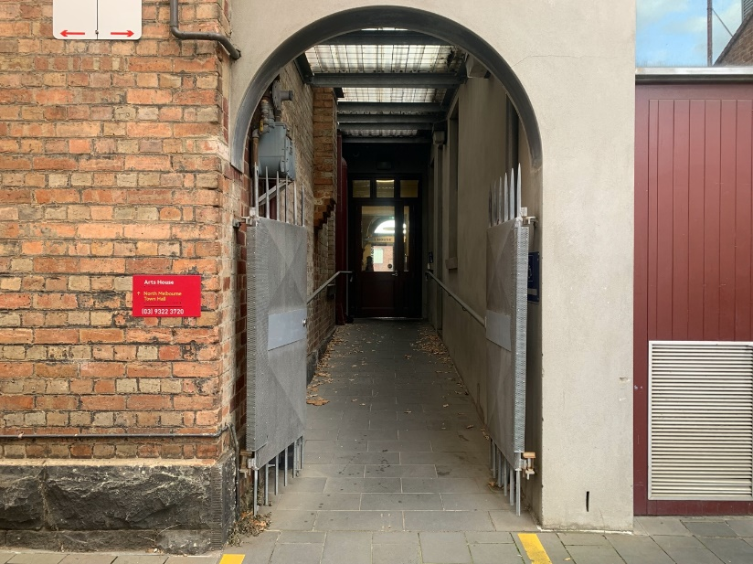

Image: view of the ramp leading from George Johnson Lane to the automated door which opens into the Arts House foyer.

## **Reception**

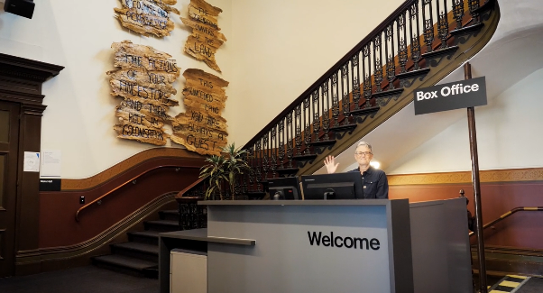

Reception is located in the foyer under the stairwell.

## **Quiet Space**



Arts House Quiet Space is located on Ground Level and is nearby reception and opposite the accessible bathrooms. It includes a range of seating options including soft furnishings, dimmable lights, sensory and stim objects. It is open during venue opening hours and events as a quiet space, prayer or parenting space.

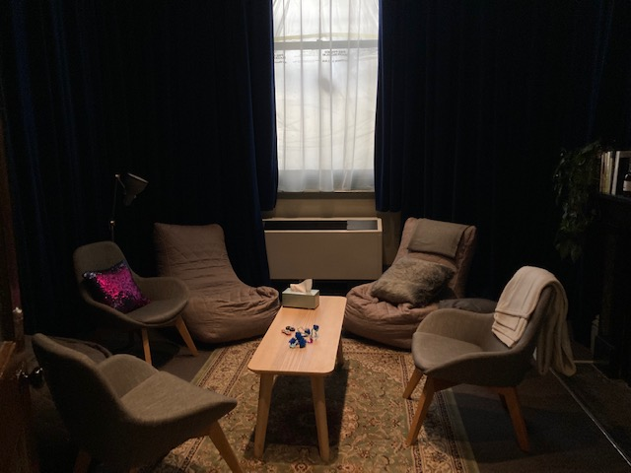

Image: Quiet space with lights dimmed

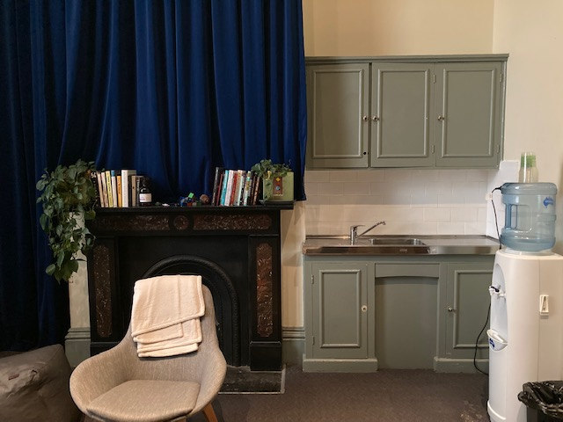

Image: Quiet space kitchenette and book shelf

## **Bathrooms**

All bathrooms have Dyson hand dryers with sensor activation. There is an accessible bathroom that is single use on ground level opposite the Quiet Space. There is another accessible bathroom upstairs – this is accessible via lift or stairs.

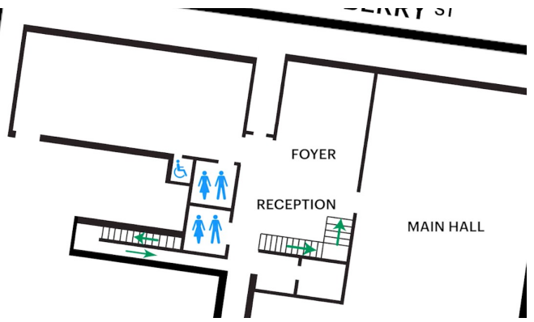

## **Lift**

The lift is located behind reception desk in the foyer.

The closest entry to the lift is via George Johnson Lane.

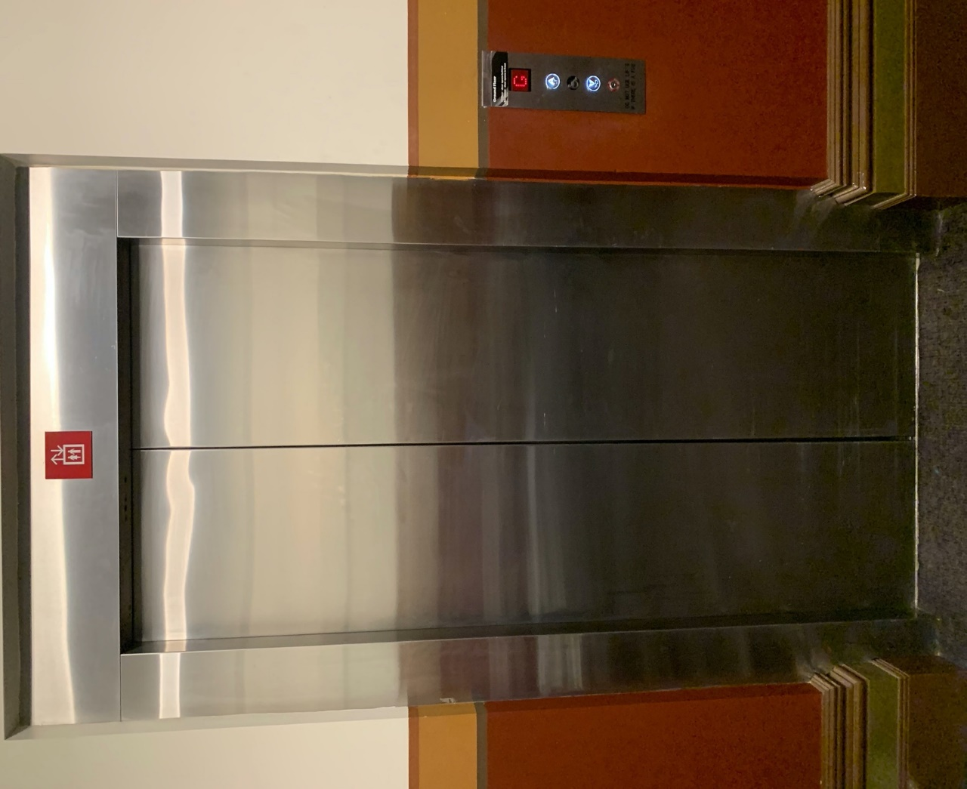

# **Transport**

## **Tram**

Route 57 (High Floor trams only)

Stop 12, North Melbourne Town Hall.

Please note, this is not a wheelchair accessible tram

[GETTING TO ARTS HOUSE VIDEO LINK](https://vimeo.com/544169506)

## **Train**

Arts House is 1.1km from   
North Melbourne Train Station,   
approximately 16 minute walk

[North Melbourne Station Information](https://www.ptv.vic.gov.au/stop/1144/north-melbourne-station/0/train/)

1.2km from Flagstaff Station,   
approximately 15 minute walk

[Flagstaff Station Information](https://www.ptv.vic.gov.au/stop/1068/flagstaff-station/0/train/#StopPage:::datetime=2023-04-06T04%3A41%3A27.669Z&directionId=-1&showAllDay=false&_auth=408ac3b1e97f4b0beb5bdf00c2f797057d10dd6e6cf2ad40a69334c4dfdf5e21)

## **Bus**

Bus number: 216

## **Parking**

There is limited paid on-street parking on Queensberry Street and Errol Street.

There are two accessible on street car parking spaces on Queensberry Street (150m to our accessible Errol Street entrance) for holders of a Parking Permit for Disabled people.

# **COVID Safety**

Please follow good health and hygiene practices when visiting Arts House.

Ticket holders who cannot attend their performance due to COVID-19 illness or symptoms are entitled to a full refund.

**Facemasks**

We strongly recommend wearing a face mask while indoors. We have disposable masks available at reception and in the foyer.

**Cleaning**

Arts House buildings are cleaned nightly Monday-Friday and on weekends as required.

We conduct touchpoint cleaning of spaces between performances.

**Hygiene Stations**

Arts House provides handwashing and hygiene stations in each amenities area, studio, and office including: hand sanitizer, disinfectant wipes, rubbish bin.

More information about COVID-19 Safety can be found through the links below:

[Our COVID-19 Safety Plan - Arts House - Melbourne](https://www.artshouse.com.au/our-covid-19-safety-plan/)